6-69
SELECT customerID, COUNT(orderID) AS NumOrders  FROM Order_T  Group By customerID; | 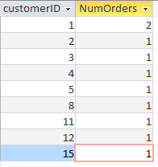

6-73

SELECT ProductID, COUNT(OrderID) AS FreqOrdered  FROM OrderLine_T  GROUP BY productID  ORDER BY COUNT(OrderID) DESC; | 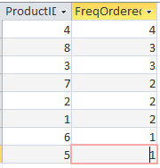

6-74
SELECT ProductFinsh, AVG(ProductStandardPrice) AS AvgPrice  FROM Product_T  GROUP BY ProductFinish  Order BY AVG(ProductStandardPrice); | 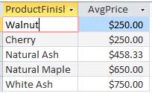

Caution: To be further verified (didn’t work in Access)  SELECT SalesPersonID, COUNT(orderID)  FROM Order_T O JOIN Customer_T C  ON O.CustomerID=C.CustomerID  JOIN DoesBusinessIn_T DBI  ON C.CustomerID=DBI.CustomerID  JOIN Territory_T Terri  ON Terri.TerritoryID=DBI.TerritoryID  JOIN SalesPerson SP  ON Terri.TerritoryID=SP.TerritoryID  GROUP BY SalesPersonID  ORDER BY COUNT(orderID) DESC; | SELECT SalesPersonID, COUNT(orderID)  FROM Order_T O, Customer_T C, DoesBusinessIn_T DBI, Territory_T Terri, SalesPerson SP  WHERE O.CustomerID=C.CustomerID  AND C.CustomerID=DBI.CustomerID  AND Terri.TerritoryID=DBI.TerritoryID  AND Terri.TerritoryID=SP.TerritoryID  GROUP BY SalesPersonID  ORDER BY COUNT(orderID) DESC;

After-class verification and exploration:

SELECT …
FROM
(Territory_T INNER JOIN
(
(Customer_T INNER JOIN Order_T
ON Customer_T.CustomerID = Order_T.CustomerID)
INNER JOIN DoesBusinessIn_T
ON Customer_T.CustomerID = DoesBusinessIn_T.CustomerID
)
ON Territory_T.TerritoryID = DoesBusinessIn_T.TerritoryID)
INNER JOIN Salesperson_T ON Territory_T.TerritoryID = Salesperson_T.TerritoryID;

Note 1: INNER JOIN
Note 2: Use parentheses!
Note 3: Since using parentheses could be very complicated, I recommend that we still use the “simpler” method of –
FROM Order_T O, Customer_T C, DoesBusinessIn_T DBI, Territory_T Terri, SalesPerson SP
WHERE O.CustomerID=C.CustomerID
AND C.CustomerID=DBI.CustomerID
AND Terri.TerritoryID=DBI.TerritoryID
AND Terri.TerritoryID=SP.TerritoryID

