Apr 15 Class Examples

- ORDER BY multiple fields; expression; usage of alias;
  - List RID, City, AnnualSales, order by City within Type (Type is Primary sort, and City 2ndry); same field, by Type within City
  - Expression – sales per squarefoot; Alias – SalePerFt: Alias can ONLY be used as the column header (for display); it cannot be used as part of a mathematical expression or Boolean operation.
  - Use alias in Boolean – see above
  - Use alias in mathematical expression as criteria – “SalePerFoot>=350” did NOT work
  - Take-out restaurants not in Miami, Orlando, or Santa Monica
SELECT RestaurantID, Typeofservice,city
FROM Restaurants
WHERE typeofservice="Take-Out"
AND city not in ('Miami', 'Santa Monica', 'Orlando');

- Group by: Aggregate function;
- COUNT(RestaurantID) >=2 – the cities where there are at least two restaurants in the DB
SELECT COUNT(RestaurantID) AS TotalNumRestaurants, city
FROM Restaurants
GROUP BY city
HAVING COUNT(RestaurantID) >=2; -- This filters the cities for those having at least 2 restaurants

- List the types of services for which AVG(AnnualSales) >= 500,000
------------------------------------------------------------------
- Group by: row value and set value
- Squarefootage added; ORDER BY the complete expression (AVG(Squarefootage)) rather than by the alias (AVGofSqFt – NO)
- TypeOfService added
----------------------------------------------------
- WHERE vs HAVING
- city = ‘Miami’ or city = ‘Orlando’
WHERE: | 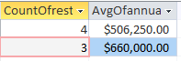
HAVING | 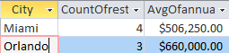

- annualsales >=400000
WHERE AnnualSales  >=  400000 | 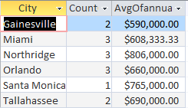
HAVING AVG(AnnualSales)  >=  4000000 | 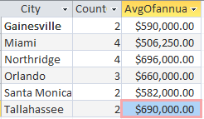

- Count(restaurantID) >=2
GROUP BY city;
WHERE: | Same or different?  Work or not work?
HAVING: | 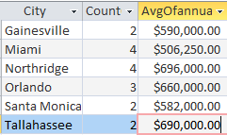

--------------------------------------------------
- Group by multiple fields
  - City and typeofservice, respectively and together
Grp By City | 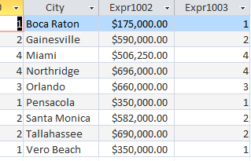
By Type | 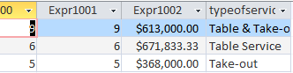
By Type then by City | 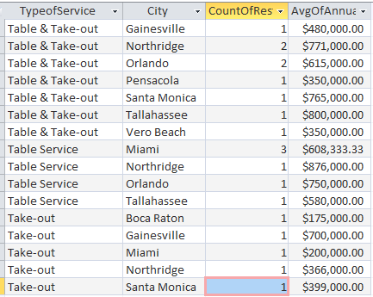

Code for the last query above:
SELECT TypeofService, City, Count(RestaurantID) AS CountOfRestaurantID, Avg(AnnualSales) AS AvgOfAnnualSales
FROM Restaurants
GROUP BY TypeofService, City
ORDER BY TypeofService, City;

