SELECT Avg(Restaurants.AnnualSales) AS AvgOfAnnualSales, Restaurants.FranchiseeID, Franchisees.HomeCity

FROM Franchisees INNER JOIN Restaurants ON Franchisees.FranchiseeID = Restaurants.FranchiseeID

GROUP BY Restaurants.FranchiseeID, Franchisees.HomeCity;

/////////////////

SELECT Restaurants.City, Avg(Restaurants.AnnualSales) AS AvgOfAnnualSales

FROM Restaurants

GROUP BY Restaurants.City;

|  |  |
| --- | --- |
|  |  |

SELECT Avg(AnnualSales) AS AvgOfAnnualSales, Restaurants.FranchiseeID, HomeCity,

(SELECT Avg(AnnualSales) AS AvgOfAnnualSales

FROM Restaurants

where city=franchisees.homecity

GROUP BY City) As HomeCityAVG

FROM Franchisees INNER JOIN Restaurants ON Franchisees.FranchiseeID = Restaurants.FranchiseeID

GROUP BY Restaurants.FranchiseeID, HomeCity

HAVING Avg(Restaurants.AnnualSales) >

(SELECT Avg(AnnualSales) AS AvgOfAnnualSales

FROM Restaurants

where city=franchisees.homecity

GROUP BY City);

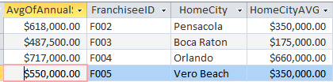

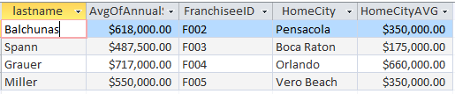

SELECT lastname, Avg(AnnualSales) AS AvgOfAnnualSales, Restaurants.FranchiseeID, HomeCity,

(SELECT Avg(AnnualSales) AS AvgOfAnnualSales

FROM Restaurants

where city=franchisees.homecity

GROUP BY City) As HomeCityAVG

FROM Franchisees INNER JOIN Restaurants ON Franchisees.FranchiseeID = Restaurants.FranchiseeID

GROUP BY Restaurants.FranchiseeID, lastname,HomeCity

HAVING Avg(Restaurants.AnnualSales) >

(SELECT Avg(AnnualSales) AS AvgOfAnnualSales

FROM Restaurants

where city=franchisees.homecity

GROUP BY City);

