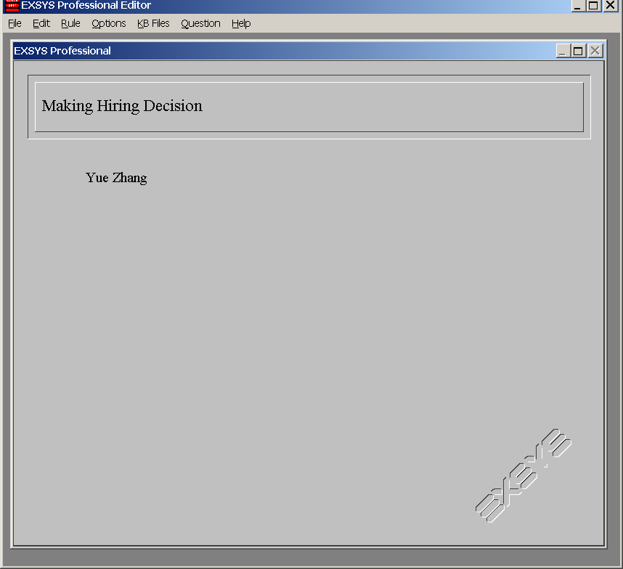

Figure 1: Starting Screen

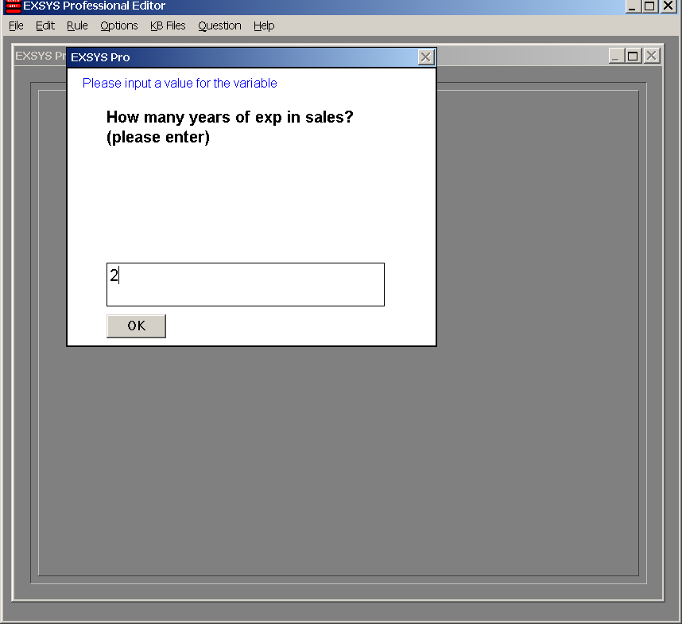

Figure 2: Run-Entering number of years of experience in sales as requested (by the system)

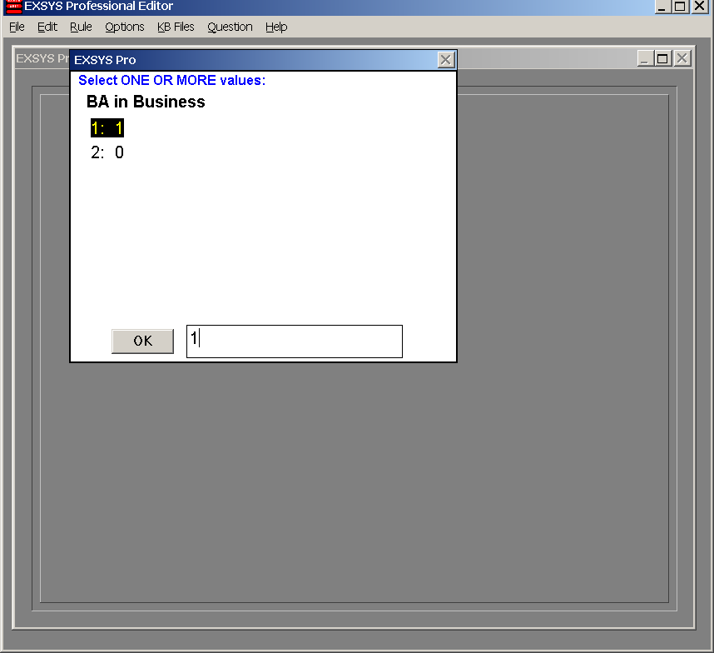

Figure 3: Run-Entering the answer to degrees as requested (by the system)
[“1” means “Yes” (1) while “2” means “No” (0)]

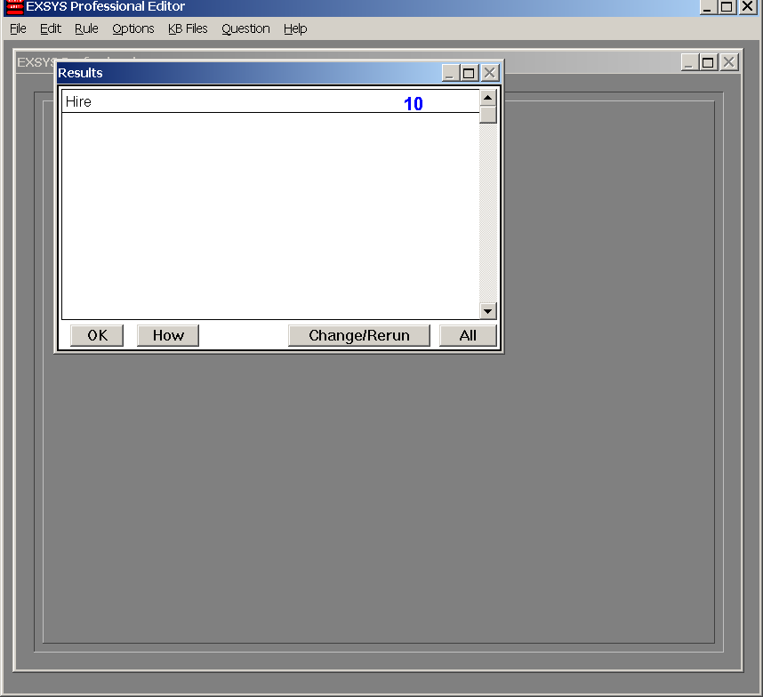

Figure 4: Run-Result: “hired”

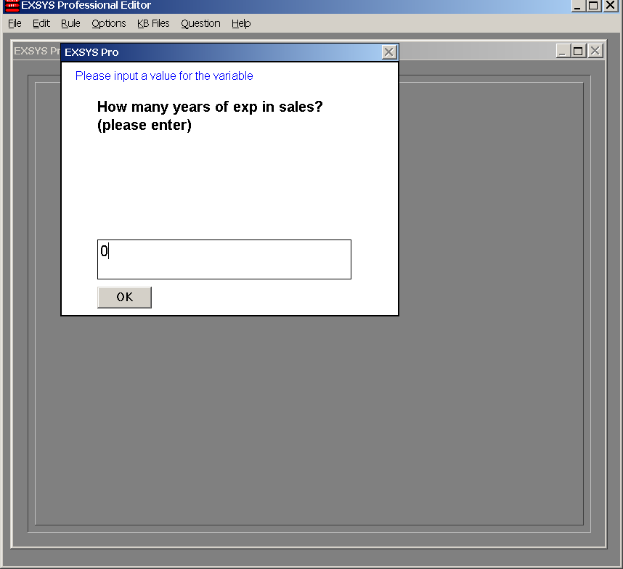

Figure 5: Run-Entering number of years of experience in sales as requested (note this time it is zero)

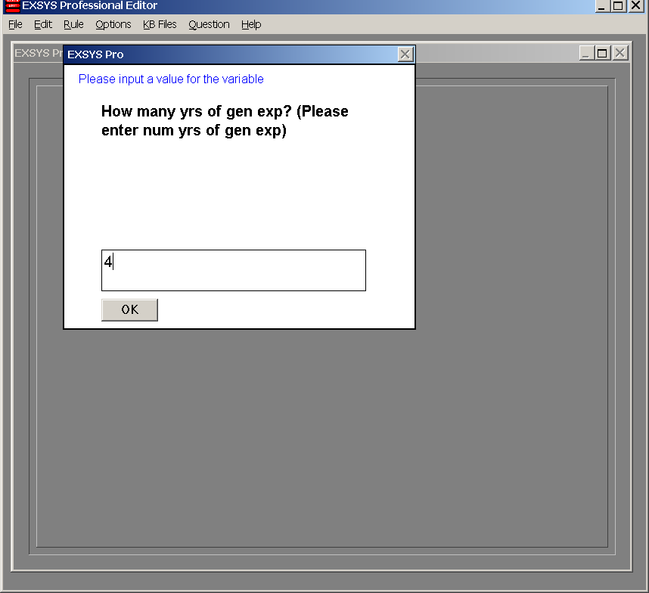

Figure 6: Run-Now the system knows to ask the second question about general experience [note I entered “4” for “4 years of general experience” – is this passing or failing?]

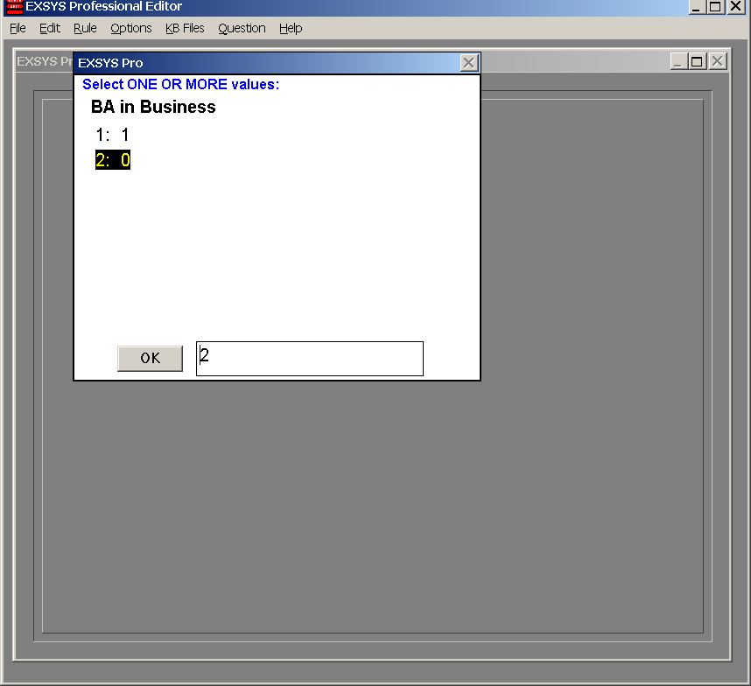

[Obviously the above test was passed, and the system asks about degree]
Figure 7: Run-Enter degree
[note I entered “2” means “No” (0) – no biz degree. What do you expect the system to respond?]

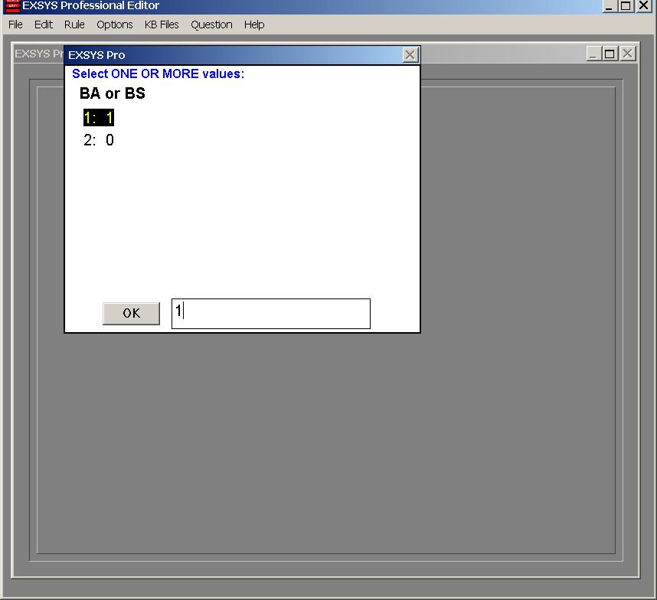

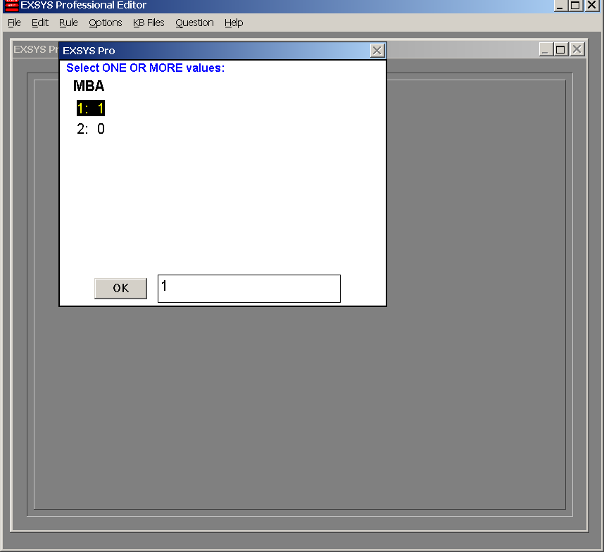

The above 2 figures should be self-explanatory. So I wont explain.

Next see an example of “not hired”:

