Electronic Spreadsheet (Excel) Handout 5:
Making Charts in Excel
Dr. Yüe “Jeff” Zhang
Version 2.4, November 15, 2006

Section 5-1: Column Charts and Pie charts

It is often desirable to present data in charts, which would enable managers to have a quick grasp of the relationships among data groups without reading numbers in a table. Excel (and all other electronic spreadsheets) provides powerful tools for creating various types of charts from spreadsheet data.

Below shows the data of digital camera and DV sales of IntelliImage in the four sales regions of Las Vegas, Los Angeles, Phoenix, and San Francisco. The VP for Marketing of IntelliImage would like to see the following charts:

- a side-by-side column chart showing the four regions, with the two product lines side by side;
- a side-by-side column chart showing the two product lines, with the four regions side by side;
- an exploded pie chart, showing the percentage of each sales region in the total sales.

You are asked to perform the above task of creating the charts. The sales data is given below:

 | A | B | C | D
4 | Sales ($million) | Digital Camera | DV | City Totals
5 | Las Vegas | 20 | 9 | 29
6 | Los Angeles | 14 | 11 | 25
7 | Phoenix | 8 | 3 | 11
8 | San Francisco | 18 | 7 | 25
9 | Product totals | 60 | 30 | 90

Table 5-1: The sales data of IntelliImage

1. Creating a column chart showing the four regions, with the two product lines side by side

(1) Highlight the range A4:C8 – the original data (including the column headers but not including the totals), then click at the Chart Wizard on the tool bar:

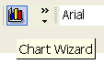
(2) The side-by-side column chart (“clustered column”) should appear as the first choice among chart types. If it does not, select the non-stacked column chart, and then click at the Custom Types tab to further make your choice: the clustered column should be the first choice there.

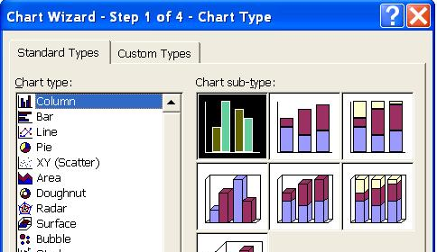

Figure 5-1: Select the chart type

(3) Click Next, Step 2 of the Wizard dialog box pops up and allows you to choose your data series. Note that the data series here are in Columns [only the data in a column will show the four cities] - note the radio button corresponding to Column is checked (default) in the figure below (Figure 5-2). In the Chart wizard (Figure 5-2) you can see that the current data grouping is by city, and within city the two product lines are side by side.

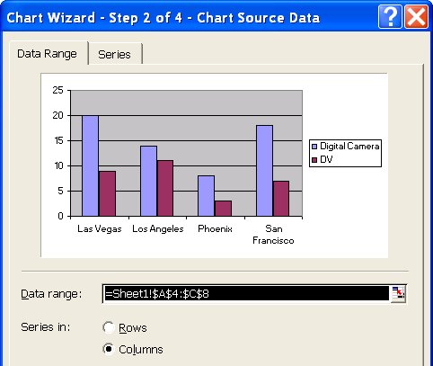
By city

Figure 5-2: Select the data series

(4) Enter chart title: Step 2 of the Wizard dialog box pops up and allows you to enter your chart title and axis. Enter Sales by Region. Click Next. The Wizard would ask you whether you want the chart to appear on a new sheet or the current sheet (Sheet 1) – default. You would accept the default: click Next, and then click Finish. The chart would appear on Sheet 1 and you can drag and resize it to the desirable location and size. The upper-right corner of Figure 5-3 shows this newly created chart.
2. Creating a column chart showing the two product lines, with the four regions side by side.

The steps would be the same as the above, except that at step (3), in Series in:, click the radio button Rows [only the data in a row will show the two products]. In step (4), enter Sales by Products as the title. Complete all the above steps. The lower-left corner of Figure 5-3 shows this newly created chart.

3. Creating a pie chart showing the percentage of each sales region in the total sales.

(1) Highlight the cities (A5:A8), hold down the <Ctrl> key, highlight the city totals (D5:D8) [this is how you can highlight two non-contiguous cell ranges], then click at the Chart Wizard on the tool bar.

(2) Same as 2 above, only that this time you want to choose Pie. For the Chart Sub-type, choose exploded pie.

(3) In Chart Wizard - Step 3 of 4, select Data Labels tab. In the new dialog box, check the check boxes Category name (which will display the city names) and Percentage.

(4) Click Next and Finish. You will have an exploded pie chart created.

See Figure 5-3 below to see all the three charts.

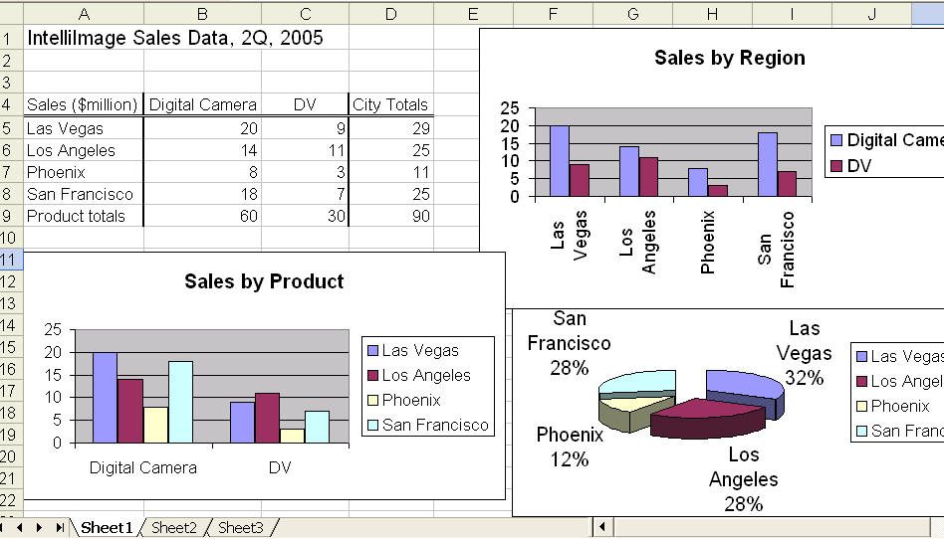
Series in columns

Series in rows Figure 5-3: Clustered column charts, and pie chart
Section 5-2: Line Charts

While column charts and pie charts are best for presenting simple data relationships, the more sophisticated data relationships such as those of functions would better be presented using a line chart. Below we will try to create a line chart helping us to visualize Moore’s Law: the computing power of microprocessor chips doubles every 24 months.

We start from January 1994, when the then Pentium chip speed was about 75 MHz (in fact I did not have that number; I estimated that number from a known number of 600 MHz in January 2000).

(1) Highlight B4:C12 (“Number of Months” and “Speed…” columns, without the column headers). Then, do the same as in Section 5-1, except that you would choose line chart now.
(2)~(4): perform the same activities as you did in Section 5-1, provide appropriate chart title, and finish the creation of the chart. You would see a chart as shown in the upper-right corner of Figure 5-4.

If you want to show the years (“1994, …, 2010”) rather than the number of months, highlight A4:A12 (the month-year column), hold down <Ctrl> key, highlight C4:C12 (the speed column). Do the same for the rest to create the chart. You would see a chart as shown in the lower-left corner of Figure 5-4.

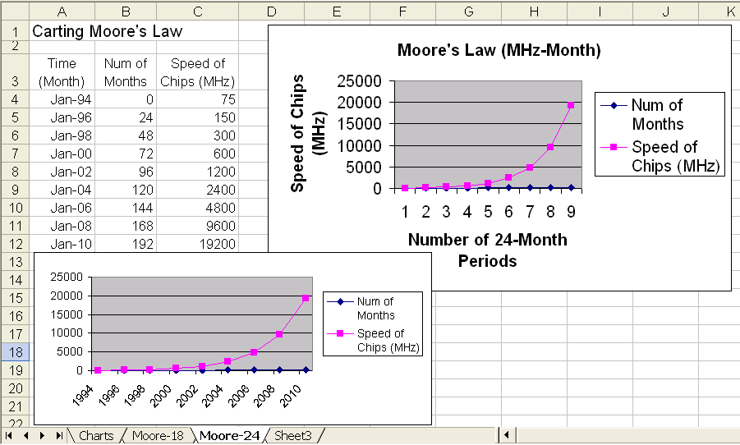

Figure 5-4: Moore’s Law (Line chart)

