**IS312 Spreadsheet HW1 “Excel in Life” Problem Explanation**

Dr. Yüe “Jeff” Zhang, October 13, 2013

We the Accounting and Information Systems faculty proposed to teach electronic spreadsheet (Excel) to our students in such a way that the students can take their spreadsheet skills and use them in their life, beyond the limited number of problems they will solve in homework and projects. We called that “excel in life” – showing to the students that Excel can be used everywhere in life. In fact I myself use Excel to help me to analyze and rank many alternative in my real-life decisions, such as comparison of computers for purchase decision, comparison of homes I am considering, to name a few examples.

In last Thursday’s class, I showed the 330 PM students an example that is logically the same as your “Excel in Life” problem in HW1. I’m creating this document so students of 2 PM class can also “see” our demo and know how to approach with that problem in the homework.

The demo problem was: “Rating/ranking of prospective jobs”.

I built a spreadsheet as follows:

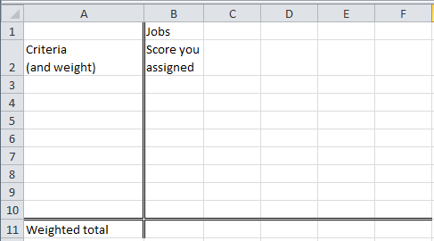

Then I asked the class to think about criteria they would use to assess the attractiveness of a job, and they came up with “Income”, “Hours”, “Stress”, and “Outlook”. I then asked them to assign weights to each of the criteria, that each weight is a decimal number between 0 and 1, and all weights add up to one. They came up with the following that I entered in the spreadsheet:

|  |
| --- |
| Income |
| 0.4 |
| Hours |
| 0.2 |
| Stress |
| 0.3 |
| Outlook |
| 0.1 |

They also thought about four jobs to compare: Retail, Waiter, Pharmacist, CEO.

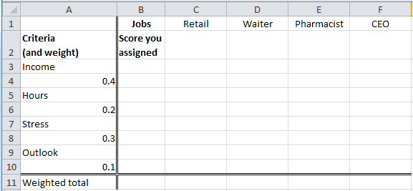

Then I asked them to give a score (1 to 10, with 1 being lowest/worst and 10 being highest/best) to each of the criteria, for each job. This is what they came up (from my memory):

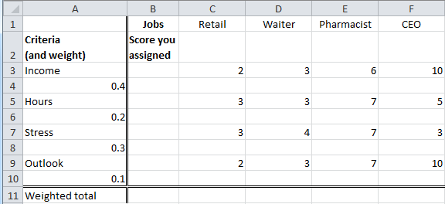

Then I wrote a formula in cell C4, that could be copied to D4:F4, and then to

C6:F6, C8:F8, and C10:F10, which calculates the weighted score by

Multiplying the score a job receives against a criterion, with the respective weight of THAT criterion (can you try to write this formula yourself? – remember: it’s only ONE formula; ONE, that can be copied all over. So you must use mixed reference) [I will give that formula at the end of this document; but for now, PLEASE try it yourself, and then compare your formula with mine ☺ ]

The spreadsheet looks like this:

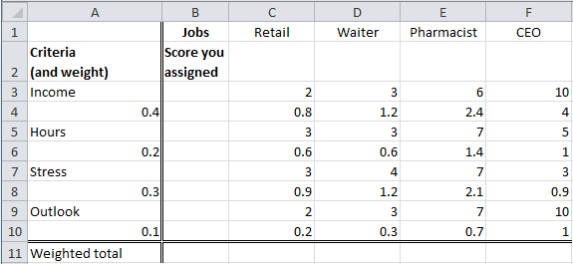

Finally, I added up the weighted scores for each of the four jobs, and they look like the following:

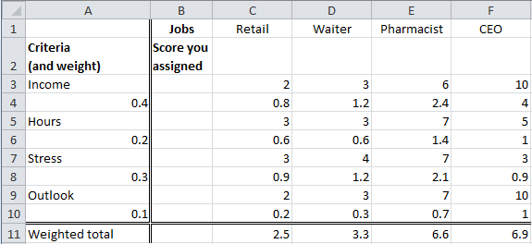

So from the total score we can see that, based on the four criteria you chose, and the respective weights (.4, .2, .3, and .1) you decided, the four jobs has their respective scores 2.5, 3.3, 6.6, and 6.9. So the conclusion: ***with the given set of criteria and their weights***, the preference of these jobs are (high to low): CEO, Pharmacist, Waiter, and Retail ☺

This problem has the same logic as the “Excel in Life” problem” in your Excel HW1, and I hope the above procedure with screenshot can help you to approach the solution of your HW problem.

Now, have you figured out the ONE formula that you need to enter in cell C4? ☺ …

…

…

…

… it is … =C3*$A4. Did you get the same formula?