Electronic Spreadsheet (Excel) Handout 1:
References, Common Functions, PMT Function, and Goal Seek
Dr. Yüe “Jeff” Zhang
Version 11, February 26, 2018

General Notes:
0. You are REQUIRED to read through the tutorial, and work through the exercises (if applicable), so you will come to class with a "prepared mind."
1. Common tasks that you are already familiar with from other Microsoft Office applications (such as Open, Close, Print) are not noted here.
2. You can try applying in Excel many skills you learned in Word.
General requirement/ reminder:
1. Use parameters! Do NOT enter a number (such as “5%”) in a formula.
2. Use ONLY ONE formula wherever the logic is the same!! !! !!
3. Format ($, %, etc).
4. Use 12-point font.

3. Critical note on P.5 & rules on P.6 of this handout.

Section 1-1: Basics of Excel Spreadsheet
[Study by yourself. Will have a bonus question in Exam 1 on this section]

1. Rows, columns, and cells
Rows: 1, 2, …; Columns: A, B, …; Cell: intersection of a row and a column - A3, B11, …

2. Sheets
Look for tabs at the bottom of an opened spreadsheet: “Sheet 1,” “Sheet 2,” etc.
Moving around sheets: Click at the tabs. Sheets can be renamed (right-click, Rename).
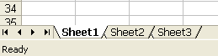

3. Entering a formula
All formulas must begin with an equal sign “=”.
In spreadsheet programs, multiplication is a “*” and division is a “/”.
3.1 Use type-and-point to enter formulas: As an alternative to typing the cell addresses in a formula, you can click at the involved cell when you intend to enter the address of that cell.
3.2 Formula bar: Displays the formula in the “Active Cell” (the cell with thick borders).

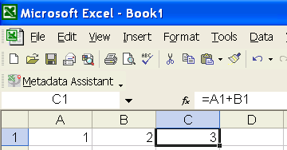
“=@SUM(A1+B1)” would clearly demonstrate a MIS-understanding of
(1) @SUM, and
(2) formulas as a whole.

➔**Will -1 if seen in homework ⬅

@SUM means “sum”! It does NOT mean “formula”.

Fill handle (for next point: “Copy cells”)

4. Copy cells
(0) Basic concept: Copying a cell (or a range of cells) takes the formula, RELATIONSHIP, AND formatting of the cell (or a range of cells - “Source range”, “From-range”) to the cell (or range of cells) you want to copy to (“Destination range”, “To-range”).
(1) Copy to adjacent cell(s): point the mouse at the fill handle of the “From-range” where the mouse will become a cross hair, drag it to the desirable range.
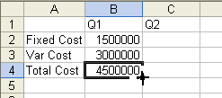
Drag the Fill Handle to copy
(2) Copy to non-adjacent cell(s):
Method 1: Highlight “From-range” - Click Copy button - Click first cell of “To-range” - Paste button
Recommended method
Method 2: Highlight “From-range” – shortcut <Ctrl>-<C>
- Click first cell of “To-range”- <Ctrl>-<V>
4.1. Move cells
Highlight “From-range”- click at the border of the range-Drag the whole range to the first cell of new location [Question: Difference between copy and move???]
Explore: What if you move a cell that is used in a formula?
4.2 Copying cells and relative reference
Copying a cell/cell range takes the RELATIONSHIP and format of the “From-range” to the “To-range,” we can expect changes in cell addresses in the formulas – more later.

5. AutoFill: When you enter data that has a pattern, such as weekdays or months, or continuous numbers or odd/even numbers, you can use the AutoFill feature. Simply point the mouse at the fill handle of the Source Range and drag (right/down). [Explore: (1) Type 1, and drag the fill handle: can it auto fill? (2), type 1, then 2 in next cell, then drag; what happen? (3) What if I want a series of 2, 4, 6, …? (4) What if I want 1, 4, 7, …?]

6. AutoSum
Highlight the full range of cells to be summed, click at the sum button on the toolbar (a button with the summation sign Σ)

7. Format a cell range
Highlight the range, right click within the range. A formatting dialog box would pop up. Choose the tab that would allow you to perform the formatting you want.
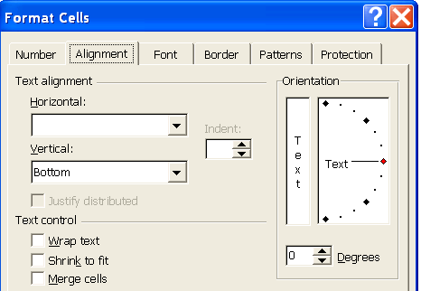 | 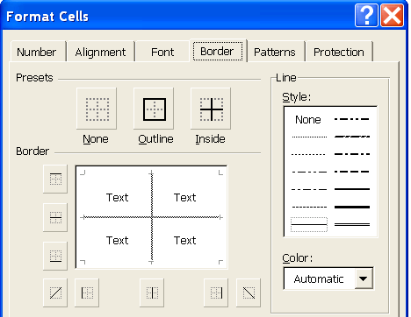
Figure 1-1(a) Formatting a cell for text alignment | Figure 1-1(c) Formatting a cell for border type and size

8. Use Format Painter: You can save the effort of formatting a cell/range when you intend to have it formatted the same way as an existing cell/range. Simply do these: Click within “Source-range”-Format Painter button-Highlight “Destination-range” (DONE!!)

9. Common error: @SUM(A1+B1+C1) ➔ either =@SUM(A1:C1) , or =A1+B1+C1, but NOT BOTH

Section 1-2: Common Functions [Largely review. Study by yourself]

1. Common statistical functions
Syntax | =AVERAGE(cell range) | =MAX(cell range) | =MIN(cell range) | =STDEV(cell range) | =MEDIAN(cell range)
Result | Avg of the numbers in the cell range | Max of the numbers in the cell range | Min of the numbers in the cell range | Standard devia-tion of the #s in the cell range | Median of the numbers in the cell range
Example | =average(b5:m5) | =max(c5:c15) | =min(i2:k12) | =stdev(h3:k9) | =median(i5:i15)
A cell range can be a row (like A1:F1) or a column (like A1:A10),
or a rectangle (like A1: F10)
2. ROUND and INT functions. Syntax:
=ROUND(cell to round, decimal place).
=INT(cell to find the integral part of the value).
Numeric example: Assuming that the value of C5 is 3.758, then,
= ROUND (C5, 2) would display 3.76 (rounded UP here!), yet
= INT (C5) would display 3 (integral part!)

3. TODAY function and NOW function
Syntax:
=NOW() – captures and displays date and time of the formula entry
=TODAY() – captures and displays today’s date [Note: same in Access]

4. Date calculation
The difference of two dates are the number of days between the two dates.
Numeric example: Assuming that the value of D5 is 7/30/2017, and the value of D6 is 8/5/2017, then, the formula =d6-d5 will return (result in) a value of 6 (July has 31 days).
With the TODAY function, you can easily calculate a person’s age, given his/her birthday.

5. Future value [Very useful in accounting and finance] - The syntax for FV function is:
=FV( rate, nper, [pmt], [pv], [type] )
rate | - | The interest rate, per period
nper | - | The number of periods for the lifetime of the annuity
[pmt] | - | An optional argument that specifies the payment per period  (if the [pmt] argument is omitted, the [pv] argument must be supplied)
[pv] | - | An optional argument that specifies the present value of the annuity - i.e. the amount that a series of future payments is worth now  (default value 0. Also, if [pv] is omitted, the [pmt] argument must be supplied)
[type] | - | An optional argument; defines whether the payment is made at the start or end of the period.  0 - the payment is made at the end of the period (default)  1 - the payment is made at the beginning of the period
The Excel Help feature:
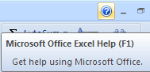 | Whenever you have question, use the Excel Help feature

Section 1-3: Using Parameters

Suppose we need to calculate discounts for a long list of transactions – common scenario in retail businesses. The following section of a spreadsheet shows a discount rate of 10%:

 | A | B | C | D
1 | Serial No. | Subtotal | Discounted Price
2 | 1 | 123 | =B2*0.9
3 | 2 | 550 | =B3*0.9
4 | 3 | 300 | =B4*0.9
 | … | … | …

Figure 1-2(a) A discount example

Often times, store owners would adjust the discount rate to attract more customers. Assume that the store owner changes discount rate from 10% to 20%, she will have to go to the first formula and change 0.9 to 0.8, and then copy the formula down the column.

Fortunately, there is a feature called Automatic Recalculation: place in a cell (D2 here) a “parameter” that will be used by the formulas in a certain range (Column C here), and refer to the Cell Address of the parameter (D2) in the formulas. When the parameter needs to be changed, it only needs to be changed ONCE, in its own cell:

 | A | B | C | D
1 | Serial No. | Subtotal | Discounted Price | Discount Rate
2 | 1 | 123 | =B2*(1-D2) | 10%
3 | 2 | 550 | =B3*(1-D2)
4 | 3 | 300 | =B4*(1-D2)
5 | … | … | …

Figure 1-2(b) A discount example, with a parameter
Example 1-1, Using parameter: Demo-1.xls, worksheet 1-Parameter

Critical note: Whenever there is a parameter, ALWAYS put it in a separate cell, clearly labeled, and then use the cell address of the parameter in a formula.

Section 1-4: Relative, Absolute, and Mixed References

We have learned that when a cell’s content is copied to another cell, the formula, relationship, and the format of that cell are also copied.
Think about the following situations: the formulas in E1, E2, and E3 are being copied to F1, E3, and F5, respectively. What would be the corresponding results? (Rules in Fig 1-4 next page)

 | A | B | C | D | E | F
1 | 1 | 2 | 3 | 4 | =A1+B1
2 | 5 | 6 | 7 | 8 | =C1+C2
3 | 13 | 12 | 11 | 10
4 | 3 | 4 | 5 | 7 | =B2*C3
5
Figure 1-3 Three scenarios of copying a formula to another cell
Example 1-2, Relative reference: Demo-1.xls, worksheet 2-Rel-Ref

Figure 1-4 Rules of formula changes when it is copied

Rules about relative reference, mixed reference, and absolute reference:

Rule 1. When a formula is copied DOWN the column, the row number increases by the number of rows it goes down (relative reference); [C10 becomes C11, C12, C13, ...]
Rule 2. When a formula is copied ACROSS the row, the column letter increases by the number of columns it goes right (relative reference); [C10 becomes D10, E10, F10, ...]
Rule 3. When a formula is copied BOTH down and across, the column letter AND row number increase by the number of columns it goes right AND row number increases by the number of rows it goes down (relative reference);
Rule 4. If there are any "$"s to "freeze" or "fix" the row number or the column letter or both, the corresponding row/column will not change (mixed reference, and absolute reference).
["Absolute reference" - $C$10 stays the same, no matter where the copy goes;
"Mixed reference":
When copied across, C10 → D10 → E10, ... but $C10 stays $C10 - "fixed column C";
When copied down, C10 ↓ C11 ↓ C12, ... but C$10 stays C$10 - "fixed row 10".]

Summary of relative, absolute, and mixed references with example:

Copy ➔ ➔➔ ➔➔ ➔➔ ➔➔ ➔➔ ➔➔ ➔➔ ➔
Copy
 | =A1+$B$2*C$1/$D2 | =B1+$B$2*D$1/$D2 | =C1+$B$2*E$1/$D2 | Handy references
 | =A2+$B$2*C$1/$D3 | =B2+$B$2*D$1/$D3 | =C2+$B$2*E$1/$D3 | Handy references
 | =A3+$B$2*C$1/$D4 | =B3+$B$2*D$1/$D4 | =C3+$B$2*E$1/$D4 | Handy references

Example 1-3, Absolute reference: Demo-1.xls, worksheet 3-Abs-Ref

Example 1-4, Mixed reference: Demo-1.xls, worksheet 4-Mix-Ref

➔ Recap and summary of three references at the end of P. 9. ⬅

Quick Practices (“Quick Quiz”)
Result on P.9
Applying the above rules, let's do some more practices:
(a) Assuming that in cell E7, there is a formula =B7/C5
What will be this formula become when it is copied to cell G10?
(b) Assuming that in cell E7, there is a formula =B7/$C$5
What will be this formula become when it is copied to cell G10?
(c) Assuming that in cell E7, there is a formula =B7/$C5
What will be this formula become when it is copied to cell G10?
(d) Assuming that in cell E7, there is a formula =B7/C$5
What will be this formula become when it is copied to cell G10?

Analyze the above box (do NOT use a computer!), and determine the resulted formula. Then go to the end of this handout (“Solutions”) to check your answers.

Back to Figure 1-2(b) (“A discount example, with a parameter”), since Column C has ONE LOGIC, which suggests that we should be able to write just ONE FORMULA and copy it down the column. What would happen if you copy the current formula in C2 down the column? Test it. And what should we do to obtain our intended results?

Changing types of refs
The Excel Shortcut to change types of references: <F4> key
Example: There is a formula containing the cell B12. With cursor at B12, pressing <F4> consecutively will cause the following changes: B12 → $B$12 → B$12→ $B12 → B12

Section 1-5: PMT Function

The PMT function is used to calculate monthly payment of a loan, given interest rate, length of payback term, and the loan amount. The higher the interest rate, and/or the shorter the payback term, the higher the monthly payment will be. You will learn the mathematical inference in your finance class. Here we are only introducing the USAGE of this function.

Syntax (Syntax: rules to follow to say a sentence in a language):
=PMT(monthly interest rate, number of monthly payments, negative loan amount)
Since interest rates are often given in ANNUAL rates, and number of payments is often given in number of YEARS, the use of the PMT function is in the format (THINK: why?):
=PMT(annual rate/12, num of years*12, -loan)
[1. Why "/12", "*12", and "-"?] [2. Note: THREE terms inside the parentheses]
Most Excel functions have 3 terms (arguments) as input
Assuming we have annual interest rate in cell C1, payback term in years in D1, and loan amount in E1, then, our monthly payment would be: =PMT(C1/12, D1*12, -E1)
Creating a Loan Payment Table Using PMT Function: In the following auto loan scenario, the loan amount is $12,000, the annual interest rate is 4%, the payback term is 2 years. The PMT function would provide the monthly payment, as shown in cell C6 in Figure 1-5 below. Given that interest rate in cell C3, payback term in years in C4, and loan amount in C5, then, our monthly payment (in C6) would be: =PMT( ? /12, ? *12, - ? )
Example 1-5, PMT function and Goal Seek: Demo-1.xls, worksheet 5-PMT-n-Goal

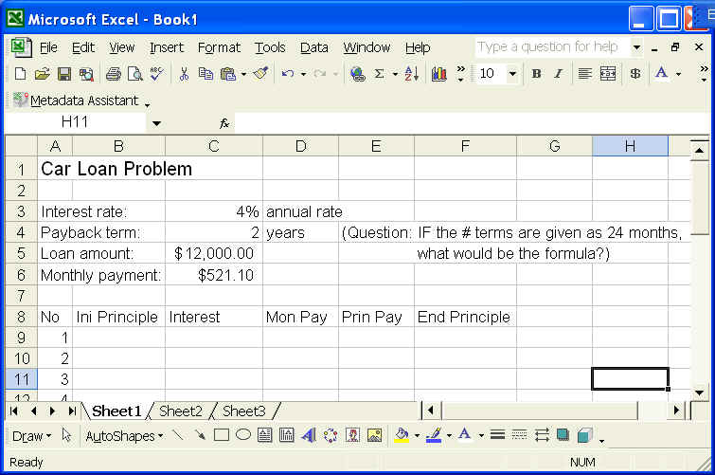

Figure 1-5 A loan payment schedule

Section 1-6: Goal Seek

Continuing from the above topic, you know that your monthly payment depends on interest rate, payback term, and loan amount. You know you can afford a certain amount of monthly payment; you will then want to see how large a loan you can afford to take, or how long your payback term would be, or what kind of an interest rate you need to negotiate for. In this kind of situations, the Goal Seeking feature of Excel (and all other electronic spreadsheets) will help. Goal seeking allows you to set a goal for a cell, and change the value of other cells that contribute to the value of the current cell (participate in the calculation of the current cell). The steps of a goal seeking are as follows:
Data Tab – Data Tools group –What-if Analysis item – Goal Seek on the menu

Logic behind Goal Seek (“GS” below to save space):
If the function value Y = some function/transformation of “arguments” a, b, and c, in the notation Y = f (a, b, c), then, Goal Seek (“GS”) allows us to set a target value of Y (say at Y₀), and see which a-value, or which b-value, or which c-value (one at a time), could help to achieve the target value of Y₀. *** So, ONLY a or b or c who are “arguments” of function of Y (that is, a or b or c CONTRIBUTES to the transformation leading to the Y-value) can be set through GS with a given Y-value.
If a variable v does not appear in the Y = f (a, b, c), then v cannot be goal sought.
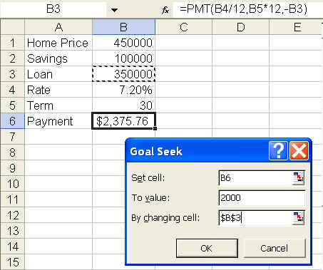
Figure 1-6(a) Goal seek – 1 (Set monthly payment at $2,000, see how loan will change)
(Note: In Figure 1-6(a), the home price you can afford is your savings plus the amount of loan you can afford to take - with a monthly payment that you can handle)
(1) In "Set cell:" Assume that you can only afford to pay (in B6) is $2,000 ("To value:") a month (which is HIGH!!), that's the goal value you want to set at.
(2) In "By changing cell:" You then want to see how much your affordable loan (B3) would become, so you indicated B3 as the cell you want to change.
When x is an argument in the formula for y, a change in the x-value would cause a change in the y-value.

Only when a parameter (a number, “x”) appears in the arguments (“variables”) of a formula (whose result would be “y”) will a goal seeking (with y as the output) respond to a change in the value of x.

If x is not part of the arguments of y, then setting the target value of y to find the contributing x will not work.
The following is the result of the Goal-Seek:
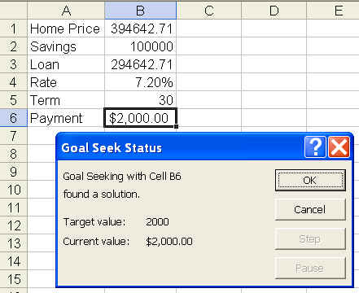
Figure 1-6(b) Goal seek – 2 (Set payment at $2,000, the loan would be $294,643)
By paying $2,000 a month, you'll be able to take a loan of only $294,642, which will give you an affordable home of $394,642. =============================
For your Excel homework and project, you will be asked to submit both the printouts of values and formulas. Also you may be asked to format your spreadsheet in a certain way. Here are two shortcuts:
Excel Shortcut: <Ctrl>-<~/`>
Holding down <Ctrl>, and press <~/`> key, Excel will display the cell formulas rather than the resulted values.
(<~/`> key is the key above the <Tab> key, below the <Esc> key)

Excel Shortcut: <Alt>-<Enter>
To enter two lines in a cell: at the end of the first line, hold down <Alt> key, press <Enter>.

=============================
SOLUTIONS TO PRACTICE QUESTIONS IN THIS HANDOUT (P.6)
Question on P.6

Because the formulas were copied from E7 to G10 (respectively, in several different scenarios), which is TWO COLUMNS to the RIGHT and three rows down, all the column letters in the formula must be increased by two letters (unless they are "fixed" with "$"), and all the row numbers must increase by 3 (unless they are "fixed" by the "$"). So, the four scenarios will become, respectively:

(a) =D10/E8
(B → D, C → E; 7 + 3 = 10, 5 + 3 = 8)

(b) =D10/$C$5
(B7 → D10 as explained above, BUT $C$5 remains $B$5 - why?)

(c) =D10/$C8
(B7 → D10, $C stays $C, BUT 5 → 8)
Homework help

(d) =D10/E$5
why? - explain yourself

Use the above format for the corresponding question in the Excel homework.
===============================================================
Recap of references (arrows show the direction of copying of formula):
Relative | Absolute | Mixed
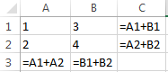  All can change – rows and columns | 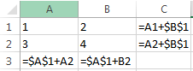  None can change – stays in EXACT cell (A1 here) | 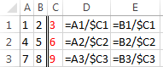  Stays in Column C, but  allow the rows to change.

