Correspondence of Exam questions and Handout, Demo, or Homework Questions

Essay Question 1:

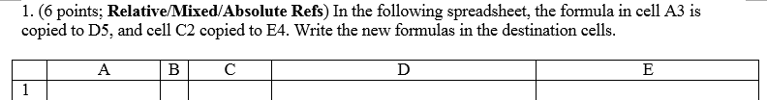

Ref: Excel Handout 1 and Demo 1

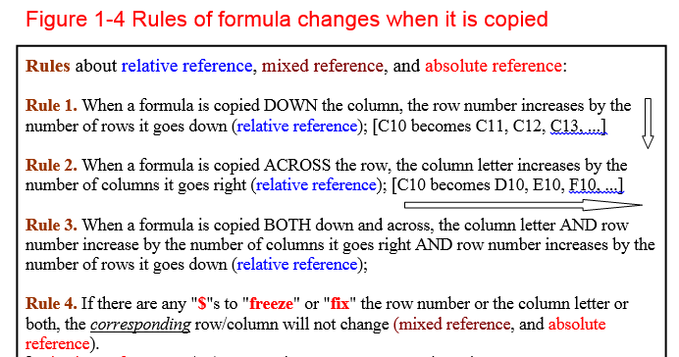

Essay Question 2:



This one is the most obvious; even the table looks so very similar

Ref: Excel-in-Life Solution, HW2 Problem 3

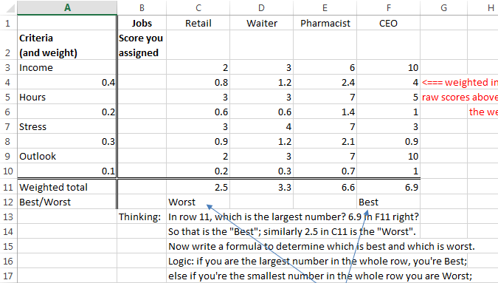

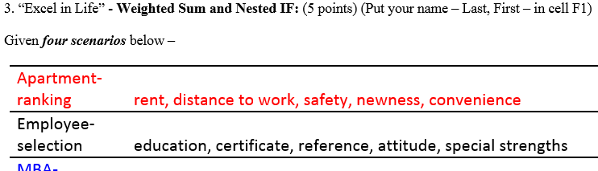

Essay Question 3:



This one is the most obvious; even the table looks so very similar

Ref: HW2, Problem 1

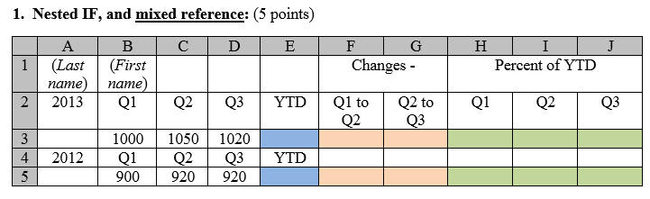

Essay Question 4:

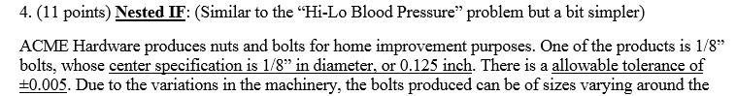



Ref: HW4, Problem 2 – Blood pressure –

Blood pressure reference value, +5 and -10 are the upper and lower limits

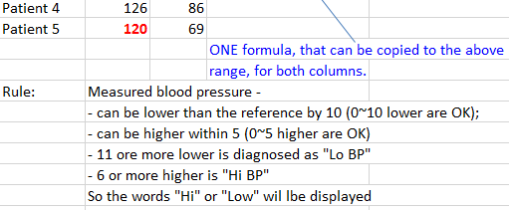

Essay Question 5:

5. (14 points) **IF + VLOOKUP**: 【Same logic as the “utility company” demo question】

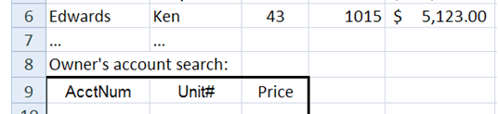

Ref: Utility company question, Demo 31 and 3-2

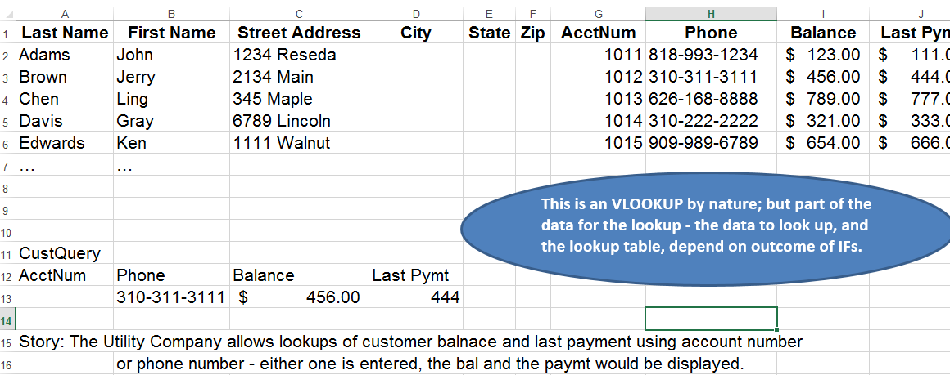

And ironically and sadly, this problem is the one that most people lost most of the points!! Yet it was the one that I did not make any change from last semester!!!

I posted, in Spring Break the following section to help with your exam preps:

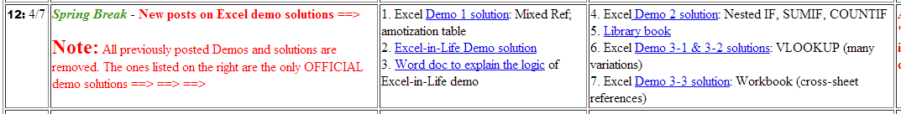

I did keep a very close correspondence between exam questions and learning materials:

Conclusion/lesson:

1. I advised you to study all demos and homework problems, and I did make the exam questions VERY, EXTREMELY close to the problems you have seen;
2. From the incident we have learned that we NEED TO IMPROVE our ability to apply the concepts and skills, that we should be able to take what has been taught and learned, to those appearing different but principally reference-able business cases - in the exam cases they are almost no difference; but in real-world business the cases are ten times more complex, and a business professional MUST possess the ability to see similarity from seemingly different, so as to be able to apply the acquired theory and skills onto the case s/he is facing.