**Navigation inside MS Access: Find and Open Objects (Tables, Queries, etc)**

*By Dr. Yüe “Jeff” Zhang, V2.2, February 5, 2017*

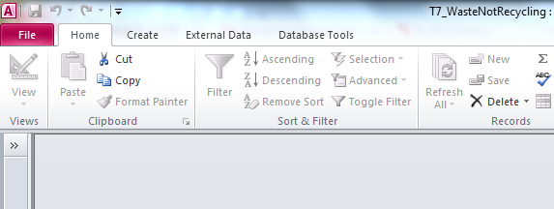

If it does not already show the objects, **click the double-arrow button to expand**

Click:

|  |  |  |
| --- | --- | --- |
|  | Four Access objects: | Click ***Queries***:    Double click the query “Annual Sales Over $500,000”: |
| Tables |
| Forms |
| Queries |
| Reports | Click Design View icon to switch back to design view: |
|  |