Database Management System Tutorial 4 and Access Demo 4:

**Access Reports, Grouped Reports, and Forms**

*Dr. Yüe “Jeff” Zhang*Version 14.3, February 5, 2017

**ACCESS REPORTS**

We often need to present our data to such audience as clients or superiors, when it would be more proper to present in a report, with proper title, headings/subheadings, and other formatting features. Access reports provide such features. The design of a report can be time consuming, so you are recommended to use the **Report Wizard** in Access. [Please note that this is the ONLY occasion in the whole learning of Access when I recommend you to use Wizard].

**GROUPED REPORTS**

There are often occasions when we need to present data in a way that the individual records are grouped together, according to certain grouping characteristics, such as:

* membership class, major of students, rating of franchisees, etc;
* make of automobiles, type of restaurant services, etc;
* cities or zipcode of customers, locations of equipment, etc.

In those occasions, it is also often desired to display some group summaries, such as total, average, maximum/minimum, etc.

The above tasks can be accomplished in Access through the creation of grouped reports.

Please note the distinction between a grouped report and a total query:

* Grouped report will **display EACH individual records, same group together;** while
* Total queries only display AGGREGATE data about groups but not individual records.

The creation of a (grouped) report follows the following logical steps:

1, choose the table(s) or query(s) to base the report on; [Reports do NOT contain data: …]

2, choose the fields that will be displayed in the report;

3, choose the **grouping field** (such as Major, Zipcode, TypeOfService, etc), if applicable;

4, (for grouped report) determine the grouping details, such as the sorting of the records (Ascending/Descending; on which field), and the group summaries (SUM, AVG, etc);

5, choose the report format (the layout/appearance).

【Our demo on grouped report – next page - will follow the above steps】

The steps to create grouped report will be provided in Demo 4 – with screenshots.

**FORMS**

Forms are the interfaces between the user and a data table. Forms allow the user to read, append (add new records) to, update (modify), and delete records from a table.

The basic steps of creating a form will be presented in Demo 4, with screenshots.

**Access Database Demo 4:**

**Grouped Reports, Forms and Subforms**

*Dr. Yüe “Jeff” Zhang*Version 13, February 16, 2016

**I. GROUPED REPORTS**

We often need to present our data in a report, in a way that we group the individual records together according to certain group (such as customers’ zipcode, major of students, etc).

The **grouped reports** will **display all individual records** (in contrast with ***total query***, which only list group characters ***WITHOUT individual records***), grouped on a selected grouping field (zipcode, major, product line, sales region, etc). We also often desire to display some group summaries such as total, average, minimum, etc. A grouped report provides the above features.

A table with m rows and N types (m>N), will have a grouped report containing all m rows, plus N group summaries (if requested to produce the summaries);

A total query on the same table will produce only N rows of outputs – one row for each of the N groups.

Steps to create grouped reports with subtotals of the groups: last page (P.1), marked with a

We will create a report based on the **Restaurant** table in the **“Restaurants-Rev”** database. This report will have the following features:

1. Restaurants will be grouped by their types of service;
2. Within each group, they will be sorted on their square footage, highest first;
3. If there are multiple records that have the same square footage, they will be further sorted on their annual sales, the highest first;
4. Each group will display its average annual sales amount, and its total square footage.

=================================================================

**Screenshots of creating grouped reports 🡺 🡺 🡺**

The following are screen shots of Grouped reports with summaries of the groups.

Re-arranging and resizing of objects and groups in the report will also be demonstrated.

|  |  |
| --- | --- |
| Open the **Restaurant-Rev16** database, click at the **Create** ribbon tab, then click at the **report wizard button.** |  |

The **Report Wizard** dialog box will open as follows.

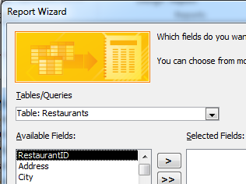

Please remember that reports are but the display format with NO data; the data should be from a table (or query). So tables or queries (or a mixture) must be chosen here.

Click the down-arrow button as indicated above to **choose the right table(s)/query(ies)** for your report, in this case the **Restaurants** table:

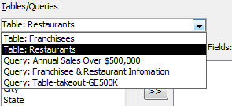

Select the Restaurants table

Select fields to be included in the report:

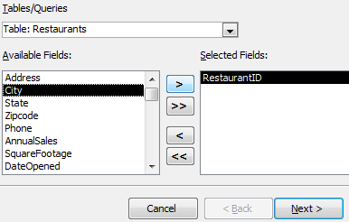

(0) RestaurantID already selected.

Or, you can simply double-click at a field to select it

(1) City highlighted to be selected

(2) Click to select

Continue and finish selecting the following fields:

**City, AnnualSales, SquareFootage, DateOpened, TypeOfService** – as in the following screenshot:

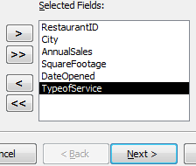

Click **Next**, you will see the following. This is for you to **add grouping level**.

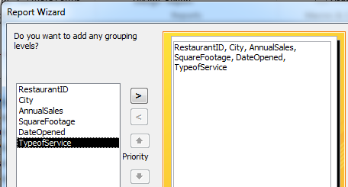

(1) Highlight TypeofService, (2) Click the select grouping level button.

You can see in the following screenshot that a grouping level based on **TpeofService** is added.

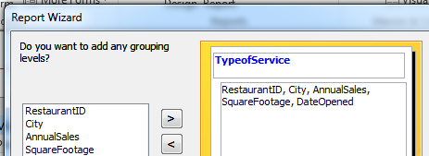

Pause and think: what other field(s) can also be used as grouping level?

Click Next, you come to the stage where you can specify sorting and possible sum/average of numeric fields.

1. First, sort “on their square footage, highest first” – choose **SquareFootage** as the sort field, and sort **Descending**.

Primary

1. Then, sort “on their annual sales, the highest first” – choose AnnualSales, and sort **Descending**.

2ndary

【Here, two fields are being sorted on; the first one is the **primary sort** and the second the **secondary sort**. Records will be first sorted on the first sort field, and then within each group that has the same value on the first sort field, further sorted on the second sort field.】

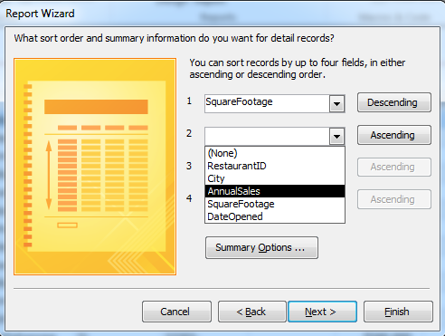

Not yet

To be changed to Descending

Do NOT click **Next yet**! Click **Summary Options …** to perform **average** on **AnnualSales** and **sum** on **SquareFootage**, as shown below:

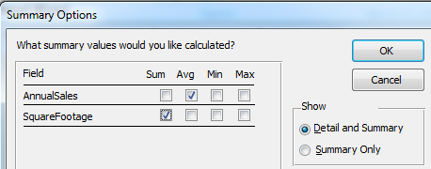

Click OK to complete this step. Click **Next** and you will be in the screens to choose layout and style. I would suggest using the default styles, but you are free to choose whatever style that appeals to you AND looks professional:

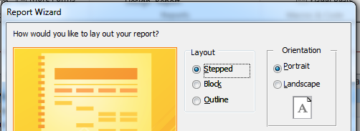

Then it is the final step: name/rename the report, where you can give the report you just created a name, which will appear as the title of the report. So although Access would accept any name – even “Cats and Dogs” ☺ I suggest that you choose an appropriate and clear name since the report would be presented to your boss or client. Here I chose “Restaurant Report, Grouped by Type”:

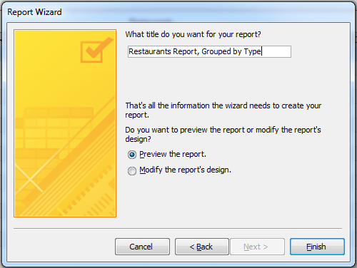

Click Finish, and you will see the completed report!

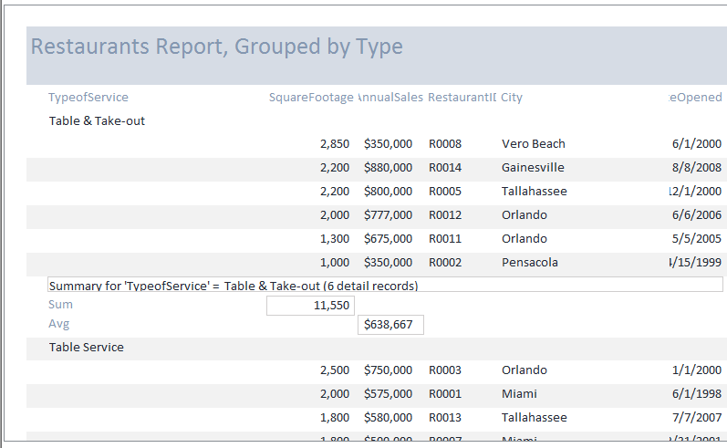

Primary: Descend-ing on SqFt

Secondary: Descending

On sales

Grouped by type

*{The last part of demo is about moving objects (headers, columns, summaries, etc), in* ***Report*** *Design View, to make the report look better.}*

Now we try to move SquareFootage and AnnualSales a bit to the left. Click the **Design View** button on toolbar. In the Design View that is displayed, first, you may need to widen the right border of the report area (the area with tiny dots) if the current design screen is too narrow.

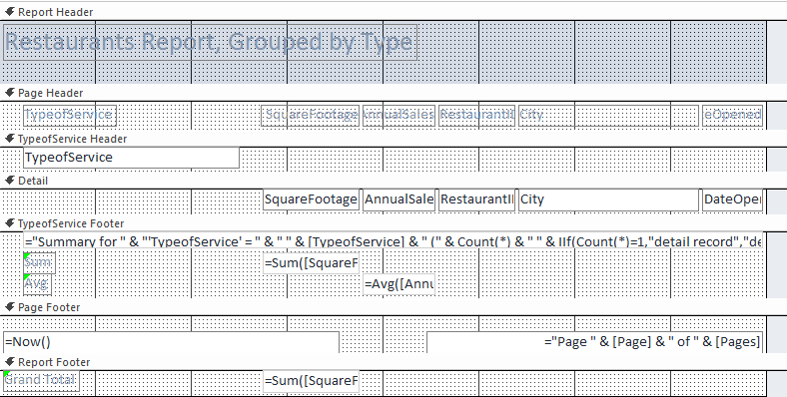Click **SquareFootage** (label), hold down Shift button and click **SquareFootage** (value), and **sum(SquareFootage).**

We can also do the following in the Design View:

* Re-write the columns’ names from the current Access data table names (such as “TypeOfService”) to an English-like name with spaces in between words (say, “Type of Service”).
* Change the column-width for any column if so desired;
* Change the relative position of current columns (move things around) if so desired.

**Explore by yourself**: Re-arranging and resizing of objects and groups in the report can be done in Design View.

=====================================================================

RECAP of key steps:

|  |  |
| --- | --- |
| **Steps** | **Details/Remarks** |
| 1. Choose table/query on which to base your report | Middle–left of the Wizard; select table/query from which your report will get data |
| 2. Select a field to group on | The field must be one that truly has group nature |
| 3. (Do not miss the) **Summary Options** button | In the window that says “you can sort records by up to four fields” |

**==========================================================**

Creating A Report Based on Query:

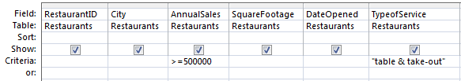

Save the above query as Table-Takeout-GE500K; then create a report based on this query: it is fairly easy after you watch the critical step: Choosing the right **query** this time (not table) – see below:

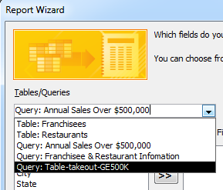

The rest will be similar to that of creating a report (no grouping will be involved)

**I. FORMS, AND SUBFORMS**

**Creating Forms with Form Wizard**

It is quite straightforward to create a simple form. It will only take about 1 minute using the Form Wizard, if you do not intend to perform any revision/editing of your form.

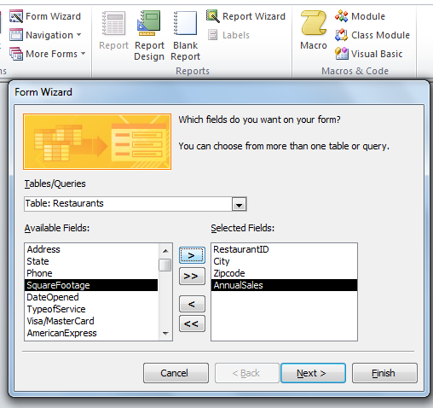

Once you finished selecting the right table(s) and/or query(ies), you would then select the fields you want to display, after which step you can click ‘Finish”.

**Subforms – Restaurants owned by franchises**

Create ribbon, Form group, Form Wizard button; choose fields from Restaurants table; choose fields from Franchises table.

After choosing the first table (Restaurants), you would then choose the second one (Franchisees) – these two tables are in a **one-to-many relationship**:

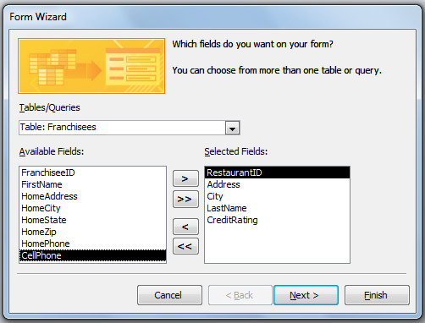

From Franchisees

From Restaurants

Key step: at “How do you want to view your data?” dialog box, double click “By Franchises”

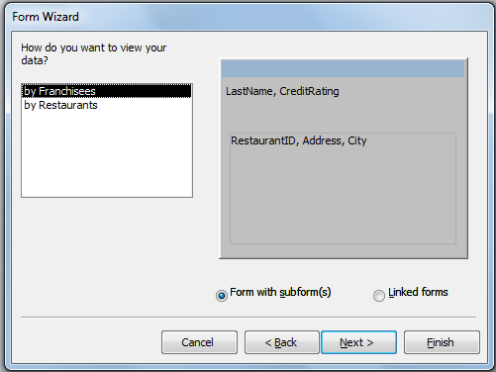

And select the “Form with subforms” radio button, and then “Finish”.