IS 312 Database (with Access) Tutorial 2 and Demo 2:   
**Basic Queries, Calculated Field Query***Dr. Yüe “Jeff” Zhang*Version 17, January 22, 2018

We have learned about tables. There are three more “objects” in Access: query, form, and report. Here are their respective functions in a database and the relationship among these objects:

|  |  |  |  |
| --- | --- | --- | --- |
| **DB object** | **Purpose/**  **Function** | **Remarks** | **Based on** |
| Table | data ***storage*** | with certain data **structure** |  |
| Query | data ***selection*** and ***organization*** *for retrieval*  and update | retrieve the **specified portion** of data from selected tables, in **specified** **organization**; update specified data | Tables |
| Report | data ***presentation*** | in the **format** we specified | Tables; queries |
| Form | data ***interface*** | **interface** w a table – to view, add, delete, change records | Tables; queries |

**Tables (Data storage)**

**Queries (Data Extraction)**

**Forms (Entry, update)**

**Reports**

**(Presentation)**

**I. Query Design Basics**

1. Open Query **Design View**: Create – Queries – Query Design

|  |  |
| --- | --- |
| With your DB opened, select  **- Create** (Ribbon)  – **Queries** (Group)  - **Query Design** (icon),  the query design window will open. |  |

2. Select Tables on Which to Base the Query

|  |  |
| --- | --- |
| In the “**Show table**” dialog box, double click the table you need for the query  (**Think**: what table(s) do you need? – how to determine?)  1) A query is based on tables, or other queries |  |

3. Choose the fields you want to display

In the tables shown, double click to choose the fields you want to display on your query:

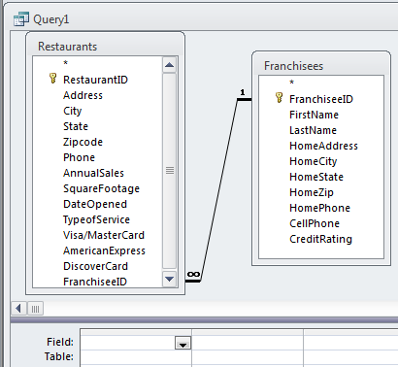

2) Query allows you to choose the fields you want to display

From two tables: Restaurants & Franchisees

4. Get familiar with **design grid**

- **Query design view:**

|  |
| --- |
|  |

1. Field row
2. Table row
3. **Total** row
4. Sort row
5. Show row
6. Criteria/or

OR query: On two different rows **(“Criteria” row** and “Or” row)

**\*\*\*Selection criteria*** -** the most important contents for learning objectives.

3) A query allows you to select to show the records (rows) that fits the logic you determine, and the “Criteria” above is where you give Access your “commands”

Critical note: “Add Table”. When you first open a design grid, there is NO table for query. You need to decide which table(s) to add to this query design, so as to be able to bring fields, FROM THE TABLES, into the query in your design.

**II. Logic in Query Design – Criteria, AND, and OR**

Some Examples of criteria connected with AND or OR operators (from another Access book):

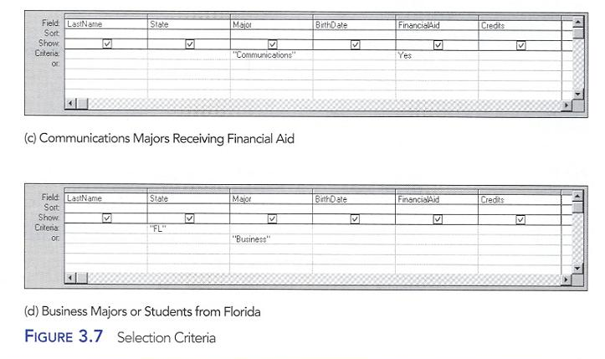

Or: Different rows

And: Same row

Or

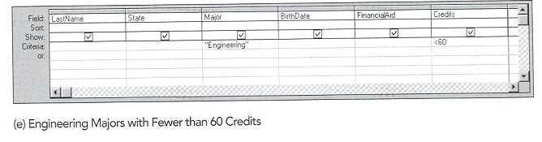

And

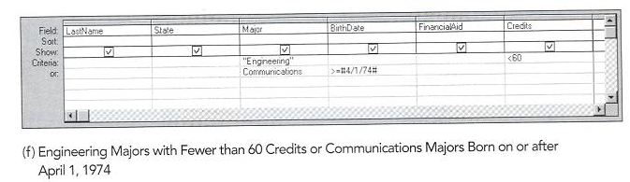

**Not equal**

And

and

Or

**Operators for criteria: >, <, >=, <=, < >**

Ways of using AND / OR logics:

|  |  |  |  |
| --- | --- | --- | --- |
|  | **Criteria in Same field** | Cri in Different fields | Remarks |
|  | Only AND or only OR | |  |
| **AND** | Use AND to connect two cri | Cri on the same row | BOTH cri must be true |
| Example | |  | | --- | | **Credits** | | >= 30 AND <= 60 | | |  |  | | --- | --- | | **Major** | **Credit** | | “Business” | >=30 | |  |
| **OR** | Use OR to connect two cri | Cri on different row | ONLY ONE of cri needs to be true |
| Example | |  | | --- | | **Major** | | “Science” OR “Business” | | |  |  | | --- | --- | | **Major** | **Credit** | | “Business” |  | |  | >=30 | |  |
|  | **Use operator AND or OR** | **Use cri positions in rows** |  |
|  |  |  |  |
|  | **AND/OR combined with OR/AND** | |  |
| AND ***and*** OR - 1 | |  | | --- | | **Credits** | | >= 30 AND <= 60 | | >= 90 | | |  |  | | --- | --- | | **Major** | **Credit** | | “Business” | >=90 | |  | <30 | | First row (which is an AND), or second row (single cri) |
|  |  |  |  |
| AND ***and*** OR - 2 | |  | | --- | | **Credits** | | >= 30 AND < 60 | | >= 90 AND < 120 | | |  |  | | --- | --- | | **Major** | **Credit** | | “Business” | >=90 | | “Engineering | <30 | | Only one row needs to be true, but w/in the row there’s AND/OR |

Demo 2-1: Creating a query using design view; features include AND, OR, AND and OR.

Study by yourself; MUST study

**III. Wildcard character queries**

Wildcard characters (? And *) can be used to replace any characters to make queries easier: when you do not know ONE exact character, you can use “?”; when you do not know several characters you can use “*” - * represents any number of characters.

One thing must be watched when using “?” or “*”: the position of wildcard.

“*on” and “on*” are different:

* “*on” could return as outputs “upon”, “Johnson”, “Jackson”, “Lawton” (oil city in Oklahoma), etc;
* “on*” could return as outputs “once”, “ongoing”, “Onalaska” (a town in Wisconsin), etc;
* “*on* could return as outputs “long”, “content”, “Guangdong” (a booming province in China, next to Hong Kong – yes: Hong Kong itself would be returned), etc.

One more to watch when using “*”: Do not replace too many or too few characters.

If your data contains Northridge, North Hills, North Hollywood, New Port Beach;

1. “north*” would display all, except New Port Beach;
2. “north h* would NOT display Northridge, compared to (1);
3. “n*” would also display New Port Beach, in addition to the other three.

Therefore, you need to watch your use of “stated-characters + *” very carefully.

**IV. ACCESS FUNCTIONS AND CALCULATED CONTROLS**

***Calculated fields***:

There may be situations when a value needs to be calculated from existing database fields.

**New Field Name: [Field name 1] operator [Field name 2]** (more operator [Field name 3])

This is to be entered in the Field row of the query design view:

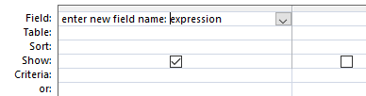

The “**New Field Name**” will be displayed as the column header of the newly created column of “**[Field name 1] operator [Field name 2]**”

In the Restaurants table, we can calculate the length of a restaurant in service by the following **expression** (formula):

**YearInBusiness:NOW()-[DateOpened]**

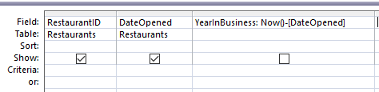

The above expression means: “The created field ‘YearInBusiness’ is defined as the NOW function’s value (which is today’s date) minus the DateOpened value.”

“**YearInBusiness**” will become the **column header** of the new column.

Note:

1. Use “ : ” (means “defined as”), instead of “ = ”;
2. “*” for multiplication; “/” for division;
3. Field names must be spelled exactly (case does not matter);
4. WATCH OUT for your parentheses!!! – this is math (algebra) and logic.

++++++++

Instant practice: Assuming that there are fields FixedCost, UnitVariableCost, and UnitsSold; please create the **Access expression** to generate a calculated field UnitCost.

++++++++

Note 1: “Operators” are +, -, *, /

Note 2: Field names must be in EXACT SPELLING as they are in the data table

Demo 2-2: Creating a query with calculated fields.

**Note: Calculated fields are called “derived attributes” in DB texts.**

**Logical Operations for Queries - MUST BE VERY FAMILIAR:**

|  |  |  |  |
| --- | --- | --- | --- |
| **Meaning** | **Operators** | **Example** | **Interpretation** |
| Greater than | > |  |  |
| Later than (a date) | > | >01/01/2018 | later than 01/01/2018 |
| Less than | < |  |  |
| Earlier than (date) | < | <12/31/2018 | earlier than 12/31/2018 |
| Greater than or equal to;  No less than | >= |  | more than; at least same as |
| No earlier than, since (date) | >= | >=01/01/2018 | 01/01/18 or later;  since 01/01/18 |
| Less than or equal to;  No more than | <= |  | less than; at most same as |
| No later than, by (date) | <= | <=12/31/2018 | 12/31/18 or earlier; by 12/31/18 |
|  |  |  |  |
| There is no value for this field | Null | - in the criteria row, enter the word ***null*** | |
| This field is not empty (has value) |  | 🡨 What to enter in criteria row? Your exploration (hint: related to the row above) | |

The last two situations can be very useful in queries. Think about their business usage scenarios.

Please be very familiar about the signs (especially the directions of "<" and ">")!!

During the exams, questions such as

"*is '<' less than or greater than*"

will NOT be answered.

**IS 312 Access Database Demo 2: Creating Queries**

**Demo 2-1: Creating Basic Queries**

Use of text, numeric, or date data as the criteria, combination of criteria using AND, OR, and NOT operators, wildcard character queries.

In criteria, do NOT enter “$” or “,”

1. Simple queries (single-criteria query)

(1) Text as criteria: Type of service is “Takeout Service”

(2) Number as criteria: Annual Sales at least $200,000; An.Sale more than $200,000 – difference?

(3) Date as criteria: Date Opened on or after 1/1/2001

2. Queries with criteria linked by AND and OR

(1) (Cri in same field): “Annual Sales at least 350,000 AND at most 800,000”

“Annual Sales more than 800,000 OR no more than 350,000”

Summarize

(2) (Cri in different fields): similar to the examples in P.3 - put criteria in corresponding fields; **same row if criteria are logically connected with AND, and different rows if OR.**

AND/OR can be about different or same field; P.4 1st half

TypeofService is Table Service AND AnnualSales at least 750000

TypeofService = Table Service OR AnnualSales at least 750000

3. NOT, BETWEEN, and Wildcard character

(1) NOT: Typeofservice = NOT Table Service; Typeofservice **<>** Table Service

(2) BETWEEN: DateOpened BETWEEN 1/1/2000 and 12/31/2000

(3)-(5) are wildcard queries:

“?” represents ONE character; “*” represents m chars

(3) DateOpened is any date in the year 1999

[In 4 & 5, watch the position of the “*”]

(4) City is something-“cola” (for Pensacola); “Tal”-something (for Tallahassee)

(5) Address is on Grand (but am not sure what number, and not sure it is Blvd or Ave or St)

4. AND, OR, AND and OR, **across two tables** 【almost same; just need to select the involved table**s**】

(1) AND: CreditRating = AA AND AnnualSales >= 500000

(2) OR: CreditRating = AA OR AnnualSales >= 500000

(3) AND and OR City = Miami AND AnnualSales > 500000, OR

No matter what city, AnnualSales > 800000

**NOW function**: NOW ( ) 🡪 today’s date

**2-2: Calculated Fields Queries**

(1) Length of service in days: LengthOfService:NOW()-[DateOpened]

(2) Length of service in months: MonthOfLease:**(**NOW()-[DateOpened]**)**/30

(assuming each month has 30 days; can use INT function)

(3) Length of service in months, as of 7/1/2017 – how to write the expression?

(4) Length of service at least 10 years, as of 7/1/2017 – how to write the expression and set criteria?

Use **#......#** to indicate a date constant (specific date)