Access Database Demo 4:
Grouped Reports, Forms and Subforms
Dr. Yüe “Jeff” Zhang
Version 11.0, February 13, 2013

GROUPED REPORTS (Corresponding and in addition to Tech Plug-In: Plug-In 8)

We often need to present our data in a report, in a way that we group the individual records together according to certain group (such as membership class, make of automobiles, major of students).

The grouped reports will display each individual records (in contrast with total query, which only list group characters WITHOUT individual records), grouped according to a selected grouping field. We also often desire to display some group summaries, such as total, average, minimum, maximum. A grouped report provides the above features.

Steps to create grouped reports with subtotals of the groups

We will create a report based on the Restaurant table in the “Chapter 1 Practice 7” database. This report will have the following features:

- Restaurants will be grouped by their types of services;
- Within each group, they will be sorted on their annual sales amounts, highest first;
- If there are multiple records that have the same sales amount, they will be further sorted on their date of opening, the earliest first;
- Each group will display its average annual sales amount, and its average square footage.

=================================================================
Screenshots of creating grouped reports using Access 2003 (later versions similar) ➔ ➔ ➔

The following are screen shots of Grouped reports with summaries of the groups.

In this part, we will create a report based on the Restaurant table. This report will have the following features:

- Restaurants will be grouped by their type of service;
- Within each group, they will be sorted on their annual sales amounts, highest first;
- If there are multiple records that have the same sales amount, they will be further sorted on their date of opening, the earliest first;
- Each group will display its average annual sales amount, and its total square footage.

Re-arranging and resizing of objects and groups in the report will also be demonstrated.

Open the Chapter 1 Practice 7 database, click at the Reports object, double-click Create report by using wizard.
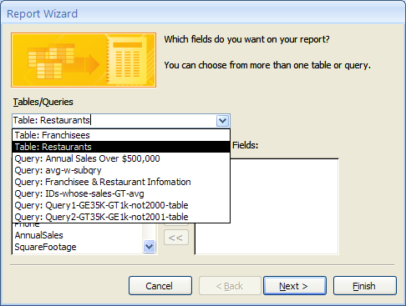

Click the button in the box Tables/Queries to choose the right table, here Restaurants.
Select fields to be included in the report:

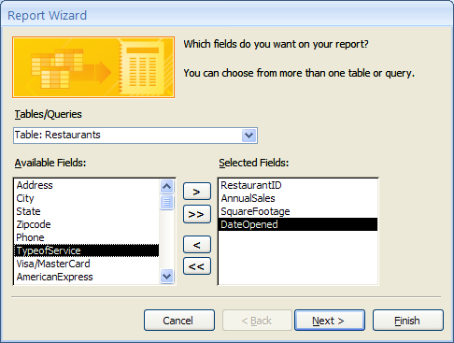
TypeofService highlighted to be selected.

Click Next, you will see the following. This is for you to add grouping level. (1) Highlight TypeofService, (2) Click the select grouping level button.

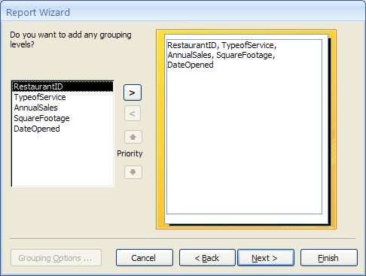
1
2

You can see in the following screenshot that a grouping level is added.

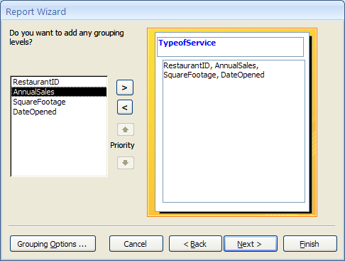
Click Next, you come to the stage where you can specify sorting and possible sum/average of numeric fields.
Sort “on their annual sales amounts, highest first” – Descending. Then sort “on their date of opening, the earliest first” – Ascending.

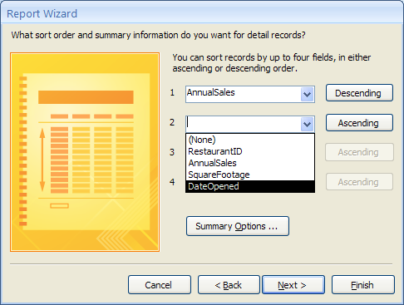
We’re about to do group summaries, BEFORE leaving the current window

Do NOT click Next! Click Summary Options … to perform average and sum on AnnualSales and SquareFootage.

Check the Avg box for AnnualSales, and Sum box for SquareFootage below.
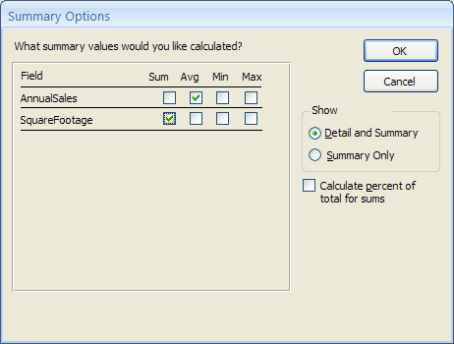
Click OK to complete this step. Click Next and you will be in the screens to choose layout and style. Click Next in both cases, and you will be in the final screen, where you can name the report. For example, you can enter Report of Restaurants (Grouped) as the name of your report. Click Finish, and you will see the completed report!

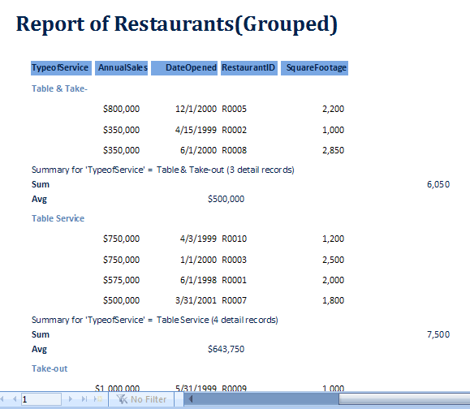
Grouped by type
Descending
On
Sales
Ascending
On date

{The last part of this demo is about moving objects (headers, columns, summaries, etc) around to make the report look better. The following screenshots were taken with Access 2003, but they are operationally the same as 2007 and 2010. So I will not replicate them in Access 2010 or 2007, but simply keep the screenshots.}

Now we try to move AnnualSales and DateOpened a bit to the left. Click the Design View button on toolbar. Click AnnualSales (label), hold down Shift button and click AnnualSales (value), and Avg(AnnualSales).

Re-arranging and resizing of objects and groups in the report can be done in Design View.

Watch these details:

Note | Details/Remarks
Table/query on which to base your report | Middle–left of the Wizard; select table/query from which your report will get data
Select a field to group on | The field must be one that truly has group nature
Do not miss the Summary Options button | In the window that says “you can sort records by up to four fields”

Subforms – Restaurants in/under franchises

Create ribbon, Form group, Form Wizard button; choose fields from Franchises table； choose fields from Restaurants table. Key step: at “How do you want to view your data?” dialog box, double click “By Franchises”

