Class Summary for Thursday, September 7, 2012
In today’s class, we learned the following:
- Appendix C slides, covering the topics of –
  - One-to-one and one-to-many relationships (slides #21-26);
  - Explained that the “one-to-one” and “one-to-many” cannot be determined until the same question is asked “from left to right, and right to left”, and this question is:
  - Given any one entity instance/and one row in this entity/this table, how many entity instances/rows in another entity/table will be associated. The question must be asked TWICE, each from one direction, to determine whether the relationship is one-to-one or one-to-many.
- Then we skipped several slides and jumped to #40-45, talking about
  - Three operations – projection, selection, and joining;
  - Four objects – what are they?
- Access Tutorial 2 (the one by Dr. David Miller), which covers –
  - Import data table (P.1) – please learn by yourself;
  - Establish the Relationships (P. 2) – please learn by yourself; may have a VERY brief demo w/o explanation; (same as Tech Plug-in 6 [below], part 4)
  - Create queries and run queries (PP. 3-5): the skills were demonstrated in Demo 2 summarized below; the skills and steps here (PP. 3-5) should be studied by yourself as a review of Demo 2;
  - Total query and calculated field query (PP. 6-9): not covered yet; please learn by yourself as a preparation for Tuesday’s class.
- Demo 2: Creating queries, which covers –
  - Simple queries – done;
  - AND and OR queries – done;
  - The rest of Demo 2 are to be completed Tuesday. Please study in advance as the preparation.
  - You are REQUIRED to replicate/redo the demo problems as your review (using the posted database Restaurant DB).
- Then we quickly went through Technology Plug-Ins 6 and 7 that came with the book:
Tech Plug-in 6 covers: (Please study the Plug-In thoroughly, either for review or preview)
1. Describe the primary functions using Microsoft Access.
2. Describe the steps for creating a new database file using Access. – learned last week; plz review
3. Describe the steps for creating and modifying a table and fields using Access. – last week
4. Describe the steps for creating relationships between tables using Access. - learn by yourself (Same as Access Tutorial 2 [above], Part b)
Tech Plug-in 7 covers: (Please study the Plug-In thoroughly, either for review or preview)
1. Describe the process of using the Query Wizard using Access. – we learned Query Design
2. Describe the process of using the Design view for creating a query using Access. – mostly done; PLEASE review
3. Describe the process of adding a calculated field to a query using Access. – next week
4. Describe the process of using aggregate functions to calculate totals in queries using
Access. – next week
5. Describe how to format results displayed in calculated fields using Access.- next week
6. We then briefly went through the homework:
- The homework was posted on the class web;
- The problems for the homework are from Tech Plug-In 7 (details in the HW and in Plug-in 7);
- The two databases (DBs) needed for the homework are also posted on the class web (WasteNotRecycling, and ClassicCars)
EXCEPT for “creating a relationship between data tables” (problem 1, part 2), all the skills that are needed for other problems and for Part 1 of Problem 1, have all been demonstrated in class. It is your responsibility to review those skills using –
- Access Tutorial 2,
- Tech Plug-In 6,
- Tech Plug-In 7
Since I have fairly detailed requirements for the format of the homework outputs, I asked you NOT to print UNTIL AFTER you have carefully studied and understood the requirements, stated at the beginning of the homework assignment (reproduced below).
-------------------------------------------------------------------
Please assemble the printouts in the order as given in the assignment; -2 if not.
Requirement for prints: (with explanation)
For tables, and query results (list of selected data): use Access Print function; -NOT screen print! | I.e., in Access, click File, then click Print
for Design View: Windows 7 please use Snipit/older Windows please <Alt>-<PrntScrn>, select the area with query info (do NOT give me the whole screen/whole desktop – whole screen will result in tiny prints), paste on Word, properly resized & annotate the graph, print the Word doc. | Either use Snipit to select proper area that contains the fields and the criteria, then paste it on Word;  Or use Alt-PrntScrn to print the active screen, then paste on Paint, then choose the proper portion (as indicated above), and paste on Word
for data table relationship: same as query Design View (print screen).
All query design view must be carefully selected and resized to be readable; -2 if not
Not resized or selected:  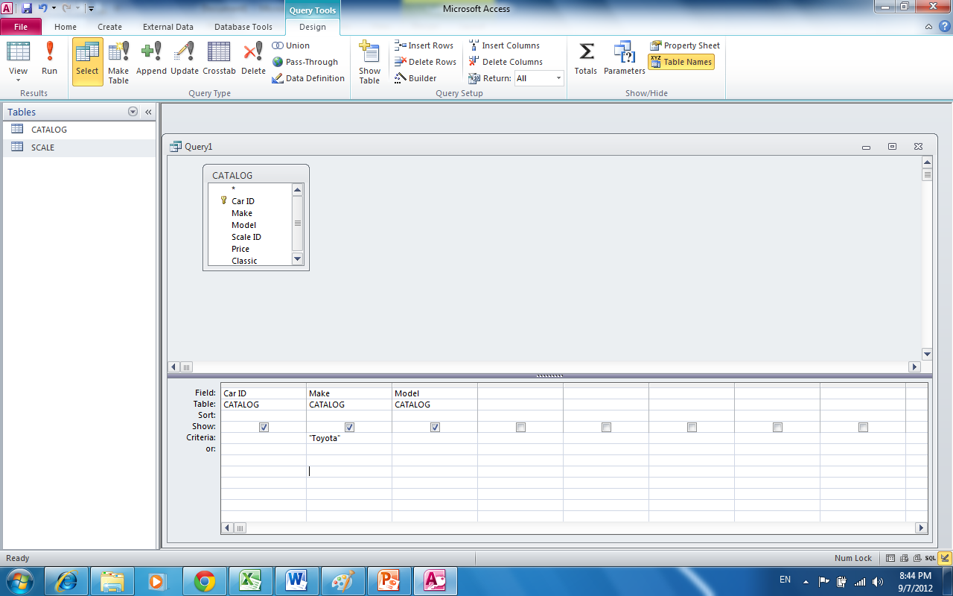 | Resized and selected:  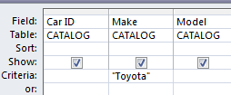  - Contains ONLY the RELEVANT info, and resized to be very readable

