FrontPage Short Tutorial

By Dr. Yüe “Jeff” Zhang (Version 1: Jul `01; Version 8: Feb `06)

A. Create your Web folder on your computer

A.1. Create a folder named yourname_local (such as smith_local) on A: or C: drive (depending on your preference and/or upload connection, i.e., you might need to take your diskette to school to publish).

A.2. Open FrontPage (“FP” hereafter), create your Index page. Save this blank page as index – lowercase!! Detailed steps are as follows:

A.2.1 The first time you open FrontPage (“FP”): Open FP, then File-Open Site (Open Web in FrontPage 2002):

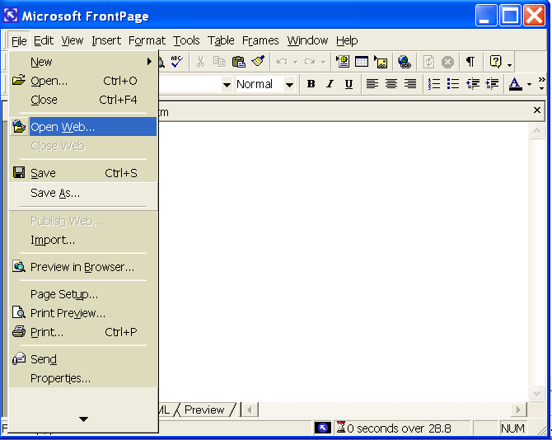

Select the folder you just created (yourname_local), open it. FP will ask you a question as follows:

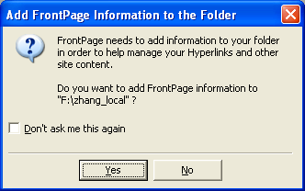

Answer Yes, you will see a screen like the one below. Pay attention to the left panel, where you can see your Web folder yourname_local – it was created as a regular file folder and has been opened as a Web folder in FP – from now on it is your Web folder.
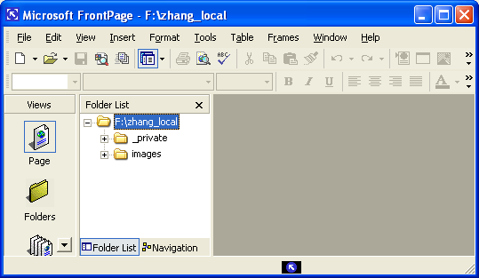

A.2.2.1 Click the button of a blank page, you will open a new page. Note the three tabs Design, HTML, and Preview. [Note: in FrontPage 2002, Design tab was named Normal]. → next figure --

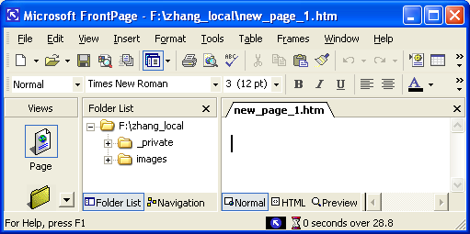
Three tabs

A.2.2.2 You can now begin to add contents to the new_page_1.htm on your right panel. After you are done, save this new page, give it the name index. The full filename will now be index.htm – FP automatically adds a file extension “.htm” to every page created. Your FP window now looks like:

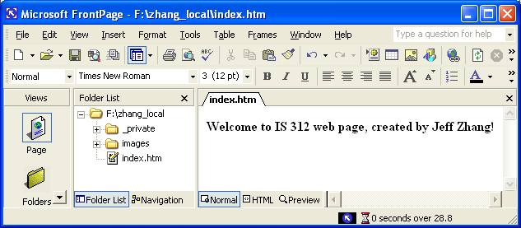
A small pencil indicates this page is being edited
A.3. Use the same procedure to create your Bio page (filename: bio) and Favorite page (filename: favorite).
Question: what should your left panel look like now? [Hint: How many files are there now? What would be the filenames?]
A.4. Make sure all the three HTML files are inside your Web folder. Make sure all other files (graphics, etc) needed are also inside the Web folder, in their appropriate subfolders if applicable.
[Note: you can either put all the files in your Web folder, in that case you don’t have to worry about subfolders; or you can put, say, all the graphic files in the folder “images”, but then REMEMBER to include the folder in your A HREF pathnames! – non-IS students are advised not to use folders]

B. Basic HTML and FrontPage (“FP”)

Note: You will use Web authoring software such as Microsoft FrontPage (“FP”) or Netscape Composer (which works in a similar way as FP) to create your Web pages. You have your freedom in choosing whatever tool you prefer, but I will only demonstrate using FP.

B.0. HTML tags are always in pairs! – except <BR> for line break and <HR> for horizontal lines (“Horizontal Rules”).

B.1. Headings –
(1) Using FP: on Tool bar, the left-most text box has Normal as default. When you want to create a heading, you can use the down arrow button to show the complete list of options, and select such items as Heading 1 or Heading 2 (…) as you need. Then you can begin to enter the text for your headings. Remember to go back to the box on left-most of Tool bar to reset the mode to Normal before you enter the text for the other portions of your Web page.
(2) Using HTML: <H1>your text for the heading </H1> (or <H2> … </H2> etc).

One pair

B.2. Horizontal lines - in FP: Insert-Horizontal line, or in HTML: <HR>

B.3. Paragraph breaks – in FP hit <Enter>, or in HTML: <P> (your text contents)</P>
Line breaks – in FP: Insert-Break, select Normal line break; or in HTML: your text<BR>

B.4. Ordered/Unordered lists: (1) Type the list items, with <Enter> at the end of each item; (2) Highlight the whole list; (3) Click the Numbering or Bullets buttons on tool bar.

B.5. Tables –
(1) In FP: Table-Insert, in the dialog box, choose the table properties (such as number of rows and number of columns). Then begin to provide the contents of each cell in the table.
(2) In HTML:
<TABLE ATTRIBUTE=value> | Beginning of the table
<TR ATTRIBUTE=value> | Beginning of table Row #1
<TD ATTRIBUTE=value >contents of the cell</TD> | Cell 1 of Row 1
<TD ATTRIBUTE=value >contents of the cell</TD> | Cell 2 of Row 1
… </TR> | End of Row 1
<TR ATTRIBUTE=value>  … | Beginning of table Row #2
</TR> | End of Row 2
</TABLE> | End of table
The ATTRIBUTEs are such things as align, width, border, ..., and values are your settings.
** More about changing table properties on “Web Page Creation Demo” (end of this document)
B.6. Graphs: Three methods to insert a graph in a web page – inserted from saved graphic files (.jpg, etc); copied and pasted from the Internet (caution: copyright issue); inserted from MS Clip Arts.

B.7. Hyperlinks:
(1) in FP: highlight the text or graphic that you want to make a link, right-click, select Hyperlink at the pop-up menu, and then type the URL, or browse and choose the page you want to link to.
(2) in HTML:
<A HREF=the filename of the page or the URL to link to>
the text/graphics you want to use as the hot link</A>

Allowing surfers to e-mail you:
(1) in FP: highlight the text or graphic that you want to make an email link (such as “Contact me” etc), right-click, select Hyperlink at the pop-up menu. In the dialog box that appears at the click, in the same row as URL, find a small button with an envelope, click the button. A dialog box entitled Create e-mail hyperlink would pop up. Type your email address in the box. Click OK, and you will see the text
mailto:jane.smith(which should be replaced with your e-mail account)@csun.edu
appears in the URL slot. Click OK and the e-mail hyperlink is done.
(2) in HTML:
<A HREF="mailto:youre-mailaddress”>whatever you want to make a link</A>
B.8. More tips about links:
- Menu of Web site links: A good web site will have a list or menu of links to the other pages within the web site. Below is an example:

[ Home | Product Info | Order Info | Useful Links ]

A menu like this (similar but don’t have to be the same) should appear on every page within the web site, allowing easy navigation from one web page to another.

- Use paragraph form for links to another web site. A good link to another web site will contain clear and concise information about the site for the user. Here is an example of a good information link:
This link will take you to the corporate home page of Microsoft, Inc. The web site contains information and support for many popular computer software applications including Microsoft Office and Microsoft Windows.
Here is an example of a poor information link – which does not provide any further info: http://www.microsoft.com.

B.9. Background images and resources for colors and backgrounds

A background can be added to a home page. It can be a solid color or an image can be used. Backgrounds are images that are tiled. The following are some Web resources on backgrounds and colors:
- Netscape Backgrounds (http://www.netscape.com/assist/net_sites/bg/backgrounds.html)
- ColorMaker (http://www.bagism.com/colormaker/)

[►End of Web Tutorial 1: FrontPage Short Tutorial◄]
IS 312 Web Page Creation Demo Using Microsoft FrontPage (FP)
(Summary of FrontPage Short Tutorial). Dr. Yüe “Jeff” Zhang, Version 6.2 Sept ‘06

No | Activity | Sub-activity | Description | Time (min) | Note
Note: “A” – setup folder and website structure; “B” – create a page; “&” – preview and publish
A1 | Create folder | File-New-Folder, type yourlastname_local | Create a file folder | 1 | In Windows Explorer
A2.1 | Convert regular folder to web folder | File-Open Site (Open Web) | Open the folder as web folder (or convert folder to web folder) | 1 | All steps are in FrontPage from this point
A2.2 | Create blank pages | Save As: index;  Save As: bio;  Save As: favorite | Three new pages created in the web folder yourlastname_local | 1 | (So as to be organized)
B1 | Headings |  | H1, H3, etc | 1
B2 | Horizontal line (HR) | Insert-Horizontal line; right-click to set properties | Insert line; change line properties → → → | 1 | Width, height, color, etc
B3 | Paragraphs | Type; <Enter> | Create paragraph | 1
 | Line break | Insert-Break-Normal line break | Forced line wrapping when needed | 1
B4 | Ordered/un-ordered lists | a. Type items, <Enter>  b. Format as list | a. type and <Enter>  b. highlight & format with buttons → → → | 1 | bulleted or numbered list
B5 | Table: | a. Table-Insert-Table-select #rows & #columns) | Create a table w desired # of rows/columns | 1
 |  | b. Right-click, Insert row/column |  | 1
 |  | c. Right-click, Table Properties, set → → | …borders, background, padding, etc
 |  | c1. select border … | size, color | 1
 |  | c2. select background |  | 1
 |  | c3. select padding … | and spacing | 1
 |  | d. Resize row/column | d. Drag at the row/ column border | 1
B6 | Graphs: | Get from files | Right-click, copy, paste | 1
 |  | Get from the Internet | Right-click, copy, paste | 1
 |  | Resize graphs | Click at graph, drag | 1
B7 | Links: | a. Text as links | Highlight, right-click, then →(a1 or a2) | 1
 |  | a1. Internal links | Type file name | 1
 |  | a2. External links | Type URL | 1
 |  | b. Graphs as links | Same as “a”, then a1/a2 | 1
 |  | c. Email links | mailto:email_addr
& | Preview your web | a. “Preview” tab in FP; or  b. Open the page from a browser |  | 1 | save page before preview
& | Publish your web | Use SSH (see separate tutorial) | 1. move right things  2. to right folder | 2
 | Total time… | (except publishing): |  | 22 | 20-40 min

