IS 312 Exam 1 Study Guide, Spring 2018
Dr. Yüe “Jeff” Zhang

In your review, you MUST cover ALL these materials: your textbook (including Plug-It-Ins), all the slides, and all the Tutorials and Demos.

There will be about 25 multiple choice questions, subtotal about 50 points, and five to six essay questions/problem solving, subtotal about 50 points. The total of Exam 1 will be 100 points.

Note: ALL review questions are potentially corresponding to multiple test questions.

Chapter 1: Introduction to Information Systems

- Definition of information systems
- Major types of information systems positions (analysts, database administrators, CIO, etc)
- Differences among data, information, and knowledge
- Definition and example of a transaction processing system (TPS) and of inter organizational system (IOS)
- Impact of IT/IS on managers’ job

Essay question: None

Chapter 2: Organizational Strategy, Competitive Advantage, and Info Sys

- Market pressure: today’s customers
- Technology pressure: innovation and obsolescence
- What is BYOD?
- Porter’s five forces model; what the IT advancements will change each of the forces’ impacts?
- The five strategies for competitive advantage; examples of their implementation through IT application
- What is a strategic information system?
- Characteristics of business – IT alignment

Essay question: State and BRIEFLY explain Porter’s five competitive forces; name one competitive strategy and give an example of this strategy’s IT implementation (either mention “XYZ company’s so and so system [name the type of IT or even the name of the system]”, or use a generic manner such as “companies can use [name the IT, such as database] to _____________ [BRIEFLY describe how that specific IT helps with the implementation of the named strategy]”)

Chapter 3: Data and Knowledge Management

- Difficulty in managing data
- Data quality: dimensions
- Data hierarchy; definition of each component of the hierarchy
- Clearly differentiate among entity, entity instance, attribute, and relationship; know examples of each of the above concepts
- Defining big data; big data characteristics; big data application scenarios

Essay question/problem-solving: will be in Access part below.
PI 3: Data and Knowledge Management

- Understand one-to-one, one-to-many, and many-to-many relationships; can give examples of each of the relationships
- Understand primary key, secondary key, and foreign key
- Types of attributes
- Three basic operations in a relational database: project, select, join
- Four types of database objects, and their respective roles
- Dealing with many-to-many relationships: convert them to two pairs of one-to-many

Essay question: None
***Do NOT forget the DB with Access tutorials!!! (Especially Tutorials 1, 2, and 3)

PI 2: Hardware and Software

- Hardware components
- Primary vs secondary storage: what do they hold (store); their types (register, cache, RAM, ROM, Magnetic disk, …); what are their respective characteristics (volatile, non-volatile; speed; cost, etc)
- Definition of software; two types of software
- Software issues/trends
- Binary system; binary-decimal conversion [binary to decimal only, for 2017/18]

Problem solving/calculation: Binary-decimal conversion [binary to decimal only, for 2017/18]
***Do NOT forget the binary number system tutorial!

Chapter 4: Telecommunications and Networking

- Types of networks (LAN, MAN, WAN)
- Components of LAN (server, client, media, network operating system; communication processors)
- Types of communications processors
- Analog and digital signals; modem
- Media types and their characteristics; comparison/selection of media
- Protocols: what they are, and what they do
- Packet switching
- Internet, intranet, extranet; World Wide Web
- ISP; NAP (network access point)
- Access technologies (DSL, cable modem, …)
- IP address
- Components of a web address (top-level domain, organizational name, server name)

Essay question: None

Access Databases
(***Please remember to study the “Database with Access” tutorials)

- Data types
- Relationships among tables, queries, reports, and forms
- Clear concept re design view and datasheet view
- Clear concept re regular query and total query
Essay question/problem-solving:

- Given a specific query design, apply the logic of the query design onto given data (tables), produce the result (query results in datasheet) ⬅ “Run the query in your head, and produce the printout with your writing”
  - Example: you may see something like the following, and you will be asked to run this query on the GIVEN tables. You should be able to LIST the data that is produced by the query.
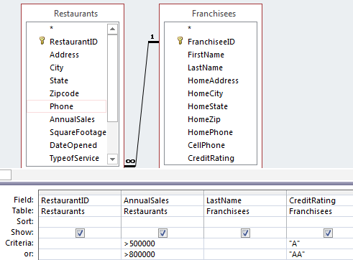
- Given statements of desired queries, fill out the given query design view to design the query that will produced the desired results as stated. Example:
  - For a “regular query,” know how to set the query criteria, especially when there are multiple criteria that have the logic of NOT/AND/OR operations;
  - For a total query, given such task as “Find out the average asking price of autos and the oldest autos in their model, for all autos by their make,” you should be able to fill in the given query design grid to design the query – such as Group By Model, AVG Price, MIN DateModelToMarket…
- Note: in the above 1 and 2 (a,b), wild card characters and calculated fields may be involved.

- Total query: Three types of questions re total query: CLOSELY study Access Tutorial 3; the following screenshot is provided to remind you that you have seen them in the demo so it will be easy for you to find them:
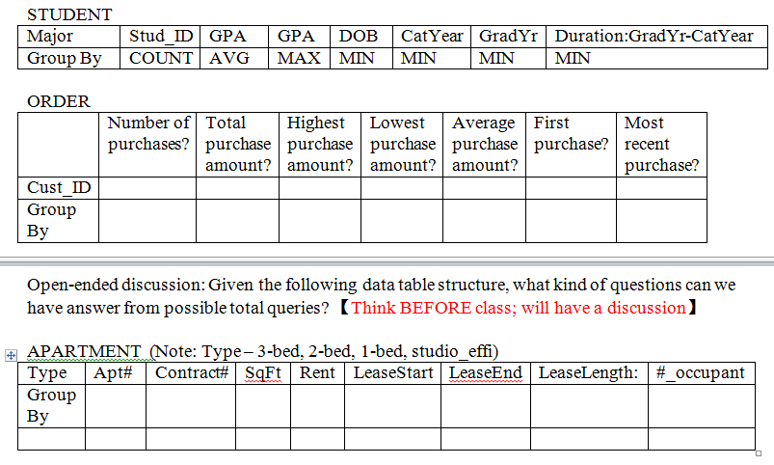

~ ~ ~ ~ ~ ~ ~ ~ ~ ~ ~ ~ ~ ~ ~ ~ ~ ~ ~ ~ ~ ~ ~ ~ ~ ~ ~ ~ ~ ~
~ ~ ~ ~ ~ ~ ~ ~ ~ ~ ~ ~ ~ ~ ~ ~ ~ ~ ~ ~ ~ ~ ~ ~ ~ ~ ~ ~ ~ ~
~ ~ ~ ~ ~ ~ ~ ~ ~ ~ ~ ~ ~ ~ ~ ~ ~ ~ ~ ~ ~ ~ ~ ~ ~ ~ ~ ~ ~ ~

General reminder/rules:
- ARRIVE 10 MINUTES EARLIER SO WE CAN BEGIN RIGHT ON TIME (after my announcements and/or clarifications)
- Students are not allowed to leave the classroom during the exam.

- Bring scantrons (882, the one of green color) and two #2 pencils. No calculator is needed.
- Please turn off your cell phone before the exam (5 points penalty for violation).

