IS 312 Excel Assignment 1 [10 points + 2 bonus points = 12 points]
Rqrmts applicable to all Excel HWs

- In Row #13 of Q1 spreadsheet, add: “In my printouts, all characters are of fonts 11 or 12 point. I did not squeeze contents to 1 page” [This is to remind you to follow reqrmt]
(1) Print: (a) formulas (obtained by: <Ctrl>-<`/~>). (b) the spreadsheet showing the cell values;
***A problem without formula print automatically lose 75% of the points for that problem.
(2) Columns containing major formulas must be sufficient to show complete formulas, -2 if not;
(3) Use parameters! – use cell addresses rather than numbers in formulas!! – 1 if not;
(4) MUST stick to the given spreadsheet – do NOT move or change.
(5) Format appropriately (1, show grid lines; 2, show %, $, etc. for corresponding contents)
(6) You may want to use landscape orientation *if* you have a short but wide spreadsheet.

1. “Brain Exercise” on Relative, Absolute, and Mixed References [3 points]

Apply your knowledge regarding the change/fixing of cells (relative, absolute, & mixed refs), predict the new formulas as the one in E12 is copied to three new locations: (Write 3 formulas)

 | E | F | G | H | I | J | K
12 | A5+$B6*$C$7-D$8 |  |  |  | 1
13 |  |  | Example |  | Do NOT use Excel; type answers in Word
14
15 | 2 |  |  |  | 3
16
Example: If E12 is A3+$B6*$C$9-D$5, copied to H14 would become: D5+$B8*$C$9-G$5
Show details of the reasoning (A→D,3→5;$B unchanged,6→8;$C$9 unchanged; D→G,$5 unchanged)

2. Gradebook (Mixed references) [4 points] (Ref: Tutorial 1)
Your LName,
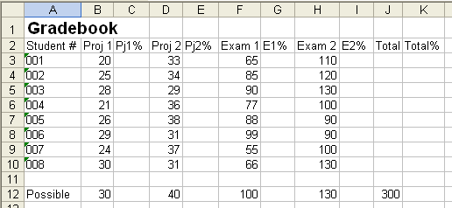
Your FName

Formula
Copy
Arrows mean copies
Create the spredsheet using given data, in DESIGNATED cells
Given the spreadsheet above (type the given numbers above to create your spreadsheet), (1) find the totals in column J, then (2) write ONE formula for cell C3, that can be copied to ranges C4:C10, then E3:E10, G3:G10, I3:I10, K3:K10 (one logic, so ONE formula and then copy it).
Logic: Pj1% = Project 1 score divided by Project 1 Possible; the same logic applies to all other columns (E, G, I, and K).
3. PMT function, amortization table, and Goal Seek [5 pts] (Ref: Tutorial 1)

Use the following spreadsheet (contents must be in EXACT cells as shown in the figure below – moving contents will result in penalty),
- Use PMT function to evaluate the value for C8;
- COMPLETE the loan repayment table (amortization table), i.e., write appropriate formulas for each cell in the first and the second rows, and then copy the formulas in the second row down the column until the end of the repayment (payback) period.
- Page setup: Sheet-Gridline.
- Print for the first 12 rows (rows 1-12) and the last three rows of the spreadsheet [Hint: Highlight the ranges, then File-Print-Print Selection].
- Perform goal seeking for a target payment of $2,000 per month, by changing the payback term, note the new payback term, print screen (as that in Tutorial 1, P.9), paste it on a Word document, and type your observation of the payback term (the new number for payback term); print the Word document; then select Cancel (i.e., do not accept the result of Goal Seek) to go back to the original spreadsheet scenario;
- Repeat 5, by changing target home price; this time, accept the goal seek, print the new spreadsheet with the ranges as indicated in “4” (do not need to do “print screen” this time). [Note “7” below, which is CRITICAL to the success of the current step]

- ****!!!! → Note -- Column D in the spreadsheet below INSTRUCTS you what to enter in column C. D3:D4 tell you what C3:C4 are, respectively, and D5 gives you the logic of the formula in C5. And of course C8 is a formula.
Problem could result if not reading #7 carefully

Your FName

Your LName,

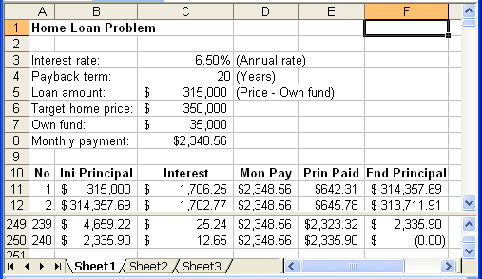
Note: C5 is a formula; if you enter a number, the goal seek in the problem will not work (Why? – do your exploration about Goal Seeking, and think)

**Note: For Goal Seek, there is no formula; so, take screenshot of the Goal Seek box. Other than that, all prints must be printed from the regular Excel “File” – “Print”.

