Recreation & Tourism Management Faculty Members Headcount by Employment Status
Numbers | Fall 2006 | Fall 2007 | Fall 2008 | Fall 2009 | Fall 2010 | Fall 2011
Full-Time | 8 | 6 | 7 | 7 | 7 | 7
Part-Time | 4 | 12 | 13 | 12 | 15 | 20
Total | 12 | 18 | 20 | 19 | 22 | 27

Percent | Fall 2006 | Fall 2007 | Fall 2008 | Fall 2009 | Fall 2010 | Fall 2011
Full-Time | 66.7% | 33.3% | 35.0% | 36.8% | 31.8% | 25.9%
Part-Time | 33.3% | 66.7% | 65.0% | 63.2% | 68.2% | 74.1%
Total | 100.0% | 100.0% | 100.0% | 100.0% | 100.0% | 100.0%

Recreation & Tourism Management Faculty Members FTEF Headcount by Employment Status
Numbers | Fall 2006 | Fall 2007 | Fall 2008 | Fall 2009 | Fall 2010 | Fall 2011
Full-Time | 8 | 6 | 7 | 7 | 7 | 7
Part-Time | 1 | 3 | 6 | 5 | 6 | 7
Total | 9 | 9 | 13 | 12 | 13 | 14

Percent | Fall 2006 | Fall 2007 | Fall 2008 | Fall 2009 | Fall 2010 | Fall 2011
Full-Time | 88.9% | 66.7% | 53.8% | 58.3% | 53.8% | 50.0%
Part-Time | 11.1% | 33.3% | 46.2% | 41.7% | 46.2% | 50.0%
Total | 100.0% | 100.0% | 100.0% | 100.0% | 100.0% | 100.0%

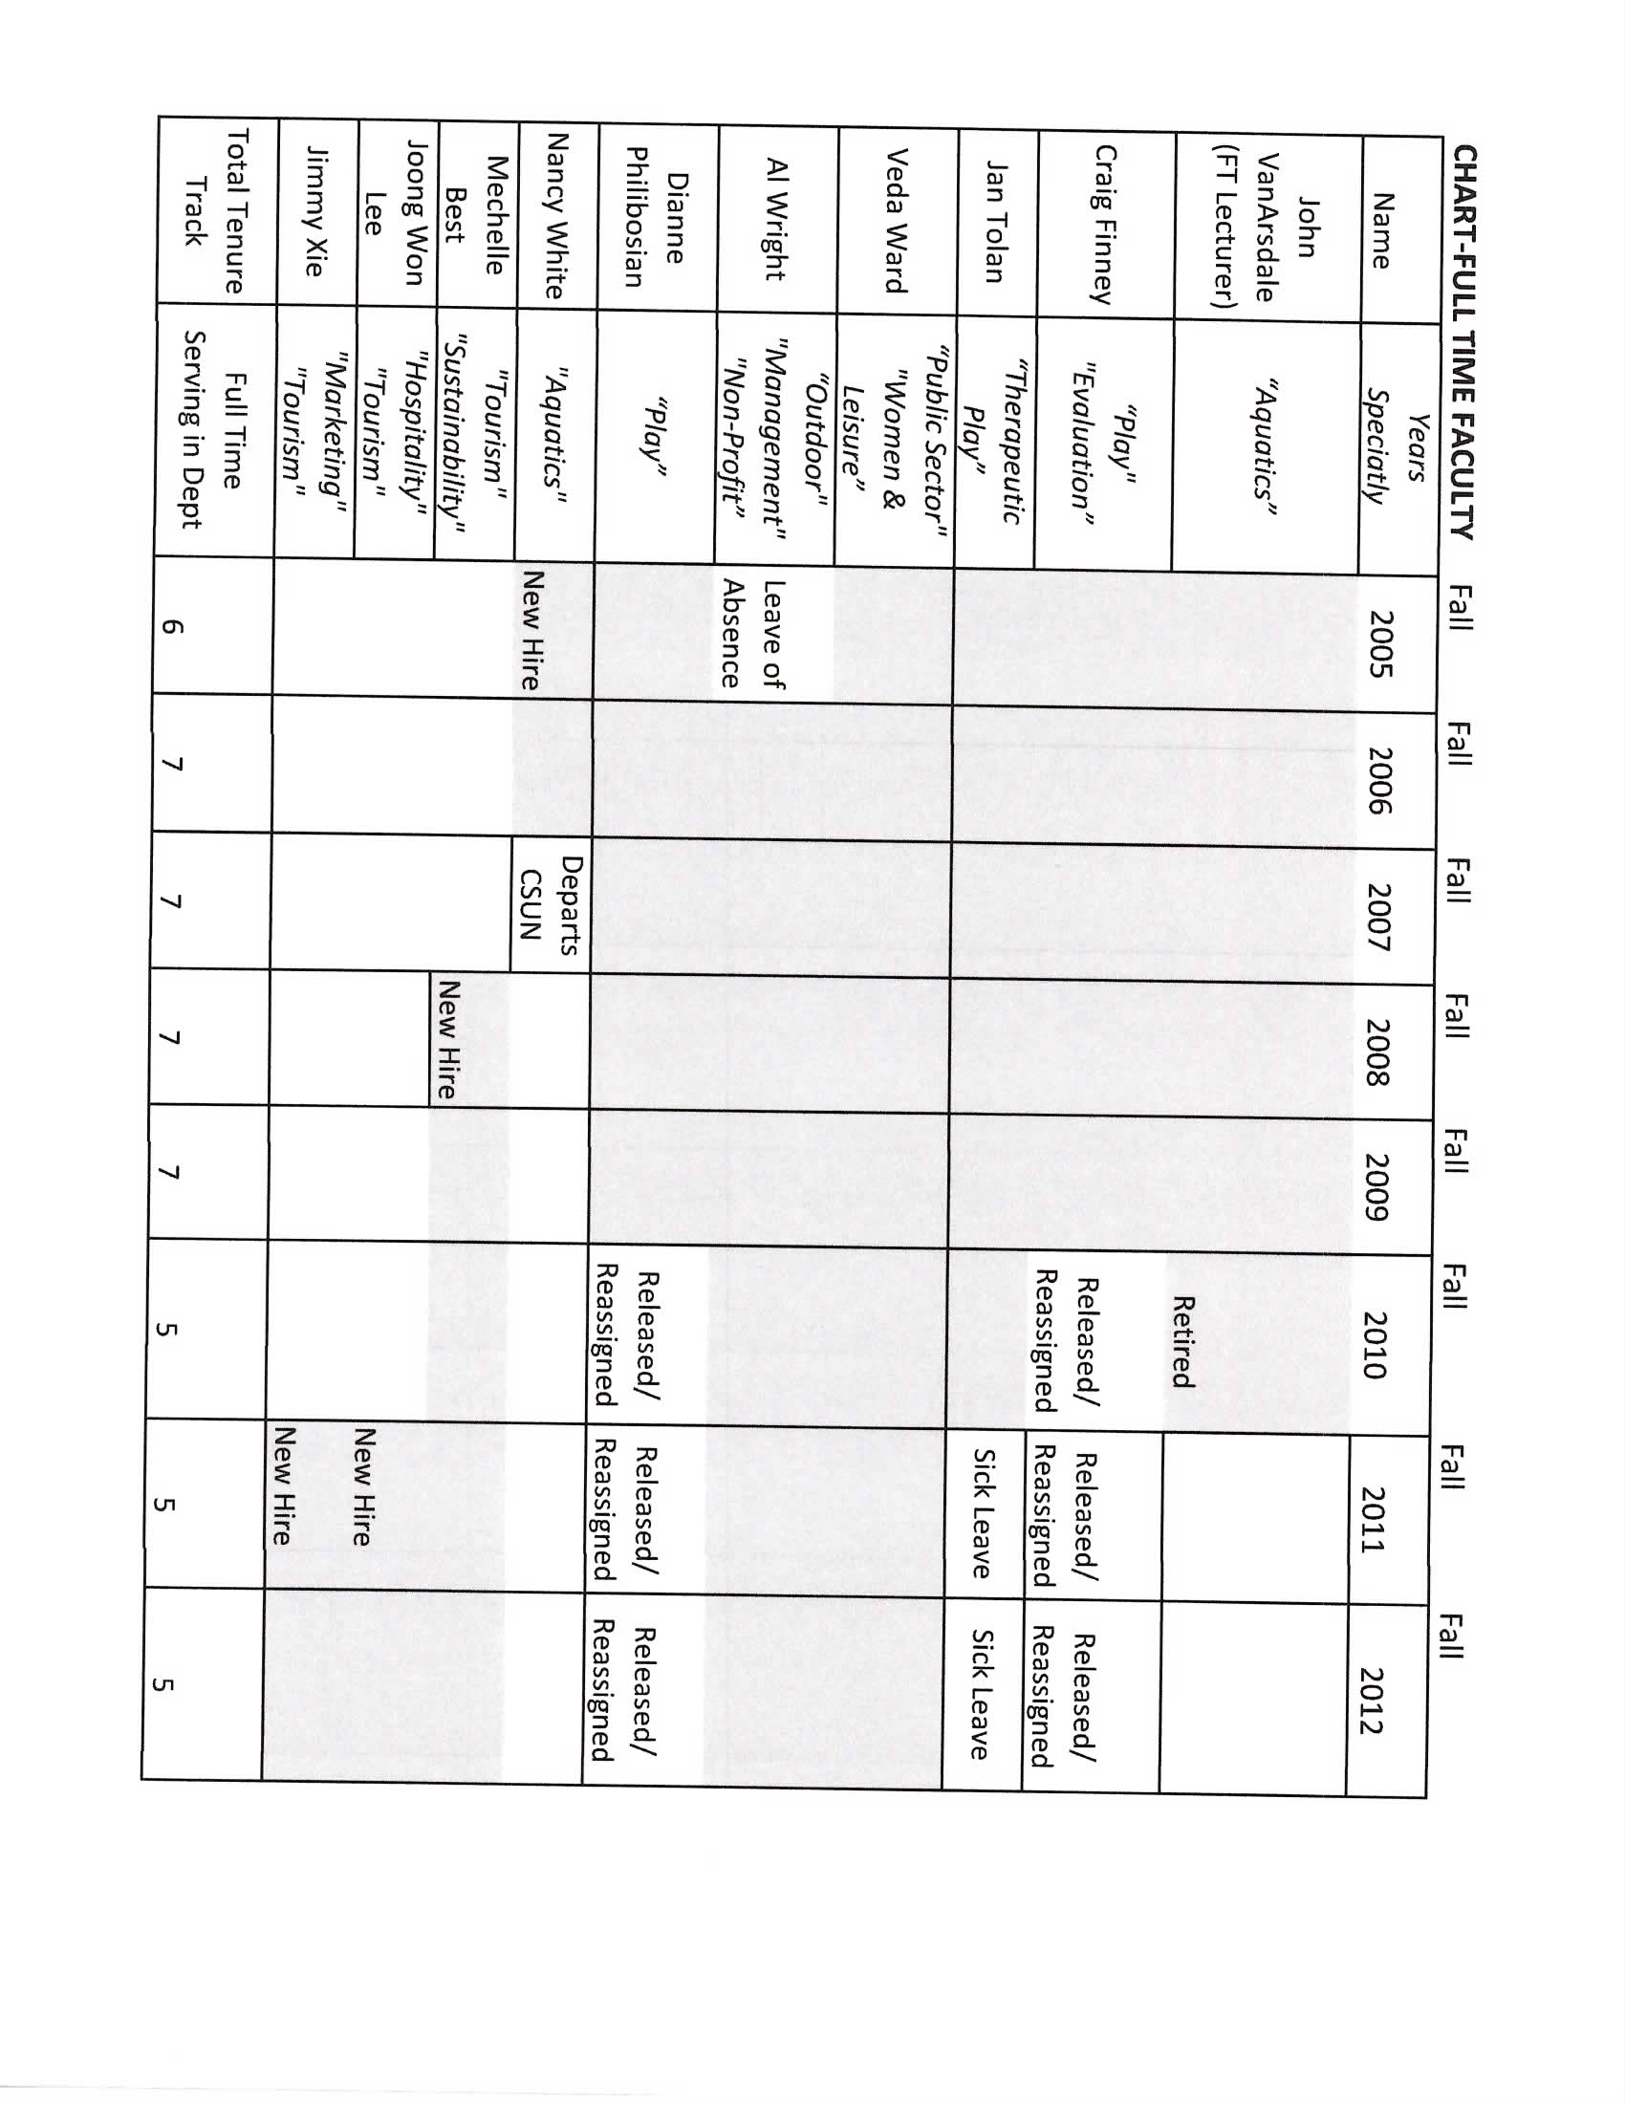

Recreation & Tourism Management Faculty Members Detailed Information Headcount by Academic Rank
Numbers | Fall 2006 | Fall 2007 | Fall 2008 | Fall 2009 | Fall 2010 | Fall 2011
Tenured
Professor | 3 | 3 | 3 | 4 | 4 | 3
Associate Professor | 2 | 2 | 2 | 1 | 1 | 1
Subtotal | 5 | 5 | 5 | 5 | 5 | 4
Tenure Track
Assistant Professor | 1 | 0 | 0 | 0 | 0 | 3
Lecturer
Lecturer | 6 | 13 | 15 | 14 | 17 | 20
Grand Total | 12 | 18 | 20 | 19 | 22 | 27

Percent | Fall 2006 | Fall 2007 | Fall 2008 | Fall 2009 | Fall 2010 | Fall 2011
Tenured
Professor | 25.0% | 16.7% | 15.0% | 21.1% | 18.2% | 11.1%
Associate Professor | 16.7% | 11.1% | 10.0% | 5.3% | 4.5% | 3.7%
Subtotal | 41.7% | 27.8% | 25.0% | 26.3% | 22.7% | 14.8%
Tenure Track
Assistant Professor | 8.3% | 0.0% | 0.0% | 0.0% | 0.0% | 11.1%
Lecturer
Lecturer | 50.0% | 72.2% | 75.0% | 73.7% | 77.3% | 74.1%
Grand Total | 100.0% | 100.0% | 100.0% | 100.0% | 100.0% | 100.0%

