DEPARTMENT of RECREATION and TOURISM MANAGEMENT

Assessment of Student Learning

2010-2011

Assessment Liaison, Veda E. Ward
Department Chairperson, Alan Wright

FALL 2011 Status Report
Prepared by Veda E. Ward, Department Assessment Liaison

Table of Contents

Page(s)

Executive Summary

Introduction

2009-10 Liaison Report

2010-11 Liaison Report

Emotional Intelligence

Portfolios

Involving Students and New Faculty

Appendices

EXECUTIVE SUMMARY
The Department of Recreation and Tourism Management (RTM) initiated a
comprehensive review of its approach to assessment of student learning during the 2010-11
academic year. A new five-year review cycle was underway, and the department was in
the midst of internal Program Review. An initial draft of a proposed five-year plan was
developed by incoming assessment liaison, Veda Ward with information shared by the
previous assessment liaison, Dr. Tolan. The year can best be described as period of intense
and thoughtful transition.

Early in the Fall 2010 semester, the department was informed of an opportunity
to undertake a search for two new faculty members during that academic year, and both
the incoming and outgoing assessment liaisons, along with department chairperson Wright
served as the search and screen committee. Assessment was incorporated into the
language of the position descriptions, and interview schedule which heralded a new era for
including the role of assessment as a responsibility of all faculty members.

In anticipation of successful hiring, the faculty chose not to move forward with
an aggressive five-year assessment plan until the new hires were in place during Fall 2011.
In addition to a new department chair, and assignment of two senior faculty members to
external responsibilities, the department major had expanded professional focus, and as a
result enrollment had increased dramatically. During the period of expansion, only one
tenure-track hire had been added, so that many of the departmental core courses were
covered by part-time faculty. The new hire focused on development of the graduate
program and tourism courses, while the individual coordinating Program Review was often
busy on reassignment with the campus Health and Wellness Institute. Intermediate steps
taken included the following:

1. Review of course assignments relative to department learning outcomes;
2. Provision of information regarding coordination of course assignments,
development of student portfolios and assessment of student learning;
3. Discussion of alignment among Program Review process (and progress),
assessment of student learning and professional preparation;
4. Decision to pursue external accreditation by National Recreation and Park
Association (NRPA- which now offers a process based in the assessment of student
learning outcomes), or other professional accreditation in experiential education or
hospitality/tourism;
5. Develop a succession plan across assessment liaisons that would ensure continuity
over time. Drs. Ward and Tolan presented at Faculty Retreat January 2011, and to
department faculty in March.

6. Revisit and affirm core values that would inform and support future internal and
external reviews, including assessment of student learning outcomes;
7. Consciously and consistently integrate objectives for internal program review with
those of external accreditation and the assessment of student learning;
8. Investigate student status on Emotional Intelligence (Department SLO# );
9. Review samples of department major "capstone" portfolios for indicators of
strengths and weaknesses as a vehicle for assessment of department SLOs, and;
10. Developa possible new SLO focusing on professional ethics, which would align with
an overarching professional theme within the College of Health and Human
Development.
11. Encourage scaffolding of learning between undergraduate and graduate programs
through coordination of and discussion about student learning and curriculum
development at both levels.

In addition, the department proposed, approved and moved forward name changes for
degrees at both the graduate and undergraduate levels. At the conclusion of the academic
year, the department had made significant progress on the anticipated integrative
processes, two new hires were completed and both joined the CSU Northridge and
Department of Recreation and Tourism Management faculty in August 2011.

The following pages provide an overview of progress toward meeting stated
objectives. The Department of Recreation and Tourism Management was among the first
in the University to publish its student learning outcomes and continues to committed to,
and mindful of the need to carefully consider the creation and evaluation of the Assessment
process as the profession and specific career pathways within the profession continue to
evolve. Provided for easy reference throughout this report are the current departmental
SLOs:

1) Students will demonstrate critical thinking including analysis, synthesis and
evaluation in the fields of play, leisure, recreation, parks and/or tourism through a
variety of pedagogies;

2) Students will practice and self-assess progress toward mastery of the standards and
competencies of appropriate accrediting bodies through continual self-assessment
and portfolio development;

3) Students will demonstrate application and integration of theoretical knowledge in a
practical setting through 600 hours of professional internship in preparation for
pursuing professional employment, and;

4) Students will demonstrate an increase in Emotional Intelligence while pursuing
their degree(s) as measured by an Emotional Intelligence survey instrument at
point of entry and exit from the degree program. (2010-12 University Catalog, p.
531).

Assessment of Student Learning in the Department of Recreation and Tourism
Management: 2010-2011
Introduction
The assessment of student learning is never simple regardless of whether the
academic unit is large or small. The faculty members of the Department of Recreation and
Tourism Management (RTM) are very dedicated to providing an excellent learning
environment for its majors, who self-select into an academic unit devoted to preparing
them for both professional competence in human services and personal life satisfaction
through application of course concepts. In addition, RTM faculty members are committed
to integrating curricular and co-curricular experiences of students, and hold degrees or
emphases in professional areas of study such as human development, parks and recreation
administration, tourism/hospitality and management, and education. Part-timers are often
selected from ranks of Student Affairs staff on campus or successful practitioners.
Occasionally, department alumni return to staff courses following completion of Master's
degrees.
In recent years, the department has attracted several international students, has
broadened its "umbrella" to emphasize professional career growth areas such as
international and sustainable tourism, hospitality, recreational sport management, outdoor
adventure recreation, and event planning and management (both large and small scale].
The result has been rapid growth in both numbers and diversity of majors, which in turn,
prompted increased interest in assessment activities which could help align and make
procedures consistent with new directions. A new department assessment liaison was
appointed, with the goal of having a smooth transition, or succession, between the two
colleagues.
The following report attempts to capture the activities of 2010-11, with a brief
insight into the emphasis on continuity as new faculty members were hired and the
decision was made to forgo internal campus program review in favor of external national
accreditation. Those accreditation standards can be found in Appendix_.

The 2009-10 Assessment Feedback
Professor Jan Tolan was the Assessment Liaison in 2009-10. Weaknesses identified
in April 2010 as part of the internal Program Review process were reported to faculty.
Student focus groups helped inform the entire program review process as indicated by the
form identifying assignment of students to review groups. The students identified were
enrolled in the senior Internship class, which met monthly as a group in addition to
individual meetings with the faculty member, because group meeting attendance was
mandatory, tying input to this class was particularly effective in gathering student input.

Date | Time | Location | Moderators | Recorders
April 15, Thursday  RTM 494 Dr. Ward | 7.00p.m | Sagebrush  Hall 105  And  108 | Rita  Dettenmaier  Luda Gogolusko | Daniel  Ruvalcaba  Phyllis Tiger

Group 1
Aquino, Carl

Berson, Samantha

Benford Erica

Camarillo, Robyn

Castro, James

Cooper, Katy

Cuevas, Evelin

Cunningham, John

Dischekenyan, Andy

Duma, Tom

Freeman-Anderson, AJ

Galindo, Breeze

Garcia, Ali

Hanna, Connie

Lee, Sky

Prochnow, Raechel

Rogoff, Rebecca

Group 2
Saltzman, Jill

Sanchez, Mike

Serrano, Rachel

Seidman, Nicole

Spencer, Shireen

Stewart, Sarah

Taylor, Therin

Thomas, Andrea

Udomratsak, Chris

Ziser, Deon
Keisel, Kyle

Riley, Dylan

Glanz, Jenna

Ornelas, Joni

Evans, Mike

Again, student feedback is highly valued in the department. External feedback form
various levels of the campus are also helpful. An example of such feedback is provided
below.
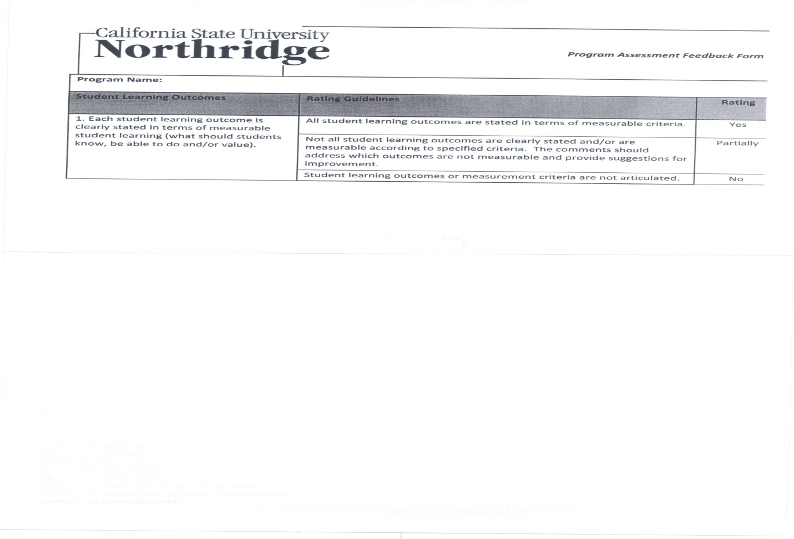

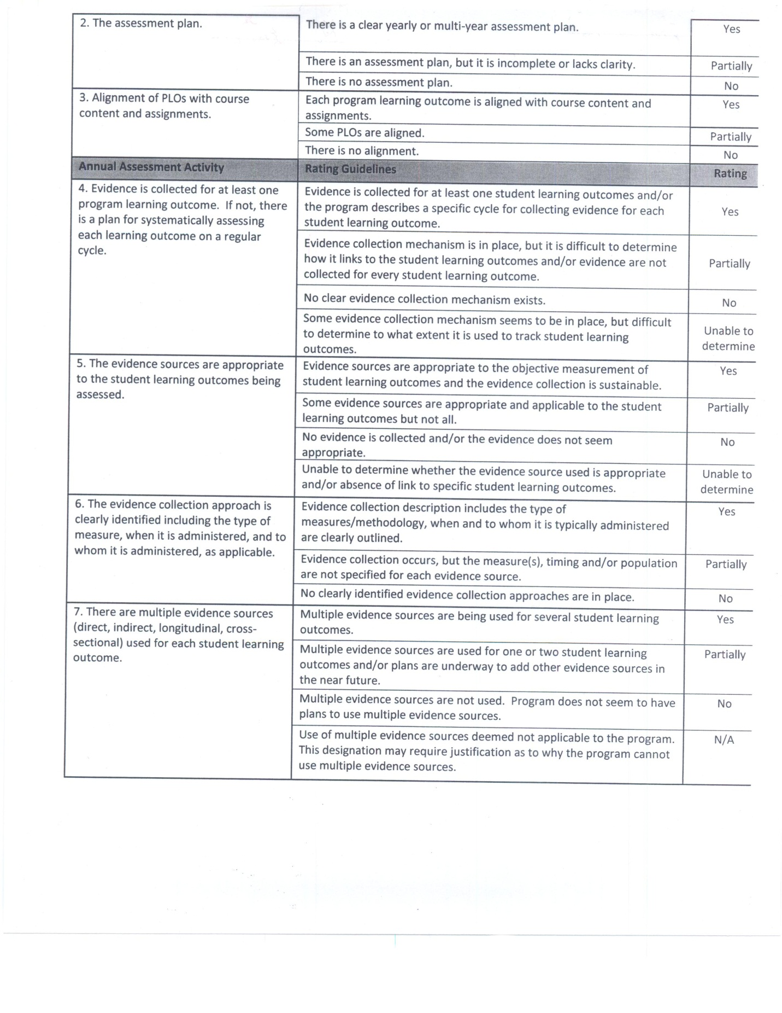
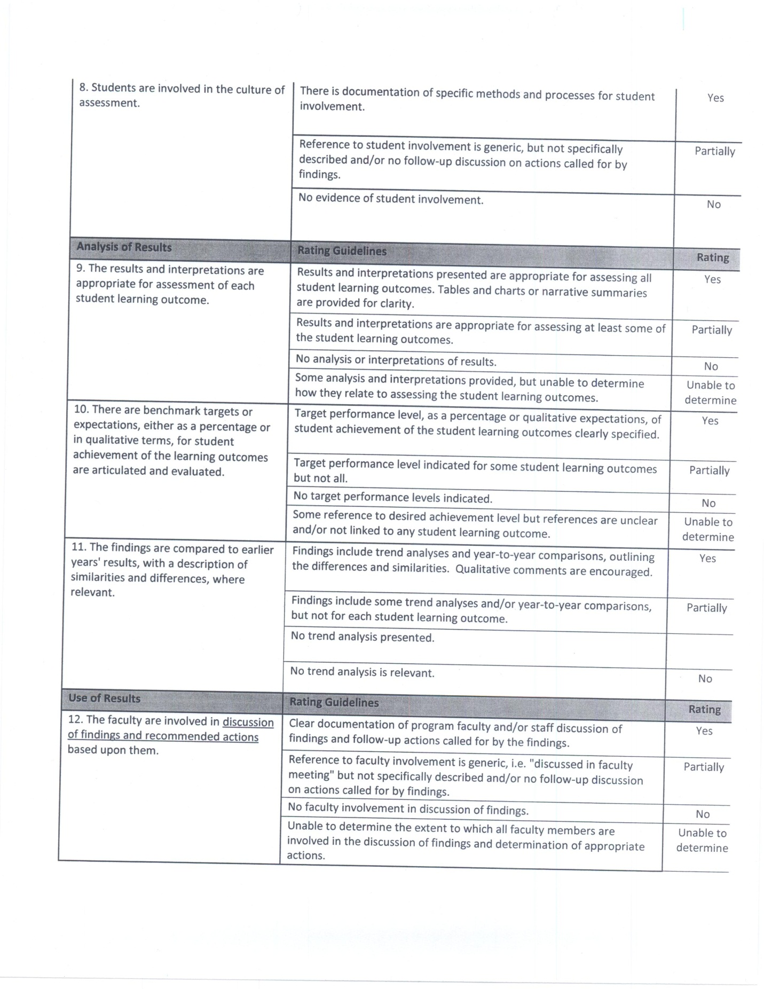
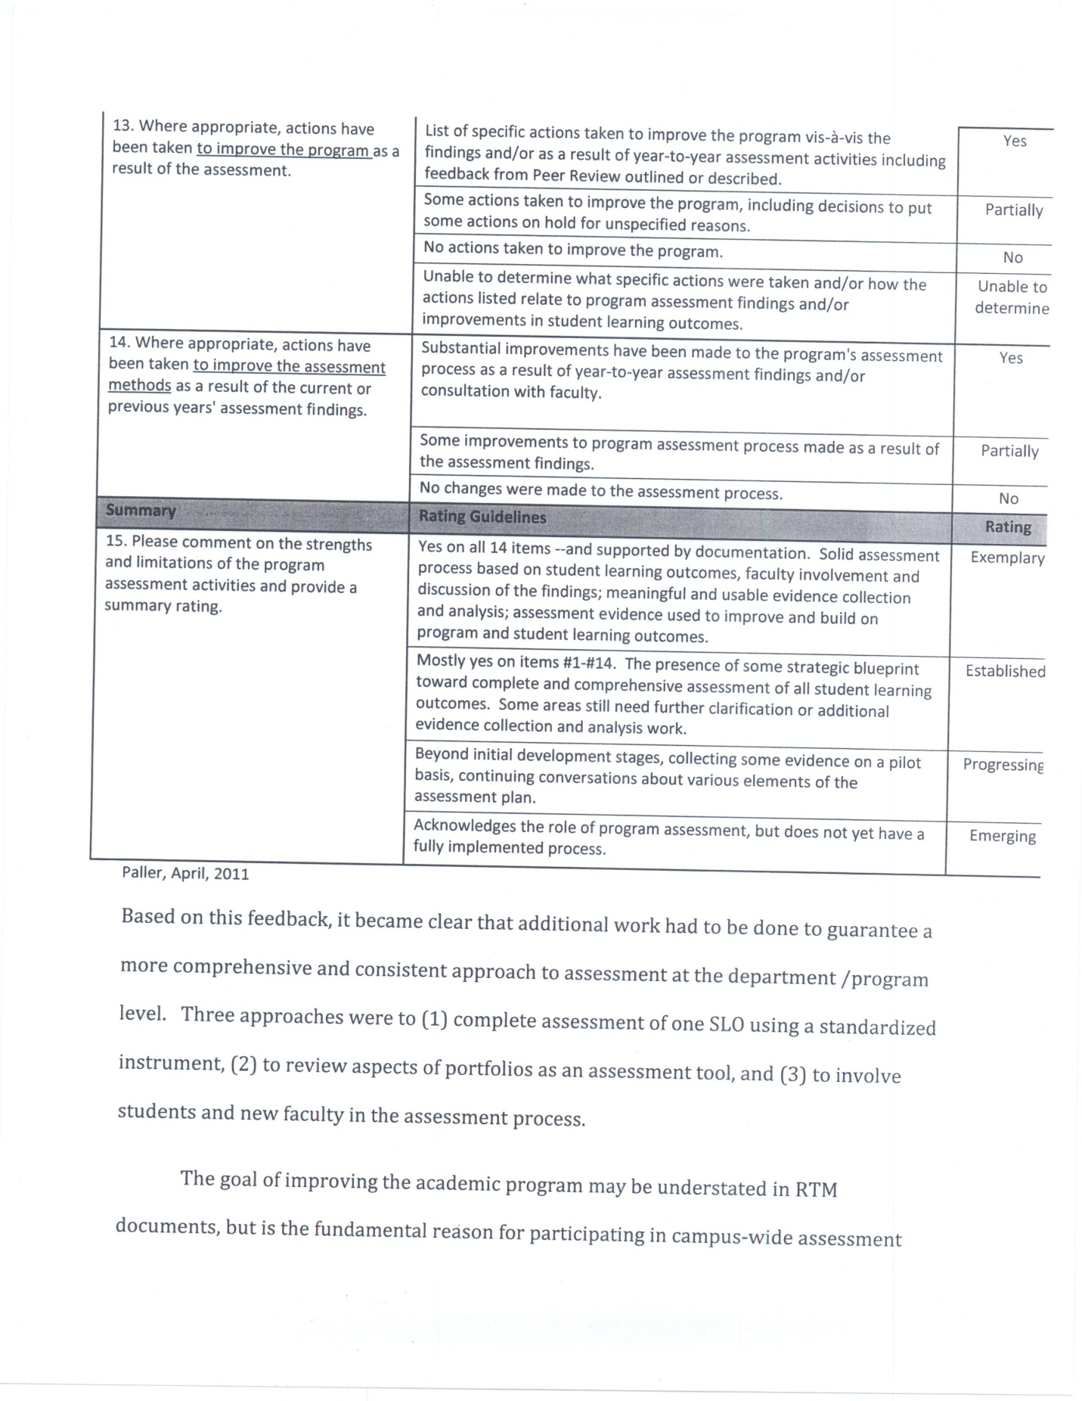
Based on this feedback, it became clear that additional work had to be done to guarantee a
more comprehensive and consistent approach to assessment at the department /program
level. Three approaches were to (1) complete assessment of one SLO using a standardized
instrument, (2) to review aspects of portfolios as an assessment tool, and (3) to involve
students and new faculty in the assessment process.
The goal of improving the academic program may be understated in RTM
documents, but is the fundamental reason for participating in campus-wide assessment
and external review. Faculty members wish students to be both academically and
professionally prepared and continuous improvement in teaching and learning supports
attainment of those desired outcomes. Moreover, when asked, most tenure-track faculty
members clearly see the benefit in sharing standards and expectations for students across
courses.

Assessment of Emotional Intelligence Among RTM 490 Students (Spring 2011)
Purpose
The Department of Recreation and Tourism Management (RTM) department SLO #4
states that students will demonstrate an increase in Emotional Intelligence while pursuing
their degree(s) objectives as measured by an Emotional Intelligence survey instrument at
point of entry and exit from the degree program (University catalog, p. 531). Department
faculty had selected emotional intelligence as particularly helpful to majors as they
prepared for careers that were highly dependent upon interpersonal communication,
customer service and self-management for long term success. The commitment to use a
standardized instrument for assessment posed some financial concerns for the unit, but a
short-term solution was found.

Below is a description of the process undertaken to assess student majors on SLO # 4,
some findings are presented and recommendations made.

Instrumentation
For this analysis, an adapted version of Hunsaker's (2001) What's your emotional
intelligence score? was used to assess students enrolled in the department capstone course,
RTM 490 which was taught by the department Assessment Liaison (DAL). The 25-item
instrument was re-typed (from online version) and distributed to students unannounced.
Due to the nature of the course, which incorporated a variety of career-related activities,
students expressed minimal concern when asked to complete the survey in class. Next,
students exchanged papers with a course-mate and scored the instrument. A subsequent
step was to discuss the findings and relationship to department SLOs and career
preparation. The course instructor collected all of the surveys, and other course activities
ensued.

Analysis of Data
The El instrument consisted of 25 items and was broken down into five sub-scales; self-
awareness, managing emotion, motivating yourself, empathy and social skills. A student
seeking "extra credit" in the course volunteered to complete descriptive analyses of the
data using Excel, and to convert findings into a Powerpoint presentation that could be used
by the department for future examination. This project concluded the last week of the
Spring 2011 semester. Results of the analysis were not completed until early in the Fall
2011 semester.
Upon review of the data, the DAL decided to establish a cut-off level for acceptable
responses where 25% of respondents identified their ability at the mid-range response (3=
Moderate Ability) on the 5-point scale. For items where additional students (5 % or
higher) identified there ability as (2= Slight), this was indicated, suggesting that more than
one-quarter of students enrolled were indicatinga level of competence in El that could
raise concerns for department faculty members.

Discussion: Responses to El Survey Items for which Action might be Undertaken
Based on descriptive data, 68% of students rated themselves as 4 (Much Ability) or
5 (Very Much Ability) on most items. Items where respondents only reported competence
at level 3 (Moderate Ability) stood out when they exceeded more than one-quarter of the
students (28%). This meant an opportunity to craft teaching and learning experiences that
would increase student "success" or efficacy in these areas. No students described
themselves as having the lowest level, Very Slight (1), ability in Emotional Intelligence. To
some extent this makes sense, since students self-select into a major that is heavily service-
oriented. Percentages across the 25 items ranged by level from level 1 =0%, to level 2=4%,
to level 3=28%, to level 4=40%, and at level 5= 28%. Below is a list of items where one-
quarter or more of student respondents expressed ability (competence) with Emotional
Intelligence at level 3 (or compounded with 5% or more respondents at level 2)

Item Responses at Levels 3 or 2
Q2 Relax when under pressure situations 3= 24%
Q5 Initiate successful resolution of conflict with others 3=29%
Q 6 Calm yourself quickly when angry 3=48%
Q 8 Regroup quickly after a setback 3=24%
Q 9 Recognize when others are distressed 3=24%, 2=5%
Q 10 Build consensus with others 3=28%, 2=5%
Q 11 Know what senses you are currently using 3=28%, 2=5%
Q 13 Produce motivation when doing uninteresting work 3=43%, 2=9%
Q 14 Help others manage their emotions 3= 33%, 2=10%
Q 16 Identify when you experience mood shifts 3=24%, 2=5%
Q 17 Stay calm when you are the target of anger from others 3=43%, 2 = 5%
Q18 Stop or change an ineffective habit 3=43%, 2=5%
Q 21 Know when you become defensive 3= 38%
Q 23 Follow your words with actions 3=28%
Q 24 Engage in intimate conversations with others 3=28%, 2=5%
Q 25 Accurately reflect people's feelings back to them 3=48%, 2=5%

Of these items, students seemed particularly aware of their inability to calm yourself
when angry (Q6), to produce motivation when doing uninteresting work (Q 13), to stay calm
when the target of anger from others (Q 17), to stop or change an ineffective habit (Q 18), to
know when you become defensive (Q 21) and to accurately reflect people's feelings back to
them (Q 25). These items could easily be incorporated in classroom activities, lectures,
Powerpoint presentations, videos or guest speakers. Overall, improvement of studemt
ability and competence in this area will enhance internal communications (student-
student, student-staff, and student-faculty) while encouraging greater awareness of El
dimensions in both interpersonal and professional interactions. Results of improvement in
El will be evident In RTM students being selected for highly competitive internships and
jobs upon graduation. A spillover effect is that the academic program will become known
for producing students who genuinely and consistently behave appropriately and
demonstrate resilience on the job (and hopefully in their personal lives).

The next aspect of analysis was to determine the sub-scales where RTM student
respondents may demonstrate weakness based on moderate to low level responses to
survey items.
Hunsaker’s Adapted El Sub-Scale Items | RTM Student Responses at Levels 3 and 2
Self-Awareness = Items 1, 6, 11, 16, 21 | (6, 11, 16, 21)
Managing Emotion = Items 2, 7, 12, 17, 22 | (2, 17)
Motivating Yourself = Items 3, 8, 13, 18, 23 | (8, 13, 18, 23)
Empathy = Items 4, 9, 14, 19, 24 | (14, 19, 24)
Social Skills = Items 5, 10, 15, 20, 25 | (5, 10, 25)

As is evident in this table, each sub-scale was comprised of five items. Applying the same
level of "concern" as with the general item response analysis, -in this case where student
responses at levels 3 and 2 matched three or more of the subscale items- faculty could
identify areas where current RTM majors were not expressing high levels of confidence
with Emotional Intelligence; Self-Awareness, Motivating Yourself, Empathy, and Social
Skills.
At the final faculty meeting of the Spring semester, the RTM department faculty
engaged in a preliminary discussion about these results and possible strategies to improve
student abilities in these areas. A summary of these points is presented below.
Possible Approaches to Increasing Competence in El
First and foremost, faculty recognized that Emotional Intelligence (El) seems to be a
function of human development and experience. RTM majors are involved in many in-class
as well as field experiences (including a 600-hour (+) internship where they have the
opportunity to assess and improve El. So, while the findings were of interest, they were not
considered inconsistent with students at a similar life stage, point in their professional
career development, or as university undergraduates.
Possible strategies for improving student competency in this area begin with
informing the faculty instructing key courses where students interact with the community
an can be observed and rated on El. This can become part of the feedback provided on
course projects by instructors, community sponsors/participants and by course-mates.
Faculty members may also wish to share information, resources or training on El that they
have had in other contexts. Faculty members may also incorporate "practice" sessions in
courses that expose students to possible scenarios where El will be tested.
It is important to recognize that El has some limitations to which faculty need to be
sensitive, including cultural, generational and contextual biases. Faculty themselves may
have strengths and weaknesses of their own when it comes to El, and it may be a helpful
framework to approach this area as one where we continue to grow and evolve together
over time. As a result, El becomes a shared goal among faculty and students.

PORTFOLIOS
The Department of Recreation and Tourism Management (RTM) identifies as its second
Student Learning Outcome (SLO) Students will practice and self-assess progress toward

mastery of the standards and competencies of appropriate accrediting bodies through
continual self-assessment and portfolio development (2010-2012 University Catalog, p. 531).
Self-assessment has not been consistently operationalized throughout the department, and
is presumed to be a consequence of rapid growth and assignment of increasingly less
campus-experienced faculty members. Before expanding assessment responsibilities to
new faculty members, whether full or part-time, it was decided to use 2010-11 as a year to
review the intersection among assessment practices.

The primary and most enduring method of documenting student learning has been the
portfolio, which has been around in various iterations for almost a decade. While the
department has an SLO devoted to portfolios, this was not the primary focus of department
assessment during the 2010-11 academic year. It is important to note that because
portfolios have been stored over time, they provide the Department opportunities for ongoing
assessment.

At present, portfolios are required of all students during the capstone course (RTM
490) and updated at the conclusion of Senior Internship (RTM 494 ABC). During the 201011
academic year, the Department Assessment Liaison had the opportunity to teach both
courses, and to begin reviewing the portfolio process in conjunction with other assessment
activities. Four major projects related to portfolios were undertaken:

1) Students were encouraged to submit and maintain portfolios in both hard and
electronic formats;
2) A preliminary rubric for portfolio evaluation was developed and piloted Spring
2011;
3) Portfolios were introduced as a course requirement in RTM 330, an upper division
general education course also taught by the department Assessment Liaison, and
4) New hires were involved in a hands-on assessment activity to determine what an
unbiased eye would reveal as student learning based on their evaluation of sample
portfolios.

Although accomplishing these goals became a huge undertaking with so few full-time
faculty, the Assessment Liaison became the point of intersection for most of these
undertakings, which had its benefits and limitations. For the most part the commitment to
engaging the new hires meant delaying some assessment activities until early in the fall
2011 semester, but offered a valuable new-lens perspective on prior activities.

Assessment reports from two new hires can be found in Appendix . At this point,
more data need to be gathered from continuing faculty members, both full- and part-time
to establish a baseline comparison. The initial templates are presented in "draft" stage and
will be reviewed by faculty at future meetings to refine content, structure and supportive
rubrics. Below are samples of this year's early efforts which bridge the department's past
approaches to the assessment of student learning with those of the future.
SAMPLE LANGUAGE to ASSIST WITH REVIEW of PORTFOLIOS
For Core Course Analysis
Type of Evidence | Skills | Abilities | Knowledge
Narrative “Research”  Papers/Reflections/Journals | Format &  Typing (3) | Organization  (2)  Critical  Questions/  Thought (2) | RTM  Terminology/ Professional  Language (2)
Projects/Reports/Oral | “Professional”  Presentation (4) | Diverse  Research  Sources (4) | Incorporates info from  Local community (3)
OTHER

Powerpoints | Uses different  Designs / layouts | Incorporates  YouTube  Clips 3 | Contains Key terminology  And references (4)
Photos | Centered,  Capture setting  And people (3) | To work with  diverse  populations  (2) | Key dimensions of  Activity or group are  Captured (2)

So here is ONE way you could approach what you see in the portfolios. The key features
will vary from student to student, and instructor to instructor, however. Feel free to use
your own words, as everyone has taught before, as well as been taught. I also left a space
for "other" types of evidence which may be unique or not covered by other categories.

Developed by Veda Ward
September 2011

RTM PORTFOLIO ASSESSMENT of STUDENT LEARNING
Faculty Reviewer ____________________________
What did students learn in RTM core courses as presented in the portfolio? First identify
then rate each on a scale of [+) 4 ……….. 1 (-)

Date of Portfolio Core Course # Skills
Knowledge Abilitities
RTM 202/202L

RTM 204

RTM 278

RTM 302

RTM 303

RTM 304

RTM 402

RTM 403

RTM 490
(capstone/portfolio)
RTM 494 ABC
(Internship)
Electives in RTM

Comments

Recommendations
For Improvement

VEW/vew
Developed by Veda E. Ward September 2011
The two new tenure-track faculty members were able to complete this exercise, and based
on their feedback, it was quite challenging. As the semester moves forward, their
experience [and feedback on same), will assist department faculty as they refine
assessment forms and processes.

The specific objectives planned for 2011-12 emerged from these assessment
activities and extensive formal and informal conversations among department faculty
members, was discussed at the September 14 faculty meeting and is presented below.

1. Gain a regular "space" on faculty meeting agendas for reporting (by assessment
liaison) and engagement of all participating faculty
2. Hold a minimum of three department activities that focus on increasing alignment
between and synergy among student learning outcomes, professional competencies,
internal (campus) program review, external accreditation standards and other
relevant measures of student that encourage/allow integrations.
3. Extend responsibilities for assessment beyond a single liaison (small faculty
committee including at least one part-time faculty member).
4. Develop and maintain a known location for assessment literature and reports;
including, but not limited to electronic formats and hard-copy notebooks.
5. Review annual and five-year assessment plans to strengthen process and remain
reflective of growth/change in both higher education and professional
diversification.
6. Review process by which students identify need/requirement to produce a portfolio
during the capstone experiences in the major [currently RTM 490 and 494 A, B, and
C).
7. This document remains open to additions and refinements

CONCLUSIONS and RECOMMENDATIONS

APPENDICES

CAMPUS ASSESSMENT TOOLS

COURSE ALIGNMENT MATRIX
ctions: Assess the how well (course) contributes to the program's student learning outcomes by rating each course obj
. PorD.
I=introduced (basic level of proficiency is expected)
P=practiced (proficient/intermediate level of proficiency is expected)
D=demonstrated (highest level/most advanced level of proficiency is expected)
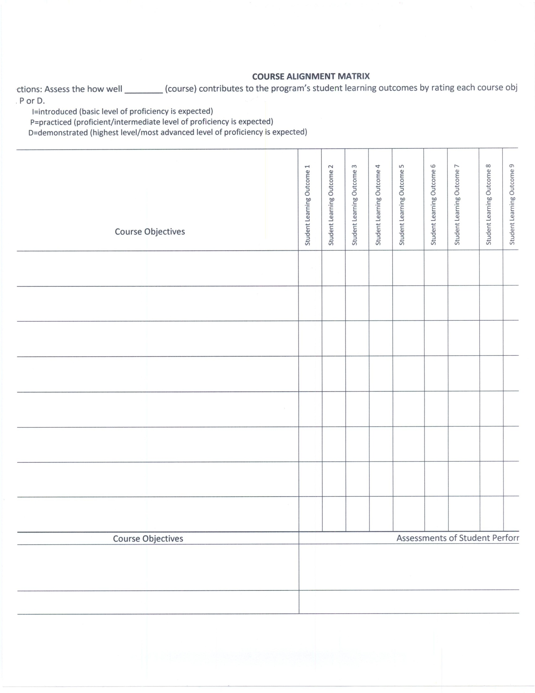
Program Assessment Plan, 2011-2016
Department/Program________________________________
Time Period  (Academic Year, | Assessment  Activity  (Outcome  Assessment,  Outcomes  Review, Alumni survey, Assessment Analysis etc | Responsible Individual or Organization  (Specify who is responsible to see that this activity is carried out.) | Relevant Planning Information  (For Outcome Assessment  indicate information such as  where the evidence will be  gathered, type of student work to  be used, whether this is a direct  or indirect assessment, what  results would indicate success,  etc. as appropriate and known at  the time the plan is created. For  other assessment tasks, indicate  how they will be carried out.) | Status  (Use this  column to  indicate the  status of the  activity during  Assessment  Plan review.  E-g,  Completed,  Postponed,  In-Progress,  Deleted, etc.)
Lingard, Version B

COAPRT
NATIONAL ACCREDITATION STANDARDS

Selected Bibliographical Resources

Katz, S, N. (2010). Beyond crude measurement and consumerism. Academe, 96, 5, pp. 16
20.
Walvoord, B. E. (2010). Assessment Clear and Simple: A Practical Guide for Institutions,

Departments and General Education (2nd Edition). San Francisco: Jossey-Bass/Wiley
Imprint.

