Student Investment Fund
end of semester report

Acknowledgements
The College of Business and Economics Student Investment Fund would like to thank the following for sharing their knowledge and experiences with the class this semester:

Doug Christopher
Jim Ragan
Andrew Crowell
of
Crowell, Weedon & Co.

Razmig Der-Tavitian
of
Dorchester Capital Advisors

Robert Neff
of
MacroRisk Analytics

Portfolio Managers

Roger Castillo

Brian Andrew Coco

Timothy Lee Cole

Jennifer L. Friedman

Shawn H. Hakim

Allen Hakopian

Samuel Anthony Harwit

Hoang Nhat Ho

Huo Jie

Miguel Angel Jauregui, Jr.

Thanh Vinh Nguyen

Damon B. Olson

David Potter

Christopher Peter Sanchez

Esseye Tadesse

Frank Teran

Transactions (All on 4/28/2010)

Undergraduate Portfolio:

Sales:
AMERICAN INTL GROUP INC | AIG | 25
ARCHER DANIELS MIDLAND CO | ADM | 500
BARRICK GOLD CORP | ABX | 865
CISCO SYS INC | CSCO | 1000
COCA COLA CO | KO | 200
CONOCOPHILLIPS | COP | 475
FREEPORT-MCMORAN COPPER & GO | FCX | 260
INTEL CORP | INTC | 1850
INTERNATIONAL BUSINESS MACHS | IBM | 200
IRON MTN INC | IRM | 800
J P MORGAN INTL DERIVATIVES | JPM | 100
MARATHON OIL CORP | MRO | 550
PRICE T ROWE GROUP INC | TROW | 550
VERIZON COMMUNICATIONS INC | VZ | 790

Purchases:
BIG LOTS INC | BIG | 500
COGNIZANT TECHNOLOGY SOLUTIO | CTSH | 1000
COMPANHIA BRASILEIRA DE DIST SPN ADR PFD CL | CBD | 800
GEEKNET INC | LNUX | 800
LINCARE HLDGS INC | LNCR | 1100
ROSS STORES INC | ROST | 900
VISTAPRINT N V | VPRT | 300
WHITE RIVER CAPITAL INC | RVR | 3600

Graduate Portfolio:

Sales:
ADOBE SYS INC | ADBE | 900
CONSOLIDATED EDISON INC | ED | 600
VEOLIA ENVIRONNEMENT SPONSORED ADR | VE | 215
NOKIA CORP SPONSORED ADR | NOK | 670
FLUOR CORP NEW | FLR | 400
CISCO SYS INC | CSCO | 900

Purchases:
AMGEN INC | AMGN | 100
COGNIZANT TECHNOLOGY SOLUTIO | CTSH | 200
COLGATE PALMOLIVE CO | CL | 200
COMPANHIA BRASILEIRA DE DIST SPN ADR PFD CL | CBD | 300
LINCARE HLDGS INC | LNCR | 400
QUALITY SYS INC | QSII | 300
ROSS STORES INC | ROST | 300
SPORT CHALET INC | SPCHA | 100
VISTAPRINT N V | VPRT | 100
WHITE RIVER CAPITAL INC | RVR | 300

Combined Portfolio Holdings
 |  |  | 12/31/2009 |  |  |  | 5/21/2010
Company | Ticker |  | Shares | Equity Weight | Values |  | Shares | Equity Weight | Values
ADOBE SYS INC | ADBE |  | 900 | 2.14% | $33,102.00 |  | 0 | 0.00% | $0.00
ALTRIA GROUP INC | MO |  | 475 | 0.60% | $9,324.25 |  | 475 | 0.67% | $9,979.75
AMERICAN INTL GROUP INC | AIG |  | 25 | 0.05% | $749.50 |  | 0 | 0.00% | $0.00
AMGEN INC | AMGN |  | 0 | 0.00% | $0.00 |  | 100 | 0.35% | $5,244.00
APPLE INC | AAPL |  | 110 | 1.50% | $23,180.52 |  | 110 | 1.80% | $26,655.20
ARCHER DANIELS MIDLAND CO | ADM |  | 1200 | 2.43% | $37,572.00 |  | 700 | 1.20% | $17,787.00
AT&T INC | T |  | 500 | 0.91% | $14,015.00 |  | 500 | 0.84% | $12,425.00
AUTOMATIC DATA PROCESSING IN | ADP |  | 600 | 1.66% | $25,692.00 |  | 600 | 1.65% | $24,372.00
BARRICK GOLD CORP | ABX |  | 865 | 2.20% | $34,063.70 |  | 0 | 0.00% | $0.00
BIG LOTS INC | BIG |  | 0 | 0.00% | $0.00 |  | 500 | 1.23% | $18,135.00
BLDRS ASIA 50 ADR INDEX FUND | ADRA |  | 1295 | 2.16% | $33,307.40 |  | 1295 | 2.09% | $30,898.70
BLDRS EMERGING MARKETS 50 ADR INDEX FUND | ADRE |  | 500 | 1.43% | $22,065.00 |  | 500 | 1.31% | $19,415.00
CANADIAN NATL RY CO | CNI |  | 590 | 2.08% | $32,072.40 |  | 590 | 2.25% | $33,264.20
CATERPILLAR INC DEL | CAT |  | 800 | 2.95% | $45,592.00 |  | 800 | 3.25% | $48,072.00
CHUBB CORP | CB |  | 900 | 2.86% | $44,262.00 |  | 900 | 3.07% | $45,351.00
CISCO SYS INC | CSCO |  | 1900 | 2.94% | $45,486.00 |  | 0 | 0.00% | $0.00
COCA COLA CO | KO |  | 400 | 1.48% | $22,800.00 |  | 200 | 0.70% | $10,318.00
COGNIZANT TECHNOLOGY SOLUTIO | CTSH |  | 0 | 0.00% | $0.00 |  | 1200 | 4.02% | $59,388.00
COLGATE PALMOLIVE CO | CL |  | 0 | 0.00% | $0.00 |  | 200 | 1.08% | $15,918.00
COMPANHIA BRASILEIRA DE DIST | CBD |  | 0 | 0.00% | $0.00 |  | 1100 | 4.46% | $65,890.00
CONOCOPHILLIPS | COP |  | 475 | 1.57% | $24,258.25 |  | 0 | 0.00% | $0.00
CONSOLIDATED EDISON INC | ED |  | 600 | 1.76% | $27,258.00 |  | 0 | 0.00% | $0.00
COSTCO WHSL CORP NEW | COST |  | 1000 | 3.83% | $59,170.00 |  | 1000 | 3.88% | $57,440.00
DISNEY WALT CO | DIS |  | 1000 | 2.09% | $32,250.00 |  | 1000 | 2.22% | $32,870.00
FEDEX CORP | FDX |  | 300 | 1.62% | $25,035.00 |  | 300 | 1.69% | $24,918.00
FLUOR CORP NEW | FLR |  | 400 | 1.17% | $18,016.00 |  | 0 | 0.00% | $0.00
FREEPORT-MCMORAN COPPER & GO | FCX |  | 260 | 1.35% | $20,875.40 |  | 0 | 0.00% | $0.00
GEEKNET INC | LNUX |  | 0 | 0.00% | $0.00 |  | 800 | 0.07% | $1,048.00
GOLDMAN SACHS GROUP INC | GS |  | 375 | 4.10% | $63,315.00 |  | 375 | 3.57% | $52,732.50
HEWLETT PACKARD CO | HPQ |  | 500 | 1.67% | $25,755.00 |  | 500 | 1.58% | $23,290.00
INFOSYS TECHNOLOGIES LTD | INFY |  | 550 | 1.97% | $30,398.50 |  | 550 | 2.10% | $31,014.50
INTEL CORP | INTC |  | 1850 | 2.44% | $37,740.00 |  | 0 | 0.00% | $0.00
INTERNATIONAL BUSINESS MACHS | IBM |  | 200 | 1.69% | $26,180.00 |  | 0 | 0.00% | $0.00
IRON MTN INC | IRM |  | 800 | 1.18% | $18,208.00 |  | 0 | 0.00% | $0.00
ISHARES GLOBAL CLEAN ENERGY | ILF |  | 900 | 1.30% | $20,032.20 |  | 400 | 1.13% | $16,676.00
ISHARES NASDAQ BIOTECH | IBB |  | 400 | 1.24% | $19,116.00 |  | 300 | 1.64% | $24,225.00
ISHARES S&P LATIN AMERICA | ICLN |  | 300 | 1.59% | $24,549.00 |  | 900 | 0.92% | $13,626.00
J P MORGAN INTL DERIVATIVES | JPM |  | 740 | 2.00% | $30,835.80 |  | 640 | 1.73% | $25,632.00
JOHNSON & JOHNSON | JNJ |  | 400 | 1.67% | $25,764.00 |  | 400 | 1.65% | $24,352.00
KELLOGG CO | K |  | 600 | 2.07% | $31,920.00 |  | 600 | 2.19% | $32,448.00
KRAFT FOODS INC | KFT |  | 328 | 0.58% | $8,915.04 |  | 328 | 0.66% | $9,738.32
LINCARE HLDGS INC | LNCR |  | 0 | 0.00% | $0.00 |  | 1500 | 4.58% | $67,695.00
LUXOTTICA GROUP S P A | LUX |  | 730 | 1.21% | $18,746.40 |  | 730 | 1.21% | $17,914.20
MARATHON OIL CORP | MRO |  | 550 | 1.11% | $17,171.00 |  | 0 | 0.00% | $0.00
MARKET VECTORS ETF TR | KOL |  | 685 | 1.60% | $24,742.20 |  | 685 | 1.42% | $21,050.05
MASTERCARD INC | MA |  | 100 | 1.66% | $25,598.00 |  | 100 | 1.45% | $21,385.00
MEDCO HEALTH SOLUTIONS INC | MHS |  | 192 | 0.79% | $12,270.72 |  | 192 | 0.73% | $10,767.36
NESTLE GROUP | NSRGY .PK |  | 2000 | 6.26% | $96,700.00 |  | 2000 | 6.09% | $90,080.00
NIKE INC | NKE |  | 444 | 1.90% | $29,335.08 |  | 444 | 2.14% | $31,697.16
NOKIA CORP | NOK |  | 670 | 0.56% | $8,609.50 |  | 0 | 0.00% | $0.00
ORACLE CORP | ORCL |  | 1575 | 2.50% | $38,634.75 |  | 1575 | 2.36% | $34,905.94
PEPSICO INC | PEP |  | 500 | 1.97% | $30,400.00 |  | 500 | 2.15% | $31,790.00
PFIZER INC | PFE |  | 1400 | 1.65% | $25,466.00 |  | 1400 | 1.46% | $21,560.00
PRAXAIR INC | PX |  | 300 | 1.56% | $24,093.00 |  | 300 | 1.56% | $23,130.00
PRICE T ROWE GROUP INC | TROW |  | 550 | 1.90% | $29,287.50 |  | 0 | 0.00% | $0.00
PUBLIC STORAGE | PSA |  | 400 | 2.11% | $32,580.00 |  | 400 | 2.45% | $36,188.00
QUALITY SYS INC | QSII |  | 0 | 0.00% | $0.00 |  | 300 | 1.18% | $17,376.00
ROSS STORES INC | ROST |  | 0 | 0.00% | $0.00 |  | 1200 | 4.26% | $63,060.00
SPORT CHALET INC | SPCHA |  | 0 | 0.00% | $0.00 |  | 100 | 0.02% | $263.00
STRYKER CORP | SYK |  | 345 | 1.12% | $17,377.65 |  | 345 | 1.23% | $18,181.50
TARGET CORP | TGT |  | 510 | 1.60% | $24,668.70 |  | 510 | 1.87% | $27,718.50
UNITEDHEALTH GROUP INC | UNH |  | 520 | 1.03% | $15,849.60 |  | 520 | 1.01% | $14,924.00
VEOLIA ENVIRONNEMENT | VE |  | 215 | 0.46% | $7,069.20 |  | 0 | 0.00% | $0.00
VERIZON COMMUNICATIONS INC | VZ |  | 790 | 1.69% | $26,172.70 |  | 0 | 0.00% | $0.00
VISTAPRINT N V | VPRT |  | 0 | 0.00% | $0.00 |  | 400 | 1.23% | $18,176.00
WASTE MGMT INC DEL | WM |  | 1400 | 3.06% | $47,334.00 |  | 1400 | 3.07% | $45,360.00
WHITE RIVER CAPITAL INC | RVR |  | 0 | 0.00% | $0.00 |  | 3900 | 3.53% | $52,260.00
 |  |  |  |  | 12/31/2009 |  |  |  | 5/21/2010
Total Equity Value |  |  | Equity | 96.57% | $1,544,980.96 |  | Equity | 95.67% | $1,478,604.88
Cash |  |  | Cash | 3.43% | $54,899.00 |  | Cash | 4.33% | $66,993.36
TOTAL PORTFOLIO VALUE |  |  |  |  | $1,599,879.96 |  |  |  | $1,545,598.24

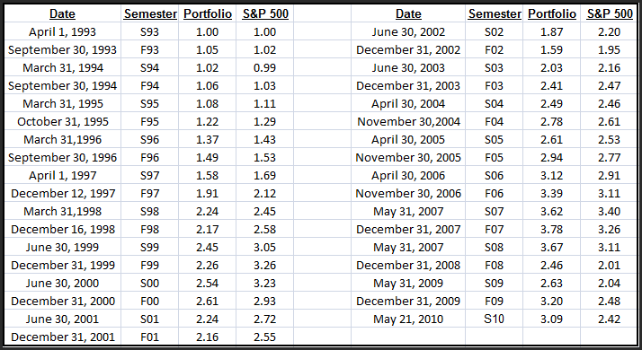

Analytics

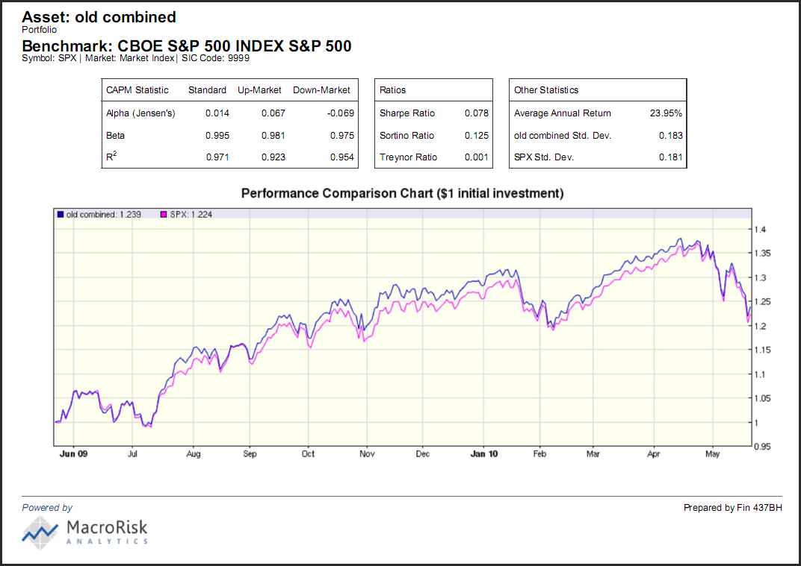
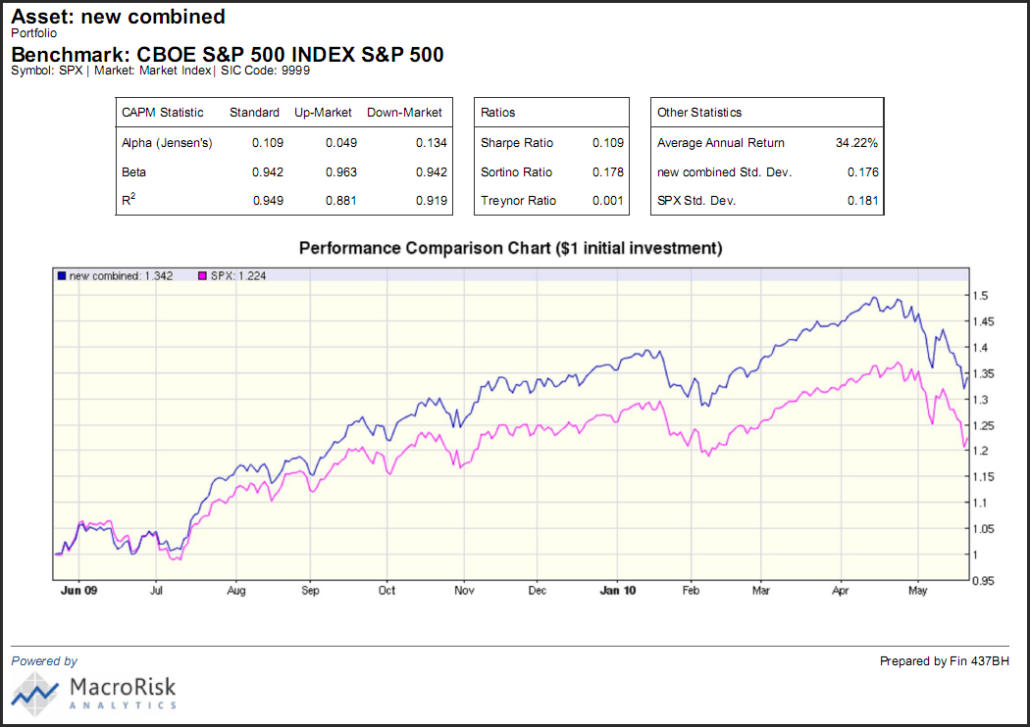
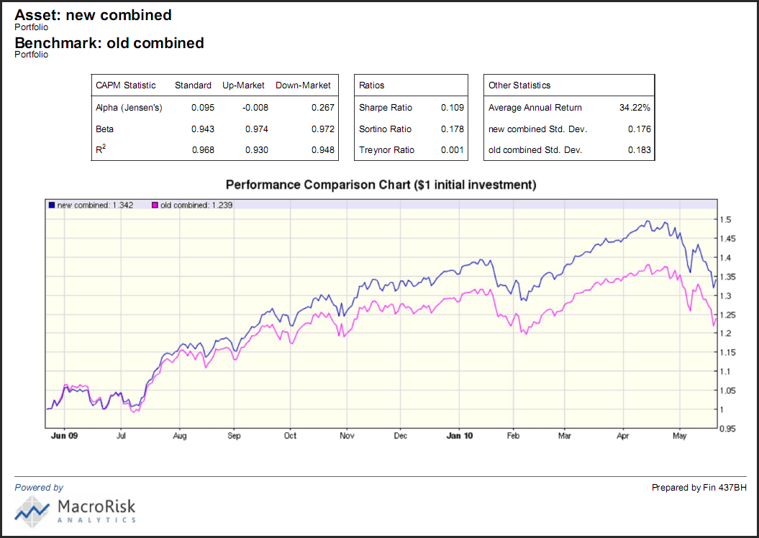

Portfolio | (Benchmark) | Standard |  | Up-Market |  | Down-Market |  | CMRI | Sharpe Ratio | Sortino Ratio | Treynor Ratio
 |  | alpha | beta | alpha | beta | alpha | beta
"Old" Comb. Portfolio | S&P 500 | 0.014 | 0.995 | 0.067 | 0.981 | -0.069 | 0.975 | 79 | 0.078 | 0.125 | 0.001
"New" Comb. Portfolio | S&P 500 | 0.109 | 0.942 | 0.049 | 0.963 | 0.134 | 0.942 | 67 | 0.109 | 0.178 | 0.001
"New" Comb. Portfolio | "Old" Portfolio | 0.095 | 0.943 | -0.008 | 0.974 | 0.267 | 0.948 | 67 | 0.109 | 0.178 | 0.001
S&P 500 | S&P 500 | 0 | 1 | 0 | 1 | 0 | 1 | 70 | 0.075 | 0.118 | 0.001

 | Actual Returns (Equity Portion)
 | 12/31/2009 - 4/28/2010 | 4/28/2010 - 5/21/2010
"Old" Comb. Portfolio | 5.23%
"New" Comb. Portfolio |  | -8.01%
S&P 500 | 6.84% | -8.70%

The "New" Combined Portfolio was weighted to provide lower exposure to economic risk (measured by the CMRI, "Composite Macro Risk Index") and systematic index risk (measured by the various beta statistics).
Compared to the "Old" Combined Portfolio, the new portfolio has a 6% lower relative beta and historically would have generated positive alpha overall and in down market conditions.
Since the portfolio rebalancing date of April 28, 2010, the equity components of the "Old" portfolio would have lost 8.17% in value while the equity component of the "New" portfolio lost 8.01% in value. During this same period, the S&P Index lost 8.7%. Overall, the S&P lost 2.47% and the combined "Old" and "New" portfolios lost 3.3%.

The Stocks

Altria Group, Inc. (MO) was founded in 1919 and is based in New York, New York. Through its wholly owned subsidiary Philip Morris International it engages in the manufacture and sale of cigarettes and other tobacco products worldwide. It produces seven of the top 20 best-selling global cigarette brands. Philip Morris USA is the largest tobacco company in the U.S. and has half of the U.S. cigarette market’s retail share. Its brands include Marlboro, Virginia Slims, Basic and Parliament. Phillip Morris Capital Corporation is an investment company whose portfolio consists of leveraged and direct finance lease investments and other tax-oriented and third party financing. In April of 2007, Altria Group spun-off its ownership of packaged foods manufacturer and seller Kraft Foods Inc., in order to focus on its primary operations.
Amgen (AMGN) was founded in 1980, and is headquartered in Thousand Oaks, CA. Formerly AMGen (Applied Molecular Genetics), the company develops products focused on advancing recombinant DNA and molecular biology. It is credited with developing the biotech industry’s first blockbusters with the release of EPOGEN and NEUPOGEN. These products in particular have increased the quality of life for hundreds of thousands of patients who suffer from a multitude of ailments ranging from kidney disease to cancer. Its net income has increased annually from $2.95 billion in 2007 to $4.605 billion in 2009. Today the company’s portfolio offers a wide range of pharmaceuticals, but considers itself a leader in innovation and as both science-based and consumer-based.
Apple (AAPL) was founded in Cupertino, California, on April 1, 1976. Apple Inc., formerly Apple Computer, Inc., designs, manufactures and markets personal computers and related software, services, peripherals and networking solutions. It also designs, develops and markets portable digital electronics including telephones, music players, personal organizers, and tablet devices. It also markets many accessories, including the online sale of third-party audio, video, and software products. Its revenues have skyrocketed from $19.315 billion in 2006 to $42.905 billion, leaving net profits of $1.989 billion in 2006 and $8.235 billion in 2009. Revenues reflect increased sales in every one of its product categories. The momentum generated by its constant stream of innovative products (iPods, iPhones, iTV, iPad, etc.) has been at the foundation of its success.

Archer-Daniels-Midland Company (ADM) was founded in 1898 and is headquartered in Decatur, Illinois. It engages in the procurement, transportation, storing, processing, and merchandising of agricultural commodities and products. The company operates in three segments: Oilseeds Processing, Corn Processing, and Agricultural Services. The Oilseed Processing segment processes oilseeds, such as soybeans, cottonseed, sunflower seeds, canola, peanuts, and flaxseed, into vegetable oils and meals for the food and feed industries. The Agriculture Services segment engages in buying, storing, cleaning, and transporting agricultural commodities, such as oilseeds, corn, wheat, milo, oats and barley, and reselling these commodities to the agricultural processing industry. The Corn Processing works in over 60 countries producing and distributing corn products including fuels, sweeteners, and other products.
AT&T, Inc. (T) was founded in 1983 as a result of a merger between Southwest Bell, formerly a regional Bell operating company, and American Telephone and Telegraph, at one time the largest telephone monopoly in the world. Formerly known as SBC Communications, Inc., the combined entity changed its name back to AT&T, Inc. in 2005 to take advantage of national recognition and to acknowledge the company’s growth beyond the southwest region. AT&T provides telecommunication services and products to residential, business, and governmental customers in the United States and internationally. Its services include local exchange services, long-distance services, wireless communications, data/broadband and Internet services, managed networking, cable television service, wholesale services, directory advertising and publishing, and the sale of telecommunications equipment. The company offers a range of wireline services, including local and long-distance services; caller ID, call waiting, and voice mail services to retail customers; switched access service to service providers; and call routing by origination point, time-of-day routing, and virtual private network applications, including dedicated outbound facilities. AT&T’s wireless services comprise local wireless communications service, long-distance service, roaming services, and wireless data services.
Automatic Data Processing (ADP) was founded in 1949 and is headquartered in Roseland, New Jersey. It provides technology-based outsourcing solutions to employers, vehicle retailers and manufacturers. It operates in three segments: Employer Services, Professional Employer Organization Services, and Dealer Services. The Employer Services segment offers a range of human resource information, payroll processing, and tax and benefits administration solutions and services, including traditional and Web-based outsourcing solutions. The Professional Employer Organization Services segment provides employment administration outsourcing solutions, including payroll, payroll tax filing, HR guidance, 401(k) plan administration, benefits administration, compliance services, health and workers’ compensation coverage, and other supplemental benefits for employees primarily in the United States.
Big Lots, Inc. (BIG) was founded in 1967 and is headquartered in Columbus Ohio. Through its subsidiaries, it operates as a broad line closeout retailer in the United States. As of January 30, 2010, it operated 1,361 stores in 47 states. It offers products under various merchandising categories, which include consumables category, home category, furniture category, hardline category, seasonal category and other category. Since 2006 its revenues have remained stable ranging between $4.6 billion and $4.8 billion.
BLDRS Asia 50 ADR Index Fund (ADRA) seeks to provide investment results that correspond generally to the price and yield performance of the Bank of New York Asia 50 ADR Index. The fund typically invests most of its assets in the securities that make up the index. Its main holdings include Canon Inc. ADR (4.96% of assets), Mitsubishi UFJ Fin (8.57% of assets) and Toyota MTR CP ADR (14.35% of assets). The fund’s inception date was November 8, 2002 and has assets of $125.10 million.
BLDRS Emerging Markets 50 ADR Index Fund (ADRE) The investment seeks to provide investment results that correspond generally, before fees and expenses, to the price and yield performance of the Bank of New York Emerging Markets 50 ADR index. The fund will typically invest substantially all of its assets in the securities that make up the index. It is non-diversified.
Canadian NATL RAILWY (CNI) Canadian National Railway Company, together with its subsidiaries, engages in the rail and related transportation business in North America. It provides transportation for various goods, including petroleum and chemicals, grain and fertilizers, coal, metals and minerals, forest products, and intermodal and automotive products. As of December 31, 2009, the company operated a network of approximately 21,000 route miles of track which spans Canada and mid-America, from the Atlantic and Pacific oceans to the Gulf of Mexico. It serves ports of Vancouver, Prince Rupert, British Columbia, Montreal, Halifax, New Orleans, and Mobile in Alabama, as well as metropolitan areas of Toronto, Buffalo, Chicago, Detroit, Duluth, Minnesota/Superior, Wisconsin, Green Bay, Wisconsin, Minneapolis/St. Paul, Memphis, and Jackson in Mississippi, with connections to various points in North America. The company was founded in 1922 and is headquartered in Montreal, Canada.
Caterpillar (CAT) Caterpillar Inc. manufactures and sells construction and mining equipment, diesel and natural gas engines, and industrial gas turbines worldwide. Its Machinery business engages in the design, manufacture, marketing, and sale of construction, mining, and forestry machinery, such as track and wheel tractors, track and wheel loaders, pipe layers, motor graders, wheel tractor-scrapers, track and wheel excavators, backhoe loaders, log skidders, log loaders, off-highway trucks, articulated trucks, paving products, skid steer loaders, underground mining equipment, tunnel boring equipment, and related parts. This business also involves in the design, manufacture, remanufacture, maintenance, and service of rail-related products, as well as offers logistics services. The company’s Engines business designs, manufactures, markets, and sells engines for electric power generation systems, locomotives, marine, petroleum, construction, industrial, agricultural, and other applications; and related parts. This business also provides remanufacturing services for other companies. Its Financial Products business provides various financing alternatives to customers and dealers for the company’s machinery and engines, solar gas turbines, and other equipment and marine vessels, as well as offers loans to customers and dealers. This business also provides various forms of insurance to customers and dealers to support the purchase and lease of its equipment. Caterpillar markets its products through distribution centers. The company was formerly known as Caterpillar Tractor Co. and changed its name to Caterpillar Inc. in 1986. Caterpillar was founded in 1925 and is headquartered in Peoria, Illinois.
Chubb (CB) The Chubb Corporation, through its subsidiaries, provides property and casualty insurance to businesses and individuals. Its Personal Insurance segment offers insurance products, such as automobile, homeowners, and other personal coverage products, as well as supplemental accident and health insurance. The company’s Commercial Insurance segment provides multiple peril, casualty, workers compensation, property, and marine insurance products. Its Specialty Insurance segment offers various professional liability coverage and surety products for privately and publicly owned companies, financial institutions, professional firms, and healthcare organizations. The company provides its products and services through independent insurance agents and brokers in the United States, Canada, Europe, Australia, Latin America, and Asia. The Chubb Corporation was founded in 1882 and is based in Warren, New Jersey.
Coca-Cola Company (KO) The Coca-Cola Company manufactures, distributes, and markets nonalcoholic beverage concentrates and syrups worldwide. It principally offers sparkling and still beverages. The company’s sparkling beverages include nonalcoholic ready-to-drink beverages with carbonation, such as energy drinks, and carbonated waters and flavored waters. Its still beverages consist of nonalcoholic beverages without carbonation, including noncarbonated waters, flavored waters and enhanced waters, noncarbonated energy drinks, juices and juice drinks, ready-to-drink teas and coffees, and sports drinks. The Coca-Cola Company also offers fountain syrups, syrups, and concentrates, such as flavoring ingredients and sweeteners. It markets its nonalcoholic beverages primarily under the Coca-Cola, Diet Coke, Fanta, and Sprite names. The company sells its finished beverage products primarily to distributors, and beverage concentrates and syrups to bottling and canning operators, distributors, fountain wholesalers, and fountain retailers. The Coca-Cola Company was founded in 1886 and is headquartered in Atlanta, Georgia.
Cognizant Technology Solutions Corporation (CTSH) Cognizant Technology Solutions Corporation provides information technology (IT) consulting and technology services, as well as outsourcing services in North America, Europe, and Asia. Its IT consulting and technology services include business and knowledge process consulting; IT strategy consulting; technology consulting; application design, development, integration, and re-engineering, such as complex custom systems development, data warehousing/business intelligence, customer relationship management (CRM) system implementation, and enterprise resource planning (ERP) system implementation; and software testing services. The company’s outsourcing services comprise application maintenance, including custom application, CRM, and ERP maintenance; IT infrastructure outsourcing; and business and knowledge process outsourcing. It offers its services to various markets, such as financial services, healthcare, manufacturing and logistics, retail and hospitality, communications, and high technology, as well as information, media, and entertainment markets. The company markets and sells its services directly through its professional staff, senior management, and direct sales personnel. Cognizant Technology Solutions Corporation was founded in 1998 and is headquartered in Teaneck, New Jersey.
Colgate-Palmolive CO. (CL) Colgate-Palmolive Company, together with its subsidiaries, manufactures and markets consumer products worldwide. It offers oral care products including toothpaste, toothbrushes, and mouth rinses, as well as dental floss and pharmaceutical products for dentists and other oral health professionals; personal care products, such as liquid hand soap, shower gels, bar soaps, deodorants, antiperspirants, shampoos, and conditioners; and home care products comprising laundry detergents, dishwashing liquids and detergents, household cleaners, and oil soaps, as well as fabric conditioners. The company offers its oral, personal, and home care products under the Colgate Total, Colgate Max Fresh, Colgate 360°, Colgate, Colgate Plax, Palmolive, Softsoap, Irish Spring, Protex, Speed Stick, Lady Speed Stick, Caprice, Ajax, Fabuloso, Murphy’s, Suavitel, and Soupline brand names to wholesale and retail distributors. It also provides pet nutrition products for dogs and cats. The company markets its pet foods through pet supply retailers and veterinarians for everyday nutritional needs under Science Diet name; and a range of therapeutic products through veterinarians to manage disease conditions in dogs and cats under the Prescription Diet name. The company was founded in 1806 and is headquartered in New York, New York.
Companhia Brasileira (CBD) was founded in 1948 and is headquartered in Sao Paulo, Brazil. With its subsidiaries the company operates retailers of wholesale food products, bazaar articles, clothing, home appliances and other products. Its outlets include: Pao de Acucar, CompreBem, Extra, Extra Eletro, Extra Perto, Extra Facil, Extra.com, Sendas, Assai, and Ponto Frio e PontoFrio.com. In total, as of December 31, 2009, the company has 1,080 stores in Brazil.
Costco (COST) was founded in 1976 and is based in Issaquah, Washington. The company operates membership-only warehouses that sell branded and private-labeled products in a wide range of merchandise categories at low prices. As of October 2009, the company operates 560 warehouses (407 in the United States, 77 in Canada, 21 in UK, 32 in Mexico and 23 in the Asia/Pacific region). The company also has a strategic alliance with Valdez Heli-Camps.
Fedex Corp. (FDX) was established in 1971 and is headquartered in Memphis. The company provides transportation, e-commerce, and business services in the United States and internationally. Its operating segments include: FedEx Express, FedEx Ground, FedEx Freight, and FedEx Services. The FedEx Express segment offers various shipping services for the delivery of packages and freight. The FedEx Ground segment provides business and residential ground package delivery services, primarily for the small-package market in North America. The FedEx Freight segment offers less-than-truckload freight services, as well as shipment carrier services. The FedEx Services segment provides sales, marketing, information technology support, and customer service support; document solutions and business services, as well as provides access to copying and digital printing, professional finishing, document creation, signs and graphics, direct mail, web-based printing, internet access and computer rentals. As of May 31, 2009, the company operated 1,800 FedEx Office and Print Centers in the United States and 135 additional locations in seven countries, as well as 29 commercial production centers.
Geeknet Inc. (LNUX) was founded in 1993 and headquartered in Mountain View, California. Formerly known as Source Forge, the company operates websites aimed at providing software tools for casual consumers, hobbyists, and professional developers. The company’s networks include: SourceForge.net, Slashdot, ThinkGeek, Ohloh, and freshmeat.net. The company’s sites serve approximately 40 million users each month. Its primary targets are Linux users and the tech obsessed.
Goldman Sachs Group (GS) was founded in 1869 and is headquartered in New York. The firm is a leading investment banking, securities and investment management firm that provides a wide range of services to a diversified client base. The company has a solid foundation and thrives on strong relationships. Its business activities are divided into three segments: Investment banking, Trading and Principal Investments, and Asset Management and Securities Services. In May of 1999, the company converted from a partnership to a corporation.
Hewlett Packard Co. (HPQ) was founded in 1939 and is headquartered in Palo Alto, CA. The company offers various products, technologies, software solutions and services worldwide. The Services segment provides consulting, outsourcing, and technology services to infrastructure, applications, and business process domains. Its Enterprise Storage and Servers segment offers storage and server products and solutions for industry standard servers and business critical systems. The HP Software segment provides enterprise IT management solutions, information management and business intelligence solutions, and communications and media solutions. Its Personal Systems Group segment offers personal computers comprising commercial PCs, consumer PCs, workstations, handheld devices, calculators and other related accessories. The Imaging and Printing Group provides consumer and commercial printer hardware, printing supplies, printing media and scanning devices. The company acquired Palm Inc (PALM) in April 2010.
Infosys Technologies (INFY) was incorporated in 1981 and is headquartered in Bangalore, India. The company is a global technology services company providing end-to-end business solution, which leverages technology for its clients. Its services include: consulting, design, development, and software re-engineering. They provide business process management services, such as off-site customer relationship management, finance and accounting, and administration and sales order processing. The company also manufactures security and software products for the banking industry in North America, Europe and the Asia Pacific region.
Ishares Latin America (ILF) seeks investment results that correspond closely to the performance, before fees and expenses, of the S&P Latin America 40 index. The fund invests at least 90% of assets in an aggregate sample of securities that reflect the predominant characteristics of its sector index. It invests in American Depository Receipts, rather than directly holding stocks, from companies in Mexico, Brazil, Argentina and Chile. The fund’s inception date is 10/25/2001.
Ishares Global Clean (ICLN)) seeks investment results that correspond generally to the price and yield performance, before fees and expenses, of S&P Global Clean Energy index. The fund’s inception date is 6/24/2008.
Ishares Nasdaq Biotech (IBB) seeks investment results that correspond generally to the price and yield performance of the Nasdaq Biotechnology index. The fund’s inception date is 2/5/2001.
Johnson & Johnson (JNJ) was founded in 1886 and is based in New Brunswick, New Jersey. The company is engaged in the manufacture and sale of products in the health care field primarily in the United States. Johnson & Johnson has more than 230 operating companies, which manufacture and market thousands of products, all designed to help us lead healthy and happy lives. The company’s business operates through three segments: Consumer, Pharmaceutical, and Medical Devices and Diagnostics. The Consumer segment manufactures and markets a range of products used in the baby and child care, skin care, oral and women’s health care fields, as well as over the counter pharmaceutical and nutritional products. The Pharmaceutical segment franchises various products in the anti-fungal, anti-infective, cardiovascular, contraceptive, dermatology, gastrointestinal, hematology, immunology, neurology, oncology, pain management, psychotropic, and urology fields. The Medical Devices and Diagnostics segments make various products used by physicians, nurses, therapists, hospitals, diagnostic laboratories, and clinics.
Kellogg Co. (K) was founded in 1906 and is based in Battle Creek, Michigan. The company is the world's leading producer of cereal and a leading producer of convenience foods, including cookies, crackers, toaster pastries, cereal bars, fruit-flavored snacks, frozen waffles, and veggie foods. The Company's brands include Kellogg's, Keebler, Pop-Tarts, Eggo, Cheez-It, Nutri-Grain, Rice Krispies, Bear Naked, Morningstar Farms, Famous Amos, Special K, All-Bran, Frosted Mini-Wheats, Club, and Kashi. Kellogg products are manufactured in 18 countries and marketed in more than 180 countries around the world. Kellogg Company sells its products in North America, Europe, Latin America, and the Asia Pacific.
Kraft Foods (KFT) was founded in 1903 and is based in Cook County, Illinois. Through its subsidiaries, KFT engages in the manufacture and sale of packaged foods and beverages in the United States, Canada, Europe, Latin America, Asia Pacific, Africa, and the Middle East. It offers packaged food products, including snacks, such as cookies, crackers, salted snacks, biscuits, and chocolate confectionery; beverages, including coffee, aseptic juice drinks, flavored water, and powdered beverages; and cheese and dairy, such as natural, process, and cream cheeses. The company also offers grocery, including ready-to-eat cereals, enhancers, and desserts; and convenient meals, such as frozen pizza, packaged dinners, lunch combinations, and processed meats. It serves supermarket chains, wholesalers, super centers, club stores, mass merchandisers, distributors, convenience stores, gasoline stations, drug stores, value stores, and other retail food outlets. Kraft Foods sells its products through distribution centers, satellite warehouses, company-operated and public cold-storage facilities, depots, and other facilities. The company was founded in 2000 and is based in Northfield, Illinois. Kraft Foods, Inc. was formerly a subsidiary of Altria Group, Inc.
Lincare Holdings Inc. (LNCR) is founded in 1972 and is based in Clearwater, Florida. Together with its subsidiaries, LNCR provides oxygen and other respiratory therapy services to “home health care” market in the United States. It provides home oxygen equipment, including oxygen concentrators, which are stationary units that provide a continuous flow of oxygen by filtering ordinary room air; and liquid oxygen systems, which are thermally insulated containers of liquid oxygen. The company also offers respiratory therapy services, such as nebulizers and associated respiratory medications that provide aerosol therapy for customers suffering from chronic obstructive pulmonary disease (COPD) and asthma; continuous positive airway pressure devices, which maintain open airways in customers suffering from obstructive sleep apnea by providing airflow at prescribed pressures during sleep; non-invasive ventilation that offers nocturnal ventilatory support for customers with neuromuscular disease and COPD; and ventilators, which support respiratory function in severe cases of respiratory failure. In addition, it provides various home infusion therapies, including parenteral nutrition, intravenous antibiotic therapy, enteral nutrition, chemotherapy, dobutamine infusions, immunoglobulin therapy, continuous pain management, and central catheter management. Further, the company supplies home medical equipment, such as hospital beds, wheelchairs, and other supplies. As of February 8, 2010, Lincare Holdings managed approximately 1,056 local centers in 48 states.
Luxottica Group S.P.A. (LUX) is engaged in the designing, manufacturing and distribution of fashion, luxury and sports eyewear. Luxottica Group operates in two industry segments: manufacturing and wholesale distribution, and retail distribution. Through its manufacturing and wholesale distribution operations, Luxottica Group is engaged in the design, manufacturing, wholesale distribution and marketing of house and designer lines of prescription frames and sunglasses. The Company operates its retail segment principally through its retail brands, which include, among others, LensCrafters, Sunglass Hut, Pearle Vision, ILORI, The Optical Shop of Aspen, OPSM, Laubman & Pank, Budget Eyewear, Bright Eyes, Oakley O Stores and Vaults, David Clulow and its licensed Brands (Sears Optical and Target Optical). During the year ended December 31, 2008, it manufactured approximately 50.1 million prescription frames and sunglasses.
Market Vectors-Coal ETF (GDX) seeks to replicate as closely as possible the price and yield return performance of the Stowe Coal Index (COAL or the Index) by investing in a portfolio of securities that generally replicates COAL. COAL, calculated and maintained by Standard & Poor’s Custom Indices on behalf of Stowe Global Indexes LLC, is a rules-based, modified capitalization-weighted, float-adjusted index consisting of publicly traded companies worldwide that are engaged in the coal industry. The Index provides exposure to publicly traded companies worldwide that derive greater than 50% of its revenues from the coal industry with market cap exceeding $200 million and should have three-month average daily turnover greater than $1 million. The Index comprises a globally diversified group of global coal companies, including those engaged in coal transport, equipment manufacturing, and the production of clean coal. The Fund’s investment advisor is Van Eck Associates Corporation.
MasterCard Incorporated (MA) is a payment solutions company that provides a variety of services in support of the credit, debit and related payment programs of approximately 23,000 financial institutions and other entities that are its customers. Through its three-tiered business model as franchisor, processor and advisor, the Company develops and markets payment solutions, process payment transactions, and provides support services to its customers and, depending upon the service, to merchants and other clients. MasterCard manages a family of payment card brands, including MasterCard, MasterCard Electronic, Maestro and Cirrus, which the Company licenses to its customers. In December 2008, MasterCard acquired Orbiscom Ltd.
Medco Health Solutions, Inc. (MHS) is a healthcare company. It provides clinically-driven pharmacy services designed to improve the quality of care and lower total healthcare costs for private and public employers, health plans, labor unions and government agencies of all sizes, and for individuals served by Medicare Part D Prescription Drug Plans. During the fiscal year ended December 26, 2009 (fiscal 2009), the Company administered 695 million prescriptions. In January 2010, the Company completed the acquisition of DNA Direct Inc. In April 2008, Medco acquired a majority interest in Europa Apotheek Venlo B.V. (Europa Apotheek), which provides mail-order pharmacy services in Germany. In 2009, Medco formed a joint venture with United Drug plc, a pan-European healthcare provider, to provide home-based pharmacy care services in the United Kingdom for patients covered by the country’s National Health Service.
Nestle S.A. (NSRGY.PK) is the world's largest food company. The company's principal business is the manufacture of baby food, dairy products, nutrition products (cereals, dietetic foods, yogurt, etc.), ice cream, chocolate and confectionery, prepared foods, beverages, food services, bottled water, pharmaceutical products, cosmetics, and pet care products.
Nike, Inc. (NIKE) is engaged in the design, development and worldwide marketing of footwear, apparel, equipment, and accessory products. NIKE sells athletic footwear and athletic apparel. It sells its products to retail accounts, through NIKE-owned retail, including stores and Internet sales, and through a mix of independent distributors and licensees, in over 170 countries around the world. Running, training, basketball, soccer, sport-inspired casual shoes, and Kid’s shoes are its footwear categories. It also markets shoes designed for aquatic activities, baseball, cheerleading, football, golf, lacrosse, outdoor activities, skateboarding, tennis, volleyball, walking, wrestling, and other athletic and recreational uses. It sells a line of performance equipment under the NIKE brand name, including bags, socks, sport balls, eyewear, timepieces, electronic devices, bats, gloves, protective equipment, golf clubs, and other equipment designed for sports activities.
Oracle Corporation (ORCL) is an enterprise software company. The Company develops, manufactures, markets, distributes and services database and middleware software, as well as applications software that help its customers manage its businesses. Oracle is organized into two businesses: software and services. These businesses are further divided into five operating segments. Its software business consists of two operating segments, new software licenses, and software license updates and product support. Its services business consists of three operating segments, Consulting, On Demand and Education. The Company’s software and services businesses represented 81% and 19% of its total revenues, during the fiscal year ended May 31, 2009 (fiscal 2009). In January 2010, the Company announced that it has acquired Silver Creek Systems, Inc. (Silver Creek), a provider of product data quality solutions. In January 2010, the Company acquired Sun Microsystems, Inc.
PepsiCo, Inc. (PEP) is a global food, snack and beverage company. The Company’s portfolio includes oat, rice and grain-based snacks, as well as carbonated and non-carbonated beverages, in over 200 countries. Its operations are in North America (United States and Canada), Mexico and the United Kingdom. It is organized into three business units: PepsiCo Americas Foods (PAF), which includes Frito-Lay North America (FLNA), Quaker Foods North America (QFNA) and all of its Latin American food and snack businesses (LAF), including its Sabritas and Gamesa businesses in Mexico; PepsiCo Americas Beverages (PAB), which includes PepsiCo Beverages North America and all of its Latin American beverage businesses, and PepsiCo International (PI), which includes all PepsiCo businesses in Europe and all PepsiCo businesses in Asia, Middle East and Africa (AMEA). PepsiCo’s three business units are comprised of six reportable segments: FLNA, QFNA, LAF, PAB, Europe, and AMEA.
Pfizer Inc. (PFE) is a research-based, global biopharmaceutical company. The Company applies science and its global resources to improve health and well-being at every stage of life. Pfizer’s diversified global health care portfolio includes human and animal biologic and small molecule medicines and vaccines, as well as nutritional products and many consumer health care products. The Company operates in two business segments: Biopharmaceutical and Diversified. Biopharmaceutical includes the Primary Care, Specialty Care, Established Products, Emerging Markets and Oncology customer-focused units. Diversified includes Animal Health products that prevent and treat diseases in livestock and companion animals, and Consumer Healthcare products. On October 15, 2009, the Company completed its acquisition of Wyeth. In December 2009, Durata Therapeutics, Inc. acquired Vicuron Pharmaceuticals from Pfizer.
Praxair, Inc. (PX) is an industrial gas supplier. Praxair’s primary products for its industrial gases business are atmospheric gases (oxygen, nitrogen, argon, rare gases) and process gases (carbon dioxide, helium, hydrogen, electronic gases, specialty gases, acetylene). The Company also designs, engineers, and builds equipment that produces industrial gases for internal use and external sale. The Company operates in five segments: North America, Europe, South America, Asia and surface technologies business, which operates through the Company’s wholly owned subsidiary, Praxair Surface Technologies, Inc. The surface technologies segment supplies wear-resistant and high-temperature corrosion-resistant metallic and ceramic coatings and powders. In July 1, 2009, the Company's subsidiary, Praxair Surface Technologies, Inc., acquired Sermatech International Holdings Corp.
Public Storage (PSA) is a real estate investment trust (REIT). The Trust’s principal business activities include the acquisition, development, ownership and operation of self-storage facilities, which offer storage spaces for lease, generally on a month-to-month basis, for personal and business use. The Trust is an owner and operator of self-storage facilities in the United States. It operates in three segments: Domestic Self-Storage, Europe Self-Storage and Commercial.
Quality Systems, Inc. (QSII) develops and markets healthcare information systems that automate certain aspects of medical and dental practices, networks of practices, such as physician hospital organizations (PHOs) and management service organizations (MSOs), ambulatory care centers, community health centers, and medical and dental schools. The Company also provides revenue cycle management (RCM) services through its Practice Solutions division of NextGen. The Company consists of the QSI Division and a wholly owned subsidiary, NextGen Healthcare Information Systems, Inc. (NextGen Division). The QSI Division focuses on developing, marketing and supporting software suites sold to dental and certain niche medical practices.
Ross Store, Inc. (ROST) was founded in 1957 and is headquartered in Pleasanton, California. Together with its subsidiaries, the company operates two chains of off-price retail apparel and home accessories stores in the United States. Its stores offer branded and designer apparel, accessories, footwear, and home fashions, as well as gift items, linens, and other home-related merchandise. As of January 30, 2010, it operated 1,005 stores, including 953 Ross Dress for Less (Ross) locations in 27 states and Guam, and 52 DISCOUNTS stores in 4 states.
Sport Chalet Inc. (SPCHA) was founded in 1959 and is based in La Canada, California. With 3200 employees, the company operates specialty sporting goods stores in California, Nevada, Arizona, and Utah. Its stores offer traditional sporting goods merchandise, including footwear, apparel, and other general athletic products; and core specialty merchandise, such as snowboarding, skateboarding, mountaineering, and SCUBA. The company’s stores also offer various services for the sports enthusiast. As of June 29, 2009, it operated 55 store locations and a retail e-commerce store: sportchalet.com.
Stryker Corp. (SYK) was incorporated in Michigan in 1946 as the successor company to a business founded in 1941 by Dr. Homer H. Stryker, a leading orthopaedic surgeon and the inventor of several orthopaedic products. Today, Stryker Corp. is one of the world’s leading medical technology companies with the most broadly based range products in orthopaedics and a significant presence in other medical specialties. The company operates in two segments: Orthopaedic Implants and MedSurg Equipment.
Target Corp. (TGT) engages in the operation of general merchandise and food discount stores in the United States. Founded in 1902, it offers an assortment of general merchandise, including consumables and commodities, electronics, entertainment, sporting goods, toys, and home furnishings and décor; as well as a line of food items. The company operates its stores under Target and SuperTarget brands. It also serves its customers through an online presence. The company distributes its products through a new network of distribution centers and import warehouses. As of January 30, 2010, it operated 1,740 stores in 49 states and the District of Columbia. Target Corporation also provides credit to qualified guests through its branded proprietary credit cards, including the Target Visa and the Target Card.
United health Group, Inc. (UNH) provides healthcare services in the United States. Its Uniprise segment delivers health care and well-being services to employers, individual consumers, and other health care organizations; and provides consumer-driven health plans and consumer activation services, as well as health-care-focused financial services. It also offers transactional processing services to intermediates and health care entities. The company’s Health Care Services segment offers management services to customers that self insure the medical costs of its employees and its dependents. Moreover, the company’s Ingenix segment offers database and data management services, software products, publications, consulting and actuarial services, business process outsourcing services, and pharmaceutical data consulting and research services. UnitedHealth Group was founded in 1974 and is based in Minnetonka, Minnesota.
Vistaprint N V (VPRT) operates as an on-line provider of marketing products and services to small businesses worldwide. The company offers various paper based products to the business and consumer markets, including brochures, business cards, data sheets, desk and wall calendars, envelopes, folded cards, flyers, holiday cards, invitations and announcements, letterhead, note cards and note pads, presentation folders, and return address labels standard and oversized postcards sticky notes. Its non-paper based products comprise banners, car door magnets, decals, hats, key chains, lawn signs, pens, refrigerator magnets, rubber stamps, t-shirts, tote bags, and mouse pads. The company provides a range of electronic and marketing services, such as caricature content, copy writing services, email marketing services, graphic design, logo design, mailing services, and Web site design and hosting services. It has strategic partnerships with OfficeMax, Office Depot, and FedEx Office. The company is based in Venlo, the Netherlands.
Walt Disney Company (DIS) founded in 1923 and headquartered in Burbank, CA operates as a diversified entertainment company worldwide. Its media operations include broadcast television, television production and distribution, cable networks, domestic radio networks, publishing and digital operations. Disney’s media brands include ABC, ESPN, SOAPnet and various Disney-branded websites. The company also has a parks and resorts segment which operates the Walt Disney World Resort in Florida, Disneyland in California, Disney Vacation Club, Disney Cruise Line, and ESPN Zone. The company also licenses and manages Disneyland in Paris, Hong Kong, and Tokyo. The company also licenses its characters and images to manufacturers, retailers, show promoters and publishers.
Waste Management Inc. Del. (WM) provides waste management and environmental services in North America. The company provides collection, transfer, recycling and resource recovery, disposal, and landfill services. Waste Management also develops, operates, and owns waste-to-energy facilities in the United States. In addition, it engages in renting and servicing portable restroom facilities to municipalities and commercial customers under the Port-o-Let name; and involves in landfill gas-to-energy operations comprising recovering and processing the methane gas produced naturally by landfills into a renewable energy source, as well as provides street and parking lot sweeping services. The company was formerly known as USA Waste Services, Inc. and changed its name to Waste Management, Inc. in 1998. Waste Management, Inc. was incorporated in 1987 and is based in Houston, Texas.
White River Capital Inc. (RVR) was founded in 2004 and is headquartered in Rancho Santa Fe, California. As a financial credit services holding company, through its subsidiaries, the company engages in specialized indirect auto finance businesses. The company, through Coastal Credit LLC, engages in acquiring and servicing the subprime auto receivables from franchised and independent automobile dealers that have entered into contracts with purchasers of used and new cars, and light trucks. The company, through Union Acceptance Company LLC, holds and oversees its portfolio of non-prime auto receivables.
About the Business Honors Program at CSUN
The undergraduate student portfolio is managed by students in a special seminar taught by members of the Department of Finance, Real Estate, and Insurance faculty. This class is part of the Business Honors Program and so carries a “BH” designation.
The Business Honors Program is designed to recognize students who have demonstrated high academic standards and to encourage these students to continue their record of excellence as business majors here at California State University, Northridge. The Business Honors Program offers many rigorous courses that emphasize communication, critical reasoning, complex problem solving, and teamwork skills (such as this portfolio management class). In most semesters, fewer than 2% of the College’s undergraduates participate in the Business Honors Program.
There are numerous ways to participate and support the BHP. Please contact bhp@csun.edu for additional information.

About the CSUN MBA Program
In most semesters, the graduate portion of the CSUN Student Portfolio is managed by graduate students with a Finance emphasis in CSUN’s award winning MBA program.
California State University‚ Northridge´s College of Business and Economics Graduate Programs are created to satisfy the wants and needs of the working professional adult. These programs are constantly being modified and updated to adapt to the ever changing domestic and international business environment. In addition‚ new programs are being added on a continuing basis to address new business areas. The programs combine academic rigor with relevance to prepare leaders for today´s and tomorrow's challenges.
The MBA program focuses on developing leaders with an in–depth understanding of general business strategy‚ collaborative teamwork‚ leadership‚ and the skills and ethical framework to practice principled business decision–making. The graduate program also includes a Graduate Certificate in Business Administration, a Master’s of Taxation, and there are plans to introduce additional programs during the coming years.
In addition to being an AACSB accredited program, the College of Business and Economics was listed in the 2009 Princeton Review as one of the “best business schools”.
There are many opportunities to support the MBA program, participate as a guest speaker (or student), and sponsor a graduate field studies team in a consulting project for your business. Please contact mba@csun.edu for additional information.

