MRP on POM-QM for Windows

MRP Example 2: Starship Problem

MRP Example 2: Indented Bill of Materials

Item Level Lead Time # Per Parent On Hand Lot Size

Starship 0 2 1 0 1
WE 1 3 3 0 1
DC 2 2 10 0 1
PL 2 2 7 0 1
AM 2 1 3 0 1
IE 1 1 4 0 1
AM 2 1 2 0 1
PL 2 2 4 0 1

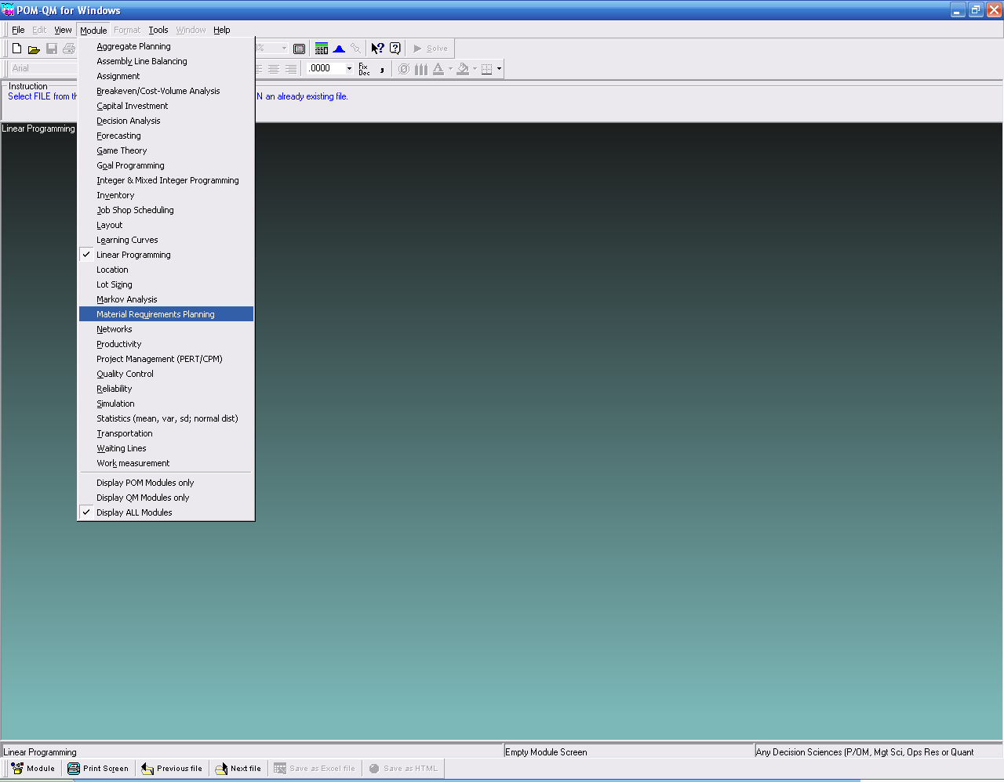

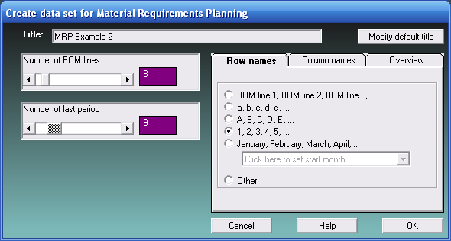

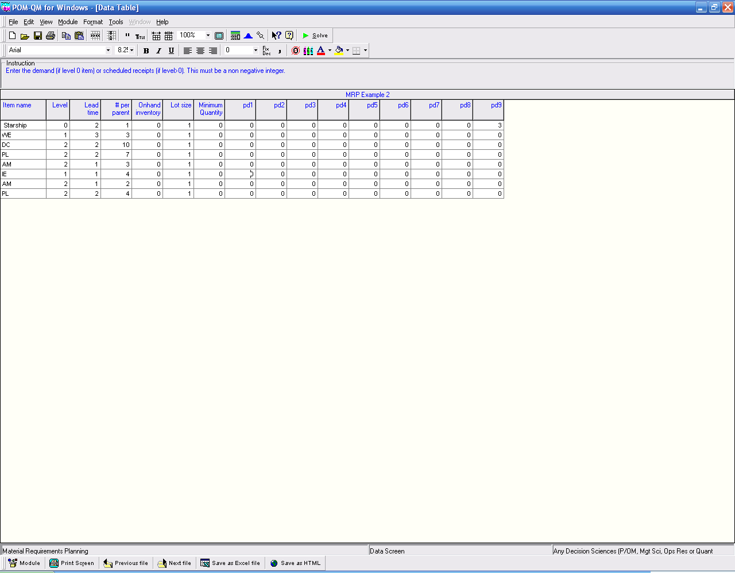

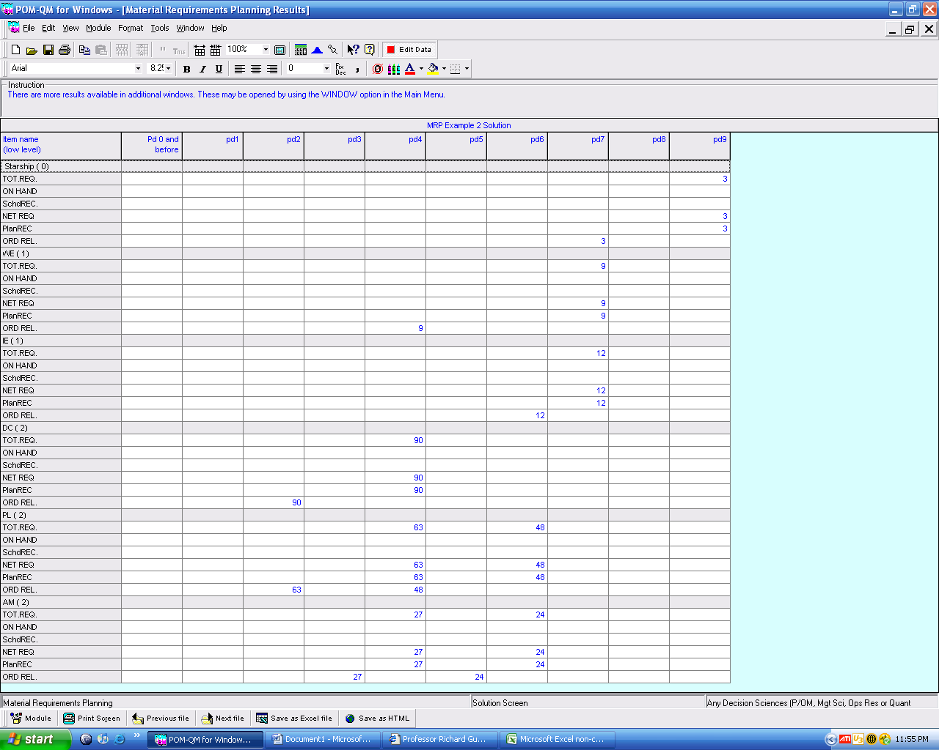

MRP Example 3

MRP Example 3: Indented Bill of Materials

Item Level Lead Time # Per Parent On Hand Lot Size

A 0 3 1 10 1
D 1 3 3 200 500
B 1 2 2 0 400
C 2 1 2 0 1
E 2 1 3 0 1
E 1 1 4 0 1
R 0 3 1 20 1
B 1 2 4 0 400
C 2 1 2 0 1
E 2 1 3 0 1
C* 0 1 1 0 1

* C as spare part.

