TYPE THESIS TITLE HERE
Your Name

SEMESTER, 200X

Geography 490
YOUR INSTRUCTORS NAME
Department of Geography
California State University, Northridge

Acknowledgments

The author wishes to thank….in the acknowledgements page, most students type a sentence or so thanking instructors, fellow students, parents, or others that have helped them craft their senior thesis, collect and analyze data, proofread, or even pay for college. This is up to you. It is not necessary to have an acknowledgements page

The numbering for pages in this “front matter” section, before the table of contents is generally numbered with small Roman numerals, but the first page (title page) will show no number.
.

Table of Contents

Acknowledgments ii
Table of Contents 1
List of Figures 3
Abstract 4
Introduction 5
Literature Review 7
Data 8
Subheading: Heading Two 8
Methods 9
References 13
Appendix 14

The table of contents can be updated automatically by right clicking on the table itself and choosing from the options: Update Field. You may only wish to update page numbers, or you may update the entire table if you’ve added new section headings.
To place new items in this Table of Contents, you must add a new Heading. You might first insert a page break (click on insert and then select break). Then type a word or phrase you’d like to use to label your new chapter/section, such as “Literature Review”. Press return. Highlight the line containing the word you just typed. Then either select from the drop down menu of styles (upper left corner of your screen…see figures below) and select Heading 1, or press Alt, Shift and the left arrow simultaneously.

List of Figures
Figure 1-Map of Six Flags Amusement Park. Source: http://gadv.com/ 9
Figure 2: Pie Chart of Expenses. Source: xx 10
Figure 3: Inserting Captions from the Insert drop down men. 11
Figure 4: Dialog Box for Caption Tool 11

The list of figures is much like the Table of Contents in terms of how it functions. However, the table only searches for text that is in the “caption” style. You can update it just like a table of contents, by right clicking on the table itself.

Abstract
Insert your abstract here. The abstract should be written last and must capture the entire argument in a few words.. It shouldn’t be flashy, but it can have a catchy, short sentence to start it off. It must be as succinct and informative as you can make it. Include a brief explanation of your research question, data and methods, and findings.

These can be hard to write if you do not have a disciplined composition style.

Introduction
Begin typing your introductory paragraphs here. Remember that this very well may be the last section of your paper that you write. It may be a good idea to have a working introduction as you begin your paper, but a re-write of your introduction is a very important component of the process.
Remember that the introduction should contain a few introductory remarks that should get the readers attention. You may then move on to making very obvious what your research question is and the resultant thesis statement or hypothesis. Your research question tends to be broader than your hypothesis. If you are writing an essay style research paper, then you may simply have a thesis statement.
This body text is in 12 point, Times New Roman font. The paragraph is double spaced. Each new paragraph begins with an indentation of 1-tab or 5 spaces. The paragraphs are left justified and have a “ragged” right hand border. Quotes over three text lines long should be single spaced, block formatted and indented by ½ inch on both right and left. An example of block quoting is in the paragraph below:
Although many wizards have claimed otherwise, there is a way to preserve life long beyond the normal 82 years most wizards live to be. One of the most unique ways was found by alchemist Nicholas Flamel some 400 years ago. According to Flamel (1642, 978): ← note the Chicago Style reference….more on that below.
The best way to live well beyond your years and to endanger young wizards such as Harry Potter, is to create a stone that can be used by bad guys like “you know who” to seek out, so they can go on a maddeningly unending killing spree, all the while seeking out multiple ways to keep from really dying so this book and movie series will go on for an eternity.
Once you’ve done your block quote, you may continue on with the rest of your essay or research paper.

Literature Review
You don’t have to call your literature review “Literature Review”. Some call it “Background” or somehow blend it in with the introduction. It’s generally a good idea for you to call leave it this way in the 490 course, simply because it aids your instructor and the assessment team with finding and evaluating your lit review.
Remember that the literature review accomplishes at least three tasks:
- It demonstrates that the author (you) have a working knowledge of prior, important research on your subject.
- It places your research in the context of what has already been written by others on the subject.
- It makes the case for your research by showing what has NOT been written on the subject….and that’s why the world needs your research.

All of your reviewed literature may not be about the same topic. You may have a section on your topic by non-geographers, a section reviewing the literature dealing with another topic that nevertheless informs your research. You may even devote a few paragraphs to the methods found in other research that helped inspire your choice of methods.

Data
You may want a section detailing why and how you obtained the data that you were using. You may want to point out the source, potential problems with your data, how you went about getting it….etc. You may also want to make quick reference to any additional studies – references that helped you figure out your data gathering process. Secondary data sources should always be cited.

Subheading: Heading Two
You may want to have an occasional subheading if your section or chapter is particularly long and you believe that it needs to be broken into sections. Don’t go over board with this however.

Methods
Sometimes data and methods are combined. Sometimes they are separate. In the more traditional, historical geography, or humanities based papers, the methods section may be missing altogether …as might be the data section.
I’ve put this section into also show you how to place a figure in a document. Most of the 490 papers will have figures of some sort, perhaps tables or charts or perhaps maps or photographs. Inserting them and labeling them correctly is important. Below is a map from the internet that I have labeled figure 1.
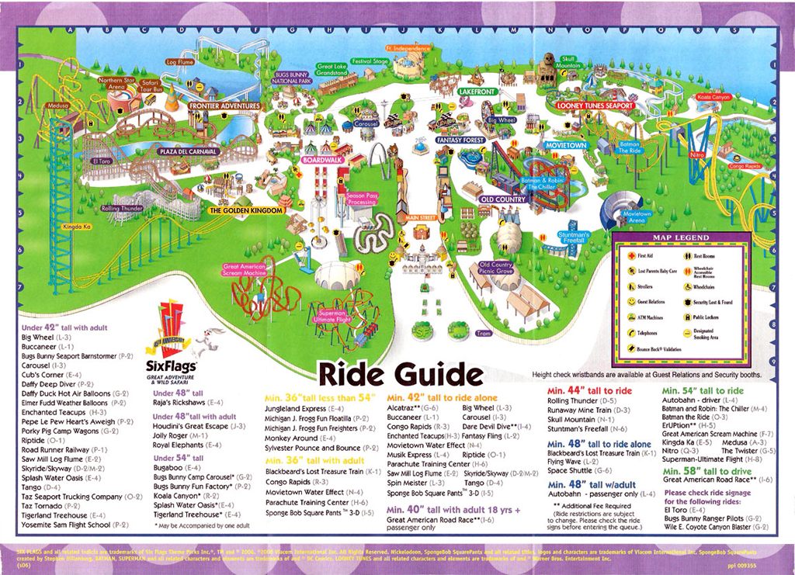
Figure 1-Map of Six Flags Amusement Park. Source: http://gadv.com/

In the section below I’ll put a table and then a chart. Each of the captions are placed immediately underneath the table or chart and they are numbered sequentially. Exceptionally large tables, maps, graphics or anything else that substantially interrupts the flow of the text document might be better placed at the end of the paper in an appendix. There is an appendix in this template document at the end.
Below is a chart that illustrates how another figure might look in this document.
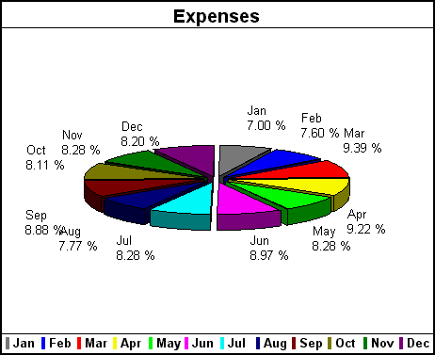
Figure 2: Pie Chart of Expenses. Source: xx
On the page below there is a table labeled Figure 3. If you would like to add your own, copy and paste it from Excel or your graphics software into this document. You can copy and paste right over the existing figures, but you’ll need to update the caption. IMPORTANT:
To insert a caption, simply place your cursor below your graphic/map/etc. and click on Insert from the top tool bar and select from the drop down menu, Reference. From the list that next appears select Caption. See figure 3 below. A dialog box will appear upon clicking Caption.
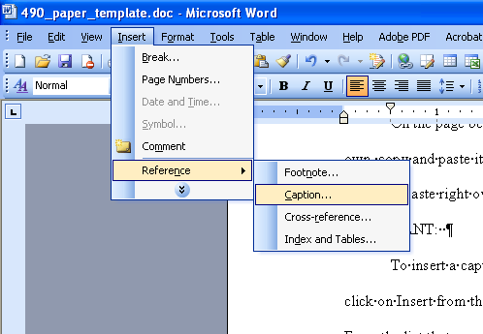
Figure 3: Inserting Captions from the Insert drop down men.
The dialog box that appears (see Figure 4 below) should automatically number the caption for you. You simply have to place your cursor after the number (below it’s 4) and type what you want in the response box. YOU CAN ALSO simply right click on the figure itself and select from the options “Caption”. Figure 4 will appear.

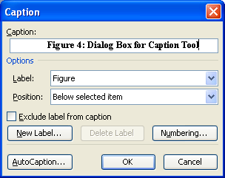
Figure 4: Dialog Box for Caption Tool
Make sure you go back to your list of figure table (above on page 3) and update it by right clicking on the table itself.

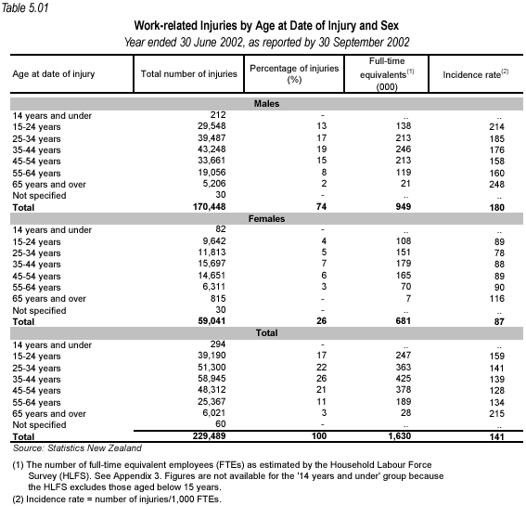
Figure 5: Random Table

Return to normal paragraph style.

References
In this section you should place your references…or your bibliography. Nothing should appear in here that does not appear in the text of your research paper, and vice verse. This includes source materials used for maps, tables, graphics, etc. References should appear as they do below for most geography courses. You may ask your instructor if they prefer another style, but the one below is the Chicago Style, that is used most often by leading publications in American Geography. You should consult the AAG style sheet and it can answer most questions regarding citations: http://www.csun.edu/~sg4002/courses/300/AAG_style_sheet.pdf
The Chicago Manual of Style is also available on line should you have additional questions: http://www.chicagomanualofstyle.org/home.html
The references below have been lifted from the AAG style sheet. Please note that that they are alphabetized, single spaced, with a hanging indent and an extra space between references. The first is from a book and the second two are from journals and the last is a web reference.
______________________________________________
Adams, J. 1776. The Wealth of Nations. London: Sage Press.

Smythe-Jones, X. 1998. Copyediting: The authoritative tome. Cambridge, MA: Small Room Press.

Smythe-Jones, X., L. Emmetson, and Q. Garraty. 1995. The art of copyediting:Nitpicking never ends. American Journal of Copyediting 27:167–89.

United States House of Representatives. http://www.house.gov/science/asrar_021199.htm (last accessed 26 February 2001).

Appendix
If you should have a great deal of data, tables or maps that are useful for reference, but not necessary in the body of the paper, you should place it in an appendix.

