* This file is under construction. It is being converted from a scanned document into a more useful format. Paragraphs in BLACK have been converted and proofread at least once. Paragraphs in RED have not been converted and proofread..

Fifteen Events That Have Shaped California’s Human Landscape

Lary M. Dilsaver
University of South Alabama
William Wyckoff
Montana State University
William L. Preston
California State Polytechnic University, San Luis Obispo

Contents
Fifteen Events That Have Shaped California’s Human Landscape 1
Introduction 3
Settlement by the First Peoples, 15,000 Years Ago 4
Cabrillo’s Landfall at San Diego, September 28, 1542 5
The Discovery of Gold at Sutter’s Mill, January 24, 1848 8
Initiation of the U.S. Public: Land Survey, July 17, 1851 10
San Francisco Takes Water from Lobos Creek, September 17, 1888 13
Creation of Suburbs, 1864 14
Yosemite State (and National) Park, June 10, 1864 17
The Coming of the Transcontinental Railroad, May 10, 1869 19
Electrification of Market Street, April 9, 1874 21
Passage of the Wright Irrigation District Act, March 7, 1887 23
San Gabriel Timberland Reserve, December 20, 1892 26
Sale of First Ford Model T, 1908 29
Wartime Buildup Begins, June, 1938 30
National Environmental Policy Act, January 1, 1970 32
Production of the Intel 8080 Microproecssor, December, 1973 35
Conclusion 37

Introduction
The year 2000 has many meanings for the people of California. Aside from the celebration and cerebration occasioned by the end of the century and the millennium, it is the sesquicentennial; of the state. It is fitting then that among the numerous chronological analyses and rosters of greatness accompanying the passage of the twentieth century, we reflect on California and what kind of place it has become. Although many scholars, pundits, and personalities have included California in their local and regional reviews, there has been little attention to the historical geography of the state’s human legacy. With this article we hope to begin the remediation of that deficiency.
We have chosen to present the fifteen events that have most affected the human landscape of California. The geographic concept “landscape” means the visual “look of the land” as used by the German geographer Otto Schluter and defined for American geographers by Carl Sauer (1925) in his seminal article “The Morphology of the Landscape.” Indeed, Sauer began a tradition of cultural landscape study that shaped much of twentieth century cultural geography in the United States. Lowenthal and Prince (1964) provided the best expression of the approach used in this article with their definition of the landscape as a palimpsest in “The English Landscape.” Humans have inhabited California for at least 150 centuries, possibly more. Each generation has altered the landscape. However, all but the first began from a base of earlier human modification. Some changes came close to sweeping away earlier patterns. Not one completely erased those patterns. The cumulative effect of their activities has altered and humanized the appearance and the substance of the state’s diverse natural environments. These changes can be detected at any scale, from the pedestrian’s viewscape to the California filmed from the space shuttle.
The human impact on the landscape is apparent in both what is present in a scene and what is absent. Cities, roads, farm fields, and channeled streams are deliberate impositions. The legacy of human error and improvidence is also evident. Vegetation change stems from accidental introduction of exotics or indirectly from alteration of the fauna as well as from burning and clearing. Even the persistence of a vegetation community often reflects deliberate decision to preserve selected resources.
Geographers do not often use specific events to explain the landscape and the human agency acting upon it. However, it can be a useful heuristic device. In the centuries of continuous human activity in California, certain processes have had the greatest cumulative impact. We choose to identify the fifteen punctuations of the state’s timeline that began the most influential processes. Where a process such as the use of automobiles began elsewhere, we have generally chosen its arrival in California as our event. These processes, in turn, spawned related but independent processes and exerted both direct and indirect impacts. Thus, the arrival of the automobile directly set off the processes of large-scale road building, oil drilling expansion of tourism, and the remaking of urban places. Indirectly, pollution from cars has impacted natural scenes by harming vegetation from the coastline to the Sierra Nevada and beyond.
One of the difficulties in choosing fifteen events was deciding which stand apart from the ongoing intertwined processes of human occupation. One could argue that the arrival of humans was the main event and the rest followed as a matter of course. In each event we try to show a compelling break from the trend of human activity and elucidate its direct and derivative processes. Thus, the establishment of wilderness areas in the state does not stand apart. It results from the creation of national forests and the policies of land management that evolved to protect and use them. Alternatively, some forms of irrigation preceded the Spanish, but the Wright Irrigation District Act enabled projects on a scale so pervasive that it serves as separate event and process.
Why fifteen events? There is a precedent for the number. Historian Rockwell D. Hunt (1958), in four consecutive numbers of the Southern California Quarterly, published “The Fifteen Decisive Events of California History.” He explained thathe based the number on Sir Edward Creasy’s The Fifteen Decisive Battles of the World from Marathon to Waterloo (1851). We concur with Hunt’s statement that:
Certainly there is no magic in the number fifteen-it is simply a convenient number that has because suggested by Creasy; large enough to afford a respectable variety of phases in human events...sufficiently small to avoid the pitfalls of particularism (4).
We hope to satisfy two ends with this essay. First, we reiterate that this not a definitive statement. Instead we hope this is the beginning of a scholarly debate. Most likely, everyone who reads this will disagree with at least one or two of our choices. We encourage all to challenge our analysis and, in so doing further historical geographic inquiry about the Golden State. Second, this article may serve as a ready paradigm for teaching geography at the K through 12 grade levels. The type of diagnostic landscape analysis we employ is eminently useful for getting students to reflect on the reality of geographic themes in the scenes that they view. Each student can choose an area and evaluate how important these events or any others have been in shaping the landscape.
We believe the following fifteen events began processes that have had the greatest impact over the widest area on the visual appearance of California’s landscape. The first two are the arrivals of the first people thousands of years ago and the Spanish nearly five centuries ago. The pervasive influence of the American cultural legacy can be divided into four categories. The imposition of settlement form includes the initiation of the rectangular land survey and the earliest suburbs. Economic development came with the discovery of gold, the diversion of water to cities, the establishment of irrigation districts, and World War II. Looming large throughout the landscape are technological innovations including the railroad, heralded by the arrival of the transcontinental line, electrification, the appearance of mass produced automobiles, and the invention of the Intel 8080 microprocessor leading to the personal computer revolution. Finally, the feverish expansion of development has been blunted or shaped by three signal events in conservation. These are the establishment of Yosemite, grandfather to all national and state parks in California, the creation of forest reserves, today’s national forests, and the passage of the National Environmental Policy Act. We have chosen them based on their impacts throughout the continuum of scale. Some effects are most apparent to the individual on the ground. Others impact the tapestry that is the entire state, accounting for both the range and spatial distribution of human phenomena. We present them in chronological order beginning with the most fundamental event of them all.

Settlement by the First Peoples, 15,000 Years Ago
Landscapes in California have been dramatically altered and shaped by humans for at least fifteen millennia. Indeed, approximately 15,000 years ago people settled permanently in California and began humanizing processes that are revealed in the state’s contemporary settings. The aboriginal legacy is observed most readily in the wild lands of California but is expressed as well among settled landscapes.
California was sporadically visited during the initial migrations that introduced Old World humans to the Western Hemisphere. This period coincided with the last glacial, or Late Wisconsin, stage of the Pleistocene epoch. By 15,000 years ago, descendants of these first migrants accompanied by more recent arrivals from the Old World, came to stay and make California their permanent home. They trave1ed to the area of the future state by both land and sea and adapted to environments governed exclusively by natural processes (Erlandson et al. 1996).
At the same time, California was experiencing rapid climate-induced changes as the glacial period subsided and the transition to modern or Holocene conditions progressed. Despite these environmental fluctuations, the first permanent settlers skillfully and successfully adapted previous lifeways to a variety of habitats within California. Immigrants who arrived by sea initially subsisted on plants, small terrestrial animals, and marine life that thrived along California’s coast (Jones 2000). Those who entered California by land were accustomed to big game hunting as a means of survival. They discovered a fertile setting for their traditional economic pursuits owing to the state’s diverse assemblage of late Ice Age megafauna. Due to the hunters’ skill as well as the animals’ inexperience with human predators, approximately 75 percent of the larger (100 pounds or more at maturity) genera of game animals were liquidated within a few thousand years (Martin 1984, 258). As a consequence, subsequent human residents inherited a relatively impoverished zoogeographical landscape where such animals as mammoths, saber toothed cats, and ground sloths were no longer part of the biota. One can only conjecture what portion of the megafauna would have survived to the historic period had these hunters not come when they did. However, the composition of the contemporary fauna and the structure of associated habitats would be markedly different (Owen-Smith 1987).
Owing in part to the substantial reduction of the state’s large game, Native Californians redirected their predation to the remaining fauna and intensified their utilization of the state’s impressive array of plants. Although few large species were driven to extinction after 6000 years ago, favored marine and terrestrial animals were locally decreased by hunting to the point that they became insignificant in aboriginal diets and resource areas (Broughton 1994, 372; Douros 1993, 557-58). These animals include various pinnipeds, otters, bears, beavers, and ungulates such as elk, antelope, and deer.
Ancient animal depletions and extinctions continue to influence contemporary landscape expressions in myriad ways. The structure and species content of ecosystems are determined from the bottom up by flora that is largely an expression of climate and also from the top down through the actions of animals. A change in any one of these factors results in alterations that cascade through much of, if not the entire, ecosystem (Huntly 1995). The relationship between otters and kelp beds provides an example. California’s kelp bed habitats are dependent on solar energy as well as upon otters that prey on sea urchins that, in turn destroy kelp. The removal or reduction of sea Otters by humans will unleash alterations that ripple through the kelp habitat (Estes et al. l978). Every terrestrial animal, to a greater or lesser extent, also exhibits analogous engineering roles in their respective ecosystems. The elimination of at least 75 percent of the megafauna and the subsequent reductions in the spatial and numerical presence of surviving wildlife by California’s first peoples yielded environmental changes that are interwoven into the character of the state’s contemporary aquatic and terrestrial landscapes (Lawton and Jones 1995, 141).
Pre-Columbian people also contributed to the con temporary presence of certain animals by transporting species to alien habitats. The introduction of foxes to the Channel Islands by Native Californians is one example (Schoenherr 1992, 708-09). The intentional modification of vegetation communities by fire and other means further altered animal demographics and distributions by increasing or decreasing the carrying capacity of some habitats. For example, the expansion of grassy prairies in the redwood forests of northwestern California increased the carrying capacity for preferred animals like deer (Dasmann 1994, 19; Lewis and Ferguson 1999, 167-68). These modifications then rebounded onto the vegetation communities due to the resulting increases or decreases of these animals’ engineering influence.
Due primarily to population pressure and the depletion of large game, Native Californians compensated by using a host of techniques to increase their vegetative resources. These included the applications of fire, pruning, coppicing, weeding, transplanting, and broadcasting (Blackburn and Anderson 1993). Where the first Californians used these practices on a sustained basis, they markedly restructured landscapes and altered their species content.
Sustained burning reduced understory in both coastal and inland woodlands. In frequently burned oak groves, a spacing of single oaks developed that later colonial people described as “oak park woodlands” (Anderson and Morratto 1996, 200; Rossi 1979, 84-90). Furthermore, the distribution of chaparral associations on coastal and interior hill slopes still reflects the ancient effects of anthropomorphic fire (Schoenherr 1992, 28-362). At higher elevations in the Sierra Nevada and Cascade ranges, intentional aboriginal burning complemented lightning fires in allowing the expansion of fire-dependent forest trees such as ponderosa pine and sequoias. Indeed, everywhere in the state’s lowlands where human-set fires were common, grasslands expanded at the expense of brush and woods (Bakker 1971, 168-69, 186).
In some locations, native peoples augmented fire with other horticultural techniques to improve the quality and abundance of floral resources. Plant species were both intentionally and unintentionally disseminated by broadcasting and transplanting as well as through processing and storage. For example, many of the oak trees observed around bedrock mortar sites result from acorns the Native Californians transported there (Anderson et al. 1997, 37-38; Bonnicksen et al. 2000, 453). These practices had consequences that extended beyond the organic world. For instance, intense management by native peoples increased and made more reliable local water yields (Biswell1989, 156; Shipek 1993). Colonial processes curtailed and quickly terminated native people’s manipulation of vegetation. Nevertheless, over thousands of years Native Californians shaped the organic stage on which these subsequent, often extreme, developments occurred. Their ancestral practices thus remain integrated in various degrees within the fabric of many contemporary wild lands (Anderson and Moratto 1996, 194). Modern land managers in government reserves like Sequoia National Park have adopted one of these ancient practices, prescribed burning (Biswell 1989).
The heritage of Native Californians is also manifest in a variety of settled landscapes. Historically, the altered aboriginal territories first observed by European and North American explorers helped formulate impressions of the settlement and economic opportunities in the region. These initial interpretations had bearing on the eventual geography and economy of coastal settlement by the Spanish. The siting of missions and the associated infrastructure of roads, ports, presidios, and pueblos are cases in point (Butzer 1990, 50; Hornbeck 1983, 4045). Albeit not as pervasive, a variety of prehistoric cultural settings endure in many locations and influence modern landscapes. For example, portions of many roads and highways follow ancient aboriginal pathways (Davis 1961).
Remnants of native settlements, resource processing areas, art work, and battle sites accentuate the rural environs of nearly every county, and at times provide destinations for tourists. These include Captain Jack’s (Kientpoos) stronghold in Lava Beds National Monument in Modoc County and Indian Grinding Rock State Park in Amador County. Furthermore, nearly every one of the state’s missions, presidios, and military forts boasts Native Californian interpretive components (Eargle 1993 155-79). Roadside businesses, signs, and interpretive centers are just few of the landscape features generated to entice visitors to these locations.
The contemporary descendants of California’s first people also have a measurable and growing impact on the state’s landscape. More than a quarter of a million Native Americans populate the state in the year 2000 and their numbers continue to grow. Many of these people live on over one-half million acres of tribal lands that are distributed in more than 100 locations (Peters et al. 1999, 180-83). Beginning in the 1980s, gaming casinos began to proliferate on tribal lands and number more than forty at present. They lure thousands of visitors and generate unparalleled wealth for various Native California groups. A portion of the earned revenue has been invested in infrastructure additions and improvements on tribal lands. In addition, native peoples hold an impressive number of festivals, dances, powwows, and other events on and off tribal lands that are open to the public (Eargle 1993, 180-83). All of these attractions have spawned an increasing presence of lodging, advertising, and other business opportunities in their vicinities. These most modern additions combine with the millennia of alterations that have permanently affected California’s human landscape to belie the familiar axiom that colonial peoples erased the Native Californian legacy from the earth.

Cabrillo’s Landfall at San Diego, September 28, 1542
Not long after the legions of Cortez laid siege to the Valley of Mexico in 1519, Old World peoples and organisms began to probe California’s frontiers. The earliest substantial visitation was the voyage of Juan Rodriguez Cabrillo in 1542-1543. Cabrillo’s exploration along California’s coast initiated landscape-altering processes that equaled if not surpassed those of the first people at the end of the Pleistocene epoch.
Cabrillo and his crews did not establish permanent settlements. However, his and other foreign explorations unwittingly introduced Old World germs and weeds to California during the period prior to the founding of the first mission 1769 (Erlandson and Bartoy 1995; 1996; Preston 1996; 2001). These organisms persisted, became naturalized, and radically changed the nature of land and life over much of the state. Afterwards, colonial settlers augmented these unintentional processes with conscious introductions of alien attitudes, settlement frameworks, a wide variety of domesticated plants and animals.
Californians and their environmental relationships were especially vulnerable to the exotic contagion that accompanied pre-mission explorations and colonial settlement (Preston 1996, 20-22). Diseases such as smallpox, measles, malaria, and virulent forms of syphilis progressively reduced native populations and destroyed traditional land use practices. As a consequence of reduced human predation, maritime and terrestrial game exploded in numbers and expanded spatially within native resource areas. Furthermore, native horticultural and associated practices such as burning, transplanting, and plant processing were disrupted and eventually terminated. These alterations resulted in more brushy understories in forests, changes in the distributions of some fire dependent plants, and extensive soil erosion caused by greater numbers of ungulates (McCarthy 1993, 223; McCullough 1997, 69; Preston 1997, 269-70, 277-81). In every environment where Native Californians were diminished or eliminated as top predator and keystone species, organic, hydrologic, and geologic aspects of the supporting ecosystem were altered (Garrott et al. 1993, 946).
The periodic forays to the state by foreigners prior to missionization also conveyed Old World weeds like wild oats and other Mediterranean annuals that spread rapidly and extensively at the expense of native species (Mensing and Byrne 1999). The transformation of California’s floral landscapes continued unabated during the colonial period. Indeed, Cabrillo and his associates initiated a process of botanical replacement that is still in progress today. As a result, approximately eighty to ninety percent of California’s contemporary grass and shrub lands are now covered with exotic plants, and about 17 percent of all plant species growing wild in the state are of non-native origin (Blumler 1995, 310; Stein et al. 2000, 135). Elna Bakker (1971, 149) stated that, ‘this successful invasion is one of the most striking examples of its kind to be found anywhere.” Alterations of California’s other visual signatures abound, most notably the golden color of the grasses that lie beneath the state’s oak groves during dry seasons. Californians deem it a quintessential characteristic of the state’s natural heritage. However, prior to the arrival of Cabrillo, these same vistas displayed greener hues owing to the prominence of indigenous perennial grasses. Furthermore, the regeneration capacity and current distribution of many of the oaks in these settings are influenced by greater soil moisture losses and an increased presence of rodents afforded by exotic grasses (Griffin 1980; Danielsen 1990, 59). The widespread encroachment of Old World invasives such as tumble weeds also influences the diversity and distribution of a wide selection of plants and animals that occupy California’s roadsides and wildland habitats. Relative differences in seasonal coverage and soil holding capacities between exotic grasses and indigenous species also have caused changes in runoff and associated soil erosion that have modified the appearance of some watersheds.
In addition to these unintentional invasives, Spanish exploration led to the introduction of a variety of domesticated plants and animals that comprise much of the state’s contemporary agricultural landscape. Although Native Californians cultivated a small number of food plants, modern agriculture in the state began with the first permanent settlement at San Diego in 1769 (Bolton 1949, 165, 174). An impressive array of Old and New World crops such as grapes, maize, wheat olives, and citrus were cultivated around the missions, pueblos, and presidios (Fig. 1) (Bryant 1967, 282, 316; Hornbeck 1983, 52-53). Later, Mexicans and Americans took note of these successful Spanish plantings and disseminated the crops and practices more widely throughout the state. 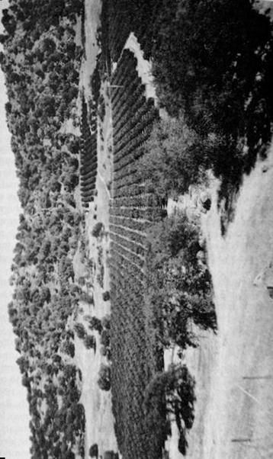
Figure 1. Mediterranean grasses sweep down to an orange grove on Highway 180 near the Sierra Nevada foothills. The influence of the Spanish extends well beyond the areas they actively settled and used. Photograph by W. Preston.
Colonial peoples also carried domesticated animals such as cattle, horses, sheep, and fowl to California. Livestock numbers quickly grew to enormous proportions in the mission realm and spread into the state’s interior (Hornbeck 1983, 54-55).The impacts of these animals on plants, animals, soils, and watersheds were additive to the changes wrought by the disruptions of wildlife (Burcham 1957, 186-88; Schoenherr 1992, 718). Periodic droughts exacerbated the devegetation and soil erosion caused by overstocked ranges (McCullough 1969, 15). Today, the residuals of these effects are still observed in much of the gullying found in the coastal ranges and on the margins of the Central Valley (Latta 1936).
The presence of colonial livestock influenced subsequent economic pursuits and their contemporary landscape expressions. Owing to the Spanish and Mexican preference for domesticated animals as well as their late colonial ubiquity, many early Americans viewed much of the state as suitable only for livestock ranching. As a result, the San Joaquin Valley was initially utilized as a great unregulated pasture (Preston 1981, 86-87). Many of the state’s lowlands have now been subsumed by other economic pursuits; however, the legacy of traditional livestock ranching remains visible in contemporary landscapes. One fifth of the state’s land is currently used for grazing livestock (Peters et al. 1998, 302) and their terraced trails show prominently on hillside lands. Barns, fences, and corrals are ubiquitous in many rural areas. California’s long history of ranching has altered a variety of physical environments that range from valley riparian areas to mountain meadows in the Sierra Nevada. The livestock industry accounts for the alfalfa and some of the feed such as yellow corn, that grace the state’s agricultural regions. Furthermore, livestock raising has directly contributed to the presence of thousands of small dams, ponds, and wells that appear on rangelands. Indeed, agriculture is the foremost consumer of fresh water in the state and the livestock industry demands the largest share of it (California Department of Water Resources 1998, 4-26).
The origin of many of the altitudes, practices, and institutions that have contributed to California’s evolving landscape can also be traced to the colonial of the Spanish. The Spanish as well as other foreign peoples arrived in the state with environmental attitudes that were considered different from those of the native inhabitants (Preston 1997, 264).
They viewed the state’s physical resources initially as inexhaustible and entirely divorced from their own spiritual existence. As a consequence, colonial people possessed few inhibitions about changing the physical environment for the purposes of settlement, economics, and sport. Both sustained commercial forestry and irrigation began in the colonial period (Clar 1959, 12-44; Hornbeck 1963, 51-53). Furthermore, some of the rules that governed the exploitation of natural resources survived to influence post-colonial landscapes. As David Hornbeck (1990, 51, 60) explains, the “principles of mining, irrigation, water, and property rights of women stem from the Spanish regime...and the large corporate farmers of California share in a common water-rights system that is a thinly disguised copy of Spanish water law. Indeed, the state’s ultimate adoption of “the doctrine of prior appropriation” as the legal framework for water use resembled the Spanish water law and allowed for the vast irrigated landscape currently observed (Hundley 1992, 72).
The initial Hispanic settlement infrastructure is also strongly reflected in California’s contemporary pattern of roads, settlements, tourist destinations, property boundaries, and architecture. A number of colonial transportation pathways provide routes for important highways and roads. The conformance of Highway 101 with long portions of El Camino Real is a noteworthy example. The pueblos, missions, and presidios served as nuclei for most of California’s largest urban areas. Today over seventy percent of the state’s population live in one of the twenty-eight sites originally founded by Spain (Hornbeck 1990, 61). Many of California’s twenty-one missions are important tourist destinations and they generate a host of landscape elements in the form of advertising and urban and roadside businesses. Furthermore, portions of the boundaries of many of the hundreds of ranchos that were granted during the colonial period have influenced the spatial patterns of countless urban and rural roads, fences, trees, power lines, and town boundaries in coastal regions such as the Santa Clara Valley (Broek 1932, 86, 94).
Most of the foregoing landscape expressions of California’s colonial past are restricted to the western portion of the state. However, the adoption of colonial themes in built environments is more spatially pervasive. The aesthetics of the Hispanic architectural legacy (e.g. mission revival, arroyo culture, and ranch-style houses) are significant and increasingly common attributes of domestic and commercial landscapes (Pitt 1970, 29l-96; Starr 1973, 390-414; Rice et al. 1996, 165). Housing tracts replete with red tile roofs and Hispanic decor for fast food outlets and banks are typical examples of the heritage, appeal, and timelessness of the state’s colonial legacy. (Figure 2) Also in many rural and urban areas are signature elements of a cultural scene created by todays Hispanic residents. Although most settled California after it became American, they represent continuity in Spanish heritage that lies heavily on the visible landscape.
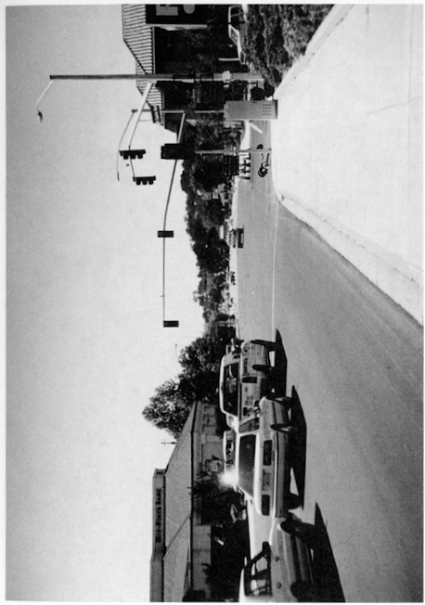
Figure 2. The use of El Camino Real as a modern highway and Spanish style roofing in late twentieth century architecture are two persistent landscape legacies of Spain shown here in Atascadero. Photograph by W. Preston.
Figure 2. The use of El Camino Real as a modern highway and Spanish style roofing in late twentieth century architecture are two persistent landscape legacies of Spain shown here in Atascadero. Photograph by W. Preston.

The Discovery of Gold at Sutter’s Mill, January 24, 1848
The story of the California Gold Rush with its compelling and romantic character is one of the most exhaustively researched topics in the West. Its inauspicious start, its ephemeral and unbalanced economic focus, and the mania that drew 250,000 people to the state in less than three years have become part folklore, part cultural genealogy (Gressley 1999; Holliday 1999; Paul 1947; Rohrbough 1997). Nobody denies its profound historical consequences not only for the region, but also for the nation and the world. Yet, two years ago, on the occasion of its sesquicentennial, several historians disputed its lasting effects on the modern state. Richard White (1998) posited that its immediate effects were superseded by later economic, demographic, and political processes. Others added that the transport, agriculture, and industry it brought would have come anyway to such a resource rich state (Bethel 1998). However, the discovery of gold ignited processes of economic development, settlement, environmental modification, and political adaptation that have spatial and visual resonance in California’s landscape of today.
The most recognizable landscape legacies of the mining era are the mines, towns, water systems, and transport links that litter the foothill and desert districts of the state. Mining directly established the settlement framework in those otherwise undesirable nineteenth century locations. In Amador, El Dorado, Nevada, and Placer counties, the major towns, including all four county seats, and the roads that link them, began as parts of the gold rush infrastructure (Dilsaver 1982, 400-103). The historic character of towns like Auburn, Nevada City, Sutter Creek, and Sonora has made the Sierra foot hills the fastest growing part of the state (Figure 3). Even abandoned towns, like Bodie and Columbia, entertain thousands of tourists and sustain a nostalgic idyll that draws the new rush of mobile workers and retirees. Mining towns are among the most recognized of historic landscapes in the country. They display a convoluted morphology and historical authenticity that stem from their adaptation to geomorphology and their unsuitability to functions other than tourism and telecommerce.
The abandoned infrastructure of mining is also present in these zones. The ruins of conveyors, mills, sluices, and equipment, and tell-tale piles of debris spotlight thousands of former mines. Due to their structural instability and the frequent presence of dangerous chemicals, state and federal agencies seek to identify and rehabilitate these sites. The Bureau of Land Management (1996) estimates that its lands alone (13.8% of the state) contain 11,500 “Abandoned Mine Land” sites. Miners dug or constructed more than 7000 miles of ditches and flumes, among the earliest in the state. In many cases these also lay in ruins. However, these early water engineers also included sources and water transport routes in the mountains that have been adapted for modern use by towns and agriculture (Rohe 1983). Their accession to high mountain water sources and elaborate distribution systems helped pave the way for California’s adoption of appropriation and massive agricultural irrigation a few decades later.
Mining also helped plot the settlement pattern and urban character of California. Gold mining established the relative importance of Sacramento, San Francisco, and Stockton. Sacramento became the state capital based on its role as a mining supply center. San Francisco dominated banking and mining finance. The presence of mining wealth drew entrepreneurs who brought the state’s earliest industry to the Bay Area and shaped its characteristics of light to medium assembly and consumer products (St. Clair 1998).The crowded and vertical financial district of today’s San Francisco lies atop sunken gold rush ships. Limerick (1998) suggests that California’s urban focused population also stems from the entrepreneurship and manufacturing derived from the mining industry. Furthermore, the distinctive Asian landscapes within California’s largest cities ultimately owe their origins to Chinese gold-seekers.
The environmental effects of mining have been the topic of intense study and comment since the time of the gold rush. Grove Karl Gilbert (1917) calculated that the industry, especially through hydraulic mining, had deposited more than 1.6 billion cubic yards of sediment dwarfing the amount generated by natural processes and other human causes such as agriculture, grazing, and deforestation. The channel bottoms of some mountain streams rose several inches per year. In some cases river channels moved. Vast outwash deposits lay over the Sierra Nevada piedmont. Towns and agricultural fields flooded. The bed of San Pablo Bay rose more than three feet and 9000 acres of tidal mudflat were created around its edges. Mine sites like Malakoff Diggings at North Bloomfield became moonscapes as hydraulicking carved away these vast sediment loads (James 1994; Rohe 1983; USGS 2000).
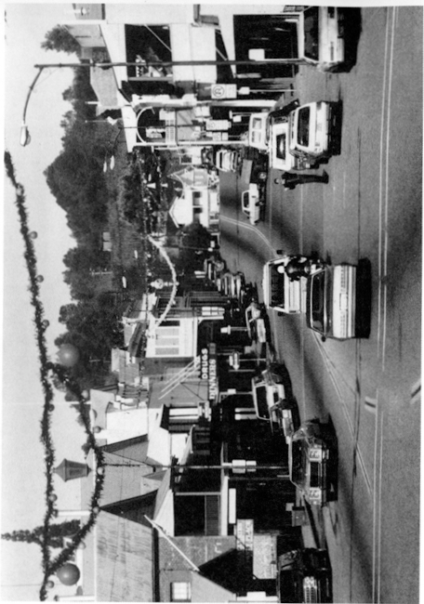
Figure 3: The historic landscape of the Mother Lode is well represented by the town of Sutter Creek. Photograph by L. Dilsaver.
Modern research has shown that erosion and revegetation have ameliorated much but not all of this amazing landscape disruption. Rohe (1983) suggests that six feet of debris along the Yuba River is probably permanent. James (1994) found terraces formed by mining debris where rivers recut their channels into the raised beds. He concurs that they are “permanent over centennial time scales.” All modern researchers agree that many millions of cubic yards of sediment still line Central Valley rivers (USGS 2000). Dredging overturned much of that sediment and left it in parallel rows of man-made eskers. Dredge spoils cover dozens of square miles along Sacramento River tributaries. At hydraulic mine sites, vegetation has reclaimed some cuts and tailings while others remain largely barren.
Mining introduced many other environmental impacts, some of which shaped the landscape in unexpected ways. Dasmann (1999) found that the mining era wiped out much of the large mammal population, especially bears. The latter are noteworthy because they function as ecosystem engineers in their natural habitats moving soil, uprooting trees and logs, dispersing seeds, and preying on other species (Lawton and Jones 1995). Mining, like no other function, impacted the fauna of mountainous areas where many minerals concentrated. At Grass Valley the collapse of shafts and slopes in the Empire Mine caused surface subsidence noticeable to anyone driving its streets. Most of the deforestation that raised the foothills tree line by up to 2000 feet and decimated the Tahoe area has been reversed. Yet the forest composition has been altered. In semiarid areas chaparral and digger pine often replaced ponderosa pine (Rohe 1983).
The gold rush also shaped the politics and culture of the state in ways that show in the landscape. The rush drastically accelerated Indian displacement or elimination. The widely scattered distribution and small size of reservations in California are byproducts of the geographically expansive search for wealth (White 1998). The international character of the rush brought large numbers of Chinese to California, resulting in enclaves of mixed Chinese and American appearance in most major cities.
The disorganized society of the early mining camps led to social attitudes and laws that have landscape expression. Batabayal (1998) suggests that they spawned an “economic liberalism” that decries government influence in use of public lands. Later Congress institutionalized this in the Mining Law of 1872 (30 USC 21-54 as amended). Among the effects of this sweeping law are more than 27,500 extant mining claims on federal land in California (BLM 1996). The California Division of Mines and Geology reported 917 active mining operations in the state during 1995 (Youngs 1996). Individuals hold most of the remaining claims. As early as 1944, the Forest Service reported that 21 percent of the claims on its lands were used for residential or commercial purposes (Friedhoff 1944). The agency now estimates that more than half the mining claims in the national forests are used for these purposes (Stone 2000). Thus, much of the infrastnrcture on California’s federal lands owes its existence and distribution to a system of egalitarian and economically liberal laws devised hurriedly amid the placer mines of the state.
One final impact of the gold rush’s legal legacy can affect the landscape in ways as startling as the hydraulic operations of twelve decades ago. Major corporations use the gratuitous Mining law of 1872 to open-pit mine for gold. Some companies confidently plan to pulverize entire hills and retrieve the gold by a chemical process known as heap leaching. A landscape left behind by this operation will have its physiography, soil profile, and biota dramatically altered. Furthermore, as scientists ponder the significance of the world’s most acidic water at Iron Mountain near Redding, both the landscape and the health consequences of mining’s chemical residue remain unknown.

Initiation of the U.S. Public: Land Survey, July 17, 1851
When California joined the United States in 1850, it became part of the nation’s public domain and subject to the federal laws governing cadastral surveys. Congress enacted the law of the land, now known as the United States Public Land Survey or Township and Range System, on May 20th 1785 (Thrower 1966, 4). Sixty-six years later, on July 17th 1851, a contract surveyor named Leander Ransom inaugurated the survey in California by establishing an initial point on Mount Diablo (White 1982, 115). This solitary act initiated a process that has shaped landscapes throughout the state.
The Public Land Survey is noteworthy for its geometric organization and grounding in coordinates of latitude and longitude. Two sets of lines govern the grid. A north-south line, or principal meridian, intercepts an east-west parallel, or base line, at the initial point. Running parallel to both the base line and principal meridian are lines that form a latticework of rectangles that are called townships. Each township incorporates thirty-six square miles and is, in turn, subdivided into square mile sections. Furthermore, each section is progressively quartered into smaller and smaller geometric units (Campbell 1993, 171). Three initial points, including the original monument at Mount Diablo, were utilized to map approximately eighty-two million acres, or about four-fifths of the state. The only portions of California not mapped in this fashion were the colonial ranchos, the Channel Islands, and certain mineral lands (Uzes 1977, 147-148, 157; White 1982, 117). The main intent of the survey was to exactly describe and identify land so that it could be readily transferred by the United States, by the State of California, and by private individuals.
The Congress of the United States enacted a number of land alienation policies - the body of laws that govern land transfers - that assisted in the distribution of the public domain to state and private concerns. Many of these measures, such as the Homestead Act of 1862, allocated parcels of land concomitant with the quarter sections of the Township and Range System. Furthermore, the Land Ordinance of 1785 also contained provisions for the transfer of larger units such as the full sections granted in considerable numbers to the Southern Pacific Railroad. However, in an effort to inhibit the monopolizing of land in large contiguous units, only alternate sections were initially available for ownership by any individual concern (Johnson 1976, 143). These alienation policies and their cadastral context are visibly distinguishable on the landscape today.
In the San Joaquin Valley, for example, the moister eastern regions were settled relatively early during the 1850s and 1860s as the public domain was transferred to homesteaders through a variety of alienation acts (Eigenheer 1976, 275-284). Although these initial land ownerships were relatively small, the cadastral framework assured that farmsteads were spatially scattered and isolated from those of neighboring landholders (Jordan-Bychkov 1999, 79). On the other hand, where alternate railroad sections were present in the Central Valley, these lands were initially unavailable or avoided by early immigrants. Later, in the 1870s and 1880s when the rail road owners began selling off the sections that had been previously granted to them, landholders from adjoining sections or newcomers to the region began purchasing the available land in larger units. This explains why in some rural areas of California east of the coast range there are fewer farmsteads and associated settlement forms visible in sections once owned by the railroad (Preston 1981, 109).
Visual contrasts between alternate sections of townships are apparent in a number of other locations in California. A case in point is the pattern of planned housing developments in the Mojave Desert. Contrasting landscapes between alternate sections are distinctly revealed in the vicinity of California City where subdivided sections containing roads and houses are interspersed among sections of desert. Similarly, oil drilling and pumping in western Fresno and Kings counties began on alternate sections during the first decades of the twentieth century. Since then, oil development has spread in some areas to adjoining sections, but the checkerboard contrasts between the landscapes of oil and ranch or farm land still exist (Jennings 1953).
The Public Land Survey has contributed both directly and indirectly to the contrasting landscapes between certain regions of the Great Central Valley. In contrast to the east side, a much greater portion of the land on the west side of the valley was monopolized during the 1860s and 1870s. Owing to the inaccurate environmental assessments of the original surveyors, the availability of land, and the fraudulent use of alienation policies such as the Swamp and Overflowed Lands Acts and Military Scrip, the public domain on the west side was acquired by relative few claimants (Eigenheer 1976, 312-320). Land speculation was often the motive for these endeavors, and resulted in the removal of huge portions of the public domain. Most notorious among the monopolists was Henry Miller whose acquisitions included a one hundred mile stretch of land along the San Joaquin River (Robinson 1979, 192-193). The contemporary legacy of his and other land monopolies during the nineteenth century is readily visible in the extensive corporate landscapes that contain larger fields and fewer homesteads than the rural landscapes on the eastern side of the valley (Preston 1981, 111-112). An indirect consequence of this division is that settlements on the west side of the valley such as Mendota and Corcoran tend to be more impoverished than those in the east as fewer landowners contribute less to the local economy. The corporate settings on the west side are largely responsible for these economic and settlement disparities and the visible landscapes of poverty bear testimony to the linkage between the Public Land Survey and community health (Goldschmidt 1978).
Perhaps the most striking contemporary legacy of the Public Land Survey is the visible geometry of rural California (figure 4). In the flatlands it imparted rectangularity to the landscape that is visually inescapable. Public jurisdictional boundaries (e.g., parks, forests, military bases, national monuments, wildlife reserves), property lines, homesteads, fences, roads, canals, field and orchard patterns, and even a few water bodies dearly demarcate the cardinal orientation and checkerboard fabric of the cadastral system. The settlement infrastructure conforms particularly well to sectional boundaries, its rectangularity intensified through subsequent farm fragmentation and consolidation. In more densely populated areas, section lines serve as the framework for continuing subdivision.
County roads in the Central Valley, for example, usually conform to sectional and township boundaries. Many straight north-south roads make an abrupt right angle jog where they encounter the survey correction lines that occur every twenty-four miles north and south of a base line (Greenhood 1971, 25). Even interregional roads such as Highway 99 and Interstate 5 in the northern San Joaquin Valley are congruent over extensive stretches with the adjoining sectional or township boundaries (Johnson 1976, 143; Johnson 1990, 137-141).
The impact of the Public Land Survey is equally impressive among urban landscapes where variations on the rectangular grid pattern sometimes occur. A number of settlements established by the railroad exhibit a rectangular street framework oriented to the tracks rather than to the cardinal directions inherent in the survey. However, once successful railroad towns expanded into the countryside, developers commonly broke from the original cadastral orientation established by the railroad and built in accordance with the Public Land Survey. The street patterns of Modesto and Fresno, like those in most railroad towns, display this phenomenon.
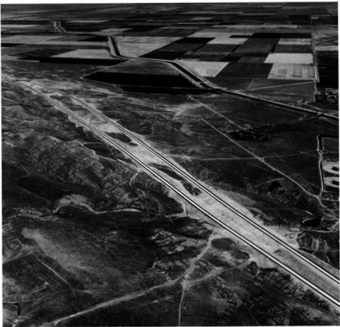
Figure 4. Figure 4. The familiar checkerboard pattern of the Township & Range land division system is especially pronounced in flat areas such as the San Joaquin Valley near Kettleman City. Photograph provided by the California Department of Transportation.
In towns and cities that have strictly adhered to the geometric dictates of the Township and Range System, its influence extends to all aspects of the human landscape. Even the smallest features such as town lots and the organizational geography of homes, yards.fences, and driveways in these communities are oriented to the straight lines of the survey system. Its impact is evident, as well around the expanding margins of California’s burgeoning cities. Cities grow at the.expense of open countryside and in the process adopt the configuration of pre-existing cadastral patterns. In this fashion, urban boundaries spread along the edges of sectional roads before filling in the development tracts (Jordan 1982, 54). Moreover, land incorporated for urban expansion is usually acquired in rectangular units of varying sizes that is, in turn, a legacy of the survey’s influence on ownership patterns. As a result, the distinction between new urban developments and the rural hinterland is often stark and delineated in conformance with the cardinal directions. The zones of suburban growth around downtown San Bernardino and Sacramento, for example, are distinct for their miles of rectangular blocks and uniform streets.
After dark, the rectangtangularity of urban lights is one of the most prominent and singularly striking patterns of California’s nightscape. This nocturnal panorama is especially impressive from an elevated perspective offered by highlands or aircraft. Indeed, the westward descent into Los Angeles International Airport at night provides unsurpassed visual testimony to the sinews of the Public Land Survey.

San Francisco Takes Water from Lobos Creek, September 17, 1888
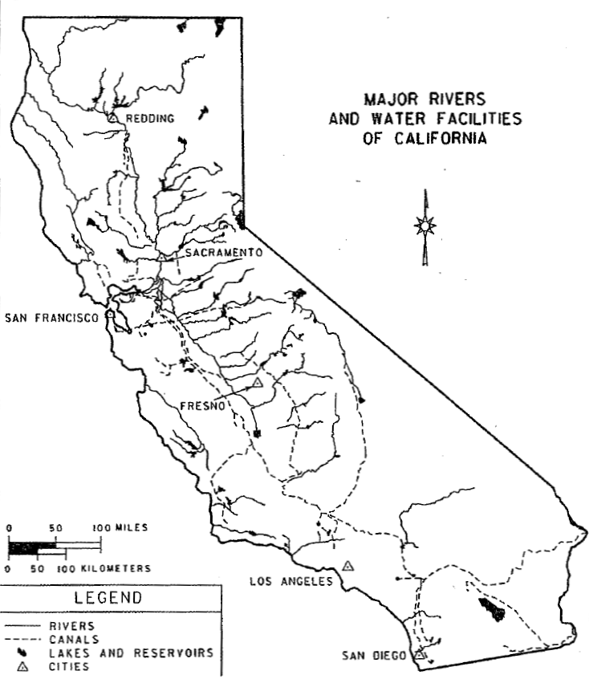 Figure 5: The major federal, state, and local water transfer structures in California. Source: California Department of Water Resources. Cartography by Margarita K. Pindak
During the early years of the gold rush, San Francisco grew so rapidly that by 1852 it had outgrown its own local supplies of fresh water. In that year the city approved a petition to tap a source of permanent water from another drainage system. After several delays and changes to the original plans, in 1858 water was transported by flume from Lobos Creek five miles to the mains of downtown San Francisco (Delgado 1982, 31-35). On completion of the project, San Francisco became the first major municipality in California to receive a pennanent water supply from another watershed. The tapping of Lobos Creek provided the precedent that inspired subsequent efforts to acquire more distant and widespread sources of fresh water by San Francisco and other urban areas throughout California (Figure 5). California’s exceptional urban growth may be traced to it and few events have initiated processes more importan to the shaping of the state’s contemporary landscapes.
The Lobos Creek diversion and subsequent projects allowed San Francisco to increase from a pre-gold rush population of 300 in 1846 to 80,000 by 1862. Additional water was again required, and the cit y expanded its infrastructure to impound and import more water. First from the peninsula to the south and then from the southern East Bay (Leonard 1978, 38-39, 42-43). By 1900, the city had reached a population of 340,000 and was now looking to the Sierra Nevada, and specifically the Tuolumne River, for additional sources (Hundley 1992, 120, 169-170). The lynch pin of the Tuolumne system would be the damming of Hetch Hetchy Valley in Yosemite National Park (Kahrl 1978, 29-31; Brechin 1999, 71-117). After considerable controversy, San Francisco was victorious and by the early 1930s was importing most of its municipal requirements from the Tuolumne watershed through the 148 mile long Hetch Hetchy Aqueduct. For years following the initiation of the project the system continued to be upgraded with a spectacular array of tunnels, dams, pipelines, inverted siphons, and powerhouses.
Imported water provided San Francisco with the ability to modify national parks, national forests, cities, and farmlands. Reservoirs such as Hetch Hetchy, Crystal Springs, Don Pedro, and Calaveras cover hundreds of square miles, and the intervening landscapes are laced with pipelines, powerhouses, and transmission lines. Many of these facilities and their rights-of-way boast a variety of recreational functions including camping, hiking, boating, and fishing (Benchmark Maps 1998, 14-17). These attractions, in turn, have generated an array of business and administrative landscapes along access routes and within gateway communities. San Francisco’s jurisdictional authority to dictate land use and management practices around the project’s facilities is extensive. The city has considerable land and water rights in a number of peninsula and southern East Bay counties and county, state, and federal fiats guarantee its influence over other lands. One result of this control is maintenance of open space by the city in some Bay Area suburbs (Brechin 1999, 88; Leonard 1978, 24-25).
Although Tuolumne water temporarily renewed San Francisco’s urban growth, further expansion was eventually curtailed more by political and physical constraints than by a lack of water. Nevertheless, the city’s influence is still felt in its ability to control water resources and as a precedent for other metropolitan environments. San Francisco currently possesses substantial water and power surpluses and it sells the excess to nurture continued urban expansion in more than fifty neighboring communities. Virtually all of San Mateo County’s residents, for example, depend upon water sold to them by San Francisco (Leonard 1978, 25; Selby 2000, 194). Additionally, the East Bay Municipal Utility District (EBMUD) mimicked San Francisco’s urban water system and imported Sierra water from the Mokelumne watershed. This water in turn continues to fuel urban expansion in the vicinities of Walnut Creek, Concord, and Danville and the growth has inspired EBMUD to consider other distant sources such as the Feather River (Littleworth and Garner 1995, 9-10).
The urban water system in Southern California conforms to the overall pattern of San Francisco’s diversion of the Tuolumne and the East Bay’s diversion of the Mokelumne River; however, the impact is of a greater magnitude. Control of the watershed of the Los Angeles River had sustained Los Angeles in its youth. However, by the end of the nineteenth century, Los Angeles had nearly exhausted its ability to extract more water (Gumprecht 1999, 41-81, 85-129). To sustain growth and prosperity, the city tapped the streams and ground water from the Owens and Mono Basins far to the north by constructing the Los Angeles Aqueduct. This storage and conveyance system is half again as long and delivers nearly six times as much water as San Francisco’s Hetch Hetchy project. The landscape impacts in the areas of extraction and consumption are far greater as well (Kahrl et al. 1978, 51).
The aqueduct allowed the population of Los Angeles to increase twelve fold and expand in area ten fold between 1900 and 1950 (Kahrl 1976, 115). Like their counterparts in Northern California, the storage and conveyance facilities have spawned bountiful recreational and commercial landscapes (Benmmark Maps 1998, 19, 25, 25). However, the consequences of urban water extraction have inflicted unparalleled changes on preaqueduct environments. Due to the Los Angeles diversion, Owens Lake is completely drained and Mono Lake severely depleted. The exposed lakebeds and shorelines are disconcertingly dramatic, and the sky over the southern Owens Valley is now turbid with dust. Moreover, the modification and elimination of riparian vegetation in the Owens Valley and along the former courses of Mono Basin’s diverted streams are notable byproducts of the aqueduct system (Gaines and DeDecker 1982; Reisner 1993, 101). The Los Angeles Department of Water and Power (DWP) exercises jurisdiction over 300,000 acres of land in Owens Valley and continues to curtail urban expansion around settlements such as Bishop and condone the deliberate removal of numerous rural farmsteads. Furthermore, the fields of irrigated crops that once carpeted the valley have been rendered into scrublands and pasture (Hart 1996).
Unbridled urban expansion in Los Angeles and other cities in southern California immediately prior to and following World War II created the need to import additional water from the north by the California Aqueduct and from the east by the Colorado River Aqueduct. Although the majority of the water is utilized for irrigation elsewhere, the Colorado River serves water to over fourteen million people inhabiting 500 cities spread over 5000 square miles (Selby 2000, 199). As a consequence of this fresh abundance of imported water, Los Angeles doubled its population again between 1940 and 1970 (Kahrl et al. 1978, 42). Furthermore, its neighboring cities stretching from Ventura to San Diego have expanded even faster, sustaining rapid growth into the twenty-first century.
Many settlements in California require varying amounts of fresh water from subterranean sources. However, interbasin water transfers have supported most of the state’s urban expansion and sustained a booming economy. Indeed, cities over large areas of the state have benefited from water projects that were constructed primarily for agricultural purposes such as the Central Valley Project. Since San Francisco’s fateful diversion of Lobos Creek in September 1858, California cities have contributed heavily to the construction of over 1300 dams and associated facilities currently scattered throughout the state (Selby 2000, 194, 203, 209). This reciprocal relationship between cities and water is a driving force behind the state’s continuing population explosion and the expansion of its urban landscapes.

Creation of Suburbs, 1864
Most of California’s 54 million people live in suburbs, and the resulting landscapes have fundamentally refashioned the visible scene. The state’s most extensive suburban landscapes ring Los Angeles, San Francisco, and San Diego where the vast majority (70-80 percent) of the urban population lives beyond the boundaries of the central city (Kenworthy and Laube 1999). Similar sprawling collections of dispersed housing, two-car garages, backyard patios, commercial strips, and shopping malls can also be found from El Centro to Redding. Much of today’s suburban landscape has been created since 1950, although the roots of California’s suburbs extend well back into the nineteenth century. The penchant for escaping central cities was already apparent in the vicinity of New York City as early as 1810 (Brooklyn Heights) Jackson 1985, 25-50). In California, the 1864 completion of a rail line from San Francisco to San Jose spawned the first generation of suburbs (Burns 1977, 1980). Bay Area elite were attracted to the pastoral lifestyles and low density housing of planned suburbs such as Burlingame and Atherton. It was the beginning of a landscape-shaping process that continues unabated almost 150 years later.
California’s suburbs have enduringly altered earlier landscapes. Where suburbs have sprouted in valley settings, they have often consumed huge tracts of agricultural land. Indeed, over 25 percent of the state’s best soils are now covered by urban or suburban land uses. For example, Los Angeles County lost over 45,000 acres of citrus land to suburban growth in the ten years following World War II (Nelson 1959, 80; Banham 1971, 161-77). As suburbs multiply, suburbanites bring in thousands of exotic trees, plant extensive lawns, displace native animals with their suburban pets, and forever alter the fundamental ecological setting (Price 1959; Streatfield 1977). Foothill environments, including many around the Bay Area as well as inland Southern California, have also been dramatically altered by suburban growth (Banham 1971, 95-109). Natural vegetation has been encroached upon, and drainage and topography have been reconfigured to suit the needs of the California hill-dweller. Frequently, such settings are also the scene for fire and flood damage, a reminder that the natural landscape is not infinitely malleable to meet human needs.
Why are suburbs where they are on the California landscape? Dozens of suburbs owe their origins to the geography of nineteenth-century interurban rail lines that radiated from major cities such as San Francisco and Los Angeles. Indeed, southern California boasted over 1100 miles of rail network and these links encouraged suburban growth in places such as the San Fernando Valley, Pomona, and Anaheim (Bottles 1987). Other suburbs popped up near industrial activity that sprouted beyond the boundaries of traditional cities (Hise 1997; Matthews 1999; Viehe 1981). For example, Brea and Fullerton appeared near oil fields, Burbank grew in response to the movie and aerospace businesses, and San Jose benefited greatly from high-technology industries in Silicon Valley. Real estate promoters have also shaped the growth of the suburban landscape. Southern California’s real estate boom of the late 1880s produced more than 60 new suburbs. While some vanished, communities such as Glendale, Monrovia, and Redondo Beach owe their origins to such activity (Nelson 1959; Streatfield 1977a). Throughout the state, however, the automobile and its associated road network have undoubtedly exercised the greatest influence on the location and spatial extent of California’s suburban landscape (Foster 1975; Meinig 1979). Between 1920 and 1950, the automobile’s flexibility encouraged the infilling of open space between older discrete, suburban communities on the edge of major cities. Since 1950, powered by spreading freeway construction, the automobile has enabled much more suburban growth often 40 to 60 miles or more from the central city (figure 6). Today, Tracy and Manteca have become Bay Area suburbs, while Temecula and Moreno Valley are within the ever-spreading reach of Los Angeles (Mcintire 1998, 44-49).
A surprising variety of settlement patterns and street layouts are associ­ ated with California’s suburban landscape (Palen 1995). The curving streets, abundant foliage, and large lots of the state’s elite suburbs form one enduring settlement model (Burns 1980; Jackson 1985, 178-81; Streatfield 1977b). Boasting social and spatial exclusivity as well as an abundance of environmental amenities, settings such as Hillsborough (near San Francisco), Montecito (Santa Barbara), and Beverly Hills (Los Angeles) illustrate the pattern. Indeed, Palos Verdes, a seaside elite suburb near Los Angeles was the carefully planned brainchild of landscape architect Frederick Law Olmsted. Another common suburban settlement pattern is the repetitive grid of cardinally oriented streets, rectangular lots, and mass-produced single-family housing. This distinctive settlement pattern expanded greatly after World War II as pent up demand for housing, a new scale of real estate and building promotion, and an accommodating federal government (FHA loans and the GI Bill spurred home construction. 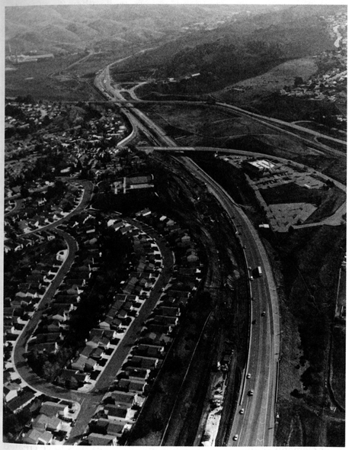
Figure 6. Figure 6. Suburban sprawl clinging to Interstate 680 in Contra Costa County.

The 1950s and 1960s witnessed large development projects in such localities as Lakewood Village south of Los Angeles and Daly City and Foster City near San Francisco (Banham 1971; Burns 1977; Price 1959). Many of California’s suburbs, however, have sprouted since 1970, and these developments have featured more eclectic settlement patterns. Some have been shaped by large-scale coordinated planning (Mission Viejo) of street layouts and land use, while others (San Bernardino and San Jose) offer a varied, spatially extensive collection of street plans and population densities, often depending on income levels, local topography, and the tastes of developers (Abbott 1993, 123-48; Kling, Olin, and Poster 1991) (Figure 7). Some feature the familiar grid, but many subdivisions also offer curvilinear layouts, cul de sacs, and a greater mix of single and multiple-family units.
Suburban architecture is similarly varied. Residential districts reflect different preferred building styles, depending on income and age of home construction (Abbott 1993, 123-48; Banham 1971; Meinig 1979; Rubin 1977). Bungalow-style housing, for example, signifies a neighborhood usually created between 1900 and 1925. Single-story ranch-style housing tracts multiplied in the 1950s and 1960s, covering many additional square miles of the California landscape. Elsewhere, higher density suburbs suggest that rising land costs and changing lifestyles of the past thirty years have created more demand for apartment, condominium, and townhouse living.
Added to this increasingly diverse accumulation of residential architecture are the varied commercial, retailing, and industrial landscapes that shape the suburban scene today (Banham 1971; Bottles 1987; Preston 1971; Longstreth 1997). Commercial strips and suburban shopping malls create a landscape that is mass-produced, franchised, and packaged to meet every need of the California consumer. Newer suburban complexes, such as those in Orange County and Silicon Valley, also offer an ever-growing variety of land uses that is creating a new landscape some have even described as “postsuburban”. ·Perhaps signaling a common American future, these places are characterized by multiple regional­ scale shopping malls, entertainment complexes, a mix of office parks and space-extensive industrial facilities (often oriented to the global information economy), a bewildering network of freeways and multilane surface streets, and a residential landscape, with both single and multiple-family housing, oriented around convenience, consumption, and personal privacy (Kling. Olin, and Poster 1991). As with so many other elements of the California landscape, these features have created a visible scene already being widely replicated far beyond the bounds of the Golden State.
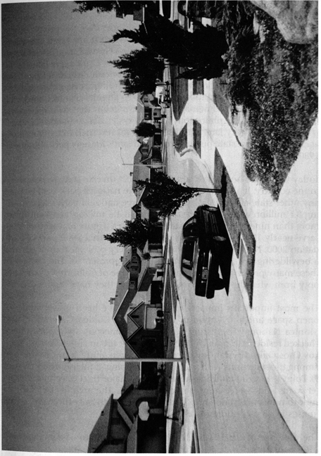
Figure 7. Figure 7. The expansive and repetitive landscape of the California suburb is exemplified by this tract in Lemoore.

Yosemite State (and National) Park, June 10, 1864
In 1864, the literate American public felt disgust over the privatization and tawdry development at Niagara Falls. When it appeared the same would befall Yosemite Valley and the Mariposa Grove, Congress set them apart as a public park for California (13 Stat. 325). Eight years later, lacking a state to receive land, another Congress established Yellowstone National Park. Yosemite, however, was the groundbreaker, the nation’s first state and, in reality, national park. A year after its creation, Frederick Law Olmsted laid out a management prescription that would become the blueprint and the philosophy for park systems nationwide (Olmsted 1865). A half-century later the Yosemite grant returned to federal management while the state pursued redwood lands for new parks (Engbeck 1980).
Today California boasts the largest and most diverse state park system in the country. It also has more units of the national park system than any other state except Alaska. Twenty-three national park units, totalling 8.1 million acres and 265 state parks at 1.4 million acres comprise more than nine percent of the state’s land area (figure 8). Together they serve nearly 120 million visitors per year (California State parks Foundation 2000; National Park Service 1997). Every ecological division and a bewildering array of historic themes are represented. The impact of these many preserved places on the landscape of California results not only from what they have wrought but what they have stopped.
The most important impacts of the parks have been preservation of open space and prevention of development Golden Gate and Santa Monica National Recreation Areas and numerous state parks have checked residential sprawl in the state’s major urban zones. Torrey Pines, Los Osos Oaks, Crystal Cove, Topanga Canyon, and Mount Diablo are among the state units with subdivisions lapping at their borders (Figure 9). Point Reyes National Seashore halted a major tract development after roads and twelve houses had been built. The area of the planned suburb now sweeps down to Limantour Spit with only three employee houses in view (Duddleson 1971; Pozzi 2000).
The presence of a park also has blocked other types of development. After San Francisco builthetch Hetchy Dam in Yosemite, Congress, in 1921, enacted an amendment to the Federal Power Act forbidding its implementation in national parks (41 Stat. 1353). In the case of the Kings River, Congress blocked a Los Angeles reclamation project by adding the area to Kings Canyon National Park. The Nationa l Park Service (NPS) and park supporters also blocked several trans-Sierra road projects, losing only at Tioga Pass. An ambitious plan to build a high elevation road

along the entire Sierra Nevada also failed due to NPS opposition (Dilsaver and Tweed 1990, 182-186).
Arguably the most important open space preserved by the parks is along California’s crowded coast. The California state park system holds title to 280 miles, or 25 percent of the shoreline. National parks account for nearly 100 miles more, not including the Channel Islands. Although all open space is important, more than a fourth of California’s parklands are designated wilderness. Here the controls on construction and use of mechanical transport promote a more complete natural signature on the land (Schaub 2000). 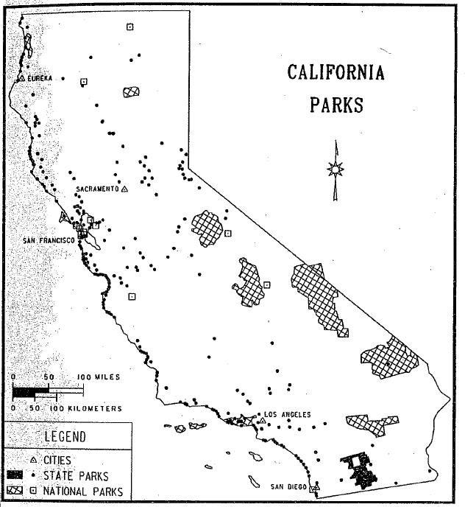
Figure 8Figure 8. National and state parklands in Califonia. Sources: California State Parks and National Park Service. Cartography by Margarita M. Pindak

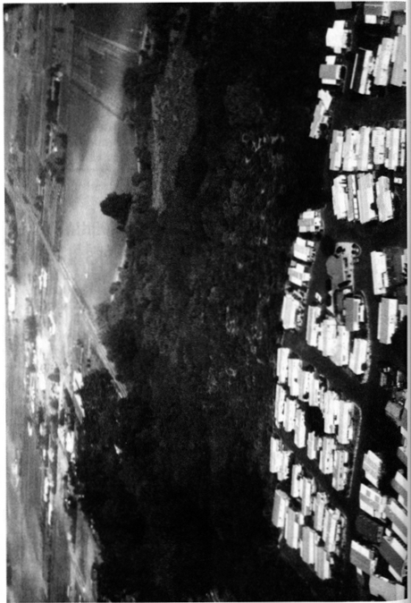
Figure 9. Los Osos Oaks State Park near San Luis Obispo protects an island of nature amid residential and agricultural development. Photograph provided by the Photographic Archives of Catifomia State Parks
Despite the preservation of open space, the legacy of human activity is present in all 288 park units. Park management has actively altered ecosystems while at the same time causing them to diverge markedly from the lands surrounding them. Among park managers’ early steps were, first, enjoinment of lumbering, hunting, and most grazing and, second, suppression of fire. Parks contain many areas of old-growth forest coveted by loggers. Originally, California boasted nearly two million acres of redwood groves. Only 86,000 acres remain, 93 percent of them in parks and reserves (Redwood National Park 2000).
Rangers practiced extensive fire suppression prior to the mid-1960s. During that time forest composition altered, sometimes dramatically, especially in the mountains. For example, giant sequoias simply did not regenerate for nearly a century. In the process, species like white fir expanded in both range and density of coverage among the sequoia groves (Sequoia and Kings Canyon 1987). During that time the fuel load in forests built up to an unnatural level that has rendered prescription burning a feeble corrective device.
Park management of fauna has also impacted the landscape. Early efforts to eliminate predators, coupled with bans on hunting, led to eruptions in ungulate populations. Deer in particular wreaked a devastating impact on vegetation. The chain reaction of these ecological changes rippled through communities contributing to near elimination of some species and increases in others. Subsequent efforts to protect predators, especially black bear and mountain lions, have led to the further divergence of parkland ecology from the surrounding areas. Bears, the aforementioned ecosystem engineers, are densest in the large parks where hunting is forbidden.
Another impact of the national and state parks is in preservation of historic structures and landscapes. Indian settlement sites, Spanish missions, forts of various groups, and agricultural industrial, commercial, and even Hollywood landscapes are preserved. Many ethnic landscapes have persisted due to their inclusion in park zones or to financial support from the state or national parks. The preservation movement, begun at Yosemite, led to the 1906 Antiquities Act (34 Stat. 225) for protection of historic resources. Ironically, President Clinton recently used it to protect the offshore rocks and islands along California’s entire coastline (US Department of Interior 2000).
Within the parks’ auto-accessible zones, planners design buildings and landscapes to exacting specifications and styles. This “parkitecture” is duplicated throughout both systems as well as various regional and local parks. Planners design campgrounds, buildings, parking areas, and
the disguised infrastructure to support them to have a “rustic” look that is both carefully wrought and itself historic (Carr 1998). Still another influence of the parks extends beyond their boundaries. Most national and state parks are major recreation destinations. The road system has evolved to cope with traffic coming to internationally significant sites like Yosemite and Sequoia, as well as the many accessible beach parks. Gateway towns such as El Portal, Mariposa, Three Rivers, and Borrego Springs have their own landscapes of tourism-lodgings, dining establishments, souvenir shops, and a remarkable array of loosely associated amusements. Parks in urban zones, with their protected open space, increase the value of adjacent lands. This, in turn, often leads to more expensive residential and commercial development. Also, parks and their tourism provide economic multiplier effects that spawn additional development in surrounding regions.
Finally, among the subtlest influences of the national and state parks is their contribution to environmental education and conservation proselytization. Outside academia, Californians encounter the environmental message most often in their parks. In some immeasurable way the cumulative impact of this message surely influences human landscapes throughout the Golden State.

The Coming of the Transcontinental Railroad, May 10, 1869
“There has never been any sustained attack on the idea that the steam railroad was the most significant invention or innovation in the rise of an industrial society.” So wrote historian Albro Martin in 1992 (12). Califorrnia History editor Richard Orsi (2000a) is more geographically specific, labeling the railroad the most important factor in California’s history and landscape. Invented in Britain, the railroad came to America when the Baltimore and Ohio Railroad Company was chartered in 1827 and became fully operational in 1830. California’s first line ran from Sacramento to Folsom in 1856 (Holiday 1999, 170; Vance 1995, 25-31). However, it was completion of the transcontinental railroad on May 10, 1869 that brought a major corporate carrier, substantial land grants, and profound economic, social and geographical change to the state. Through establishment of transport routes and towns, development of land, water resources and tourism, economic impacts on mining, agriculture, and forestry, and direct formation of both the urban and rural landscape, the railroads, led by the Southern Pacific (SP), drove California into the industrial age. Today 30 railroads, most of them local, still operate on 6341 miles of track in the state. The Burlington Northern and Santa Fe, and the Union Pacific, two national carriers, own the majority of the track (Association of American Railroads 2000).
The spatial array of transportation and settlement in California owes much of its pattern to railroad planning and construction. The Central Pacific line over Donner Pass bisected the Sierran mining region amidst a general and largely irreversible economic decline. It galvanized agriculture and service businesses, creating a growth corridor. Major wagon and auto roads followed, as did Interstate 80 (Dilsaver 1982, 184-190, 380-395). Elsewhere, the railroads also laid a tra nsport network over the state. Interstate 5 in the Sacramento Valley, State Iiighway 99 in the San Joaquin, and large portions of I-10, I-15, and I-40 in the desert closely parallel the tracks (figure 10).
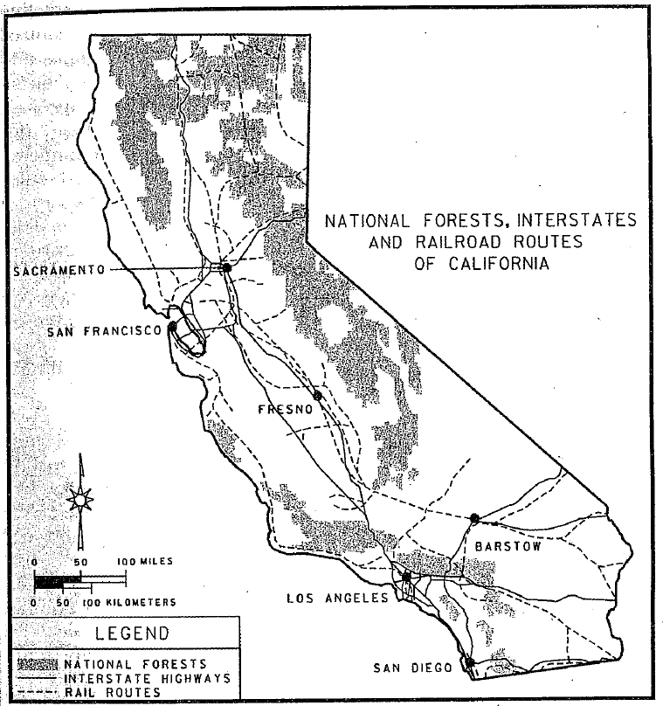
Figure 10. National forests, railroads, and interstates (plus Highway 99) in California. The forests cover the mountainous one fifth of the state. Many highways followed the routes of the railroads. Cartography by Margarita M. Pindak.

Along these lifelines, the railroads established or encouraged numerous towns to serve as passenger and freight entrepots. The Central Pacific and, later, the Southern Pacific developed Lancaster and Palmdale in the Antelope Valley, Livermore and Tracy near the Bay Area, Mojave and Coachella in the desert southeast, and dozens of market centers in the San Joaquin including Modesto, Merced, Fresno,Tulare, and Hanford. Wherever the railroad built towns, businesses and farmers followed.
In order to sell their government granted land and provide customers for their trains, the railroads did everything possible to encourage settlement. The Southern Pacific operated elaborate planning and marketing departments, both relying on the latest scientific data. It also organized and bankrolled irrigation, farming cooperatives, forestry programs, and tourism development. One profound impact on California’s modern landscape is the preponderance of orchards, vineyards, and horticultural fields in the state’s lowlands. Although many of these crops arrived with the Spanish, farmer and customer inexperience hindered their popularity and proliferation. The Southern Pacific provided settlement assistance, crop research and education, marketing in the eastern U.S. and Europe, and the nation’s largest refrigerated rail car system. The latter was particularly important with the railroad’s successful program to generate cantaloupe production in the Imperial and Coachella valleys. The SP located and dug the first wells, researched the cantaloupe as both crop and popular food, built its tracks and towns in the two valleys, installed refrigeration facilities, taught farmers to grow the strange crop, and heavily marketed it in eastern cities (Rice et. al. 1996, 282-283, 286-288; Orsi 2000b, Chap. 9; Orsi 1991, 51).
The railroads also exerted a strong impact on California’s forested landscape. On one hand, railroads deforested some areas for construction materials and, before 1880, fuel. Additionally, narrow gauge independent or spur lines spread lumbering and mining especially in the Sierra Nevada. Yet the Southern Pacific, with its long-term planning and research programs, quickly embraced forest conservation for watershed protection. SP executives believed both agriculture and tourism revenues depended on it. The company played a significant political role in the establishment of national forests in the state and a technical one through its organization of the first effective fire suppression system. The SP also pursued a vigorous program of research, education, and quarantine during the pine-rust-beetle infestation of the 1900s and 1910s (Orsi 2000b, chap. 11).
The important influence of the railroads on national parks and western tourism is well established (Rothman 1999; Runte, 1990a; Wyckoff and Dilsaver 1999). Encouragement of tourism was a source of passengers
and profit. California was no exception. Southern Pacific manipulation, much of it hidden from the public, led directly to the establishment of Sequoia, General Grant (now Kings Canyon), and Yosemite National Parks in 1890 (Dilsaver and Tweed 1990; Runte 1990b). Promotion of mountain recreation and the wilderness experience contributed to more preservation and tourism development during the ensuing thirty years. It is no overstatement to say that without the railroads’ influence the wild areas of California would be quite different today.
Urban areas too were impacted by the railroads. Some cities, like Oakland, owe their form and function to them. Older industrial landscapes
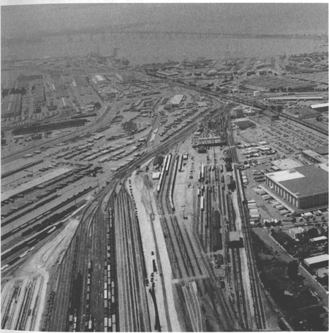
Figure 11. Oakland, like other significant California cities, has a large and impenetrable railroad yard that shapes the geography of other urban functions. Photograph provided by California Department of Transportation.

cling to their former lifeline, often near city centers. Many are now depressed and crim-ridden neighborhoods. Planning for transportation and redevelopmen t in railroad cities can be a challenge. Immovable tracks and traffic congestion during train crossing force adjustments in any spatial plan (Figure 11). Yet, the sprawl of California’s major urban areas owes its origins to suburban rails. With the functional, if not financial, success of Bay Area Rapid Transit (BART) and light rail sytems in San Jose, Los Angeles, Sacramento, and San Diego, urban rails are becoming more prevalent after years of decline (Figure 12).
Finally, as we travel through the state, there are the remnant visual scenes at every turn. In the countryside, amid the orchards and specialty crops, grid pattern town centers orient along the tracks rather than cardinal directions. Loading facilities and silo, many abandoned, still loom beside the tracks. The rails themselves impart a linear pattern that disrupts the geometry of the Township and Range and the polymorphous natural landcape. Lines of trees, planted by the Southern Pacific for shade, wood, and adornment, can be found on former rail road lands, along tracks, and at stations extant or remcmbered. They include eucalyptus, tamarisk. black locust, and palms. Some abandoned railroad rights-of-way now serve as recreation trails. Overpasses and the occasional tunnel mark the intersection of the rail and auto networks (Rademacher 1999).
Entering the dense buildup of the cities a clustering of indutry and warehouses follows each rail corridor. Large rail yards create impenetrable impediments to intra-urban flows of cars and people. The periodic traffic jams that accompany a passing train, added to these other impacts at all scales, demonst rate the enduring legacy of the golden spike on May 10, 1869.

Electrification of Market Street, April 9, 1874
The tiny nocturnal glow of Father Joseph Ned’s electrically powered arc light along San Francisco’s Market Street signaled the beginning of a new era destined to reshape the California landscape (Brechin 1999, 255-56; Williams 1997, 170). Even as early as 1890, some observers realized that the harnessing of electricity was “destined to be one of the most powerful factors entering our social condition (Williams 1997, 168). Indeed, that was the case, and California, both then and now, led the nation in innovative applications of electricity technology that enduringly refashioned the visible scene. Californian’s embraced electricity as an almost mythic symbol of progress upon the landscape: every community wanted the latest electrical street lighting and trolley systems and every California household embraced the newest electrical appliances
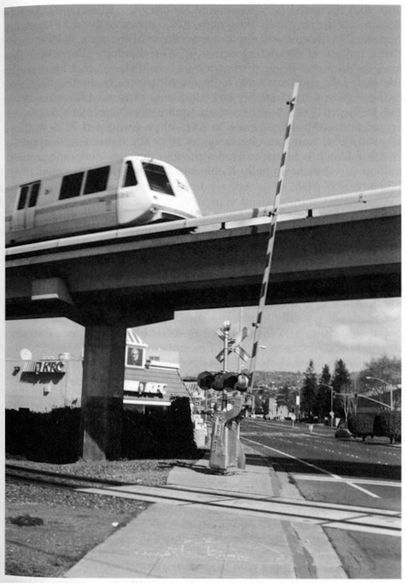

Figure 12. The California urban landscape, seen here in San Leandro, reflects the overwhelming influences of railroads and automobiles.

41

that promised to save time and money (Nye 1990, 1-2). As the demand for the new technology grew, so did the extensive infrastructure necessary to bring electricity to every corner of the state. By the early 1890s, the use of alternating current (A/C) technology allowed for the long-distance movement of electricity, a breakthrough that immensely stimulated the construction of hydroelectric power-generating facilities far from where the electricity was ultimately consumed (Brechin 1999, 255; Williams 1997, 173-177). From that point on, Californians displayed an unending thirst for power: in 1915, they consumed 2215 million kilowatt (k/w) hours of electricity; in 1950, the figure had leaped to 24,800 million k/w hours; and today the state devours more than 268,000 million k/w hours annually (California Department of Finance 1999; Williams 1997, 374).
The California landscape is filled with the infrastructure of electricity, including all of the generating facilities and transmission lines that bring the power from producer to consumer. The geography of hydroelectric power illustrates the pattern. As hydroelectricity gained in popularity with A/C technology, the state’s physical geography preordained an elaborate network of long-distance connections: California’s major mountain zones, the home of most of its hydroelectric--generating potential, are typically found at some distance from the state’s major population clusters (Williams 1997, 169-70). The result has been the construction of an elaborate series of mountain dams and hydroelectric­ generating facilities along with the development of an extensive power grid connecting these often remote sites to major zones of consumption. For example, Northern California’s Shasta complex (Sacramento River) and dozens of Sierra Nevada facilities (including projects on the Pit, Feather, Yuba, Stanislaus, Tuolumne, San Joaquin, Kings, and Kern Rivers) have reshaped the state’s mountain geography with a broad assortment of dams, reservoirs, and power lines. The potential for these mountain sites was demonstrated in 1901 when Oakland’s streetlights and trolley cars became powered by waters from the far-off Yuba River over 140 miles away (Brigham 1998, 3). Later projects were even larger in scale: the building of the San Joaquin River’s Big Creek Dam, critical in powering distant Los Angeles, involved the construction of over 56 miles of new mountain access roads, 12 work camps and construction facilities (later used for maintenance), and over 240 miles of transmission lines to the Southland (Williams 1997, 184-86). The Colorado River’s federally financed Hoover Dam project also contained a critical hydro­ electric component. By 1939, it was the world’s largest hydroelectric facility and it allowed Southern California to increase its consumption of power thereafter (Starr 1990, 157-58; Stevens 1988, 259). Indeed, electricity figured into the rationale for building many of the public dams in the West because potential power sales were used to justify the
42
construction costs of such projects (Brigham 1998, 12).
Also facilitating the creation of such infrastructure (both public and private) was the emergence of large state-regulated public utility companies that represented the consolidation of many smaller operations. Pacific Gas and Electric (PG&E) formed in 1905 and still dominates electricity generation in Northern California, while Southern California Edison (SCE), consolidated in 1909 and remains central to electricity production in the southern portion of the state (Brechin 1999, 264; Coleman 1952; Starr 1990, 157; Williams 1997, 182-83).
Technological moves beyond hydroelectricity have also shaped the state’s landscape. Today, only 18 percent of the state’s electricity is produced by hydroelectric facilities. After 1950, new steam turbine technologies allowed for the use of fossil fuels in generating electricity and today these power plants, widely scattered across the state, provide Californians with their most important source of power (Williams 1997, 277-82). In addition, the state’s nuclear power facilities in such localities as San Onofre (north of San Diego) and Diablo Canyon (near San Luis Obispo) provide an additional 15 percent of the electricity budget (California Department of Finance 1999). The largest visible imprints of so-called alternative energy production include local solar energy generating units (often atop individual homes), geothermal power plants (especially Sonoma Counties Geysers facility), and 27,000 acres of wind-generating turbines (including Altamont Pass east of Livermore, the Tehachapi Mountains northwest of Mojave, and San Gorgonio Pass east of Banning) (California Department of Finance 1999; Williams 1997, 288-91, 330-35).
The consumption of electricity has also radically altered the California landscape. In urban settings, the initial focus of electricity consumption (in the 1880s and 1890s) came in the form of electrified streetcars and street lighting (Brigham 1998, 3; Nye 1990, 69-137). Although the streetcars have largely vanished, many of the key urban commuting routes they created remain as principal urban and suburban thoroughfares today. The modern nocturnal illumination of the city, of course, remains an enduring legacy. Californian historian Kevin Starr describes the transformation of Los Angeles by the 1920s:·Nighttime Los Angeles had become a wonderland of light. From atop Mount Lowe one beheld Los Angeles, Pasadena, and fifty-six contiguous cities and suburbs spread out in a vast sea of illumination. In sheer extent…there was no other spectacle like it in the United States (Starr 1990, 157) (Figure 13). Gradually, between 1910 and 1930, residential use of electricity for lighting and home appliances added to the twinkling of urban consumption patterns (Nye 1990, 238-86). In a more subtle fashion, electricity also
43

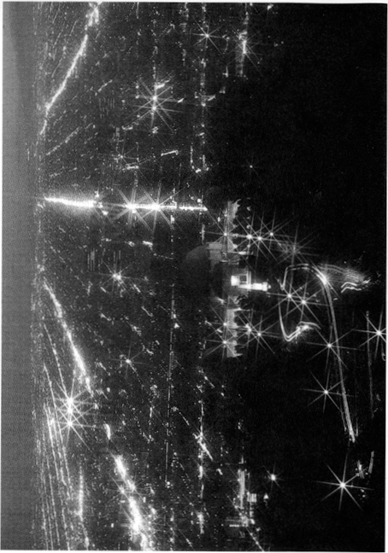
Figure 13. Los Angeles at night is an electric landscape that can be seen from space Postcard from the collection of W. Wyckoff.

44
made possible fundamental reconfiguration of California’s factory lay­outs, a transformation that remains apparent today (Brigham 1998, 134-38; Nye 1990, 185-237; Williams 1997, 203). With widely available electrical power, factories could be designed to be more hori1zontally extensive and less dependent on centralized steam-generating facilities. Indeed, after 1910, new industrial plants in California widely adopted the approach, which often included the use of longitudinally extensive and more efficient assembly line manufacturing processes.
In the countryside, Californians rushed to electricity more quickly than any other rural Americans (Nye 1990, 23-25). By 1934, 60 percent of California farms were electrified, while the national total stood at only 11 percent (Williams 1997, 222-23). One enabling factor for many California farmers in the Central Valley was the close proximity of electricity in the form of transmission lines that connected the Sierra Nevada with the state’s urban areas. Tapping into this grid allowed California farmers to vastly expand their use of electric irrigation pumping that allowed for the continued elaboration of the agricultural landscape (Smil 1994, 188-91; Williams 1997, 224-231). By the late 1920s, over 12 percent of the state’s total electricity consumption came from pump irrigation operations and this technology remains essential today in providing water for many California farmers. In addition, electric motors have proven pivotal in modernizing many other farming activities, including the use of new milking machines, poultry brooders, and refrigeration facilities. Indeed, from the state’s rural periphery to its brightly illuminated downtowns, electricity has enduringly reconfigured the cultural landscape of the Golden State.

Passage of the Wright Irrigation District Act, March 7, 1887
Artificial irrigation has been the mainstay of economic prosperity in California. However, until the passage of the Wright Act (Assembly Bill 12) on March 7, 1887, few farmers had the legal or practical means to obtain stream water for irrigation. The legislative passage of the Wright Act not only overcame this barrier, but also paved the way for the rapid expansion of irrigated agriculture in California.
During the first decades of statehood, the right to exploit stream water was influenced by English common law, Spanish practices and gold rush innovation. Under the former, the doctrine of “riparian rights” prevailed in England and the eastern United States. This principle held that only those people living on a stream bank could lay claim to it. California officially adopted this common law in 1850, but gold seekers found it unsuitable for hydraulic mining. They adopted the custom known as “appropriation.” Resembling Hispanic water law, the appropriation
45

doctrine dictated that many people could divert stream water for beneficial uses with priority going to the first comer. In 1851, California also endorsed appropriation in the gold country and ultimately incorporated both doctrines into statewide law in 1872. The legislative willingness to accommodate these contrary doctrines caused considerable confusion and litigation especially concerning crop irrigation (Hundley 1992, 67-85). The jurisdictional uncertainties, anger over land monopolists, and the inability of small landholders to afford to construct and manage irrigation projects, in turn, resulted in the passage of the Wright Irrigation District Act in 1887.
The Wright Act authorized residents in an area to organize irrigation districts, purchase land and water rights, and distribute water. Importantly, the districts could condemn all individual water rights, including riparian, and purchase them in the name of the district. Once the obstacle of riparian priority was removed, dozens of public districts rapidly formed in California and large-scale irrigation commenced. A surge of landless immigrants and small landholders rushed to take advantage of these new opportunities, and by 1889 California led the nation in irrigated acreage (Kahrl 1978, 26-27; Hundley 1992, 99-100). In the 1890s many districts fell on hard times owing to drought, poor management, and insufficient resources for comprehensive interbasin projects (Worster 1985, 110). Nonetheless, the Wright Act had established the legal precedent for future rural and urban developments, and water districts were in the forefront of the massive expansion of irrigation that blossomed in the twentieth century (Kahrl 1978, 63; Pisani 1992, 104; Littleworth and Garner 1995, 17).
With the Wright Act and associated amendments us the legal and distributional framework, the federal and state governments provided the money, centralized planning, and advanced engineering necessary for ambitious interbasin water transfers (Stene 1994; Duvall and Duvall 1997, 202). California benefited greatly from the passage of the federal Reclamation Act of 1902, which provides federal money to finance water projects in the West. Water made available under the auspices of the Reclamation Act was distributed according to the water laws of the states (Robinson 1979, 332). The Wright Act had sanctioned the formation of water districts and they in turn provided the framework for effective and widespread distribution of federal irrigation water. In short order, the Bureau of Reclamation undertook massive water projects in regions such the Salton Basin and the Great Central Valley. For example, the Bureau’s Central Valley Project, built between 1937 and 1951, supplies water to local rural and urban water districts, which manage and distribute it. Subsequently, the California State Water Project further augmented the surface water available for irrigation. Similarly, approximately sixty-five
46
percent of the water transported by the California Aqueduct is destined for agricultural water districts in the San Joaquin Valley (Littleworth and Garner 1995, 25). The landscape consequences of these projects, and agricultural irrigation in general, cannot be overstated. The visual signatures are ubiquitous and revealed in the water facilities, irrigated lands, farm related industries, and in their environmental consequences.
The irrigation infrastructure in California is visible over major portions of the state and especially within agricultural regions such as the Imperial, Salinas, and Central Valleys. The Central Valley and State Water Projects together include forty-two major dams and reservoirs, 1,200 miles of aqueducts, twenty power plants, and dozens of pumping plants (California Department of Water Resources 1998) (Figure 14). As impressive as these projects are, they represent only a portion of the storage, power, and conveyance facilities that contribute to irrigation in California. A remarkable number of additional Bureau of Reclamation, Army Corps of Engineers, and private projects account for most of the 1,300 reservoirs and associated facilities in the state. Furthermore, some urban water systems are designed for the storage and distribution of irrigation water as well. The Hetch Hetchy project and the Colorado Aqueduct are notable examples of systems associated with irrigation. Many of these reservoirs are equipped with hydroelectric facilities that distribute power to urban and rural landscapes across California.
Artificial irrigation provides not only the backbone of agriculture in California, but also is important for recreation. Approximately, sixty percent of the recreation in California involves water bodies, and artificial reservoirs comprise a substantial portion of them (Kahrl 1978, 92-93; Selby 2000, 209). Shasta, San Antonio, Pine Flat, and Lake Havasu reservoirs, as well as the Salton Sea, are wholly or partially products of irrigated agriculture and serve as important recreation destinations. They have generated a host of business, service, and administrative landscapes at the water bodies, along access routes, and in gateway communities. Like their urban counterparts, the watersheds, reservoirs, and conveyance right-of-ways have constrained other forms of commercial and residential development. This is especially true around some reservoirs, such as Shasta and Trinity lakes, which are encompassed completely or partially by national recreation areas or state and county parks (Benchmark Maps 1998, 10-33).
The spatial extent of irrigation in California is unsurpassed. By 1995, over nine million acres in California were artificially irrigated by surface and well water (California Department of Water Resources 1998, ES4-8). One-sixth of all the irrigated land in the United States is concentrated
47

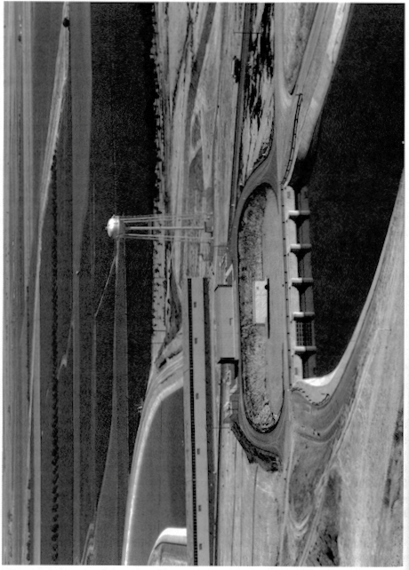
Figure 14. The California Aqueduct and the Dos Amigos Pumping Plant in the San Joaquin Valley.
Photograph provided by California Deportment of Water Resources.
48
in California’s Central Valley alone (Duvall and Duvall 1997, 201-202). In total, nearly one-tenth of the state’s surface is under irrigation. Depending on the season and plant variety, environments that were once desert, grass, shrub, marsh, woodland, or meandering sloughs have been transformed into lush geometries of color and texture. These fields, orchards, and vineyards are further laced with settlements, utility lines, sprinkler systems, wells, pumps, canals, pipelines, equipment yards, service roads and, in some locations, the technology to combat frost.
Irrigation is responsible for the larger portion of the nearly $30 billion in annual revenues derived from agriculture in California, and its economic impact has transformed landscapes beyond the farm and ranch. In 1997, for example, nearly one-third of all jobs in the Central Valley came from farming or farm related industries (Brickson 1998, 12). When employment and profit reinvestment is considered, irrigation provides significant and varying economic underpinnings for urban and rural landscapes across the state. Ironically, irrigated agricultural landscapes are being supplanted by suburbs in many areas of California due largely to their own economic success (California Department of Water Resources 1998, ES1-2).
The irrigated agriculture promoted by the Wright Act has also spawned unintended consequences that are themselves expanding components of California’s visual landscapes. The Salton Sea is a major example. Early endeavors to provide irrigation water to the dry Salton basin unwittingly resulted in its flooding by the Colorado River. Wastewater from the irrigated lands of the Coachella and Imperial Valleys continues to sustain the sea as a completely human-made water body. Soil damage is a growing problem in areas such as Sacramento-San Joaquin Delta and the Central Valley. Hundreds of thousands of acres have been rendered useless or less productive by saltwater intrusion, waterlogging, salinization, and erosion (Hundley 1992, 364-380). Moreover, various methods of agricultural wastewater disposal are increasingly important as landscape agents and features. Owing in part to wastewater, numerous stream, bay, and delta environments have lost their fisheries and the cultural manifestations they once supported. Some environments, like Kesterson Reservoir, the San Luis Drain, and thousands of acres of evaporation ponds in the San Joaquin Valley, were constructed to specifically address agricultural pollution (Department of Water Resources 1990). Although not as perceptible as reservoirs and canals, land subsidence due to ground water withdrawal is widespread and significant. This process has lowered ten percent of the land in the Central Valley (Lofgren and Klausing 1969). Irrigation, regrettably, is directly responsible for these changes and its visual impacts are growing.
49

Irrigation is one of the most important landscape agencies in California. The experiences of colonial peoples and gold miners assisted its development. In addition, technological innovations, new energy sources, and government assistance were factors in the growth and success of irrigated agriculture. However, ultimate success depended on the ability to transport stream water to non-riparian lands and then effectively distribute it to farms. The Wright Act of 1887 and its amendments made this possible.

San Gabriel Timberland Reserve, December 20, 1892

Forest conservation was a topic that gri pped eastern intellectua ls and scientists in the late nineteenth century. Various associations and, after
1881, federa l agencies sought to protect a resource that was dwi ndling alarm ingly. This concern led Congress to pass what is now called the Forest Reserve Act in 1891. 1t allowed the president to unilateraUy withdraw public lands for what would become the national forests. Twenty-one months later Benjamin Harrison procla i med California’s first un it, the San Gabriel Ti mberland Reserve, now part of Angeles National Forest. Over the next fifteen years, citi ng needs for timber and watershed conservation, presidents proclaimed un i ts i n California that now form eighteen national forests and one national grassland. They total 20,652,922 acres or twenty percent of California’s area (Figure 10). The United States Forest Service, an agency of the Department of Agricu l ture admin isters these lands (Ayres 1958; Clary 1986, 3-28; Steen 1976; US Forest Service
2000).

Establishment of the national forests initiated two profound processes that have affected the California landscape. One was the withdrawal of lands from the public doma in, ha lting pri vate land aliena tion. The existence of permanent federa l conservation lands has halted sprawl from Los Angeles to Lake Tahoe. At the former, much of the region’s recreation depends on the open space provided by national forests ringing the bloated metropolis. In El Dorado National Forest, the old resort of Tallac at South Lake Tahoe exemplifies one side effect of such designa­ tion-historic preservation. A private, water-oriented subdivision abuts
the forest bou ndary a little over a mile from the late n i neteenth cent ury complex (US Forest Service 1990; Fiske 2000).

In 1931, the Forest Service established eight "primitive areas·in California. Th i s form of management zoni ng exclu d ed roads, tourism development, and most other forest activities in favor of ecological preservat ion. Designation of pri mitive areas in California and within
the country’s other nationa l forests led ulti ma tely to the Wilderness Act of 1964 (78 Sta t. 890). Under that law, Congress has created 4. 5 million

50

acres of wilderness in California, the ma jority on Forest Service lands. (US Forest Service 1960; US Forest Service 1998).

The second process to affect the California landscape was Forest Service management a body of laws and policies underlai n by a righteous mission of utilitarian con servation. Duri ng the nineteenth cent ury, California’s forestlands su ffered decades of overgrazing, random, shepherd-set fires, and scattered deforestation. Erosion and soil deple­ tion followed, especially i n the southern pa rt of the state. Areas such as the Tahoe Basin, adjacent to Nevada’s silver mines, were particularly hard hit (Strong 1 984, 11-33). The Forest Service responded by severe!y limiting grazing and regu lating Jogging during the twentieth century (Figure 15). In 1902the agency began to reforest its lands. In the first few decades, foresters tried to expand the forests into brushlands and experimented with exotic species. While most of these efforts fa iled, the agency also favored commercially valuable western species, influencing the overa ll forest composi tion. Agency foresters continue to breed and plant superior, insect-resistant stock wh ile maintaining a seed bank to replace species eliminated by epidemics. Over the decades the agency has allowed clear-cutting followed by even-age reforestation in some places and selected species cutting in others, notably the sequoia groves of the southern Sierra Nevada (Clary 1986; Fiske 2000; Kitzmiller 1990).

Added to these actions is the agency’s history of dynamic fire suppression. Taking its cue from the railroads, the Forest Service developed an effec­ tive fire prevention system that i t shared with the National Park Service and other agencies. That prevention system, coupled with aggressive suppression, went unchallenged until the 1960s. The fi re history of California’s mountai ns and the degree to which suppression affected it are subjects of much debate among scholars. Yet the effects, while not quantifiable, are well understood and widespread: arboreal recovery, succession of meadows to forest, community composition change as scrotinous species give way to others, and adjustment of the fauna which have their own landscape impacts (Ayres 1958; Cermak 1998; Sampson
1999). The net results of a ll these actions are an i ncrease in the state’s forest cover since 1900 and a human i zation of those forests.

The Forest Service man i pulated other resources in its units. Conners (1992) has shown that the Forest Servi ce became the chief arbiter of reclamation development in the mountain wa tersheds prior to the Federal Power Act of 1920. By approving some projects and denying others it shaped the ripa ria n history of both highlands and lowlands. Recreation development in the forests has also been extensive. Los Pa­ dres Nationa l Forest a lone has more than 200 permits for second homes on its lands. Other Cal ifor nia n ational forests m atch or exceed it.

51

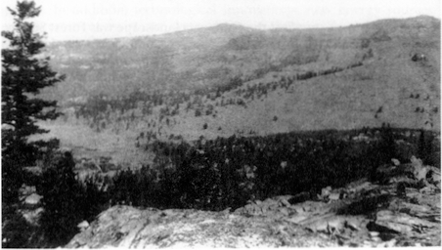
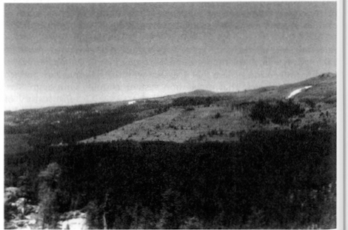

Figure 15.
Two photographs of an ElDorado National Forest scene near Caples Lake. The top one. taken in 1919, shows deforestation by Nevada miners. The bottom. from
1998. shows forest recovery under federal management.
Photographs provided by Dono Supemowicz. U. S. Forest SetYfce.
In addition to thcsr modest structures. the agency permitted tourism
development on a larger sca le ranging from the roadside commercial
strips of the Sierra Nt"v. lda highways to recreation camps for the coastal cities to major ski resorts. The Forest Service also designed campgrounds and trails to satisfy the nearly 70 million visitors that usc these lands each year. Unpaved roads and railbeds, left over from contracted log­ ging. often became the foci of off-road vehicle use and recreation homes (Los Padres National orcst n. d. ;Tweed 1980; US Forest Service 1998).

Other effects of the national forests in California extend beyond their boundaries. Encourdgcd by thei r example, the state developed its Cdli­ forn ia Demonstrat ion St. 1te Forests. Eight of these units lie within a va­ riety of the sta te’s ecologi c(I zones and tota l 71 ,000 acres. Stdte for·esters intensi vel y m(mngc them for forest improvement and nrc preven tion (Hasti ngs 1986). Marwgernent of the nationa l forests haled to key legislation other than the Wilderness Act. Over the years, cri t ics charged that the agency ignored its multiple usc mandat e in favor of one that emphasized logging. Even tually this led to the Multiple Usc Sustained Yield Act of 1960. That law and its interpretation led in tum to the National Environmental Policy Act. another of our fifteen events (fiske
2000).
In 1908 Congress passed a law (35 Stat. 251) ordering the Forest Service to rctum 25 percent of the monies gained by logging contracts. grazing perrnits, and other functionto the state. The state then distributes the funds to the counties where these forest activit ies took place. As earl y as
1930 t hat revenue exceeded the amount of money the state could raise
by taxes if the national forests d id not exist. This, in t u rn, nffccts the patterns of sta tewi de settlement and developmen t by supporting cou r>­ tics and towns, pMt icu l nrly in the northem part of the state. tha t might suffer decl i ne or abandonment wit hout those funds (US Forest Service
1930).

If one nics over the mountainous portions of California, the landscape below presents a mix of clearings, chaparral, and green forest. Twined through much of the landscape is a latticework of mostly unJ>(Wed roads totaling 45,000 miles in the eighteen forest units. A legacy of logging. fire prevention, and vehicular recreation. they halt at the edges of the Wilderness areas and at the highest elevations. Along those roads and te occasional paved highway are strung small clearings for commer­ cral and residential stnrctures. Unseen from that a l titude, but inevitably there, lie campgrounds. more spacious than those of the Nationdl f’dfk Service, tra ils mMked wit h arrows nailed to the trees, fire lookouts at the high vanwgc-poi ntand the occasiona l recreat ion hornc>tead hid­ den u nder the canopy. lJu t the most striking thi ng abou t fl yi ng over or

hiking t hrough the state’s highlands is how much of California remains forested, albeit by a h umanized aggregate of natun1l commun ities.

Sale of First Ford Model T, 1908
In his description of the California landscape, Donald Meinig (1979, 170) reminds us that “the East built the cars, but California taught us how to live with them”. ·Undoubtedly, California has provided America’s unequaled model for automobility. The automobile has stamped its identity, indeed a distinctive lifestyle, upon the California scene and few corners of the Golden State have escaped its influence. Today, more than 18 million automobiles and 6 million trucks are registered in the state (California Department of Motor Vehicles 1999). In Los Angeles, 90 percent of daily commuters utilize their automobiles and the figure is even higher for Sacramento and San Diego (Kenworthy and Laube 1999). More than 165,000 miles of roads crisscross California (including more than 4,000 miles of freeways), and state residents travel a combined 150 billion miles on them every year (Caltrans 1998)! Even more fundamentally, the automobile has shaped a lifestyle focused on individualism, convenience, consumption, leisure, the outdoors, and mobility Bottles 1987; Meinig 1979; Preston 1971). It is a lifestyle not without its hazards: almost 2.5 percent of all deaths in Los Angeles are caused by traffic accidents (Kenworthy and Laube 1999).
The roots of this commitment to the car can be traced to 1908, the year Ford Motor Company introduced the popular Model T. While the Duryea brothers in Massachusetts had already fashioned America’s first gasoline-powered vehicle in 1893, it was another 15 years before Ford initiated the mass production of inexpensive automobiles destined to revolutionize American culture, particularly in California (Flink 1988, 1-55; Palen 1995, 43). The result was a fundamental reshaping of the California landscape: houses sprouted garages and carports, urban thoroughfares became grand promenades oriented around automobile traffic, trucks revolutionized agricultural, commercial and industrial activities, and even the state’s atmosphere (“smog”·became a part of the Los Angeles vocabulary in the 1940s) and vegetation (millions of California’s trees have been damaged or killed by automobile pollution) were forever altered in the process (Krim 1992, 125; Williams 1983).
California’s highway network reveals an omnipresent signature of the automobile’s legacy, and the roadscape has become an ever more important visual element on the California scene (Abbott 1993, 123-29; Banham 1971). As cars multiplied after 1908, a series of federal and state initiatives laid the groundwork for the construction of an integrated auto highway network across the state (Caltrans 1989; n.d.; Jake1990;
54
Palen 1995, 46-7). In 1909, the first bonds were issued to create a state highway system and in 1921 a department of public works was established, including a division devoted to highways. Indeed, California highway engineers led the nation in the creation of better concrete roads and pioneered the use of raised concrete curbs to slow road erosion and add highway safety (Flink 1988, 170). At the national level, Federal Highway Acts in 1916 and 1921 established a commitment to aid states in building roads, and this led to the widespread paving of California’s major highways between 1925 and 1940. After World War II, California’s Collier Burns Act (1947) increased gas tax expenditures on state roads and the Federal Interstate Highway Act (1956) laid the groundwork for today’s long-distance routes across the state.
The resulting network of roads penetrates every portion of the state and has vastly extended the automobile’s shaping influence. Many rural residents were actually early adopters of the automobile as farmers reaped the advantages of lessened isolation (Flink 1988, 132; Jakle 1990). Indeed, the mobility of cars and improvement of road surfaces made many of California’s agricultural hamlets unnecessary and basically hailed the founding of additional farm towns in the state (Preston 1981: 167-68). Today there are fewer small communities across much of California’s agricultural Central Valley than there were 75 years ago. The automobile and commercial trucking have allowed farmers the freedom to travel farther and faster, thus bypassing the need for small er service centers. Elsewhere, the growing road network revolutionized tourism (Flink 1988, 169-187; Jakle, Sculle and Rogers 1996; Nash 1972). Cars were allowed into Yosemite and Sequoia National Parks in 1913, initiating an era of automobile tourism that annually brings millions to California’s scenic attractions. The state’s mountain, desert, and coastal landscapes are closely tied to nearby cities, auto campgrounds and motel units have multiplied by the thousands, and entire communities (from Cambria and Fort Bragg on the coast to South Lake Tahoe and Big Bear Lake in the mountains) cater to the mobile needs of the state’s car­driving recreationalists. Today, Californians also own more than three million trailers and haul them anywhere and everywhere to enjoy the state’s outdoor amenities.
Most dramatically, automobiles have refashioned the state’s urban landscapes (Figures 12 and 16). Simply the amount of urban land devoted to the automobile is staggering. For example, including highways, space-extensive parking facilities, and a myriad of auto-oriented businesses, roughl y 50 percent of the cent ral Los Angeles landscape is directly tied to the automobile (Birdsall, Florin and Price 1999, 353). The automobile has also redefined fundamental characteristics of urban geography. Because the easy mobility of the automobile has contributed to urban
55

sprawl, most automobile-orientcd California cities are less than half as densely populated as their eastern American counterparts (Hirdsall, Florin and Price 1999, 352-54). The automobile has hastened the decline of many downtown businesses at the same time that it has stimulated the rapid decentralization and suburbanization of urban residences, industrial activities, and retailing establishments (Bottles 1987; Flink 1988, 143-44; Foster 1975; Jakle 1990; Longstreth 1997, 1999). Indeed, the suburban California commercial strip has become a model for the nation. Lined with gas stations/convenience stores, fast food franchise restaurants, supermarkets, enclosed malls, and chain-store retailers, all with their oceanic parking lots, these urban corridors, pulsing with nonstop traffic and pockmarked with unending signs and billboard are the quintessential landscape signature of the automobile in California and the world
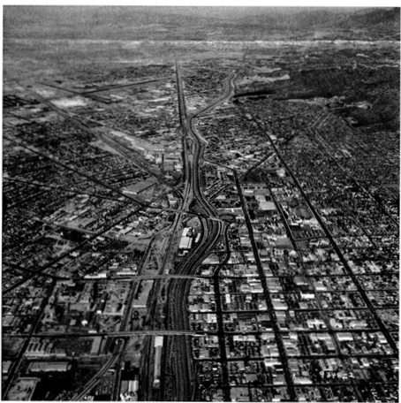
Figure 15The automotive landsca pe of the Los Angeles metropolitan area. Photograph provided by California Deportment of Transportation.

56
beyond (Banham 1971; Jakle 1990; Jakle and Sculle 1994; Kling, Olin and Poster 1991).
Freeways are the other ubiquitous imprints of auto culture in urban California. When Frederick Law Olmsted, Jr. proposed a freeway system for Los Angeles in 1930, little did he realize he was laying the groundwork for a landscape feature destined to alter not only the Golden State, but much of America (Bottles 1987, 216-20). Indeed, the completion of California’s first freeway in 1911 (the six-mile Arroyo Seco Parkway near Pasadena) as well as the construction of the Golden Gate and Bay Bridges in San Francisco during the same period assured the ongoing centrality of the automobile in the state’s two largest metropolitan areas. Seen as a solution rather than as a problem when they were created, many of California’s urban freeways are today among the nation’s busiest with average daytime speeds of less than 20 miles per hour now the norm in Los Angeles (Banham 1971; Birdsall, Florin and Price 1999, 352-54; Bottles 1987, 19-20; Flink 1998, 140-45).
Finally, auto-related industries have transformed major portions of the state. The first Ford assembly plant appeared in Long Beach in 1911 (Shallit 1989, 119). Subsequently, localities such as Van Nuys, South Gate, Oakland and Fremont were fundamentally altered by the presence of space-extensive automobile assembling facilities (Morales 1986; Nash 1972, 321-22; Rubenstein 1992). Associated new and used car lots occupy thousands of additional acreage. California’s petroleum industry also received a huge stimulus from growing demands for gasoline and engine oil (Bottles 1987, 199-200; Nash 1972, 321-22; Shallit 1989, 109-25; Viehe 1981). Large oil fields in localities such as Long Beach (Signal Hill), Whittier, Santa Barbara, and the San Joaquin Valley witnessed tremendous growth in direct response to the automobile’s never-ending appetite for fossil fuels, and oil production remains an important part of the state’s economy·

Wartime Buildup Begins, June, 1938
Three years prior to Pearl Harbor, anxious British war planners began transforming California’s economic landscape. In June 1938, Lockheed Aircraft in Burbank received one of the state’s first big foreign orders for 200 warplanes (Verge 1993, 4). Few realized at the time how momentous the next seven years would be in reshaping the Golden State. Historian Gerald Nash stated it simply when he wrote, World War II left an indelible imprint on the economy of the American West. No other event in the twentieth century had such far-flung influence” (Nash 1990, 1). Considering the magnitude and persistence of the changes, particularly for California, it is difficult to argue with Nash. During the war years,
57
over $35 billion was spent by the federal government in California (ten percent of the national total), the state’s manufacturing output quadrupled, per capita income doubled, and more than 1.5 million new residents flocked to the state (Johnson 1995,8; Malone and Etulain 1989, 107-119, Nash 1990, 1-6; Wyatt 1997, 158).
When war arrived on December 7, 1941, California immediately felt the conflict more directly than any other state. Indeed, two weeks later, a Japanese submarine torpedoed the SS Absaroka just outside Los Angeles Harbor (Verge 1995, 23·-25). Soon, large barrage balloons hung above the city (to entangle low-flying aircraft), the entire California coastline was protected with ant iaircraft guns, and coastal residents adjusted to the reality of nightly wartime blackouts. Other ephemeral, yet profound landscape changes shaped the California scene (Beck and Haase 1989, 74-78; Wyatt 1997). Prisoner-of-war camps littered the Central Valley and American citizens of Japanese descent were imprisoned at Manzanar (Owens Valley) and at Tule Lake (Northeast California), leaving a quiet, yet powerfu l legacy on the landscape that still scars America today.
Overall, the war brought four fundamental changes to the California landscape, alterations that remain apparent today (Nash 1990, 1-6). These enduring transformations included 1) the dramatic industrialization and modernization of the state’s two largest urban areas (San Francisco Bay and Southern California, 2) a broader set of infrastructure and technology investments throughout the state which sparked ongoing changes on the landscape, 3) the tremendous expansion of California lands directly controlled and subsequently shaped by the military, and 4) the sparking of an extraordinary population rush to the state that persisted for decades.
Major portions of the modern Bay Area and Southern California landscapes are directly related to wartime demands for industrial production, upgraded port facilities, and modernized urban infrastructure (Abbott, 1993, 3-29; Johnson 1993; Lotchin 1992; Nash 1990, 41-66; Shallit 1989, 170-92; Verge 1993). Port facilities in San Francisco (including the Naval Shipyard), the East Bay (including Vallejo, Alameda, Oakland, and Richmond), Los Angeles (San Pedro and Long Beach), and San Diego witnessed tremendous expansion as they became organizing and collecting points for the military and centers of war-related manufacturing (30 percent of America’s wartime ship tonnage originated in the Bay Area and more than 4000 defense-related manufacturing plants were located in Los Angeles County). Indeed, those crucial World War II investments paved the way for the state’s current role in trans-Pacific trade and the extensive port facilities that make it possible (Lotchin 1992).
58
Many major industrial landscapes of modern California have their roots in World War II. Even as direct military expenditures fell in the 1990s, the state still receives 20% of Defense Department spending and almost 50 percent of NASA funding (Birdsall, Florin and Price 1999, 555; Wyatt 1997). More broadly, while defense-related manufacturing no longer dominates the state, many of today’s industries were attracted to California precisely because of its war-spawned industrial infrastructure and skilled labor force. For example, General Motors, Quaker Oats, and Sylvania Electric all opened major manufacturing plants in California immediately following the war (Verge 1993, 146). In addition, California’s high technology industries grew from the presence of wartime concentrations of expertise and innovation in localities such as Berkeley’s Lawrence Radiation Lab and at Stanford University (Nash 1990, 1-6). While the Bay Area and Southern California were most dramatically transformed by the war, broader changes in the state’s infrastructure were also initiated and have persisted to the present. For example, the state’s oil industry, still of crucial importance today, expanded greatly during the war years (Shallit 1989, 1987). Agricultural output also soared to feed the troops, and the war generally hastened the state’s movement towards less labor intensive agriculture as thousands of young men left the farm, many never to return (Malone and Etulain 1989, 112; Shallit 1989, 187). In addition, both federal and state expenditures for basic infrastructure expanded greatly, again oriented toward wartime demands for better roads and airports, water supplies, flood control systems, communications facilities, and electricity production (Lotchin 1992, 139-52).
The military’s direct mark upon the California landscape owes a great deal to World War II. It is no coincidence that more than 3.3 million acres of California remain under federal military control (United States, Depart-ment of Defense 1995). That legacy was fundamentally influenced by the war when dozens of new military bases, airfields, shipyards, supply depots, training grounds, and testing facilities were either created or greatly enlarged. Major wartime investments in military facilities in-cluded collections of distinctive military housing (remnants still remain on or near some bases), infrastructure (airstrips, roads, and utility networks), and large open spaces designed to facilitate troop training and maneuver operations. More than a half-century later, sizeable chunks of the Cali-fornia landscape remain parts of active military facilities. Examples include Fort Hunter Liggett (purchased from the Hearst family near San Simeon in 1940) (165,000 acres), Muroc (now Edwards) Air Force Base near Mojave (300,000 acres), China Lake Naval Air Warfare Center (1,100,000 acres), and Camp Pendleton (186,000 acres) (Beck and Haase 1989, 74-76; California Trade and Commerce Agency 1999; United States
59
Department of Defense 1995; Lotchin 1992).
The recent deactivation of 29 military bases in California (as of December, 1999) has thrown a new wrinkle into the evolution of these landscapes (California Trade and Commerce Agency 1999). Facilities such as Fort Ord, Mather Air Force Base, Alameda Naval Air Station, and the Presidio (in San Francisco) have seen over 75,000 acres turned over to the National Park Service, The California State Parks system, leased to municipalities, or sold off to real estate developers. As a result, facilities such as the Mare Island Shipyard (Vallejo) have witnessed a process of adaptive reuse as old military buildings and open space have been transformed into federal agency office complexes, industrial parks, and public golf courses. Further Defense department downsizing in the future is likely to continue the process.
Perhaps most significantly, the war brought millions of people to the state, some as temporary workers, others merely as traveling service­men bound for the Pacific. These shifting migrations set the stage for a post war predilection to relocate more permanently to California. California builders eagerly met the pent-up postwar demand for housing by applying their wartime skills in the mass production of suburban communities (Hise 1997, 117-52; Johnson 1993, 87-91). Although it is impossible to measure the precise impact of the war on the state’s long­ term population growth, the pivotal years of the early 1940s produced a surge of economic investment and migration that the state is still dealing with more than a half century later (Matthews 1999; Preston 1971,5).

National Environmental Policy Act, January 1, 1970
Some of the most significant determinants of California’s landscape are those entities or processes that stop or modify human actions. Parks and national forests, with their restrictive rules, perform that function. The National Environmental Policy Act (NEPA) and its offspring, the California Environmental Quality Act (CEQA), also shape the human landscape by injecting scientific appraisal, public input, and mandatory ownership of responsibility into nearly all development decisions. As platforms for environmentalists’ guardianship of the land, they have immeasurably added to the state's cumulative human landscape.
When President Richard Nixon signed the NEPA legislation on New Year’s Day, 1970, it brought a new era of federal land and resource management by implementing five mandates: (1) agencies must strategically plan to minimize environmental impacts of their actions; (2) they must allow public input in the planning process; (3) they must produce an environmental impact statement (EIS) if there may be significant
environmental effects and evaluate alternatives to their proposed action; (4) they must cooperate with other federal, state, and local agencies; and (5) they must use an interdisciplinary, place-based, and science-based approach to planning (Caldwell 1998; Council on Environmental Quality 1997; Fogleman 1990).
NEPA has had four major effects. First is the aggregate of direct effects on planning and federal action. Foresters for the U. S. Forest Service maintain that environmentalists have used NEPA to effectively block logging, especially salvage removal of dead and down or burned trees. This in turn has preserved the forest ecosystem but also modified it by continuing to allow a buildup of fuel (Stone 2000). In Sequoia and Kings Canyon National Parks, NEPA-mandated public input caused the National Park Service to increase the size of its proposed wilderness and eliminate a number of "donut hole" exclusions where limited development could have later occurred (Dilsaver and Tweed 1990). NEPA also affects highway construction using federal funds, management of the Central Valley Project, off-road vehicle and grazing policies on Bureau of Land Management desert lands, and any other projects involving the federal government.
The second effect of NEPA is subtler but no less profound. Federal environmental management is so influenced by the law that many ideas and projects are rejected out of hand because of the expectation of an angry public reaction. Likewise, the stipulation for science-based evaluation has empowered natural and cultural resource scientists in plaiming and day-to-day management. Richard Sellars (1997) claims that NEPA was responsible for a large influx of scientists into the National Park Service and a movement of their role in planning to center stage.
The final impact of NEPA was to encourage states to adopt similar laws and practices. In California that took the form of the California Environmental Quality Act, a body of law that goes much farther than NEPA in shaping the state’s landscape. CEQA, passed later in 1970, has been shaped by court decisions to a greater degree than has NEPA. In one of the earliest and most important decisions, Friends of Mammoth v. Board of Supervisors (8 Cal. 3d 247, 1972), the court stated that CEQA not only applies to actions of state agencies, but also to actions requiring permits or other discretionary decisions from state or local government in California. This means any major development in the state, whether government or private, must follow the CEQA review process.
Like NEPA, the CEQA process mandates scientific data gathering, an assessment of alternatives and impacts, issuance of an environmental impact report (EIR) if there will be impacts, and public disclosure and

input. Also like NEPA it has become a vehicle for environmentalists’ actions to block projects. According to the California Legislative Affairs Office (1997), between 35,000 and 40,000 projects per year are subject to the CEQA process. Of these, up to 2000 per year require an EIR. Public input is a major factor. In No Oil, Inc. v: City of Los Angeles (13 Cal. 3d 68, 1974), the California Supreme Court stated that public controversy alone demands an EIR (Varner 1992). In this case the city had attempted to quietly change zoning to allow for oil exploration in Pacific Palisades.
When an EIR is necessary, delays and project costs rise dramatically. Hence it is used not only to assure environmental compliance, but also to stall projects until their proponents have lost interest or capital. According to Varner (1992), the use of CEQA by NIMBYs (not-in-my­ backyards) has discouraged many investors from even considering real estate projects. Furthermore, as the CEQA related caseload builds up, the bureaucracy is less able to expeditiously handle it.
CEQA not only affects real estate and other developments but has also been used to manipulate private industry resource use, modify state water projects, save historic structures, and preserve existing human landscapes (Littleworth and Garner 1995). A 1994 court decision required , the Pacific Lumber Company to conduct a wildlife survey as part of an EIR before cutting old-growth redwoods (Carrizosa 1994). The delay helped to forestall the company long enough for the federal and state governments to negotiate acquisition of the area for preservation. In the late 1980s, historic preservationists successfully used CEQA to save an historic truss bridge over the Russian River. A CEQA delay discouraged a developer in Santa Barbara from razing a neocolonial office building in order to build a new office-industrial complex. After opponents rejected a plan to move the old building, the developer modified his plan to incorporate it into the new complex (Freeman 1990). Again like NEPA, the CEQA process has brought acute awareness of the environmental (defined in CEQA to include the human environmental) effects of any action or policy. If only to avoid litigation, agencies and developers must be aware of the import of their decisions. Environmental “accidents” are thus less likely. Change has been slowed perceptibly on the state's lands.
A major criticism of both CEQA and NEPA is that they are project spe­ cific and defeat coordinated general planning (Varner 1992; Stone 2000). Others, including Olshansky (1996) and Rubens and Delvac (1991), challenge this opinion. However, courts in California have held that the EIR process must take into account the cumulative significance of a project. In a San Francisco case the court noted that “without such control, piecemeal development would inevitably cause havoc in virtually every aspect of the urban environment” (quoted in Rubens and Delvac 1991, 37).
The federal Council on Environmental Quality has adopted similar rules for analysis under NEPA of the cumulative impact of myriad small decisions.
The stipulations under both NEPA and CEQA to plan on the basis of cumulative impact further enmeshes land management in a very public, often acrimonious, attempt to shape the environment and landscape towards a vision imagined by human society. The cumulative impact of the two laws is impossible to quantify. Given the massive population increase in the state since their enactment and the development demands that it has brought, these checks on piecemeal, sometimes ill-considered development are perhaps among the most extensive of California landscape shapers.

Produ<;tion of the Intel 8080 Mi<;ropro<;essor, De<;em.ber, 1973

The evolution of the California landscape was hardly the concern of Intel Corporation engineers as they perfected a dramatically improved microprocessor in their lab facilities late in 1973. As technology histo­ rian Michael Malone (1995, 18-19) argues, however, "history may well recognize it (the 8080 microprocessor) as the most important single prod­ uct of the 20th century:' Indeed, its influence across California, across all of the American landscape, has been so widespread, so ubiquitous that it is almost impossible to imagine modern life without it. Within the Golden State, the computer revolution it fueled (including the intro­ duction of personal computers and software (1970s), computer networking (1980s), and the Internet (1990s) reshaped the state's economic geography and cultural landscapes in fundamental ways (Winslow 1995). Perhaps it was only appropriate that Intel's discovery took place in Cali­ fornia: since 1973, Californians have been America's consummate computer consumers and producers, both with profound geographical implications (California Trade and Commerce Agency 2000; Ceruzzi 1998). California is home to more computers than any other state and their omnipresence has fueled the profound decentralization of cities as well as the growth of many previously isolated rural areas. As the leading producer of computer-oriented high-technology hardware, the state's landscape is also liberally littered with manufacturing facilities, research centers, and associated communities, all oriented around producing the myriad products that followed the fateful introduction oflntel's 8080 innovation.

California's urban environments, and their spatial propensity to sprawl, are directly related to the ubiquitous presence of the microprocessor in everyday life. From our morning alarm clocks and coffeemakers to the evening entertainment on our satellite- or cable-fed television sets, the

60

envi ronmenta l effects and eva lu ate a lternatives to their proposed action;(4) they must cooperate with other federal,state, and local agen­ cies; and (5) they must usc an interdisciplinary. place-based, and science-based approach to planning (Caldwell 1998; Council on Environmental Quality 1997; Fogleman 1990).

NEPA has had fou r ma jor effects. First is the aggregate of direct effects on pla nning and federal action. Foresters for the U. S. Forest Service mainta i n t ha t envi ronmentalists have used NEPA to effectively block logging, especially salvage removal of dead and down or burned trees. TI1is in tu rn has preserved the forest ecosystem but also mod i fied it by continuing to allow a buildup of fuel (Stone 2000). 1n Sequoia and Kings Canyon National Parks, NEI’A-mandated public input caused the Na­ tional Park Service to increase the size of its proposed wildemess and eliminate a number of•donut hole• exclusions where limited develo?­ ment could have later occurred (Dilsaver and Tweed 1990). NEPA also affects highway constmction using federal funds, management of the Central Valley Project. off-road vehicle and grazing policies on Burea u of Land Management desert lands, and any other projects i nvolving the federal governmen t.

The second effect of NEPA is subtler but no less profound. Federal environmental management is so influenced by the law that many ideas and projects are rejected out of hand because of the expectation of an angry public reaction. likewise. the stipulation for science-based evaluation has empowered natural and cultural resource scientists in planning and day-to-day management. Richard Sellars (1997) claims that NEPA was responsible for a large influx of scientists into the National Park Service and a movement of their role in pla nning to center stage.

The final impact of NEPA was to encourage states to adopt simila r laws and practices. In Cali fornia that took the fom1 of the California Envi­ ronmental Quality Act. a body of law that goes much farther than NEPA in shaping the state’s landscape. CEQA. passed later in 1970. has been shaped by court decisions to a greater degree than has NEPA. In one of the earliest and most important decisions. Frimds of Mammoth v. Board of Suptrl’isors (8 Cal. 3d 247, 1972). the court stated that CEQA not only applies to actions of state agencies, but also to actions requiring permits or oth er d iscretiona ry decisions fro m state or loca l gover n ment in Ca l i fornia. This means any major development i n the state, whether government or private, must foll ow the CEQA review process.

like NEPA. the CEQA process mandates scientific data gathering. an assessment of altematives and impacts, issuance of an environmental impact report {EJR) if there will be impacts, and public disclosure and

61

input. ,\ Jso like NE J>A it has become a vehicle for environmenta lists’ actions to block projects. Accord i ng to lhe California Legislat i ve Affairs Office (1997), belw(-cn 35,000 and 40,000 projects per yCar are subject to the CEQA process. Of these, up to 2000 per yCar require an EIR. Public input is a major factor. In No OiL Inc. ‘ City of Los Angell’S (13 Cal. 3d 68,
197-l), lhe California Supreme Court stated that public controversy alone demands an EIR (Varner 1992). In this case the city had attempted to quietly change zoning to allow for oil exploration in Pacific Palisades.

When an E l R is ncccssal’y, delays and project costs rise d rdmatica lly. Hence it is used not only to assure environ mental compliance, but also to stall projects u ntil their proponents have lost interest or ca pital. According to Va rner (1 992), the usc of CEQA by N I MBYs (not-i n-my­ backyards) has d iscou raged many investors from even considering real
estate projects. Further more, as the CEQ/\ related caseload bu i lds up.
the bureaucracy is less able to cxpcditiouSI y handle it.

CEQA nol only affects real estate and other developments but has also been used to manipulate private industry resource usc, modify state water projects, save historic structures, and preserve existing human landscapes O. ittleworth and Gamer 19951. A 199-1 court decision required the Pacific lumber Company to conduct a wildlife survey as part of an EIR before culling old-growth redwoods (Carri7. osa 199-1). The delay helped to forestall the company long enough for the federal and slate governments to negotiate acquisition of the area for preservation. In the late 1980s. h istoric preservationists successfully used CEQA lo save an h istoric lntss bridge over the Russian River. A CEQA delay discouraged a developer in Sa nta Ba rbara from razing a n eocolon ia l omcc bui lding
i n order lo bui ld a new office-i ndustria l complex. After opponents re­ jected a plan lo move the old build i ng. the developer modified his plan to i ncorpora te il into the new com plex (Freeman 1 990). Aga i n l ike NEPA, the CEQA process has brought acute awareness of the environmental (defined in CEQ/\ to include the human environmental) effects of any action or policy. If only to avoid litigation, agencies and dc,•elopers must be aware of the import of their decisions. Environmental accidents• are thus less likely. Change has been slowed perceptibly on the sl. llc’s lands.

A major criticism of both CEQA and NEPA is that they drC proj(‘Ct spe­ cific and defeat coordinated general planning (Varner 1992; Stone 2000). Others, including Olshansky (1996) and Rubens and Dclv,,c(J991), chal­ lenge this opin ion. I lowcvcr, cou rts in California have held tlldtthe EIR process must lake into account the cumu l at i ve significance of a project.
I n a San Frd ncist’Ocase the court noted that "wilhoul such control, piecemeal
devclopmcnl would i nevita bly cause havoc in virluully every aspect of
lhc ur ba n en v ironment• (quoted i n R ubens a n d Dclvac 1991 , 37).

62
·n,e federal Council on Environmental Qual ity has adopted sim ila r ru les for analysis under NEI’A of thecumldati. . c i mpact of myriad small decisions.

The SliJ>ulations under both NEPA and CEQA to plan on the basis of cumulative impact further enmeshes land management in a vely public, often acrimonious, attempt to shape the environment and landscape towards a vision imagined by human society. The cumulative impact of the two Jaws is impossible to quantify. Given the massive population increase in the state since their enactment and the development demands that it has brought. these checks on piecemeal. sometimes ill-(:onsidcrcd development a re perhaps among the most extensive of California land cape shapers.

Production of the Intel 8080 Microproecssor, December, 1973

The evolution of the California landscape was hardly the concern of Intel Corporation engineers as they perfected a dramatically improved microprocessor in their lab facilities late in 1975. As technology histo­ rian •\lichacl Malone 0995, 18-19) argues, however, "hislOI’y may well rccogni7. c it (the 8080 microprocessor) as the most important single prod­ uct of the 20"‘ century. ‘ Indeed, its inftuence across California, across all of the American landscape, has been so widespread, so ubiquitous that il is almost impossible to imagine modern life without it. Within the Golden State, the computer revolution il fueled (including the intro­ d uction of personal t’Ompulers and software (1970s), computer networking (1980s), and the Internet (1990s) resha peel t h e state’s econom i c geography and cullural landscapes in fu ndarncnlal w. tys (Winslow 1995). l’erhaps i l was only dppropri ale thal lnlcl’s discovery look place in Cali­ fo rnia: si nce 1973. Cal i forn ia ns have been Ameri ca’s co nsu mmate compu ter consumers and prod ucers, both wit h profound geographical implic:Mions (Cali fornia Trade and Commerce Agency 2000;Ceruzzi 1998). California is home to more computers than any ot lwr state and their omnipresence has fueled the profound deccnlrdli7. alion of cities as well as the growth of many previously isolated naral areas. As the leading producer of computer-oriented high-technology hardware, the slate’s landscape is also liberally littered with manufacluring facilities. research centers, i!nd associdled communities, all oriented around producing the myriad products that followed the fateful introduction of Inlets 8080 innovation.

California’s urban environ ments, and their spatial propensity lo sprawl, a rc direct ly related to lhe ubiquitous presence of the m icroprocessor in cvcl’yd ny life. From our morn i ng a lar m docks and coffccmakcrs to the evening entertainment on our sa tellite- or cable-fed television sets, the

high-tech world has refashioned the landscape at many scales (Malone
1995, 28-30). Most importantly. it has allowed many Californians to work away from a traditional office setting. thus freeing them from the need to locate near the central city. For thousands of California businesses, it has allowed for the electronic centralization of information, while at the same t ime permitting the spatially dispersed utilization of that infor­ mation. Simply put, ponder the flowering of sma ll branch banking. brokerage, and insurance operations as well as the growth of suburban reta i l ing outlets, all seamlessly l inked to larger parent compan ies and nationa l or global econom ic networks by those glowing screens perched on a lmost every office desk. Out on the suburban boulevards beyond, the humming traffic signals, glowing streetlights, and the automobiles themselves resonate with a similar high-tech harmony. Even the pedes­ trians fumble with their palm-held electronic devices, while commuters pass the lime in traffic on their cell phones. The spatial implications are dear: all of these innovations are enabling people, information, and economic activities to move more easily across the Ca liforn ia landscape and to faci li tate the dispersal of urban activities beyond the central city (Abbott 1993, 1 23, 170-71 ). The recent grow th of the I nternet is cont i nuing the pattern and it is no coincidence that ZD Nes 10 •Most Wired Cities and Towns in America• include three large urban areas in California (San Jose, San Diego, and San Francisco) (ZO Net 2000).

Indeed, the microprocessor reaches far beyond the slate’s metropolitan heartland into even its traditionally mral recesses. Personal computers, fax machines, modems, and the immediate connect. ivity oflntemet com­ munications-all a direct outcome of the microprocessor revolution-have made it much easier for ind i viduals and sma ll busi nesses to loca te in high-amenity non metropolitan portions of the state. Indeed. as demog­ rapher Kenneth Johnson (1999) has recently demonstrated, there is a widespread and national "Rura l Rebound" shaping the cultura l land­ scapes of hundreds of America’s non metropolitan counties. Fueling the turnaround are communications advances that have freed businesses "to select nonmetropolitan locations and enjoy their perceived advan­ tagesO· ohnson 1999, II ). In California, for example, Johnson’s data re­ veal siz:. 1ble population gro\\1h rates in every nonmetropolitan county in the Sierra foothills as well as a ll across the northwestern part of the state. Other recent studies confirm the pattern and its causes. Duane’s
0999) detailed economic and socia l assessment of the Sierra foot h i lls cites su bstantial population and economic growt h i n co mmunities such as Sonora, Placerville, Grass Valley, and Nevada City, linking the phe­ nomenon to thegeneral benefits of the technology revolution as well as to the recent inmigration of high-tech firms into nearby portions of the eastern Central Valley Ontel in Folsom; Hewlett Packard in Roseville, etc. ). Smaller companies such as Educational Management Solutions
(Murphys), IntegraTech (computer consulting) (Placerville), and DuoCor, Inc. (computer data systems) (Nevada City) also illustrate the ability of new economic activity-often high-tech in nature-to focus in the midst of such nonmetropolitan settings.

Hundreds of California loca lities d irectly renectthe importa nce of high technology because the state out produces all others in the manufacturing of compu ter ha rdware and software products (Ca l i fornia Trade and Com merce Agency 2000). Silicon Valley (includi ng much of Sa nta Cla ra and po rtions of San Mateo counties) remains the hea rth of such innovations and its cultural landscapes reveal what must be the most dramatic and tangible imprint of the high-tech world upon the Golden State (Matthews 1999; Saxenian 1985; Shallit 1996; Winslow 1995). The statistics are mind-boggling: in 1999 roughly one-third of the world’s high-technology investment capital flowed into California’s Silicon Val­ Icy, and more than 250,000 new jobs were created in the area between
t 992 and 1998 (Economist 1 999). Technology heavyweights such as Intel. . llewlctt Packa rd, Cisco Systems, Sun Microsystems. Oracle, 1111d Yahoo! ca ll the Va lley home. Their landscape expressions i nclude the sprawling manufacturing and office facilities of the companies themselves, an impressive infrastmct ure of roads, schools, and parks (financed through the high-tech lax base), scores of upscale shopping complexes and luxury car lots (the Valley boasts 250,000 millionaires), and the opulent, exclu­ sive residential neighborhoods (Woodside, Portola Valley. Cupertino, Palo Alto, Atherton, etc. > that house owners and workers lucky enough to be feasting u pon the fmits ofthe latest stock options or initial public offerings (Kaplan 1 999).

Importantly. the Silicon Va lley served as the site for the Stanford Resea rch Institute (SRI) in 1 946, a 660-acre high technology i ncubator and industria l park (one of the nation’s first), originally associated with Stanford University (Cemzzi 1998; Saxenian 1985). Not only did SRI succeed in attracting many major computer-related companies to the area, it also served as a larger model of how such facilities should be designed and laid out on the landscape. Under the SRI model. such high-technology manufacturing operations were designed to have a campus atmosphere, featurespatially extensive one-or two-story buildings, and support aesthetic l andscaping and employee amen i ties (pa rk-like open areas, sports facilit i es. convenient pa rking>, a ll designed to crea te an image of a clean, modern, efficient, and pleasant work place (Abbott
t 993, 62-63; Findlay 1992, 117-59). The model proved tremendously
attractive. a prototype of the late twentieth-centu ry industrial land­ scape which has diffused to many other parts of California as well as the world beyond.

65

Today. California boasts m3ny additional Silicon Valley ·wannabees" that reveal the ongoing impact of high-technology manufacturing upon the state well beyond the bounds of the famed South Bay region. Indeed, a recent Wall Street Journal (1999) survey of Americil·"New
1\llap of lligh Tech" fea tured 1 3 nationa l "hot spots. " including four in Ca li forn ia. In addition to Silicon Valley. Ihe survey noted the growth of compu ter hardware, soflwarc and Internet-rela ted businesses in San Francisco (Web startup companies in "Multimedia Gulcll" south of
1\larket Street). the "Digital Coast" (including Ventura, Los Angeles, and
Orangecounties), and San Diego and its nearl>y suburl>s (La Jolla,Sorrento Valley, etc. >. Other firms are seeking locations ncdr Sacramento and in varied nonmetropolitan localities beyond (Duane 1999, 84, 109-1 1 0). The result is a California cult ural landscape increasingly punctuated with
the omnipresence of technology. Indeed, whether it is a high-tech stilrtup firm in some suburban or small-town community or the subtler signature of a nickering personal computer screen in a home office, the microprocessor revolution has fundamentally reshaped the California landscape.

Conclusion

Ca l ifornia is a state with extraordinary topographic and ecologica l diversity. At first glance its landscape is dominated by mountains and broad, flat valleys. deserts. bays, and steep coastal cliffs. It is a powerful canvas upon whim the actions and alterations of humanity are painted. Yet it is the accumulation of those humiln activities that shapes the vi5tl11l and experi entia l landscape encou ntered by peopl e whose connection to the natural world grows less t(mgible with each techno­ logica l innova tion. Understand i ng the evol uti on an d expression of California’s human landscape is critica l to understanding society and culture in this remarkable corner of the earth.

From at least 15,000 years ago. humans have cumulatively acted upon. managed, and accidentally or deliber,1tcly altered the natural world in California. Nearly every aspect-landforms. soils. vegetation, fauna, and hydrology-has been mod ifi ed. Earn addit i on. subtraction, or rclocdtion altered a landscape b(1se already humanized by previous people. I Iu­ man h istory in California may be likened toil river that consists of the water of many thousands of tributaries. Each new addition alters the width, color. turl>ulencc, and direction of flow of the river. But earn tributary adds to a set of riparian conditions ,1lrcady well established. Some tributaries are insignificant while others rildically alter the look and bt’llilvior of the connut•nt river as surdy (IS the Missouri ,)Iterthe M ississippi. We have tried to iden tify tht• foOccn most i mport(ml tribu­ taries in the river t hai is California’s visual landSCdpe. The event that

66
marks earn confluence has mingled with and adapted to the existing flow while fundamentally cllanging it.

Earn of the fifteen events we have chronicled is part of three broad trends-increasing popu lation. growing technological prowess, and an exploding demand for space and resources exponentia ll y greater than the population increase itself. Every environmental and h uman ele­ ment has evolved accordingly. The geomorphology of the sta te ileast affected but not immune. Indian burning modified erosion processes while Spanish and American water transfers have brought this to a new order of magnitude. Mining. suburl>an development, and the road cuts of thousands of highways and rails shape the land on a local scale. Mod i fication of the hydrology of California has been a long saga culmi ­ n ati ng in the most complete spatial manipulation of wa ter in the world. Event after event influenced California’s most important resource and, hence, everything else dependent upon it. The Spanish introduced the appropriation doctrine. The gold rush brought elaborate flumes and distribution systems. Tile railroads added organizational frameworks. Urban needs spawned the Los Lobos Creek diversion, leading to arteries of water that feed the state’s cities. The Wright Act adopted appropria­ tion and established the framework for irrigation districts and massive interl>asin water transfers. Eacll innovation built on the knowledge and the technology of the previous hydrologic manipulators.

Tile biogeography of California is perhaps the clearest example of the mingling of new processes with a landsca pe mum modified by their predecessors. Indians burned California for thousands of years and shMply altered the profile of the fauna thdl also shaped the fore ts and grasslands. Palcogeographers have only begun to research the magnitude of the changes they wrought. ·n1e Spanish shattered Indian numbers and culture sending drastic reverbera tions through the ecosystems. At the same time they and later immigrants introduced hundreds of exotic plants and animals many of which are now domi­ nant species throughout the state. Americans accelerated this process, bri nging thousands of additional exotics, logging for the gold mines, and expanding their settlements in area and dist ribution wit h the aid of milroads and automobiles. They flowed in to the slate i n vast, resource­ demd nding num bers drawn by suburbs. cheap electric power, World War II, and a computer industry that dominates the nation. National forests and parks blunted this assault on the forests, yet even there the deliberate suppression of fire modified natural communities. Drainage of lakes and wetlands. the expansion of dgricu lture. drastic mdnipula­
t ion of the faum1, and the reorientation of the hydrology also added to
the ecological transformation. Yet each built upon a b11sc already humanized by the first Native Californian fire.

67

Even more visua ll y recognizable are the structures added to the land­ scape by successive waves of humanity. At the most basic level. there are the lines on the land. Township and Range property Jines. city boundaries derived from Spanish land grants. roads. urban street patterns. railroads. power lines. aq ued ucts, and the neat rows of irrigated crops punctuate all but the most ruggedly unfriendly environ­ ment. Then there is the pattern of sett lements. The Spanish chose the coast and loca ted ncar concent ra t ions of I ndia ns. Irrigation, m ines. ra i l roads, n nd s pecialt y agricu lt ure gave economic stre ngt h and popu l at ion t o some towns and regions while dcnying them to others. Technological innovations such as suburban ra ilroads. computers, and, more than anyth i ng else. the automobile led to new residentia l and comm ercial forms and their sprawl across the sta te. Mobility, the Hispanic heritage, and the Internet have helped sha pe the architectural display of California’ssettlements. And. underlyingeach and every settled place is the presence of water brought from near and far.

Fi nally. Ca li forn ia is a culture and a cu l t ural expression. It is an innovator. Western water systems, su bu rbs, na tiona l par ks, and la rge monocul­ t ura l agricult ure started or extensivel y developed in the slate. On the other hand, railroads, automobiles, electrification, and thousands of other influences ca me from the broader American experience. The Spa nish
left a legacy that is more strongly fell in modern Hispanic neighbor­
hoods than elsewhere. The mines and then railroads brought the Chi­ nese while racism concentrated them in urban ·ChinatownsCalifornia, as the end of the migratory trail for so many years, developed a vibrant and adaptive culture according to Pa rsons 0955). This has drawn Asian and Latin American immigrants in large numbers as well as other groups from with in and beyond the United States. Each group has imprin ted its identity on portions of the Ca li fomi11 landsca pe. The migra tion t hat has spawned Parsons’ cu l tura l adaptabi l it y stems from each and every even t we have identified.

During the development of ideas for this article we considered more than t 50 separate human events that led to processes that have shaped the visual landscape of California. We believe we have identified the fifteen most influential ones a lt hough we stand ready to receive sug­ gestions and arguments for others. From time to time we asked others for thei r ideas and received a number of suggestions that usu ally but not always agreed wi th ou rs. Some geogra phers insisted on including nat ural occurrences despi te our stipulation tha t they must be human generated events. This points out one limitation of our essay. I Jumans never act entirely outside the natura l world. Three events, the drought of 1862-63, the Dust Bowl and the Long Beach earthquake of t 933. come to mind as modifiers of human actions and adaptation. Yet it is

68
the human imprint on the land that we seek to ‘;’ndcrst nd and we posit that the events we have named are the most . nflucntoal.

To anticipate a question that may arise in readers’ minds. he next five events on our list were the establishment of the movoc ondustry, the arrival of the airplane in Cal ifornia, the Williamson Act which has helped preserve agricultural space, the Nati?nal Historic Prescrvatin Act (80
Sta t. 915), and the Centra l Valley ProJect. The l atter wa s a poon t of d os­
cussion beca use a lthough we have shown t hat the Wright Act led directly to i t, water ma n ipu lation in Cali fornia is of such import that we
were tempted to devote three events to it.

In sum, a review of the human imprint on California’s landscape. the look of the natural environment, the spatial pattern of settlement and economic activity. the size and character of structures. the latLiccwork of lines, and a myriad of other elements poi nts to the liftn events . we have described as most crit ical. A look at any geographocal questoon wi ll demonstrate their i mport. Why are there vineyards near Los Banos? The Spanish i ntrod uced the crop, the gold rush famili(o rizcd Americans with wine, the cumula tive legacy ofw(o ter mano pulatoon led to the Cah­ fornia Aqueduct, transm i ssion lin es bri ng electricit y to power the aqueduct’s pumpingstations, Interstate5 brings the trucks,suburbs house some workers, and computers allow state of the art management and technology to easily reach this quiet comer.

And what of the future? Will these remain the most significant fifteen events as new. possibly revolutionary changes in human cult u re , and tL>(:hnology occur? Computers may int rod uce even greater adatatoons in lifestyle and resou rce demand. Dependence on the automobolmay wa ne to some degree. The environ mental movement. expressed o n the parks and forests of the sta le, may strengthen and redaom more tern­ tory for the forests and wetlands that are themselves hu an ied constructs. Will the influence of the lndoans ever become an hostonc?l curiosity rather than a living factor in the appearance of the Cahfooa scene? While great events will occu r in the future possobly dosplacong some of ours from the top fifteen. these that we have presented will continue to play a role. Short of tcarin¥ a house compltely down we con tinue to build on the same foundatoon. Short of razo ng the human impri nt on California, all tha t follows will be shaped by these fifteen
events.

Rercrence. s

Abbott, Carl. 1993. Tht ;\ldropolliGil fronhtr. Citin ln the:\lodtm Jlmtri(tm \\isl Tucson. AZ:.
University of Arizona Prns. , .
Andtrson, Kat . \ l and Moratto. . Michael. 1996. Na. tivt: Am(‘nr. ln Und Usc- Pr. ct:KeS

69

