How to connect to a folder in Arc Map.

When you “Export Data” from ArcMap in the VSL environment, the software is supposed to, by default, prompt you to export your data to your own folder on the VSL server.

Some students are reporting that the software is prompting them to save to the X:/107/ folder, which will not work, because students cannot save anything to that drive and folder.

In order to export a map to your own folder, you need to connect to your VSL folder.

Follow the instructions below, or [watch the short video clip detailing the process](http://www.csun.edu/~sg4002/courses/107/videos/107_lab_seg_4_mapping_drive.htm).

Step 1:Go to Data/Export Data (see below left)

Step 2: If the Export Data window (below right) is prompting you to save in the X: drive, as it is below, then you must connect to YOUR folder (X is your instructor’s folder).

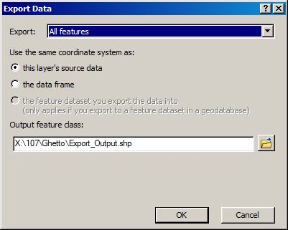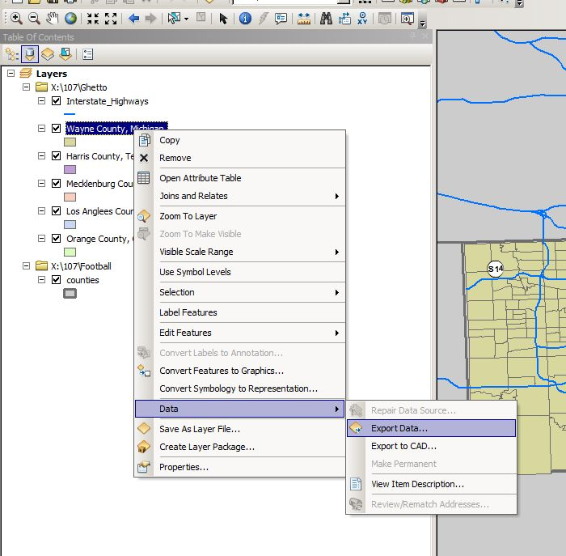

Step 3: Click on the folder icon to the right of the file name (see above). The “Saving Data” window will appear (see below). Click on the “connect to folder” icon. Which appears as a file folder with a plus sign on it.

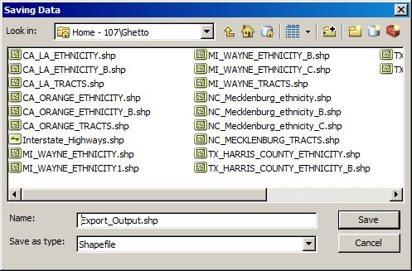

Step 4. A “The folder can’t be used” error window may appear…. Click OK. 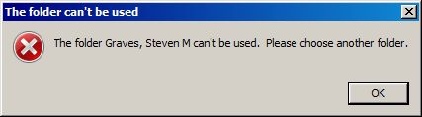

Step 5. From the list of options in the “Connect to Folder” window, click on Computer

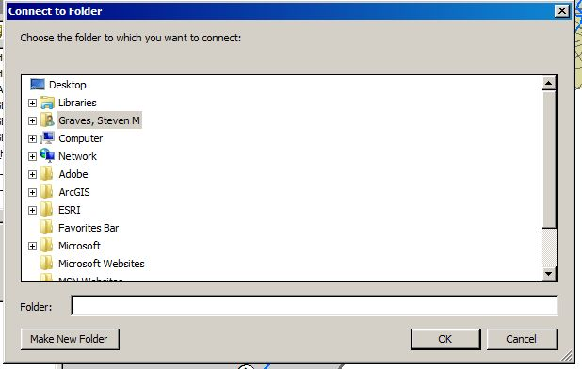

Your name

Step 6: From the list of drive options on your computer, a good place to save is on the one highlighted below, the “My Documents” on the (\\vslfiles.csun.edu\) drive. Click OK.

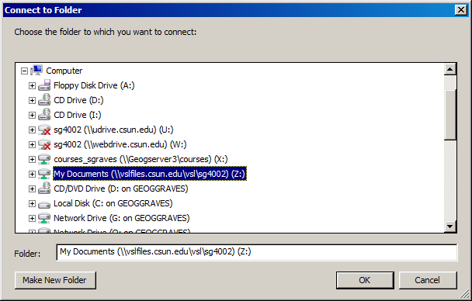

Step 7: Once you’ve connected to your VSL Z drive, then you can select it from the list of drives in the Saving Data Window.

Step 8: Save the file with the name “MI_Wayne”. Click save and agree to add the new layer to your map project.

