[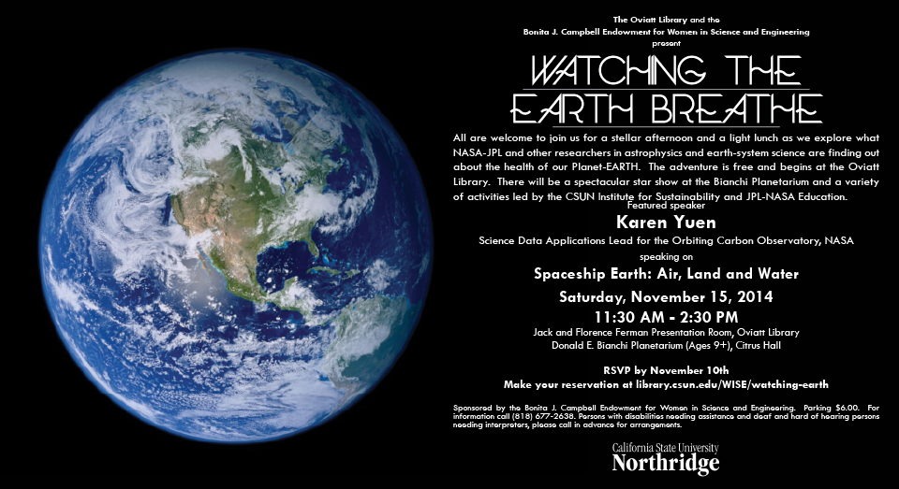](file:///C:\Users\Susan%20Belgrad\Desktop\my%20webs\Images\WISEEarthPostcardemail.pdf)