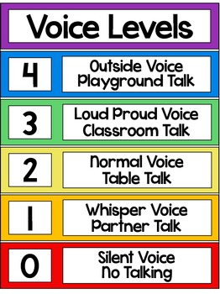

https://www.google.com/search?q=voice+level+poster&client=safari&hl=en&tbm=isch&tbo=u&source=univ&sa=X&ei=8qr_Uu_NIMbEoASCm4DQAQ&ved=0CCkQsAQ&biw=939&bih=585