Joint, Hybrid, K-6 STEM Master’s Degree Program

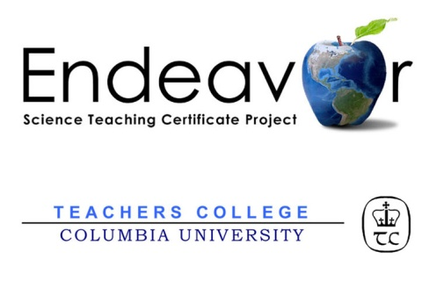
The Endeavor Science Teaching Certificate Project, sponsored by NASA, and California State University Northridge (CSUN) have teamed up to offer YOU an exciting, new Master’s Degree focused on Elementary STEM Education.
Apply now for CSUN’S Masters of Arts in Elementary Education. This exciting partnership also allows you to earn Endeavor’s prestigious STEM Education Leadership Certificate granted by Teachers College, Columbia University.

Who should apply?

K-6 educators interested in CSUN’s coursework integrated with STEM content and pedagogy –into- practice will benefit from: 1) live and online sessions; 2) asynchronous (non-live) online discussions;
3) exclusive STEM resources; and 4) the interaction with NASA experts and others.

The majority of participants include elementary generalists, technology educators, special education educators, and science and mathematics coaches, some new to STEM Education.

How long does it take?

Complete the complete program in four (4) semesters.

What else do I get?

A mentor, a STEM Education graduate, a peer from NASA Endeavor upon enrollment

A national online community of practice of like minded educators

NEXT STEPS?

For information on Enrollment: CALL (818 677-2621); Sign Up to attend a 20-minute, ONLINE orientation visit: http://stemedmasters.org/csun/

Semester 1- SPRING 2014 | Units
EED 601 (STEM Education) Curriculum,  Instruction and the Reflective Teacher   Integrates Methods of STEM Education | 3
EED 610 Research Methods | 3
CSUN Courses are administered in 8- week periods. Total: 6
Total Cumulative: 6
Semester 2- SUMMER 2014 | Units
NASA/Endeavor ELECTIVE #1 | 3
NASA/Endeavor ELECTIVE #2 | 3
EED 648 Seminar in ScienceMethods | 3
EED 698A Inquiry Project | 1
Total: 10
Total Cumulative: 16
Semester 3– FALL 2014 | Units
EED 602 Applications of Technology | 3
NASA/Endeavor The "E" in STEM:  Meaningful Content for Engineering | 3
EED 675 Multicultural Seminar | 3
CSUN Courses are administered in 8- week periods Total: 9
Total Cumulative: 25
Semester 4 - SPRING 2015 | Units
EED 643 Seminar in Mathematics Methods | 3
EED 698B Inquiry Project - Integrates NASA/  Endeavor STEM Leadership in Elementary Ed. | 2
CSUN Courses are administered in 8- week periods Total: 5
Total Cumulative: 30

