**Source Information Sheet**

* Conservation – not using consumer energy products (for example, turning lights off, walking instead of driving)
* Efficiency – benefiting from the value of using energy (for example, still being mobile), but consuming much less energy to meet same goal (for example, using an automobile with high miles per gallon)

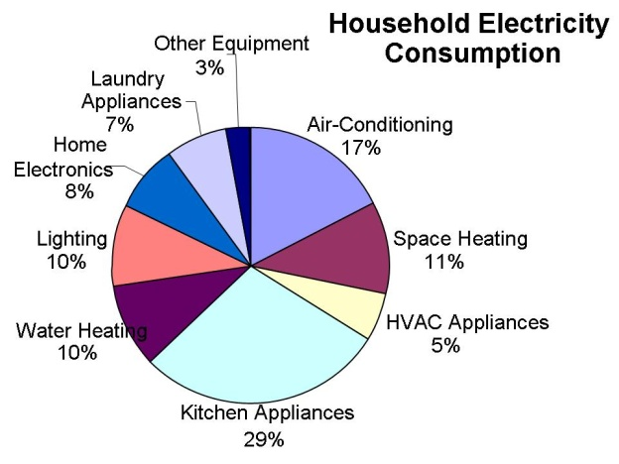  
Household electricity use in the U.S.

We use energy in our lives everyday. Our homes use energy in many ways. Home heating/cooling systems are the largest consumer of energy in most U.S. households. Heating water is also a large energy consumer.

Another large energy consumer category is electric lighting and appliances. (Refer to data in the Excel graphing activity, lesson 1, for specific information.) Our homes are filled with appliances that use electrical energy to work for us. Toasters, microwave ovens, televisions and computers are examples of the appliances we use everyday. We compare electrical energy use in units called watt-hours or kilowatt-hours. Lighting accounts for 20-25% of all the electricity used in the U.S. On average, a household uses 5-10% of its energy for lighting. A commercial industry on the other hand consumes 20-30% of its energy in lighting alone; 50% or more of the energy used is *wasted by obsolete equipment, inadequate maintenance, or inefficient use.*

Consumer demand for appliances that turn on quickly and LED lights that stay on all the time creates a constant "stand by" power requirement that can be very substantial. This power is sometimes called "leaking electricity." Unplugging these appliances is the only way to reduce the stand by power load. (Show some examples on computer, TV, other appliances that might be in the classroom.)

Energy savings for lighting will require either reduction in use or more *efficient*usage. New technologies have provided significant reductions in the power needed for lighting.

KEY TERMS

|  |  |  |  |  |
| --- | --- | --- | --- | --- |
| Force | A force is a push, pull, or twist | | =mass x acceleration | Newton (N) =kg/m/s2 |
| Joule | the SI unit for energy and work. | |  | J = W·s = N·m |
| Energy | the ability to do work | | =power x time | Joule |
| Work | Work is a force acting over a distance to move an object | | = force x distance | Joule (J) |
| Power | The rate at which work is done | | = work / time (or =energy/time) | Watt = J/s |
| Meter | the SI (Standard International) unit for distance | |  | m |
| Kilogram | the SI unit for mass | |  | kg |
| Btu | The amount of energy needed to raise 1 lb of water 1 degree Fahrenheit (1 Btu ~ heat energy from one wooden match) | |  | 1 Btu = 1055 Joules |
| Kilowatt | Typical unit for electrical power | |  | 1 kW = 1000 watts |
| Horse power | Unit for mechanical or electrical power | |  | 1 hp = 746 watts |
| Kilowatt hour | | Typical unit for electrical energy |  | kWh |

Lesson Background and Concepts for Teachers

The use of electricity in the home was addressed in the graphing activity of lesson 1. Many of the concepts covered here were introduced (superficially) in that lesson. The general concepts of this lesson include:

1. Energy conservation can be defined as the protection, preservation, management, or restoration of our energy resources.
2. Conservation is one of the ways we can reduce energy use, thus reducing the amount of pollutants put into our atmosphere from the burning of fossil fuels and reducing the negative effects resulting from the combustion of these fuels.
3. Conservation methods include modifications to our daily behaviors to reduce energy consumption (for example, turning off lights).
4. Efficiency can be achieved by choosing energy-efficient products. These products still provide work, light or heat, but do so with less energy consumption than less-efficient products.

* The U.S. EPA and U.S. Doe have a rating system to label energy efficient products and appliances. See EnergyStar at[http:/.www.energystar.gov](http://www.energystar.gov/)
* Changing light bulbs to CFLs is one way to increase the efficiency of light bulb use. As shown in the light bulb options information provided below, many engineering advances in lighting systems have occurred recently. Learn about Energy Star light bulb ratings at <http://www.energystar.gov/index.cfm?fuseaction=find_a_product.showProductGroup&pgw_code=LB>

**Light Bulb Options**

75W incandescent equivalent bulbs

Compact fluorescent light bulbs (CFLs)

See photo and product description at EarthEasy's website: <http://eartheasy.com/live_energyeff_lighting.htm>

* Wattage: 18 W (76% energy savings)
* Lasts: 8,000 hours
* Cost: $22 per pack
* Requires special bulb recycling to collect and contain mercury

Cold cathode fluorescents (CCFLs)

18 watts = 75 watt incandescent equivalent

See photo and product description at BetterBulb at: <http://ww31.betterbulb.com/>

* Wattage: 18 W (76% energy savings)
* Lasts: 25,000 hours
* Low energy costs; less mercury then CFLs

Light Emitting Diode (LED)

The 5 Watt LED light:

* is efficient and cost effective
* is the most powerful direct replacement bulb
* fits standard sockets

See photo and product description at EarthTechProducts at: <http://www.earthtechproducts.com/energy-saving-led-light-bulbs.html>

* Wattage: 5 W (93% energy savings)
* Cost: $60
* No mercury; expensive

Vocabulary/Definitions

|  |  |
| --- | --- |
| [*compact fluorescent lamp (CFL)*](https://en.wikipedia.org/wiki/Special:Search?search=compact%20fluorescent%20lamp%20(CFL))*:* | A modern light bulb that converts electricity into light through the excitation of |
| [*energy audit*](https://en.wikipedia.org/wiki/Special:Search?search=energy%20audit)*:* | A study of energy use and losses in a home, business or other system. |
| [*incandescent bulb*](https://en.wikipedia.org/wiki/Special:Search?search=incandescent%20bulb)*:* | Traditional light bulb that converts electricity to light by heating a thin wire until it glows. |
| [*LED*](https://en.wikipedia.org/wiki/Special:Search?search=LED)*:* | A light emitting diode is a solid-state semiconductor device that converts electrical energy directly into light. The process of an electron moving in the semi-conductor releases energy and produces photons with visible wavelengths. |
| [*life cycle cost analysis*](https://en.wikipedia.org/wiki/Special:Search?search=life%20cycle%20cost%20analysis)*:* | Analysi |

Key Terms