**Observer**

**CHECKLIST OF NON-COGNITIVE FACTORS**

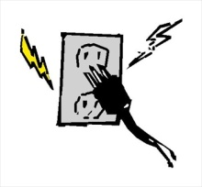

KILL-A WATT: ENEGY CONSERVATION

Place a ✓ each time you observe the behavior during the activity

|  |  |  |  |  |
| --- | --- | --- | --- | --- |
| Team Names |  |  |  |  |
| Stayed in your role helping your group complete the task on time |  |  |  |  |
| Used your 6” voices and used attentive listening strategy; |  |  |  |  |
| Helped your group with other difficult tasks; |  |  |  |  |
| Used encouragement with group members; |  |  |  |  |
| Disagreed with the idea not the person; |  |  |  |  |
| Persisted to solve problems. |  |  |  |  |
| Tally times observed |  |  |  |  |
|  |  |  |  |  |

Group Name: ___________________________________

Observer instructions: Keep notes on when you see any member engaged in the behavior (place a slash mark in the box below. Then rate your team overall for having engaged in these behaviors.

Note: As an observer, you cannot remind them that you are tallying these observations☺