**Teachers’ Directions for Student PBL on Energy Conservation**

(Note: Teachers select and convert to leveled reading text for their students. See the Energy Efficiency STEM Integrated Lesson Plan for where to introduce this important section.

**Motivation**

We are currently highly dependent on fossil fuels for most of our energy supply—this energy is instrumental for maintaining our current society. However, our supply of non-renewable energy sources is being depleted and may even reach a point at which its limited supply adversely affects our lives. The rapid depletion of fossil fuels stems in part from our current energy use habits. For example, the average American uses six times the amount of energy as the global average. Another way to describe this is that we use one million dollars worth of energy every minute in the US.

We can work to continue to use energy as appropriate in our everyday lives, but we need to make changes to conserve energy, use energy more efficiently or provide additional renewable energy resources that are technologically available to consumers. As individuals, we can make changes in our own lives and we can make decisions about our future profession to help solve our growing energy crisis.

(Introducing these statistics and the importance of energy in our lives can be accomplished with one of two engaging activities. It is critical for students to appreciate the importance of energy in their lives early in the unit. Starting the class with questions like "How did you get to school today?" or "What energy did you use this morning to get ready for school?" and "Where did that energy come from?" are good ways to get the students started thinking about energy topics. The two possible first day activities are excellent ways to begin this discussion.

Information published by the US DOE on their kids' energy web page is the best place to find information and interesting energy facts for middle school aged students.)

**Background**

People in the US use, on average, six times the energy consumed by the average of all other people in the world. This energy is consumed in three primary ways: buildings, transportation and industry (see Figure 1). Each of these sectors is responsible for approximately one-third of the total energy our nation consumes.

Figure 1. Relative energy use by sector (data from US DOE EIA).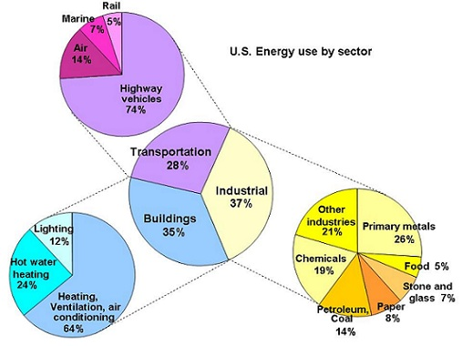

This national energy consumption includes all the energy we use as individual consumers, and all of the energy required to run businesses and industry. Figure 2 shows how we primarily use energy in our households. Heating and cooling contributes the most to household energy consumption. Thus, insulating a house is often the most effective way to reduce household energy consumption.

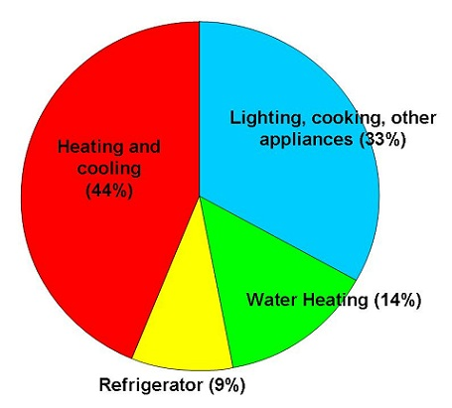

Figure 2. Household energy use in the U.S.

When we buy items, whether it's food grown on the opposite side of the country, or an automobile, a lot of energy is consumed in the production and manufacturing of these goods. The energy that is consumed in the "upstream" processes, is often called the embodied energy. It is important to consider this energy ,too, not just the energy consumed when using a product. For example, consuming food requires energy for growing the food (producing fertilizer, tractor fuel), transportation (refrigerated trucking), processing, storage, and cooking, among others.

Overall, the key concepts that are most critical that the PBL lessons include are:

1. Energy is a critical resource that is used in all aspects of our daily lives.
2. Currently, society is highly dependent upon nonrenewable energy resources, mainly fossil fuels.
3. The world's supply of nonrenewable resources is limited and their use can negatively affect our environment and economy.
4. Our personal choices affect the future of the world's energy.
5. Making smart energy decisions today are beneficial later.
6. Energy is consumed not only when we plug an appliance into an outlet or turn on our cars (direct energy use), but also through the production and transportation of material good