**Teacher Resource Information**

* Conservation – not using consumer energy products (for example, turning lights off, walking instead of driving)
* Efficiency – benefiting from the value of using energy (for example, still being mobile), but consuming much less energy to meet same goal (for example, using an automobile with high miles per gallon)

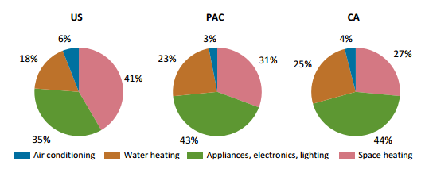

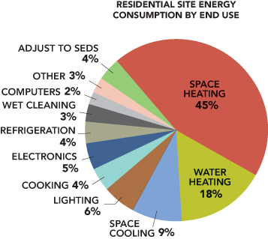

Household electricity use in the U.S.

We use energy in our lives every day. Our homes use energy in many ways. Home heating/cooling systems are the largest consumer of energy in most U.S. households. Heating water is also a large energy consumer. Recently appliances, electronics and lighting electricity use are approaching those of space heating. Energy consumption breakdown varies regionally due to the range of climate conditions across the U.S. and in California electricity use from appliances outweighs that from heating.

Our homes are filled with appliances that use electrical energy to work for us. Toasters, microwave ovens, televisions and computers are examples of the appliances we use every day. (Refer to data in the Excel graphing activity, lesson 1, for specific information.) We compare electrical energy use in units of watt-hours (watts x hours of use) or kilowatt-hours. Lighting accounts for 15% of all the electricity used in residences and commercially the U.S[1]. On average, a household uses 14% of its energy for lighting. A commercial industry on the other hand consumes around 20% of its energy in lighting alone; 50% or more of the energy used is *wasted by obsolete equipment, inadequate maintenance, or inefficient use.* This wasted energy goes into heat. (Think about how hot light bulbs get!)

Consumer demand for appliances that turn on quickly and lights that stay on all the time creates a constant "stand by" power requirement that is sometimes called "leaking electricity." Unplugging appliances is the only way to reduce the standby power load. (Show some examples on computer, TV, other appliances that might be in the classroom.) New lighting technologies including CFL bulbs, LED bulbs and “smart” lighting can save up to 85% of the energy used in lighting. Other energy savings in the home include: attic and wall insulation, dual-paned windows, weather stripping, energy star appliances such as refrigerators, air conditioners, freezers, clothes washers. There are many rebates and incentives available to SCE and LADWP customers to save energy. See list of resources below.

|  |  |  |  |
| --- | --- | --- | --- |
| Energy, work | the ability to do work, exertion involving physical effort,  force x distance |  | * Joule or newton-meter (SI unit) * watt-hours (Wh) or kilowatt-hours (kWh) (utility company and personal units) * British thermal units (Btu) (U.S. energy or heat unit) * therms (U.S. used for energy or heat from natural gas) * calories (used for energy from heat or food) |
| power | The rate at which work is done or at which energy is used |  | * watt (= joule per second) (SI unit) * kilowatt (1000 watts) * horsepower (745.7 watts) |

**Lesson Background and Concepts for Teachers**

The use of electricity in the home was addressed in the graphing activity of lesson 1. Many of the concepts covered here were introduced (superficially) in that lesson. The general concepts of this lesson include:

1. Energy conservation can be defined as the protection, preservation, management, or restoration of our energy resources.
2. Conservation is one of the ways we can reduce energy use, reducing the amount of pollutants put into our atmosphere from the burning of fossil fuels and reducing the negative effects resulting from the combustion of these fuels. Fossil fuels are the primary cause of climate change. By reducing our energy demand and reducing the use of fossil fuels we will reduce the severity of climate change.
3. Conservation methods include modifications to our daily behaviors to reduce energy consumption (for example, turning off lights).
4. Efficiency can be achieved by choosing energy-efficient products. These products still provide work, light or heat, but do so with less energy consumption than less-efficient products.

* Inefficiency amounts to energy lost, i.e. energy which is not doing useful work. This energy is wasted as heat.
* The U.S. EPA and U.S. DOE have a rating system to label energy efficient products and appliances. See EnergyStar at [http:/www.energystar.gov](http://www.energystar.gov/)
* Changing light bulbs to CFLs or LEDs are one way to increase the efficiency of lighting. As shown in the light bulb options information provided below, many engineering advances in lighting systems have occurred recently. Learn about Energy Star light bulb ratings at <http://www.energystar.gov/index.cfm?fuseaction=find_a_product.showProductGroup&pgw_code=LB>

**Local energy savings resources:**

Product marketplace for energy efficient products (refrigerators, televisions, lighting): <https://ladwp.enervee.com/>

**Lighting Efficiencies:**

Incandescent: 10% efficient (90% of energy is lost as heat)

CFLs: About 75% more efficient (use 25% of the energy for same amount of light)  
LEDs: 85-90% more efficient (use 15% of the energy for the same amount of light)

**Lifetime savings:**

CFLs: $45 (9 years)

LEDs: $150 (25 years)

**LADWP’s Home Energy Improvement Program:**

A free program for LADWP customers. An assessment of your home will be performed by trained technicians to identify the most appropriate and effective improvements. Energy improvement work is performed for free. <https://www.ladwp.com/ladwp/faces/ladwp/residential/r-savemoney/r-sm-rebatesandprograms/r-sm-rp-homeenergyimprovementprogram>

**LADWP’s Refrigerator Rebate Program:**

Older model refrigerators are replaced with new, energy-saving, ENERGY STAR® rated refrigerators, FREE of charge for non-profits and income-qualified residents.

<https://www.ladwp.com/ladwp/faces/ladwp/residential/r-savemoney/r-sm-rebatesandprograms/r-sm-rp-lowincomerefrigeratorexchangeprogram?_adf.ctrl-state=8oe0kk94a_4&_afrLoop=375638255604177>

**Free trees:**

LADWP is giving out free shade trees to residents for streets or yards: **www.cityplants.org**

**Vocabulary:**

|  |  |
| --- | --- |
| [*compact fluorescent lamp (CFL):*](https://en.wikipedia.org/wiki/Compact_fluorescent_lamp) | The principle of operation in a CFL bulb remains the same as in other fluorescent lighting: electrons that are bound to mercury atoms are excited to states where they will radiate ultraviolet light as they return to a lower energy level; this emitted ultraviolet light is converted into visible light as it strikes the fluorescent coating on the bulb. |
| [*energy audit*](https://en.wikipedia.org/wiki/Special:Search?search=energy%20audit)*:* | A study of energy use and losses in a home, business or other system. |
| [*incandescent bulb*](https://en.wikipedia.org/wiki/Special:Search?search=incandescent%20bulb)*:* | Traditional light bulb that converts electricity to light by heating a thin wire until it glows. |
| [*Light-emitting diode (LED*](https://en.wikipedia.org/wiki/Special:Search?search=LED)*):* | A light emitting diode is a solid-state semiconductor device that converts electrical energy directly into light. The process of an electron moving in the semi-conductor releases energy and produces photons with visible wavelengths. |
| [*life cycle cost analysis*](https://en.wikipedia.org/wiki/Special:Search?search=life%20cycle%20cost%20analysis)*:* | Analysis of the full cost (environmental and $) of a product taken from its creation to disposal. |

1. https://www.eia.gov/tools/faqs/faq.cfm?id=99&t=3