**LADWP SCHOOL – COMMUNITY PARTICIPATION IN SUSTAINABLE WATER AND ENERGY PROJECT**

**PROPOSED TIMELINE**

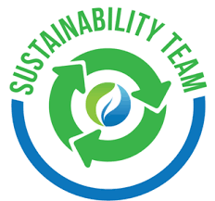

|  |  |  |  |
| --- | --- | --- | --- |
| **WHAT** | **WHO** | **WHERE** | **WHEN** |
| Professional Development On Sustainable Activities, Project Based Learning And Creating Your Own Teacher Googlesite | CSUN Faculty  Project Teachers | CSUN CAMPUS ED 2107  Stonehurst Elementary School | SATURDAY, JANUARY 16  MARCH __ TBD |
| School-based grade level development of PBL unit addressing conservation of water or energy | Project Teachers  CSUN Coordinator  School K-12 Students | Each Participating School Campus | FEBRUARY -APRIL |
| School-based Assembly or Family Nights showcasing K-12 student home-school projects addressing conservation of water or energy. | Project Teachers  School K-12 Students  CSUN Faculty | Each LAUSD Participating School Campus | MARCH-APRIL |
| Earth Day Neighborhood or Community Showcase of K-12 student projects addressing conservation of water or energy. | Project Teachers  School K-12 Students  CSUN Faculty | School Community Events and/or  CSUN Campus Event | EARTH DAY  Friday, April 22  MAY __ TBD |