Multi-mission Image Processing
Solar System Visualization Project

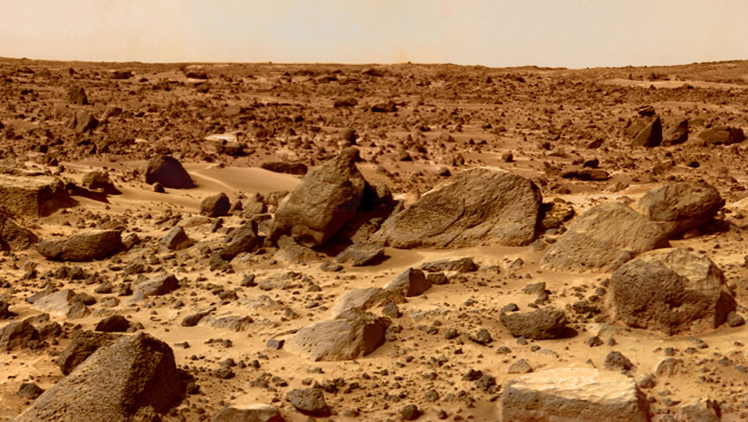

Kindergarten – 3rd Grade
Upper Elementary
Middle School
High School

The Search for Extrasolar Planets
and Possibilities Learning Science and
Math at All Levels

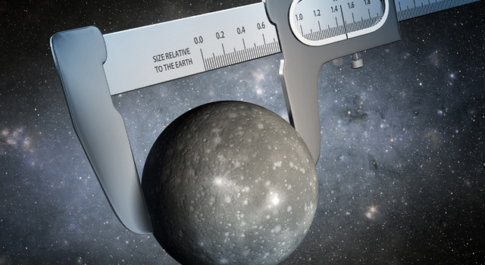

Kindergarten – 3rd Grade
Upper Elementary
Middle School
High School

Rosetta: Landing on a Comet this Fall

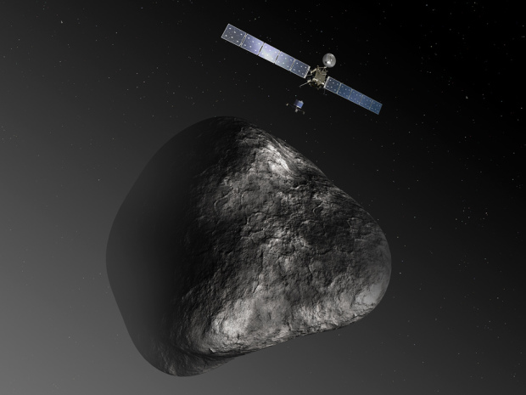

Kindergarten – 3rd Grade
Upper Elementary
Middle School
High School

Exploring the Red Planet

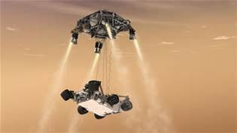

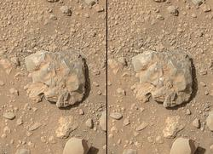

Kindergarten – 3rd Grade
Upper Elementary
Middle School
High School

Cassini Solstice Mission

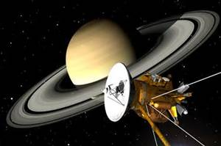
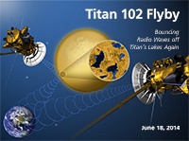

Kindergarten – 3rd Grade
Upper Elementary
Middle School
High School

Scaling the Solar System Bead Distance

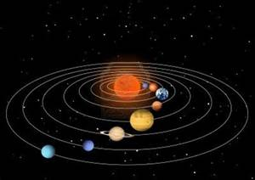

Kindergarten – 3rd Grade
Upper Elementary
Middle School
High School

Measuring Soil Moisture from Space

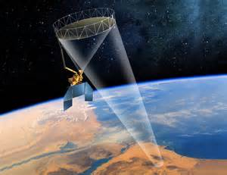

The Global Learning and Observations to Benefit the Environment (GLOBE) program is a worldwide hands-on, primary and secondary school-based science and education program

Kindergarten – 3rd Grade
Upper Elementary
Middle School
High School

Measuring Carbon in the Earth System

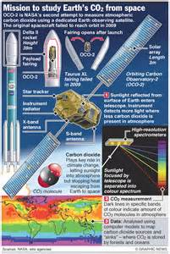

Kindergarten – 3rd Grade
Upper Elementary
Middle School
High School

Near Earth Objects

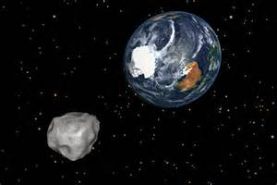

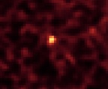

Kindergarten – 3rd Grade
Upper Elementary
Middle School
High School

The Asteroid Redirect Mission

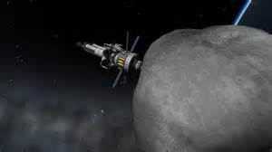

Kindergarten – 3rd Grade
Upper Elementary
Middle School
High School

