Classroom Communication Plan:
Establishing a Caring Classroom
Cozkacuauhtli Huitzilzenteotl
California State University, Northridge

Classroom Communication Plan: Establishing a Caring Classroom
At a time when world economies and the thresholds of respect and tolerance are spiraling downward, schools can make a difference in helping create citizens that are educated and caring. Because schools are where children spend most of their active lives, they should be places where children learn and are respected and validated. Historically, minority children have been underrepresented in the cultural design and function of United States of America’s educational institutions. When colored students were finally allowed to attend U.S. schools, as decided in the 1896 Plessy vs. Ferguson case, schools were racially segregated (Banks, 1981). In the mid-20th century, schools were desegregated with court rulings, such as the Mendez vs. Westminster case and the Brown vs. Board of Education decision (Valencia, 2005). Yet, for ethnic and linguistic minorities education was far from equitable. Furthermore, by the late part of the century, proposition 227 outlawed Non-English languages in schools in California. More recently, the No Child Left-Behind act has come to embody today’s attempt to homogenize U.S. students and thus ignore their cultural and academic needs. Obviously, U.S. citizens and policy makers are slow at brining about changes to make schools more equitable, therefore, the need to create classrooms that are inclusive and respectful has become a priority for caring teachers. In other words, aspects of education that the teacher can control or tailor, such as classroom environments, curriculum, and teaching practices and strategies should all be geared towards the students being serviced. For example, current demographic changes have made it clear that the Hispanics population must be reckoned with. The United States is currently home to 44 million Hispanics, making it the third largest Latino population in the world (Gasbarra & Johnson, 2008). To match current demographic changes, scholars recommend shifting resources to focus on providing a meaningful education to all students―primarily those becoming the majority in schools and cities throughout the nation (Gasbarra & Johnson, 2008; Torres, 2001).
In the eight years that I have been teaching, I have never had a student that was not Hispanic. Although there are distinct regional features amongst Mexicans and some cultural differences between Mexicans and Central Americans, there are major cultural features that interlink us. For example, value systems, gender roles, a communal nature, cultural biases, language, social relationships, learning styles and many other cultural traits are common within the Latino population. Contrastingly, the national educational system doesn’t look for similarities or differences between language and ethnic minorities to better serve them; rather it homogenizes cultures and treats all as the same. Unfortunately, the same is not always equitable. Despite the aforementioned educational dilemmas, I feel that it is the teachers who can help students reconcile cultural and learning mismatches―which can lead to an educational under-service of minorities, an increase in student disinterest in school and antisocial behaviors.
According to Banks (as cited in Gollnick, Klassen, & Yff, 1976, p. 9) multicultural education “helps students clarify their ethnic identities so that they can function in their own ethnic community and learn to function effectively with other ethnic groups.” Following Banks (1986), I feel that a sense self-worth and appreciation and tolerance are acquired through stages, therefore, students’ cultural identities should be a priority in developing individuals equipped with minds that have been opened by cultural dignity. Hence, a focus on reversing negative societal beliefs instilled in children and teachers is possible by setting social norms and instructional practices that clarify students’ cultural identities (Banks, 1986). For purposes of this discussion, I will place major emphasis on the cultural dimension of building a caring classroom. I feel that culture encapsulates key components of self that are systematically dismantled in schools; therefore, teachers need to be cognizant of students’ home cultures, ethnic learning styles, and gauge academic and cultural discourse―all essential in formulating an equitable and respectful learning climate.
Statement of Philosophy
The classroom management plan proposed here is anchored to the notion that the essential function of teachers, classrooms, curriculum, teaching practices, lessons, and strategies is to address the common and unique needs of all students represented in the classroom. Tailoring or personalizing the curriculum and learning environment to meet students’ academic, cultural and social needs, is critical to the development of a caring environment. When lessons and activities are copiloted by academic content and students’ familial knowledge, students come to develop a conceptual understanding of the targeted subject matter and further develop their cultural identities. A learning environment that goes beyond exoticizing students’ cultures (Torres-Guzman & Howes, 2008) and instead is a continuum of their home and community culture, develops in students a sense of ownership of the classroom and of their learning. In this manner, the educator who drives instruction with students’ knowledge and culture is consistently exemplifying what being interested, respectful, and appreciative of others’ cultures looks like and feels like. In an environment where students are respected and have a voice, student generated procedures and rules convey (a) home values and (b) academic and cultural expectations and consequences. To orchestrate an equitable and caring classroom, this proposal offers four suggestions: (a) using teaching practices that incorporate home culture and knowledge, (b) applying teaching styles and methods that match students’ learning styles, (c) monitoring and developing classroom discourse (teacher-student and student-student) to maximize learning and respectful interactions, and (d) engaging students in moral development lessons and activities.
Theoretical Rationale
The theoretical cornerstone of this classroom management proposal is an eclectic one. The following theoretical perspectives: developmental, social learning, multilingual-multicultural, language acquisition, and cultural-historical, have been intermeshed to provide a syntretic knowledge-base from which effective practices, lessons and strategies can be derived.
Some theorists argue that the development of students’ morality or conscience and hence prosocial behavior, assists in diminishing conflicts and antisocial comportment (Termini & Golden, 2007). Understanding, or at least being aware, that a student’s upbringing, personal experiences, genetic makeup and innate temperament are some of the determinants of their manifested behaviors, both prosocial and antisocial (Kochanska & Aksan, 2006; Termini & Golden, 2007). Hence, it is fundamental to provide students a learning environment where moral conscience is developed and it is a social norm to be considerate and caring with one another. As aforementioned, there are effective practices, such as considering students’ home-culture, cognitive and ethnic learning style, and gauging and developing classroom discourse, that assist in creating meaningful instruction and equitable classrooms.
Plan for Creating a Caring Classroom
Personalizing a classroom and its curriculum is not only an effective teaching practice (Kretzmann & McKnight, 1993; Moll, Amanti, Neff, & Gonzalez, 1992), but a powerful gesture of consideration and acknowledgement of an individual’s existence. According to Kohn (2006) creating a caring class describes a relationship between classroom members, teacher included. It entails acquiring sets of social and anger management skills and partaking in ongoing analysis and self-reflections. In this proposal, a caring classroom is also characterized by the teacher’s effort and practices used to create meaningful connections between students’ lives and academic content. Students’ culture, learning styles, and verbal and social interactions are avenues through which cultural dignity, morality and respect can be effectively developed and guided. The following suggestions are based on literature reviewed and my personal experience as a teacher. The actual experience of the educator is a critical component in understanding theories because the validity and applicability of a theory is often supported or called into question once it has been placed into practice.
Home-culture. At the beginning of the school year, my students do not enter a room that is full of commercial posters, rules and expectations; rather the room is somewhat bare. Some multicultural researchers and theorists such as Nieto (1977), suggest building curriculum and environments from students’ cultures and avoiding commercial multicultural materials and plans that usually are “well laid out but sterile” (pp. 5-6). In a sense, the process of students coming into a classroom is similar to moving into a new home. The experience of moving into a pre-furnished space with some type of authoritative figure is an experience socio-emotionally distinct to having the opportunity of building the environment to one’s likings and with the assistance of a facilitator you trust.
Qualitative methods of research, such as home-visits, are effective in attaining community knowledge that makes curriculum engaging and equitable (Gutierrez & Stone, 1998; Kretzmann & McKnight, 1993; Moll, et al., 1992). To make home connections, early in the year teachers can schedule home-visits with available parents in order tailor academic content to students’ familial strengths, talents, and interests. The classroom’s culture needs to reflect the students’ culture. The family connection is a key component, because it is from where teachers can extract students’ personal familial histories, narratives, stories, values, beliefs, talents and knowledge. This student data base or “Funds of Knowledge” (Moll, et al., 1992) drives the curriculum throughout the school year. In this manner, students feel ownership of the class and of the subject areas taught. Using familial and community resources to develop student-centered curriculum and lessons is an attempt to make every aspect of my students’ educational experience relevant and meaningful.
The forming and norming of social skills and intelligent behaviors is a collaborative process in a caring classroom. As a result, all class members need to work together to set up class responsibilities and decide on a rotation schedule so that all students get to circulate through the jobs. Everyone needs to have a position and others will need to be created throughout the year. In a caring class, the classroom guidelines and procedures are generated collaboratively by everyone in the class, including the teacher. In addition, teachers must put an effort to integrate students’ familial history with the curriculum to strengthen their cultural identities and bring academic content to life. For example, teacher-researcher Berriz (2002) found that through autobiographies students “reconnected with family stories and values,” which is critical for the development of cultural identity, particularly for those who have had negative experiences while migrating or living in this country (p. 86). It is in this personalized context that classroom walls begin to exhibit student work, student-generated posters, teacher-student generated criteria charts, rubrics and word walls.
Socially and morally, it is through explicit lessons on moral development and ongoing practice and modeling that students’ dispositions and behaviors become developed and pro-socially sophisticated. Termini and Golden (2007) discuss using stories to develop children’s conscience or “inner guiding systems.” In the stories or narratives the protagonists are described as engaging in antisocial behaviors which serve to engage students in discussions about the “proper” actions or the feeling of the victims. Researchers also recommend using problem solving strategies, contracts, journals and checklist to help students develop needed social and moral skills (see Appendix A).
To further maintain and develop students’ cultural identities and provide equitable learning opportunities, students’ home language needs to be honored in the classroom. While obligated to work within the mandated programs, teachers can turn to research-based language acquisition strategies and practices that assist English language learners working on English tasks. Prominent language acquisition theorists and researchers have documented numerous academic and socio-cognitive benefits associated with the use of students’ L1 (Antón & DiCamilla, 1998; Seng & Hashim, 2006; Swain & Lapkin, 2000). While language acquisition theorists for the most part focus on language instructional models and their effectiveness, and not on their implications on cultural identities, it is the teacher working to bring linguistic equity and diversity that may bring relevant findings to the classroom. Incidentally, researchers recommend permitting students to use their L1 when working collaboratively to clarify instructions, unknown vocabulary meanings and concepts (Seng & Hashim, 2006). Additionally, Burke suggests using bilingual logs and checklists to assist English language learners to accelerate the acquisition of language and academic content (see Appendix B).
Moreover, when students conduct family interviews, its recommend that they take advantage of their bilingual nature and conduct their interviews in the interviewee’s language, which can later be translated if needed. To validate students’ diverse registers of language, during casual group discussions allowing bilingual students to code-switch, as long as they do it per phrase or sentence, is arguably a sound strategy. Moreover, following Gutierrez’ and Stone’s (1998) practice of using languages to validate home-cultures is suggested, therefore, allowing time for bilingual students to discuss other types of speech such as slang and “Spanglish” is also suggested. Overall, the extra effort invested to better meet the cultural-linguistic needs of language minorities not only makes academic content accessible to them, but it develops in students a sense of cultural acceptance.
Ethnic learning style. Diverse socialization and interaction patterns exist. Incidentally, each ethnic group functions more naturally in particular settings. Hispanics and other minorities benefit from social organizations that are primarily group-oriented. For example, students are receptive to group tasks, dialogues, projects, and support (e.g., academic and socio-emotional). According to Castañeda (as cited in Banks, 1981, p. 30), Mexican-American youths rather work collaboratively on tasks and develop strong emotional ties to their peers because of their ethnic cognitive style. On the other hand, Castañeda describes Anglos’ cognitive style as “field-independent,” which entails behavior that is competitive and self-gratifying. Current educational institutions teach to the style belonging to the dominant culture and teachers are the only ones who could possibly care enough to create activities that match students’ learning styles. In regards to social interactions, Gutierrez and Stone, (1998) describe activities as “social practices that include norms, values, division of labor and community goals” (pp. 3-4). It is important for activities to reflect students’ cultural and social norms because if they are not maintained, then they will lose part of their identity.
To establish a caring and group-oriented classroom, the development of cooperative learning strategies needs to be ongoing and consistently modeled and upheld by the teacher. To Hispanics, ser educado, “to be educated,” essentially means (a) to be a studied person and (b) to be respectful and courteous to others. Upholding such cultural definitions is meaningful to students. Therefore, it is effective to draw “common courtesies” from students’ home-cultures to implement in everyday dealings within the class. In this manner, the classroom’s socialization norms and procedures feel natural and are quickly set. A component that overlaps students’ language development and use, as well as, their ethnic socio-learning styles is classroom discourse. This is another component critical in establishing a caring classroom.
Academic and Cultural Discourse. The analysis of classroom discourse has led me to understand the complexities of student interaction and the cultural implications of dialogue. In Western societies, both tendencies: to dominant conversations and the desire to outperform peers are culturally driven (Rosenthal, 1996). Contrastingly, Hispanic students, as do other minorities, often come from homes and cultures that place major emphasis on communal work and thus problems are solved collectively. The nature of the interaction and the individual’s objective (i.e., to win or collaborate) determines the type of student-student discourse that will take place. Being aware of this is essential in building lessons and activities that promote equity and respect during team and classroom discussions. The analysis of classroom discourse can reveal if the groupings are “symmetrical,” or equitable, in terms of student participation in the team’s discourse (Lier, 2001). For example, through discourse analysis teachers can figure out which students dominate conversations and who imposes their views onto others. It appears that when there are certain differences amongst the participants (i.e., cultural, language proficiency, and gender), that the generated discourse tends to be inequitable and non-contingent. Contingency is experienced when discourse in characterized by “utterances created on the spot” rather that searching for pre-learned and preplanned responses” (Lier, p. 99).
Unbalanced or asymmetrical discourse results in nonparticipants, simplistic thinking or competitive discourses. Cultural-historical theorists Gutierrez and Stone (1998) document how discourse occurs within three types of “social spaces.” The official space is where the discourse is teacher-dominated and students are passive, the unofficial is where students who do not identify with the institutional practice or knowledge tend to engage in their own discourse, and the third space is where students engage in a genuine conversation (Gutierrez & Stone, 1998, pp. 9-11). Asymmetrical discourse can also result from teacher-dominated conversations and from heterogeneous groupings, because at times certain students take control of the dialogue. Surprisingly, homogeneous groups can very well generate authentic and contingent discourse (Lier, 2001). Perhaps it is impossible to create fully symmetrical and contingent conversations, but awareness of such leads teachers to try different grouping arrangements and not stick to one particular type, such as, heterogeneous groups.
Teachers keen and sensitive to the type of discourse taking place in the class allow for them to empower students who are normally dominated. Caring teachers are thus able to validate students’ opinions and guide them towards becoming respectful and democratic when conversing and academically arguing. Improving classroom discourse is a complicated task, therefore, ongoing analysis of classroom discourse can help in providing students culturally-tailored discourse arrangements. Furthermore, for students to respect each other’s opinions and thoughts can essentially come to care about other’s feelings and outlooks.
Teacher Reflection
It is imperative for teachers to partake in an on-going analysis of their teaching practices and their students’ learning. Keeping note of the effects that the tasks, discourse, and environment are having on students’ social skills and attitudes is crucial in ensuring a caring classroom. Kazemi (1998) and Van Zoest and Enyart (1998) suggest analyzing classroom discourse (e.g., by audio recording a lesson) and rating or identifying the type of questions being asked of students and the type of discourse they are engaging in. They further recommend setting personal goals to gradually improve classroom discourse: teacher-student and student-student. Identifying aspects of instruction that hinder, or assist, the development of students’ genuine interest in learning, determines if lessons need to be modified or built upon for future instruction.
The ongoing analysis of the teaching and learning taking place is fundamental to effective teaching. It is the only way to measure if short and long-term goals are being met. While teaching, teachers apply educational, linguistic, psychological, and an array of other theories daily and their effectiveness needs to be gauged in order to adequately change practices, lesson plans, and discourse to better scaffold students’ conceptual understanding of social norms and academic knowledge. Another way to assess teaching and learning is analyzing student work samples and social-interaction skills. Socially, for example, teachers can analyze student journals, logs and checklists (see Appendix C) utilized during conflicts and lessons on moral development.
It is difficult to isolate practices that develop caring individuals from practices that aim to improve academic performance. Because a classroom is micro-sample of larger society, developing a caring class is, essentially, an effort to improve our societal relations and interactions. Furthermore, if students feel cared for and learn to care for others, it is plausible that their “new” sense of worth will enable them to perform to their fullest potential.

References
Antón, M., & DiCamilla, F. (1998). Socio-cognitive functions of L1 collaborative interaction in the L2 classroom. The Canadian Modern Language Review, 54, 314-42.
Banks, J. A. (1981). Social problems and educational equity in the eighties. [Electronic version] Presented at a Working Meeting of the School of Finance Project, United States Department of Education, Washington, DC. (ERIC Document Reproduction Service No. ED220366)
Banks, J. A. (1986). Cultural diversity in western societies: Challenges and opportunities. [Electronic version] Presented at the Annual Meeting of the Association for Supervision and Curriculum and Development, San Francisco, CA. (ERIC Document Reproduction Service No. ED274577)
Burke, K. (2008). What to do with the kid who (3rd ed.). Thousand Oaks, CA: Corwin Press.
Gasbarra, P. & Johnson, J. (2008). Out before the game begins: Hispanic leaders talk about what’s needed to bring more Hispanic youngsters into science, technology and math professions. Presented at America’s Competitiveness: Hispanic Participation in Technology Careers Summit, IBM Executive Conference Center, Palisades, NY.
Gollnick, D., Klassen, F. H., & Yff, J. (1976). Multicultural education and ethnic studies in the United States: An analysis and annotated bibliography of selected ERIC documents. Washington, D.C.: American Association of Colleges for Teacher Education, Ethnic Heritage Center.
Gutierrez, K., & Stone, L. D. (1998). An emerging methodology for cultural-historical perspectives on literacy learning: Synchronic and diachronic dimensions of social practice [Electronic version] Unpublished manuscript, University of California, Los Angeles. (ERIC Document Reproduction Service No. ED426935)
Kazemi, E. (1998). Discourse that promotes conceptual understanding. Teaching
Children Mathematics, 4(7), 10-14.
Kochanska. G. & Aksan, N. (2006). Children’s conscience and self-regulation. Journal of Personality, 74, 1578-1618.
Kohn, A. (2006). Beyond discipline: From compliance to community. Alexandria, Virginia: Association for Supervision and Curriculum Development.
Kretzmann, J. P., & McKnight, J. L. (1993). Building communities from the inside out: A path toward finding and mobilizing community assets. Chicago: ACTA Publications.
Lier, L. V. (2001). Constraints in classroom talk: Issues of equality and symmetry. In Candlin, C. and Mercer, N. (Ed.) English teaching in its social context.
Moll, L. C, Amanti, C., Neff, D., & Gonzalez, N. (1992). Theory Into Practice, 31(2), 132-141.
Nieto, S. (1977). Developing curriculum for the bilingual classrooms: Toward defining the role of the teacher. [Electronic version] Presented at the Symposium on Spanish and Portuguese Bilingualism, Amherst, MA. (ERIC Document Reproduction Service No. ED200062)
Rosenthal, J. W. (1996). Teaching science to language minority students. Philadelphia, PA: Multilingual Matters, Ltd.
Seng, G. H., & Hashim, F. (2006). Use of L1 in L2 reading comprehension among tertiary ESL learners. Reading in a Foreign Language, 18(1), 29-53.
Swain, M., & Lapkin, S. (2000). Task-based second language learning: the uses of the first language. Language Teaching Research, 4, 251-74.
Termini, K. A. & Golden, J. A. (2007). Moral behaviors: What can behaviorist learn from the developmental literature? International Journal of Behavioral Consultation and Therapy, 3(4), 477-493.
Torres, C. C. (2001). Latinos in the south: Trends and outcomes. [Electronic version] Presented at the Annual Meeting of the Southern Rural Sociological Association, Fort Worth, TX. (ERIC Document Reproduction Service No. ED456961)
Torres-Guzman, M. E. & Howes, E. V. (2008). Experimenting in teams and tongues: Team teaching a bilingual science education course. In K. R. Bruna and K. Gomez (Ed.), The work of language in multicultural classrooms: Talking science, writing science (p. 317). New York: Routledge.
Valencia, R. (2005). The Mexican American struggle for equal educational opportunity in Mendez v. Westminster: Helping to pave the way for Brown v. the Board of Education. Teacher's College, 107(3), 389.
Van Zoest, L. R., & Enyart, A. (1998). Discourse, or course: Encouraging genuine mathematical conversations. Mathematics teaching in the middle school, 4(3), 150-157.

Appendixes

Appendix A
Burke’s Problem Solving Journals, Contract and Checklists
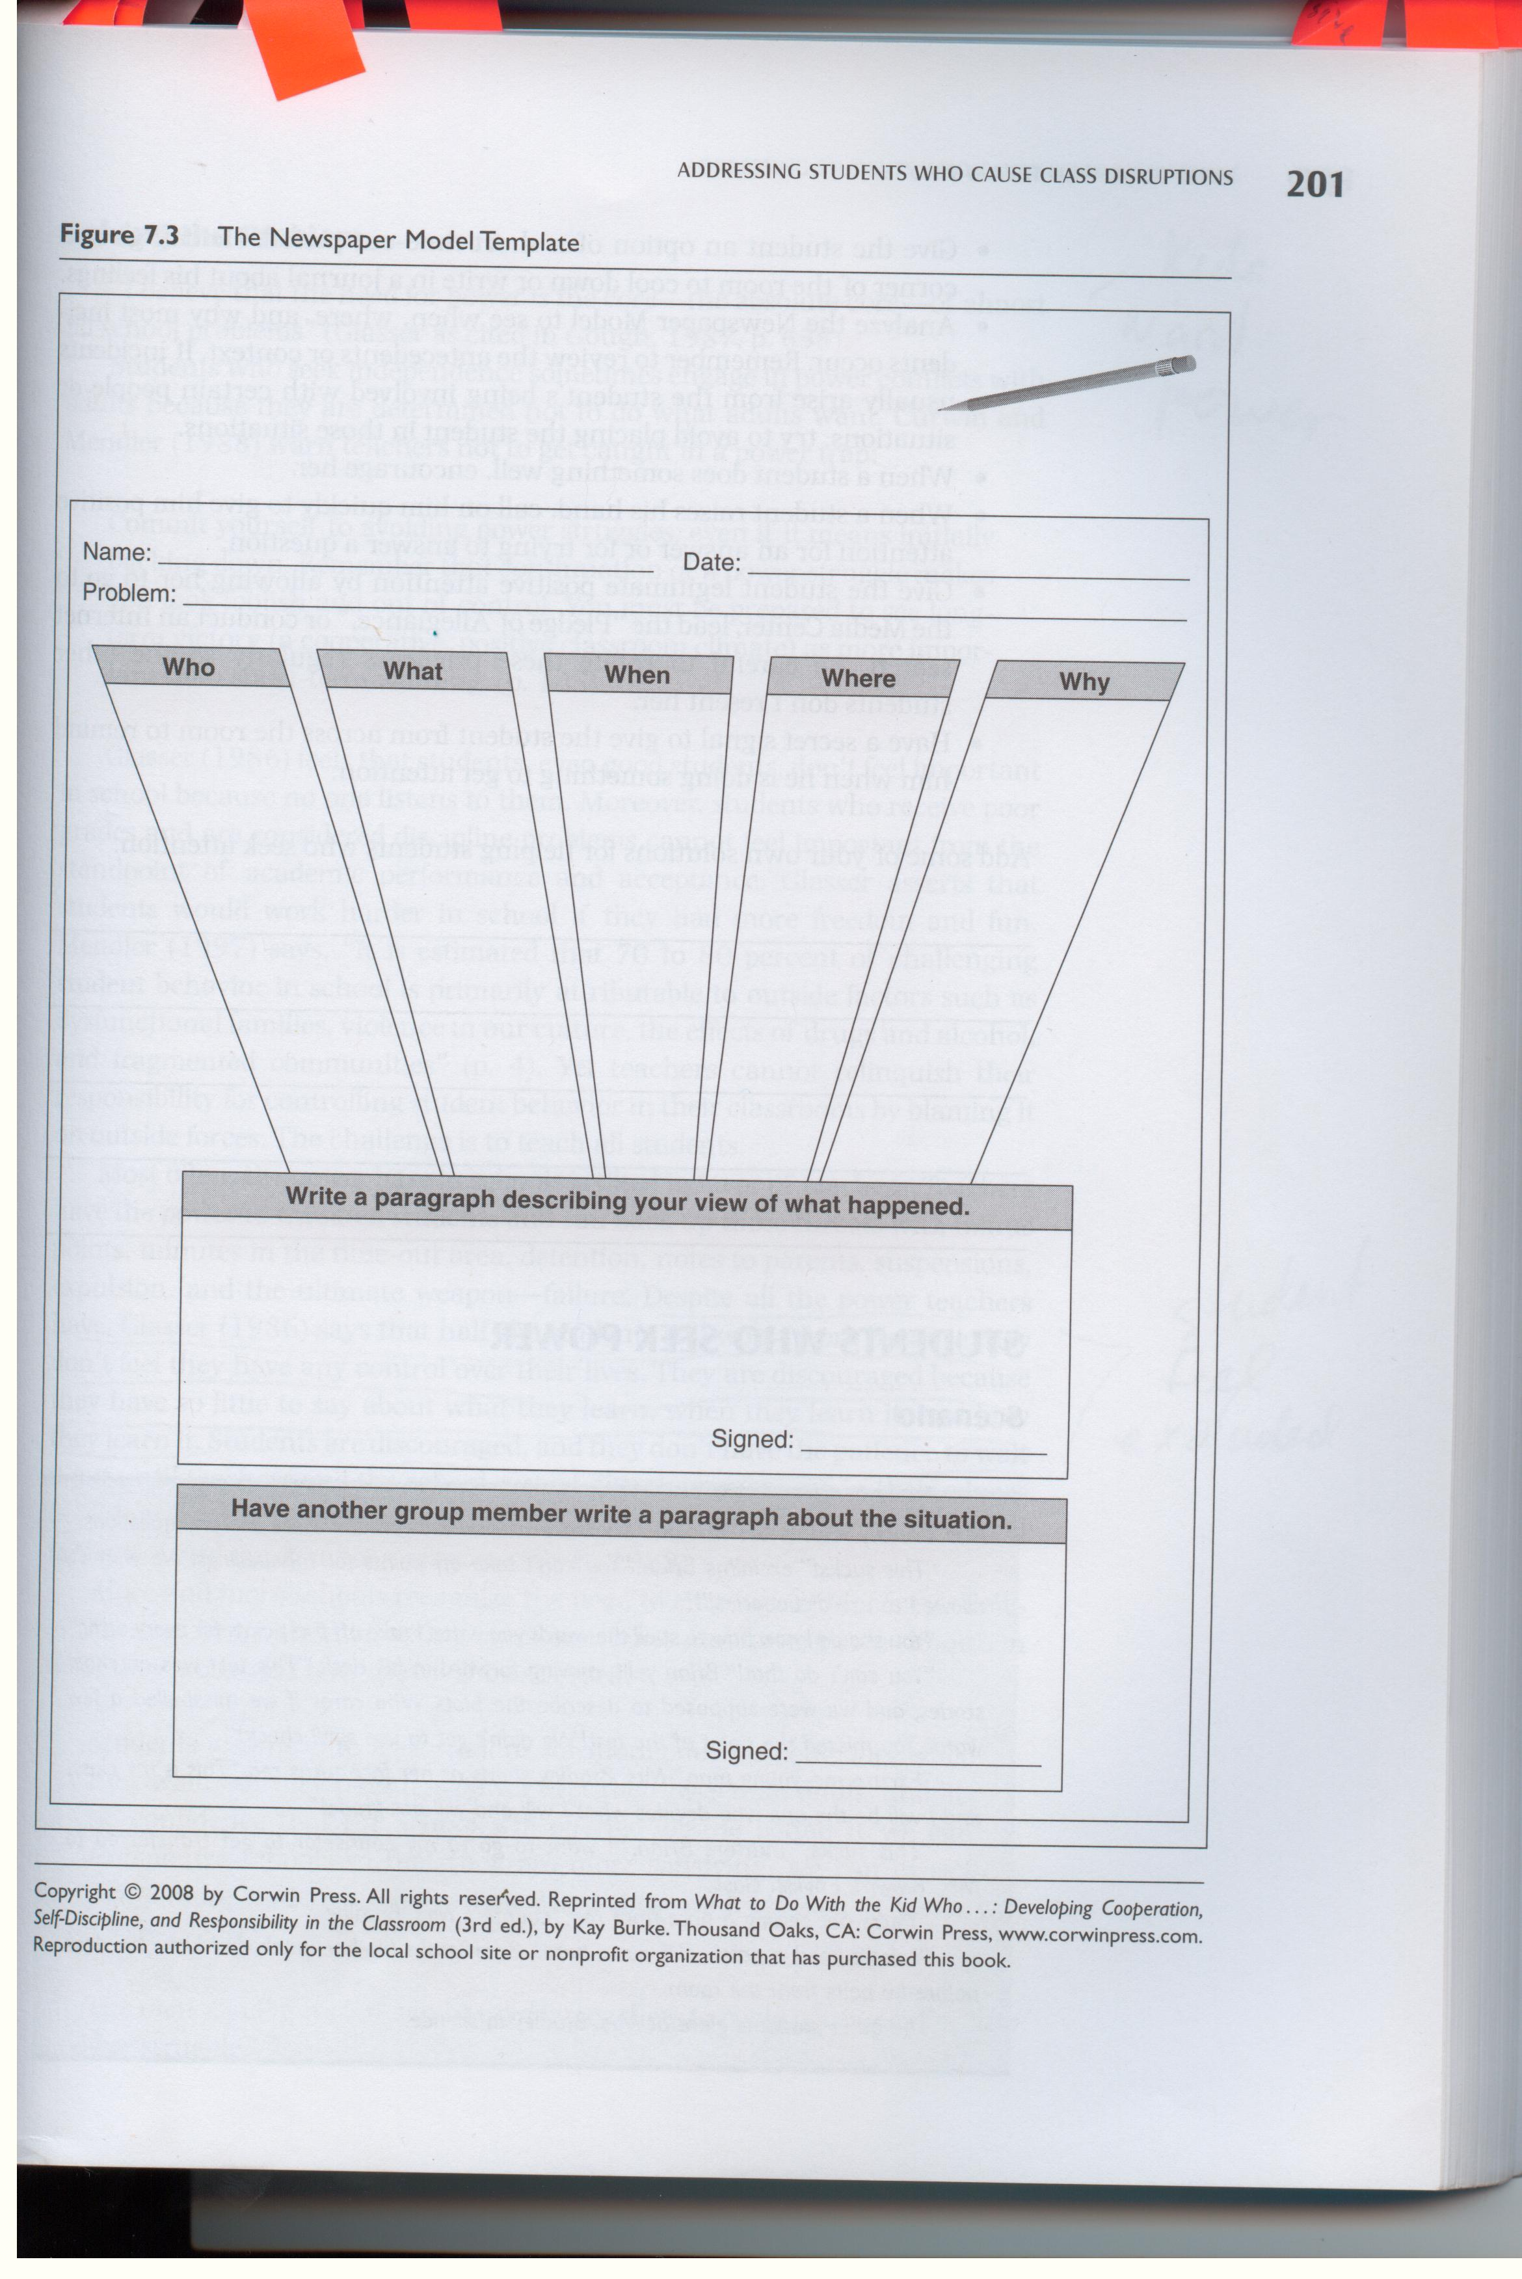
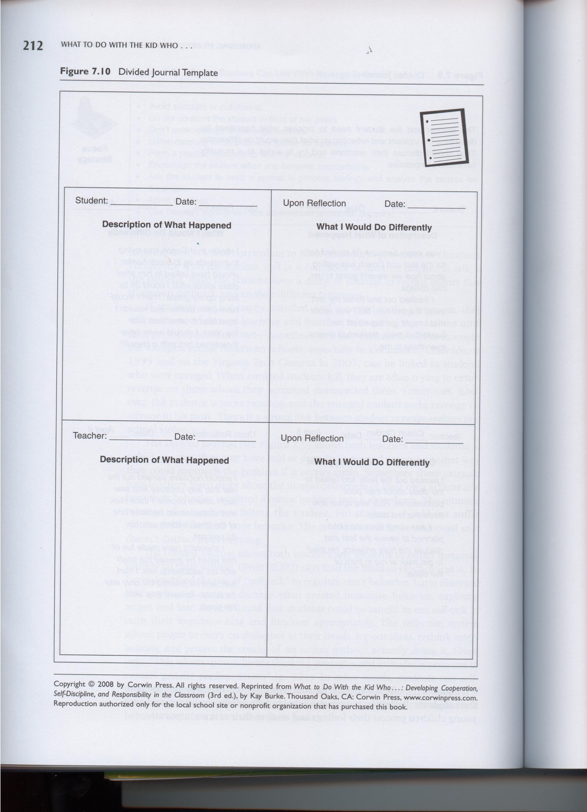
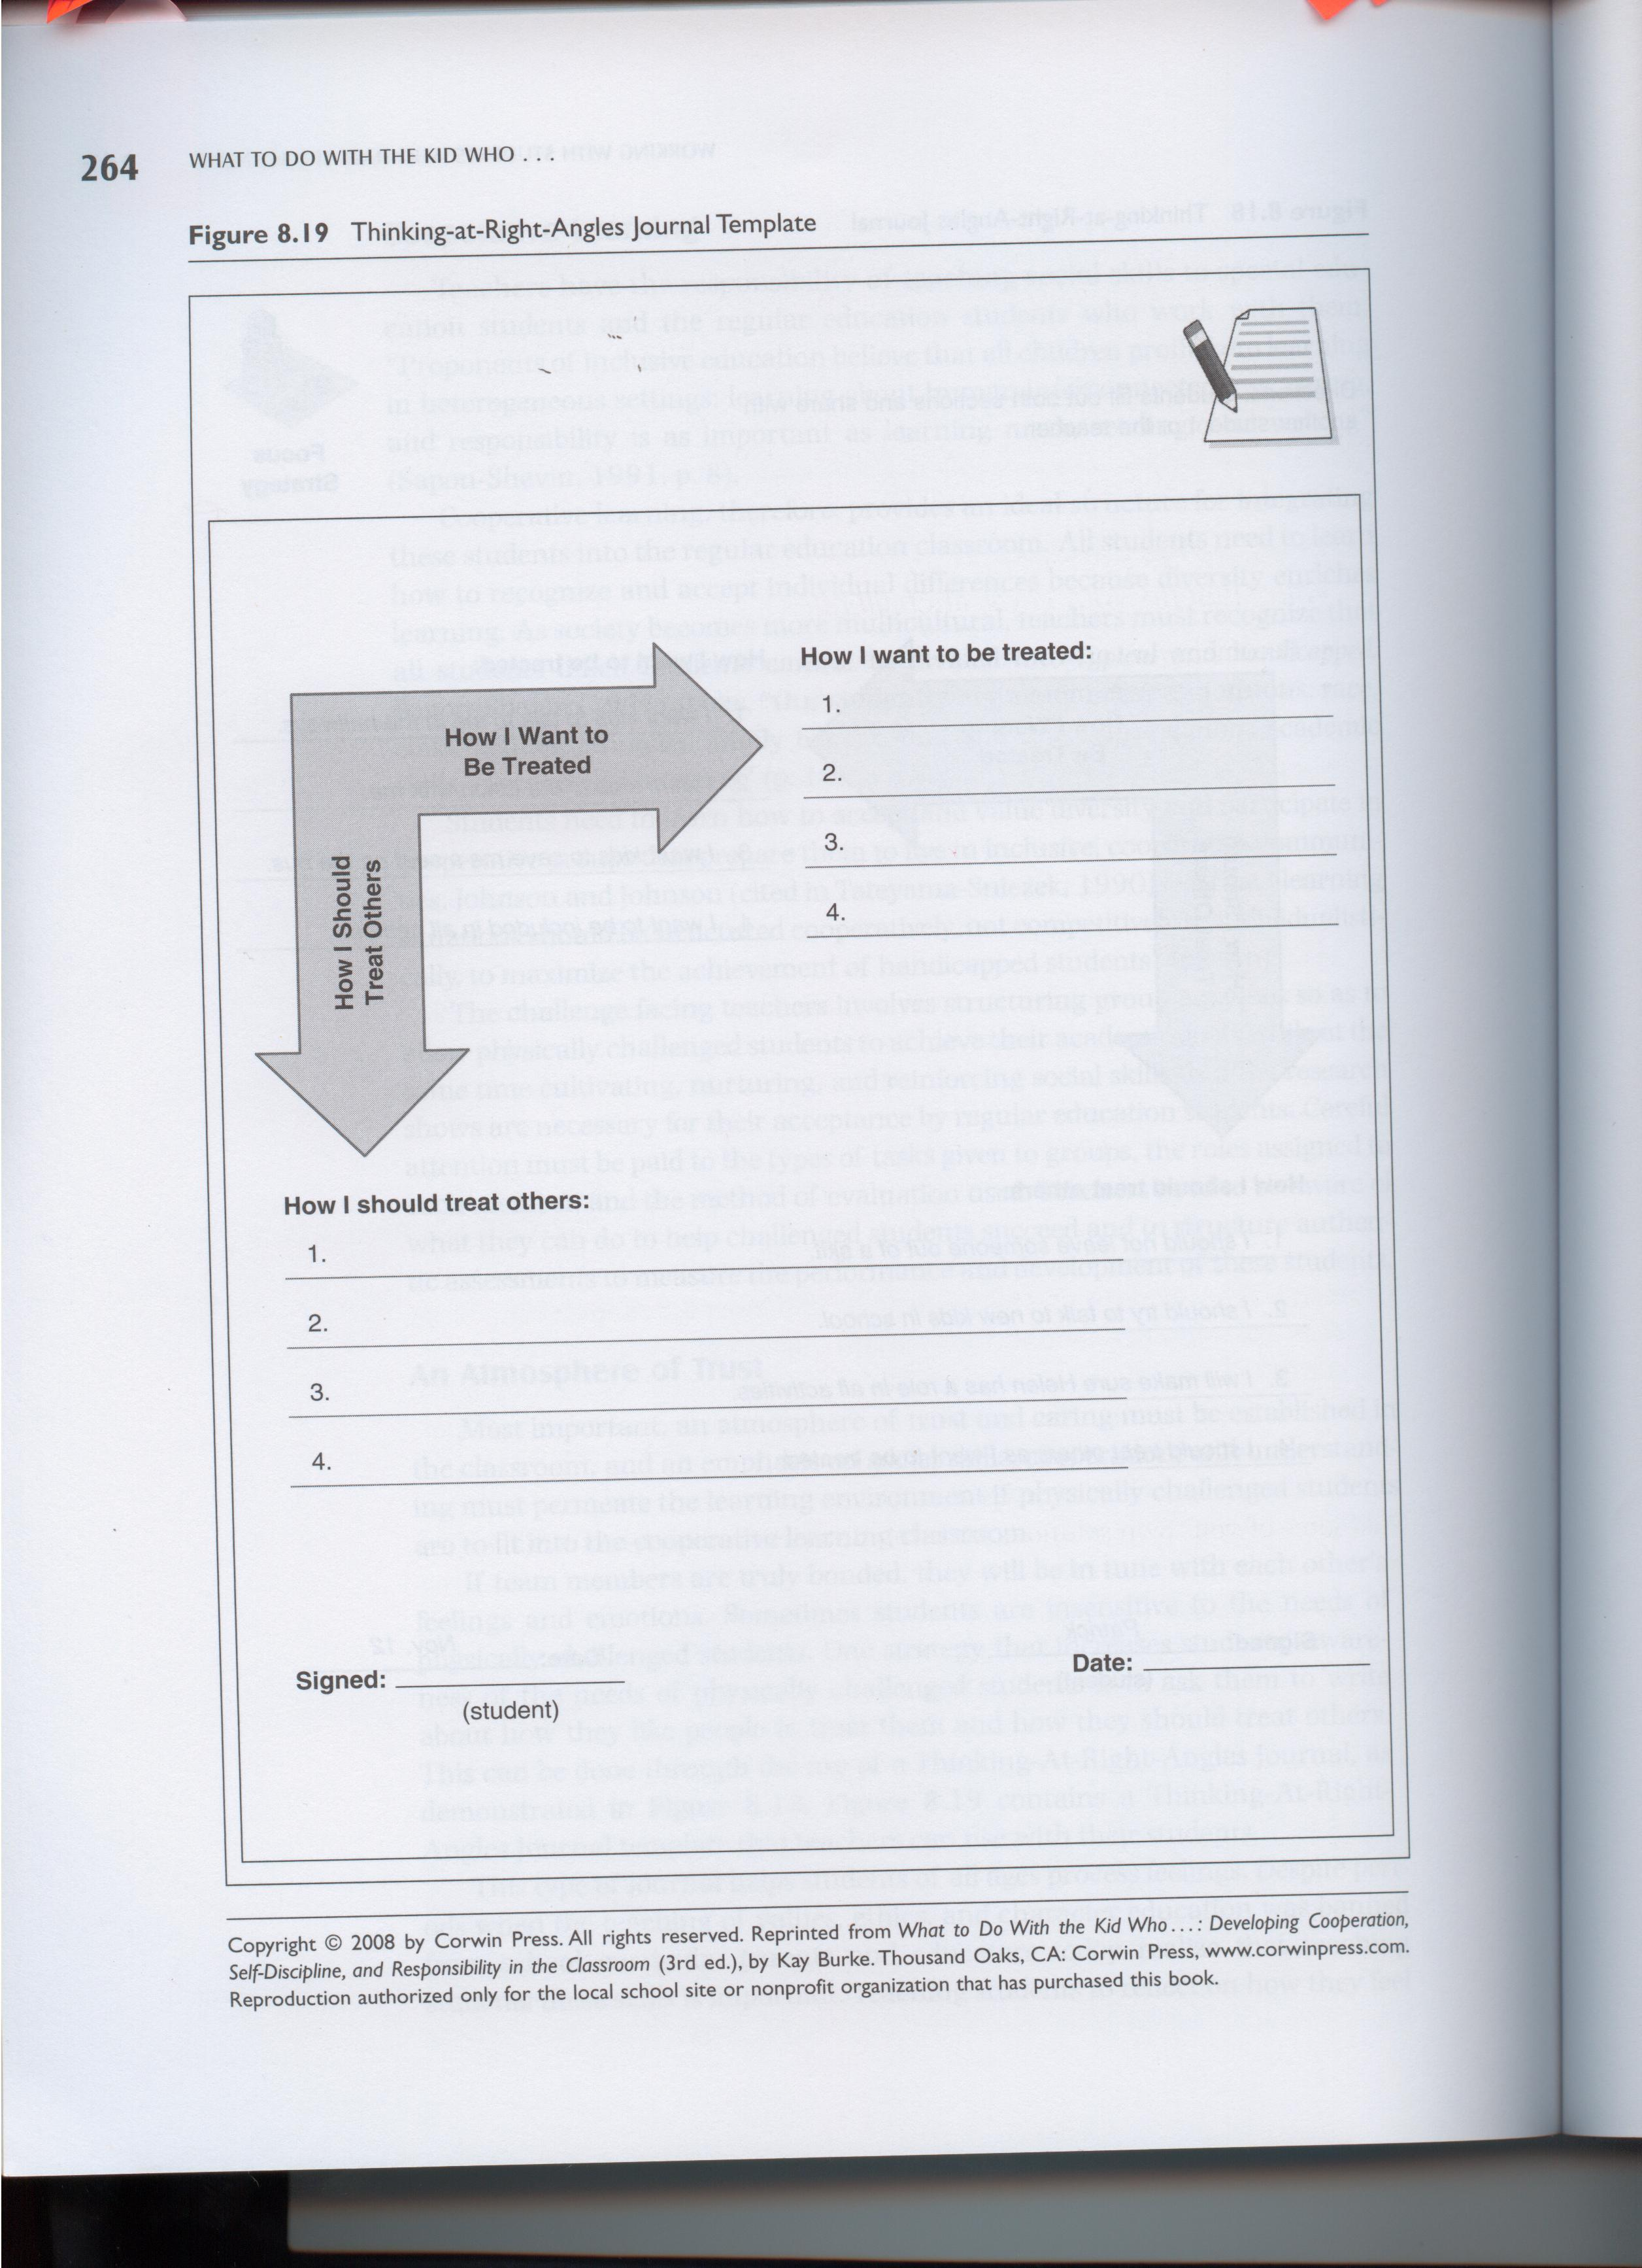

Appendix B
Burke’s Bilingual Logs and Checklists
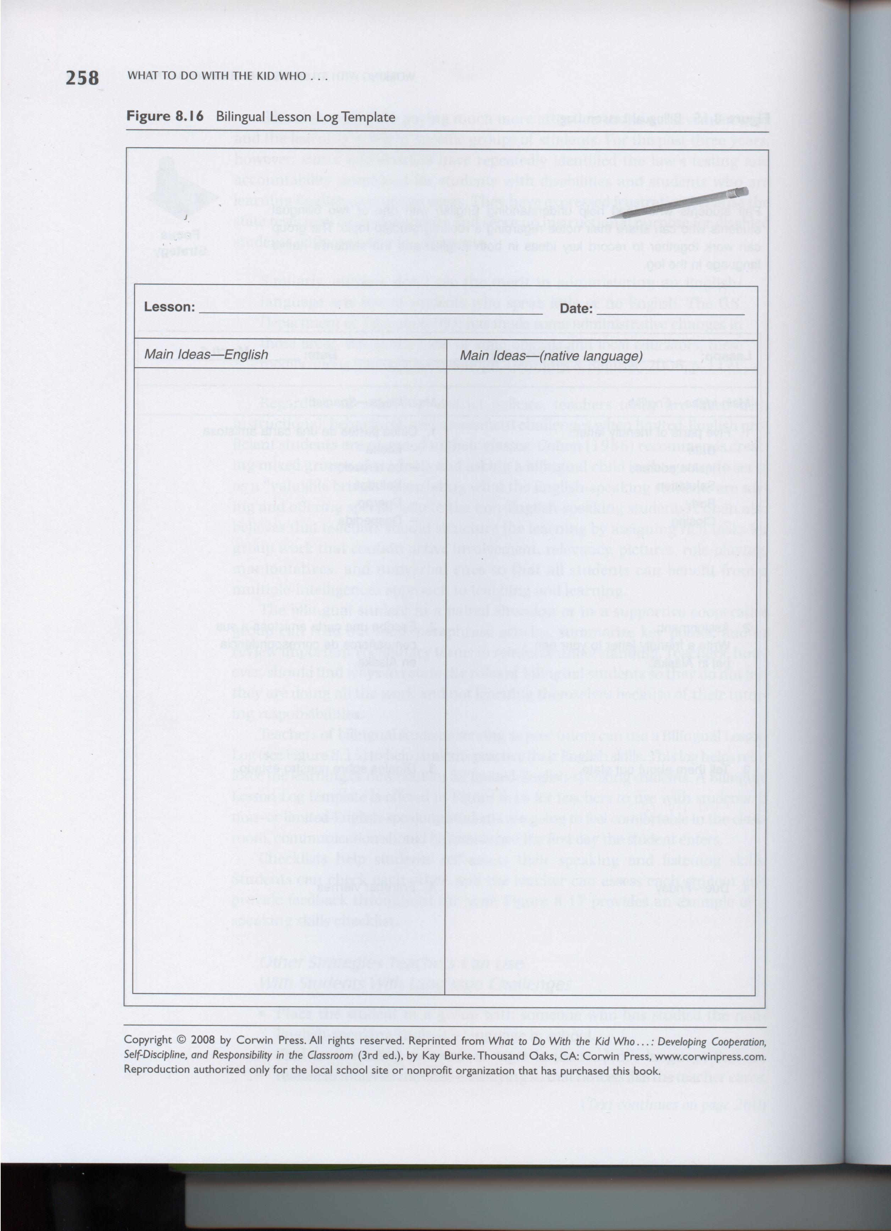
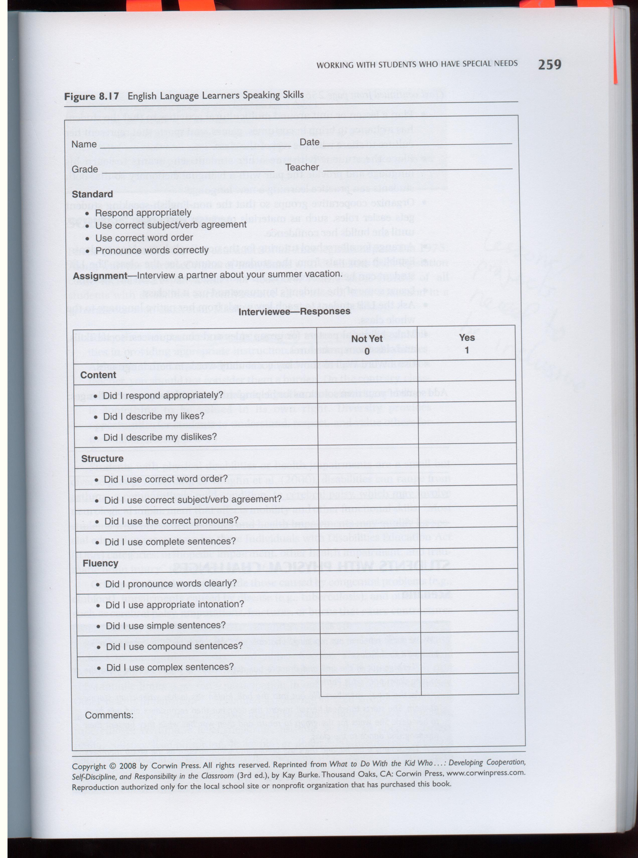

Appendix C
Burke’s Social and Group Checklists
