Checklist for Writing
Standard: Writing Applications 2.0: Students write compositions that describe and explain familiar objects, events, and experiences.

Assignment: Write about a game you played with your friend.

Performance Indicators: | Did It! | Not Yet.
I wrote about a game I played with my friend.

I completed a flow map of my writing.

I used correct capitalization.

I used correct punctuation.

I used transitional/order words.

I wrote in detail using sensory words.

I wrote neatly.

I read my story to my partner.

Student Self-Assessment

Name Date

Use the following scale to see how well you did on your writing assignment:
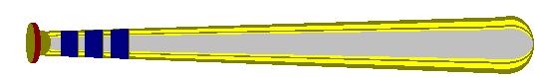
Strike Out - I did not complete the writing assignment.
There is a lot of room for improvement.

A Hit - I tried to follow the directions and work neatly, but
I know this is not my best effort. This writing
could have been better.
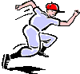
Home Run - I followed all of the directions. It is done neatly. It
is my best effort, and I am proud of my work.

My writing included a game I played with my friend.

Strike Out A Hit Home Run

I completed a flow map of my writing.

Strike Out A Hit Home Run

My writing was edited for correct use of capitalization, punctuation, and spelling.

Strike Out A Hit Home Run

My writing includes lots of detailed sentences.

Strike Out A Hit Home Run

My writing includes order/transitional words.

Strike Out A Hit Home Run

My writing is organized and neat.

Strike Out A Hit Home Run

