Department of Elementary Education Lesson Plan Format

Candidate  Talin Nazaryan  Leah Bach  Isabella Chacon  Summer Barlow | Date  11/06/19 | Grade Level  1st | Subject Area(s) & Topic(s)  Science & Ecosystems, Food Chains, Energy
☐ Single-day lesson  ☐ Multi-day lesson | ☐ Whole-class lesson  ☐ Small-group lesson | Name of Instructional Model  ☐ Explicit/Direct Instruction  ☐ Inquiry, Problem-Based Lesson, or Project-Based Lesson  ☐ Other______________________
Student Learning Profile
English Language Development levels of students in the class or group (please check all that apply) |  |  | Student(s) present with:
☐ Emerging  ☐ Expanding OR  ☐ Bridging | ☐ ELD 1 (Beginning)  ☐ ELD 2 (Early Intermediate)  ☐ ELD 3 (Intermediate)  ☐ ELD 4 (Early Advanced)  ☐ ELD 5 (Advanced) | ☐ IFEP (Initially Fluent English Proficient)  ☐ RFEP (Redesignated Fluent English Proficient)  ☐ English only | ☐ IEP  ☐ 504 plan

Before Teaching the Lesson

Standard(s) |  | Common Core/Content Standard(s):  NGSS.L.S1.A Structure and Function- All organisms have external parts. Different animals use their body parts in different ways to see, hear, grasp objects, protect themselves, move from place to place, and seek, find, and take in food, water, and air. Plants also have different parts (roots, stems, leaves, flowers, fruits) that help them survive and grow. (1-L.S1-1)  NGSS.L.S1.B Growth and Development of Organisms- Adult plants and animals can have young. In many kinds of animals, parents and the offspring themselves engage in behaviors that help the offspring to survive. (1-L.S1-2) |  | ELD Standard(s):  ELD.1.PI.1 Exchanging information and ideas with others through oral collaborative conversations on a range of social and academic topics.
Prerequisite Knowledge |  | Students should know what a living thing is and that every living thing has characteristics.
Objectives |  | Lesson Objective(s)/Goal(s):  Students will:  a. Define the word “food chain” and identify the producer, consumer and decomposer.  b. Assemble the pictures of organisms in a food chain.  c. Appreciate the importance of food chains in an ecosystem. |  | Language Objective(s):  The students will improve verbal production of English by participating in a whole group discussion, as well as small group discussions. They will also improve ability to comprehend English by listening during the lesson and instruction.
Vocabulary and Academic Language |  |  | New Vocabulary: energy, ecosystem, producer, consumer, decomposer  Academic Language: define, assemble, identify
Materials, including technology and visual aids |  |  | Visual Aids, pictures, chips, tape, markers
Classroom Management Strategies, including room arrangements and student grouping plan |  |  | Formation of Groups: Students will be randomly given a picture that is numbered. That number will indicate the role of the student.  Role Assignments: Beginning with the Checker all roles are assigned to the right (clockwise)  -Materials Manager/ Encourager: Students assigned the number 1- This student will get and clean up all materials for their group. They are also in charge of positively supporting their group members.  -Checker/Timekeeper: Students assigned the number 2- This student will watch the clock, keep track of time, and make sure the group is on task.  -Data Recorder: Students assigned the number 3- This student will keep track of the group’s ideas and take notes.  -Observer/Reporter: Students assigned the number 4- This student will see how their group is doing throughout the lesson and share their groups information with the class.  -Other- Traveler/Spy: Students assigned the number 5- This student will check in to see what the other groups are doing throughout the lesson.
Supports, accommodations, and/or modifications for specific students or groups |  |  | In order to support students who are English language learners or have a learning disability, this lesson will consist of lots of visuals. Students will also be grouped up and able to work collaboratively together.
Teaching the Lesson/Sequence of Lesson Procedures

Lesson Procedures/ Steps | Teaching Steps and Student Involvement/Activity  State what student teacher is teaching/doing Remember to embed differentiation strategies State what students are learning/doing Remember to embed differentiation strategies  - Students will watch a video on the food chain of plants and animals. - Pictures in the lesson will be passed out for each animal and plant. - Students will work in groups to share ideas and collaborate. • This will help the visual learners see the food chain the way it is designed. • These pictures will be a great way for students to visualize each animal for their food chain. • This will help the low achieving learners and ELL’s by giving them an opportunity to talk with others.  Introduction:  Engage: To excite and engage students, show them a kid friendly video that discusses ecosystems, energy, and food chains.  Body:  Introduce/Teach New Concepts/Explain:  1. The energy captured by plants is the only source of energy for all living organisms. Plants are the primary producers of food in an ecosystem.  2. Organisms that feed on others are called predators. Animals that feed on plants are predators called herbivores or primary consumers. Predators that feed on animals are called carnivores or secondary consumers.  3. Animals whose diet consist of both plants and animals are called omnivores. Parasites live on or inside another species the host on which they feed.  4. A sequence by which energy, in the form of food, passes from a plant to an animal and then to other animals is called a food chain.  -Ask questions to check for understanding and give students the opportunity to explain in their own words what they just learned.  Explore: Before beginning the activity, pass out plant and animal cards to the students. Give them some time to explore and look at all of the different types of plants and animals. Let them talk amongst each other.  Independent Activity:  Task:  - Students will be placed in groups of four to five and seated around a table with a pencil and a piece of paper. Each member of a group will be asked to give a name of a plant or an animal. Students will take turns recording their answers on the paper as it is passed around the table.  - Each student will receive a picture that will be numbered. Based on the pictures, students will classify plants as producers and animals as consumers. Teacher will choose a number from each group and the students will be asked to come forward. With the cooperation of all the students the pictures will be connected to form a food chain.  - Each student in the group will be asked to place their pictures on the table and to brainstorm ways to organize the pictures in order to construct a food chain with the pictures available on each table. Each student from each group will be given a chip. In order for students to share their taught, they must place their chip in the centre of the table.  - Teacher will ask each group to share their food chain to the rest of the class and point  out the producer, consumer and decomposer.  Elaborate: Provide a worksheet for students to identify the parts of a food chain. This will give them the opportunity to independently practice what they have learned.
Assessment Plan | Evaluate: We will formally assess student learning by collecting the final worksheet and using the following rubric to evaluate them. This will show us which students have an understanding of the concepts.  Rubric:  3 2 1  Classify Student is able to classify plants as producers and animals as consumers. Student is able to partially classify plants as producers and animals as consumers. Student is not able to classify plants as producers and animals as consumers.  Assemble Student is able to organize the pictures in order to construct a food chain with the pictures. Student is able to organize the pictures in order to construct a food chain with the pictures with minor errors. Student is not able to organize the pictures in order to construct a food chain with the pictures.  Importance Student is able to point out the producer, consumer and decomposer in the food chain. Student is able to point out only one or two of the following (producer, consumer and decomposer) in the food chain. Student is not able to point out the producer, consumer and decomposer in the food chain.  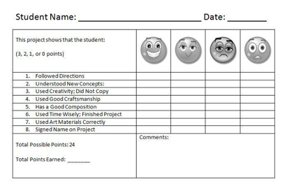
Review/  Closing | Review:  - What is a food chain?  - The components of a food chain (producer , consumer and decomposer )  - Discuss the importance of a food chain in an ecosystem  - Discuss how well your groups worked  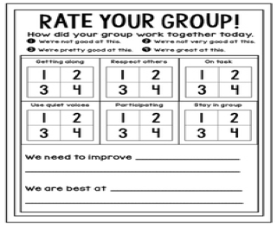  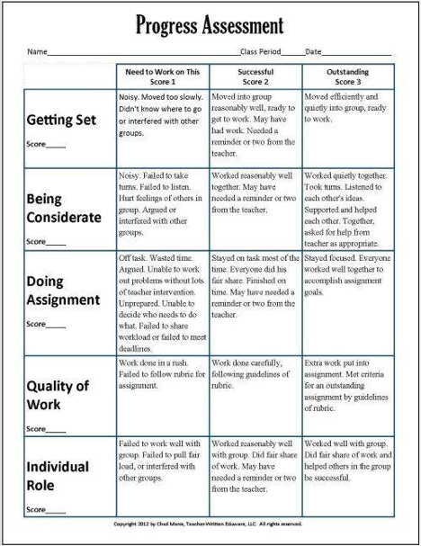
After Teaching the Lesson

Lesson Reflection Notes (written after teaching) | 1. What was most effective about this lesson and how do you know?  2. If you were going to teach this lesson again to the same group of students, what changes would you make to address collective whole class learning and individual student needs as identified in the student learning profile?  3. How did your questioning and/or feedback during instruction build understanding of key concepts, related skills, higher level thinking and student discourse? How do you know?  4. Based on your responses above (#1-3), how would formal/informal assessment data from the lesson inform the changes you would make in the next lesson in this series?  5. What is one piece of evidence that indicates you created a challenging, positive learning environment that promoted mutual respect among students and welcomed various perspectives?

