**Big Idea:** Water Conservation- How Much Water Do We Really Have?

**Objectives:**

At the conclusion of this lesson, students will be able to:

* Identify sources of fresh water available for consumption
* Understand the need for water conservation due to the limited fresh water supply
* Explore strategies for conserving water at home
* Compare the benefits and drawbacks of using different water management techniques, particularly dams

**Standards:**

**W.4.1.a–d-**Write opinion pieces on topics or texts, supporting a point of view with reasons and information. (4-LS1-1)

***ESS3.A: Natural Resources***

§  *Energy and fuels that humans use are derived from natural sources, and their use affects the environment in multiple ways. Some resources are renewable over time, and others are not. (4-ESS3-1)*

**I.  Formation of Groups:** Students will be organized into a human graph. The students will form into three groups: those who know a lot about the “How Much Water Do We Really Have?”, those who know something about the Gold Rush, and those who do not know anything about it. Once the human graph is formed, one person will be selected from each knowledge level to create their cooperative learning group so that each cooperative learning group has a student from each knowledge level.

**II. Role Assignments:**

Each student will be given a number. The numbers will be assigned to a role. The following are the roles the students will fulfill:

**Materials Manager:** Will be responsible for collecting, dispersing and returning all materials

1.   Two 2-liter bottles full of water

2.   Food coloring (dark color preferable)

3.   Measuring cups (for measuring amounts ranging from 50 ml to 14.5 ml)

4.   Five clear containers (to hold water ranging in volume from 1,950 ml to 0.5 ml)

5.   Markers and tape for making labels

6.   Water Use Worksheet

7.   Notebooks for student’s work

**Encourager:** Will routinely encourage and praise students’ hard work. The encourager will also motivate the group’s work ethic and progress on the project.

**Checker/Timekeeper:** Will hold the timer and keep track of how much time is left to complete the project or activity in the given day. This person also makes certain all tasks are carried out correctly, answers team questions and seeks out assistance when team requests it.

**Recorder:** Will annotate and take notes about the information to be included in the newspaper**.**

**Reporter:** Will report on the group member’s participation**.**

**Traveler/Spy:** Will be able to visit other groups to gain inspiration or ask for help**.**

**III. Task:**

1.   Tell students that you would like them to think about the answer to this question: What percentage of Earth's water is available for human consumption? Ask students to write down their answers in a KWL chart. You may want to remind students to consider what they know about oceans and about the type of water that is considered usable by people. Ask students to fill out the first two sections of the KWL chart. Ask students what they want to know by the end of the lesson.

2.   Ask a volunteer to demonstrate his or her answer to the question. Give the student a 2-liter bottle filled with colored water and a clear, empty container. Tell the class that the bottle represents all of the water on Earth. Ask the volunteer to pour into the empty container the amount of water that he or she thinks represents the percentage of Earth's water available for human use. Then ask the class to make suggestions about whether more or less water needs to be in the container. Have the volunteer adjust the amount until there is a general consensus among the students. Put the class estimate aside.

3.   Tell students that you will now demonstrate the amount of water on Earth that is available for human consumption.

4.   Show students the second 2-liter bottle filled with colored water. Tell them that this bottle again represents all of the water on Earth. Measure out 1,950 ml of the water and pour it into a clear, empty container. Label the container “Salt water”. Tell students that this represents how much of our planet's water is found in oceans — 97%.

5.   Pour the remaining 50 ml from the bottle into another container, and tell the students that this represents the amount of freshwater on Earth — 3%. Label this container “Fresh water”. Ask students to guess what percentage of freshwater is available for human use

6.   Divide the class into small groups and ask them to discuss what they had just witnessed in your demonstration and in the interactive activity. Have students answer the following questions during their small-group discussions

·  Where is usable water located?

·  Is this water a renewable resource?

7.   Bring the class back together and ask student groups to share some of their ideas. Conclude by reminding students that water is necessary for life and thus important to conserve and maintain so that it stays available for human consumption, as well as for consumption by plants and animals, which people use for food.

**IV. Time Limits:**

The students will be given an hour to work on the project for a whole school week.

**V. Social Skills and or Habits of Mind to Engage/Assess:**

      (Attentive Listening;  Disagree with Idea- Not the Person; Flexibility in Thinking; Perseverance; Team Work, Compromise)

**VI  Level of Voice:  (Classroom Level 2 – Normal  Voice Table Talk)**

The level of the voices in the classroom, as the learners are collaborating in a group, should be moderate to high. This activity requires the learners to move around the classroom to gather materials, which they may need. Likewise, the learners will need to discuss with each other in their group, on what information should be in the newspaper.

**VII. Processing--Questions for groups and individual reflections:**

**VIII. Assessment Content:**

One of the questions proposed to the learners would be, “How Much Water Do We Really Have?”. This will allow me to identify how much usable water does the earth really have. An additional question to be proposed to the learners will be, “Where is usable water located”, this will be a great opportunity for me to identify who understood the lesson and who is not. I will ask the students to respond to these two questions on the L portion of their KWL charts and any additional information they learned.

For the individual reflections I would have them reflect on how the groups collaborated. I will have the learners write about “If they worked well with the people in their group”. Furthermore, I will have them write about “Some of the challenges they faced, when collaborating in a group”.

**Assessment of Cooperation/Collaboration and Student**

**Self-Assessment of Collaborative Performance**

**Scoring Rubric for Team Performance of The Water Conservation Project**

|  |  |  |
| --- | --- | --- |
| Criterion | **Met** | **Unmet** |
| Answer the questions  ·  Where is usable water located?  ·  Is this water a renewable resource? |  |  |
|  |  |  |
|  |  |  |
|  |  |  |
|  |  |  |

**Peer Assessment (Rate Your Mates)**

**The Water Conservation Assessment**

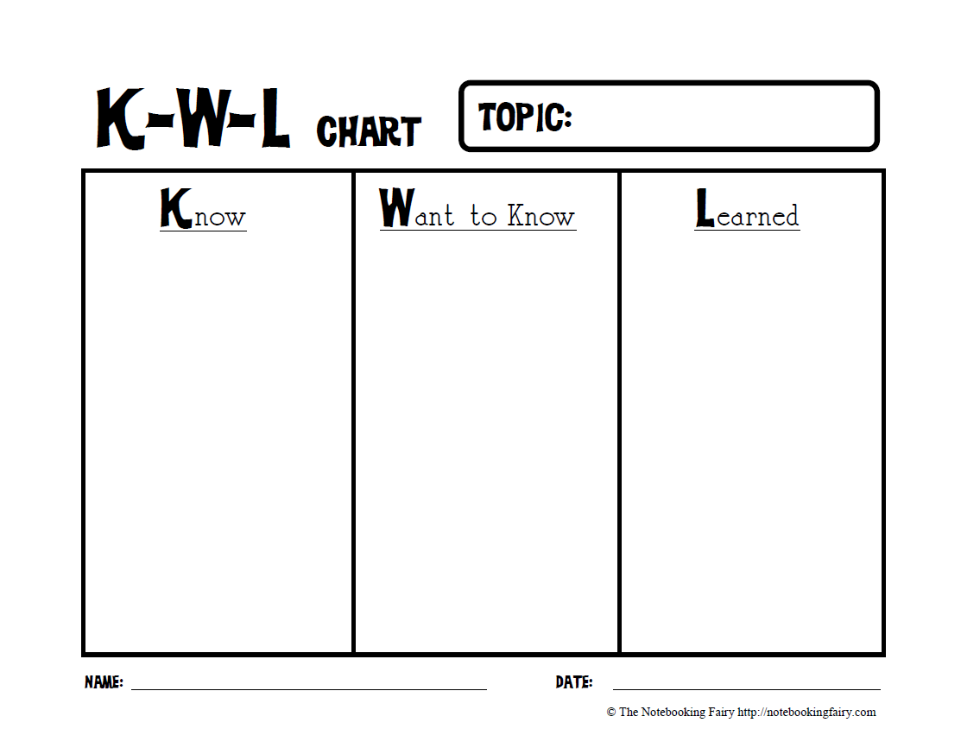

|  |  |  |  |  |
| --- | --- | --- | --- | --- |
| **Group Member Name** | **Encouraging** | **Attentive Listening** | **Working Toward Consensus** | **Staying on task and with the group** |
|  |  |  |  |  |
|  |  |  |  |  |
|  |  |  |  |  |
|  |  |  |  |  |
|  |  |  |  |  |
|  |  |  |  |  |

**Scoring Key: Never=N  Sometimes=S Frequently=F**

**VIII. Encouraging Energizer:**

When appropriate, the encourager will lead the group in a self-encouragement exercise, during which each member will give themselves a Stamp of Approval, stamping their fist against their other palm.