**Cameron Johnson**

**Mckenzie Davidson**

**Water Filter Fun**

**Water Rolls, Water Rises by Pat Mora**

**Illustrated by Meilo So**

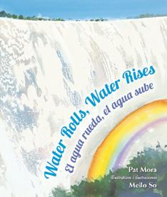

**Objective:** Students will be able to use and classify different materials in order to create a water filter.

**Big Idea:** What materials do you think you need to make the best working water filter?

**Setting the Stage:**

Students need to be able to understand how water gets polluted and why it is important to keep our water clean. It is important that students get to go out into the campus and look for different trash that may be surrounding rain gutters and investigate how water travels in our cities. If students are able to understand this part of the investigation students will understand the importance for water filters and therefore have motivation to create one. Students will be read a story called *Water Rolls, Water Rises* written by Pat Mora and illustrated by Meilo So. We will discuss what we learned from the book through a series of critical-thinking dialogue questions. Students will learn about aquifers and the connection to the water cycle, then they will create their own filters to help demonstrate this knowledge. Students will be able to explain what happens after water is absorbed and how to conserve water.

**Next Generation Science Standard:** 2-PS1-1.: Plan and conduct an investigation to describe and classify different kinds of materials by their observable properties.

2-PS1-2.: Analyze data obtained from testing different materials to determine which materials have the properties that are best suited for an intended purpose.

**Science and Engineering Practices in the Next Generation Science Standards:**

This lesson addresses science practice (SP 3): Planning and carrying out investigations.

During the investigation, students will be designing their water filters to make the best water filter possible. It is important that students plan out their water filters so that they go into the investigation of what they want to create.

**Background Knowledge:**

Students have already learned about the water cycle. They know that water such as ground water and the ocean evaporate into the air. They know that condensation occurs next followed by precipitation. Students know that when the water runs off of mountains the process occurs again. Students know how water pollution occurs and have conducted an investigation to see the different rain gutters that have accumulated trash.

**Materials**

|  |
| --- |
| **For the whole group** |
| * water bottles * rubber bands * coffee filters * paper clips * cheesecloth * cotton squares * scissors * dress fabric * charcoal * gravel * sand * dirt * paper * pencils * green felt * plastic tub * poster board on the water cycle * Water Rolls, Water Rises written by Pat Mora and illustrated by Meilo So |

|  |
| --- |
| Roles: |
| Materials Manager/Traveler (SPY) |
| Checker |
| Recorder/Reporter |
| Observer/Illustrator |

**The instructor/ facilitator begins this activity by assigning the materials manager/spy, checker, recorder/reporter, illustrator/observer. The materials managers will be provided with the celery lab sheet that enables their teams to follow along in their roles.**

**Preparation**

Prepare materials a couple of days before. This includes pre-cutting the water bottles for the filters, gathering the sand, dirt, and gravel together, as well as the coffee filters, paper clips, cotton squares, scissors, and rubber bands. There is also a premade poster board that has been created for this lesson with the labels removed so that students can place them. The plastic tub of water is being filled with water and dirt to create our dirty water. The tub is being set in the sink with the green felt to create a lake type environment. It’s important to make sure that we have everything ready and prepared for our families and that the materials are ready to go.

|  |  |
| --- | --- |
| **Engage** | 10 minutes |
| **Explore** | 15 minutes |
| **Explain and Elaborate** | 5 minutes |
| **Evaluate** | 15 minutes |
| **Total** | **50 minutes** |

**Engage *10 minutes***

We will begin reading the book while walking around to show the images in the story. After reading the book, the instructor will begin reviewing the different stages of the water cycle using the water cycle poster below.

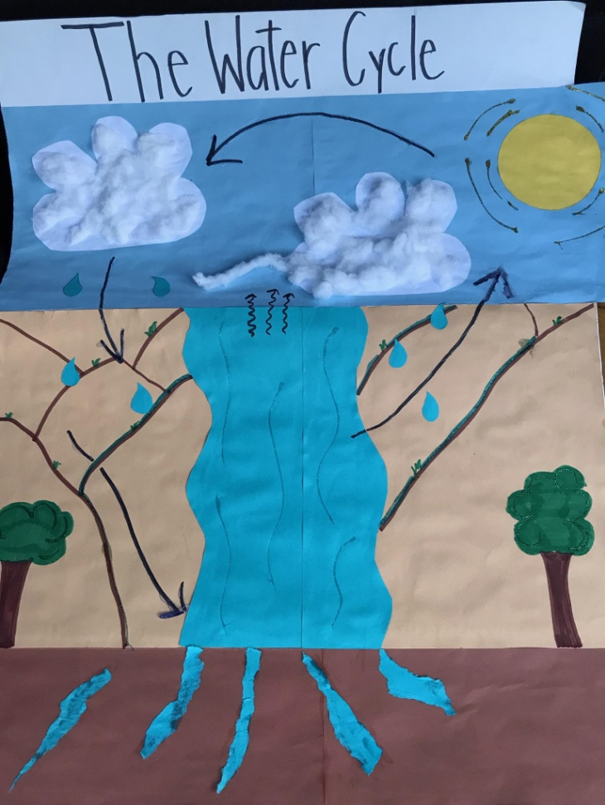

**Exploring *15 minutes***

**1. Water Filter creations**

In this step, students will be creating their own water filters. To start, the materials manager will give their group the different materials that they can use and a piece of paper and a pencil. This way they can plan out what materials they are going to use and how they are going to make their water filter. The checker at this time will be making sure that all of their group members are on-task and participating. Giving them time to explore the different materials is important for students. Recorders will be writing in the worksheet provided and answer questions with their group as they are making their water filters. After the groups have planned out what materials they want to use they will receive a precut water bottle from their materials manager. They can use coffee filters, rubber bands, cotton balls, paper clips. How they create their water filter is completely up to the team that they are in. The materials manager will also walk around the room and spy on what other materials groups are using and come back and report to their own group.

**Explain and Elaborate *5 minutes***

After they believe their water filter is finished students will come over to the sink and create the dirty water that they want to test their water filter on. If the filter does not work they can choose if they want to retry and come up with a new idea for their water filter or if they want to keep their water filter the way they first created it. Everyone will get the chance to try their water filters.

**Evaluate *5 minutes***

Once everyone has created their own water filters, the class will come together for the groups to share. When it’s a group’s turn, the observer will share the materials they used, how they built their water filter, what kind of dirty water they used, and if their filter was successful or not. If their filter wasn’t successful, they will also share what they would change on their water filter to make it succeed.

**Worksheet:**



**Collaborative Project Peer Assessment:**

|  |  |  |  |  |
| --- | --- | --- | --- | --- |
|  | 1 | 2 | 3 | 4 |
| Work | He/she did very little work throughout the activity. | He/she did most of the work assigned to the team. | He/she did all of the work assigned to them. | He/she graciously accepted the work given to them. |
| Organization | He/she did their own thing. | He/she followed directions. | He/she helped to organize the group. | He/she took charge and organized the group. |
| Contribution | He/she held your group back. | He/she helped our group succeed. | Our group was better because of him/her. | Our group was much better because of him/her. |
| Motivation | He/she prevented us from doing our best work | He/she expected too much from me. | He/she pushed me to be better. | He/she brought out the best in me. |

|  |  |  |
| --- | --- | --- |
| Group Member’s Name | Overall Performance | Total from Above |
|  | 1 2 3 4 | _____ /16 |
|  | 1 2 3 4 | _____ /16 |
|  | 1 2 3 4 | _____ /16 |
|  | 1 2 3 4 | _____ /16 |
|  | 1 2 3 4 | _____ /16 |