Dominguez Martinez, Miriam
EED 480
Professor Belgrad
Bean Seed Experiment Grade Kindergarten
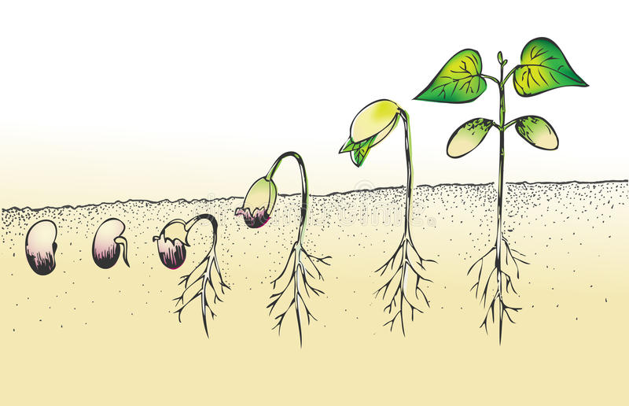

Objective
Students will show evidence that they can recognize that seeds germinate at different rates depending on how much water and sunlight they receive by observing four bean seeds.

Big Idea
This experiment will allow students to record and observe the development of four bean seeds.

Setting the Stage:

Both humans and plants need food and water to survive. In this experiment students will see what happens when plants receive both water and sunlight, water only, sunlight only, and no water and sunlight.

Next Generation Science Standards
K-LS1-1. Use observations to describe patterns of what plants and animals (including humans) need to survive.
This lesson focuses on investigating whether a plant needs sunlight and/or water to grow. Throughout the weeks, students will have the opportunity to record the growth of 4 bean seeds to investigate if the seeds need water and/or sunlight to survive.

Science and Engineering Practices in the Next Generation Science Standards
This lesson addresses S8. Obtaining, evaluating, and communicating information. Students will gather data by observing throughout the days how a bean seeds with and without sunlight and water. Then they would evaluate why certain beans grew the most or grew the least. As well at the end of the lesson students will have the opportunity to share their results with other groups and share any similarities or differences they had.

This lesson also addresses S3. Planning and carrying out investigations. The overall concept of this lesson is for students to carry out an investigation of whether a bean seed needs water and sunlight to grow the most.

Structure and Function
In this lesson, students will be given four bean seeds where they will label each cup.
First cup: water and sunlight
Second cup: Water only
Third cup: Sunlight only
Fourth cup: No water and sunlight
By having these four cups, students will be able to see and understand that plants need water and sunlight to grow the most.

Background Knowledge:
Students already know that humans need food and water to survive. This lesson will show that plants can still grow without water/sunlight, but is it as successful when compared to a seed that receives both water and sunlight.

Materials:
Pinto Beans
Soil
Clear plastic cups
Water
Window that has sunlight/patio
Bin to place their pinto beans cups

Stickers to label their cups.

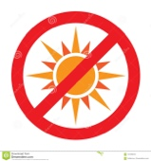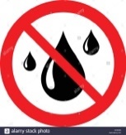

Formation of Groups: Students will be in groups of 4 people. Students will be numbered off by numbers 1-4. Depending on the numbers they receive, that’s the role they will receive. To help students remember their role, they have a role tag that will hang around their neck.
Roles:
- Materials Manager/Traveler (SPY): The Materials Manager will be in charge of making sure that every group has the required materials such as 4 pinto beans, soil, 4 clear plastic cups, a jar of water, and stickers.
- Checker: Will be in charge that their group is focusing on completing their group work timely. Will also be in charge of spraying the plants with water.
- Recorder/Reporter: Will label each cup with the correct sticker. Will also be the first speaker to present their group’s data.
- Observer/Illustrator: Will be in charge of drawing out the results of the beans.
Task:
Opening: We will begin the lesson by reading a book: From Seed to Plant by Allan Fowler. After we finish reading the book aloud, we will start a discussion on what a seed needs in order to grow into a plant. Then we will transition into watching a video on how a seed becomes a plant.
Body: Then the teacher will introduce and explain the experiment to the whole class. Each group will receive four cups with soil and four beans. They will label each cup, and record their observations everyday by drawing a picture. After the teacher introduces the experiment, she tells students that first they will predict what will happen to the beans that receive no sunlight and water. The teacher will pass out a handout where each group will write down their predictions.
Closing: To end the lesson, each group will share their data to the whole class where they will discuss their predications from the beginning of the lesson. They will record which seed grew the most and which grew the least. Which will also be shared with the class.
Time limits:
Opening: 15 minutes
Body:15-12min. Time will vary because this will be done for two weeks
Closing: 25 min
Social Skills and or Habits of Mind to Engage/Assess
- Wait until the speaker is finished before you speak
- Follow role assignments
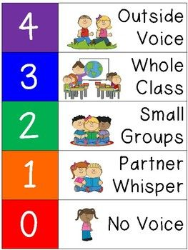
Level of Voice:

Processing-Questions for groups and individual reflections
Questions for groups | Questions for Individual
- Which bean will grow the most? Why?  - Which bean will grow the least? Why? | - Which bean will grow the most? Why?  - Which bean will grow the least? Why?

Assessment Content:
Assessment of cooperation/collaboration and Student:
Student Name: | 3 | 2 | 1
Cooperation | Student cooperated with his/her peers all the time. | Student cooperated occasionally with his/her peers. | Student did not cooperate with his/her peers.
Listening | Student listened to their group and shared his/her ideas. | Student listened occasionally to the group, and sometimes shared his/her ideas. | Student did not listen to the group and did not share his/her ideas.
Participation | Students participated in the group by performing their role. | Student participated in the group by doing most of their role. | Student did not participate in their group by not performing their role.

Self-Assessment of Collaborative Performance
This is how I think I am doing
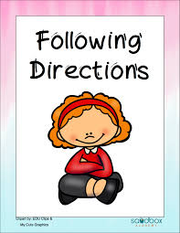
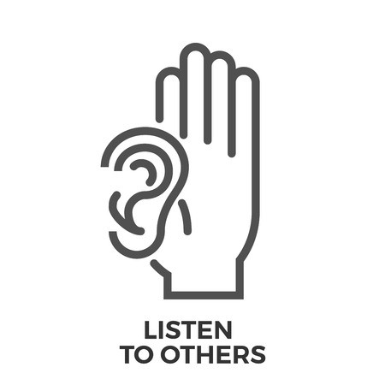

Getting work done

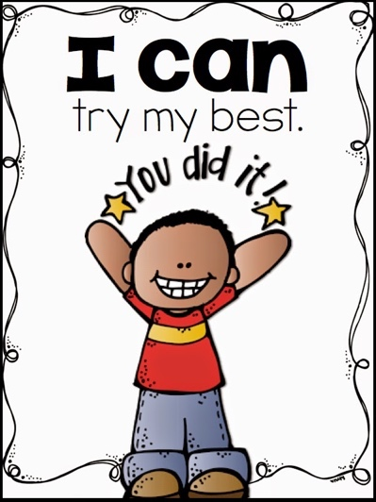

Peer Assessment
My group member, __________________ was…
Working
Focused
Shared ideas
Organized

THE 5-E FRAMEWORK
ENGAGE
10 MINUTES
Reading a book: From Seed to Plant by Allan Fowler. After we finish reading the book aloud, we will start a discussion on what a seeds needs in order to grow into a plant. Then we will transition into watching a video on how a seeds becomes a plant.
EXPLORE
10 MINUTES
Developing Questions
Lead your fellow students in understanding that they will conduct an investigation.
- Do plants need both water and sunlight to grow?
- Can plant grow with only water or only sunlight?

Extend
15 minutes
- Groups will write down their hypothesis before they begin the experiment. “What will happen”
- Record responses on the lab sheets.

EXPLAIN
25 minutes
- At the end of the two weeks, each group will have the opportunity to share their predictions, and their results of the experiment.

EVALUATE
15 minutes
- At the end of the two weeks, students will look at and discuss their results within their group and then they will share their results with another group.
- After they’ve shared, they will order their four plant cups from the seed that grew the most to the seed that grew the least.

Processing the Bean seed Experiment
National Science Teaching Standards Met by the Bean Seed Experiment
Students will understand that as humans, plants need both water and sunlight to survive. It is important that students have the opportunity to investigate how much plants grow varying on how much water and sunlight they receive. In this lesson, students will observe four seeds that will either receive water and sunlight, water only, sunlight only, or no water and no sunlight.
DISCIPLINARY CORE IDEAS
The Science lesson focuses on NGSS LS1-1, where students participate in an investigation to find which seed will grow the most. This experiment will help students understand the importance of water and sunlight in order for a seed to grow.

SCIENCE AND ENGINEERING PRACTICES
This lesson addresses SP 8: obtain, evaluate, and communicate information. During the experiment, students will obtain data for two weeks. Then at the end of the two weeks, students will evaluate their data by evaluating which seed grew the most, and which the least. Then they will record their data and will communicate it with the whole class.
CROSS-CUTTING CONCEPTS
# Structure and Function
In this lesson, students understand that plants need water and sunlight. But with this experiment they will learn that sunlight and water affects plants on how much they grow.

Background (Prior) Knowledge:

The prior knowledge that students have in regards to this lesson is that they know that plants need water and sunlight in order to have the most effective growth.

