Emily Rucker
EED 480 PBL with 5E Framework
- 5th Grade Science- Who lives in my Backyard?

- BIG IDEA: The Food Web investigation
Students work with organism cards to create food chains and food webs in a woodland ecosystem that includes terrestrial and aquatic environments. Students learn that by using the Sun’s energy, plants and algae are the primary source of matter and energy entering most food chains and food webs. Students are introduced to the terms for different functional roles that organisms play in food chains.
Focus Question: What are the roles of organisms in a food chain?
- JUSTIFICATION:
In this lesson series the students will be able to:
- learn about the various roles that animals play in food webs. They will then investigate food webs found in local outdoor areas.
- learn that All living organisms, including humans, need energy and nutrients to survive.
- discuss trophic levels and the roles—producer, consumer, and decomposer—played by different animals in the food web.
- think of examples of producers, consumers, and decomposers from ecosystems they’re familiar with.
- write down the various trophic levels to reference while doing their investigation.
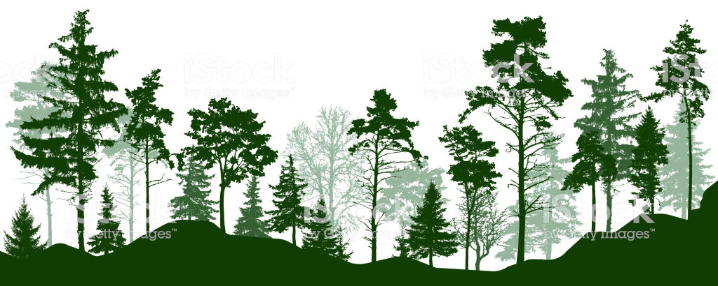
- examine different animals to categorize which role they play in nature.

- STANDARDS:
Next Generation Science Standards (NGSS)

5-LS2-1. | Develop a model to describe the movement of matter among plants, animals, decomposers, and the environment. [Clarification Statement: Emphasis is on the idea that matter that is not food (air, water, decomposed materials in soil) is changed by plants into matter that is food. Examples of systems could include organisms, ecosystems, and the Earth.] [Assessment Boundary: Assessment does not include molecular explanations.]

5-LS1-1 | Support an argument that plants get the materials they need for growth chiefly from air and water. [Clarification Statement: Emphasis is on the idea that plant matter comes mostly from air and water, not from the soil.]
5-PS3-1. Use models to describe that energy in animals’ food (used for body repair, growth, and motion and to maintain body warmth) was once energy from the sun. [Clarification Statement: Examples of models could include diagrams, and flow charts.]

Science and Engineering Practices in the Next Generation Science Standards

This lesson addresses science practice (SP8): Obtain, evaluate, and communicate information.

V. MEASURABLE OBJECTIVES
- Students will learn about the different roles that animals play in the food web

- students will investigate an outdoor area by searching for animals and thinking about how they fit together in a food web

VI. TOTAL TIME: 60+ minutes 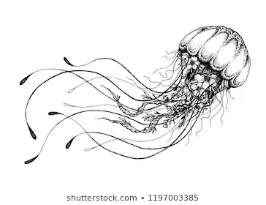
VII. Social Skills and or Habits of Mind
~ to Engage/Assess to Promote Student Motivation and Success
- Positive communication
- Open to feedback
- Team work
- Question things that are happening
- Share your ideas
- Flexibility
- Support Teammates
VIII. Level of Voice Appropriate for Each Day/Period
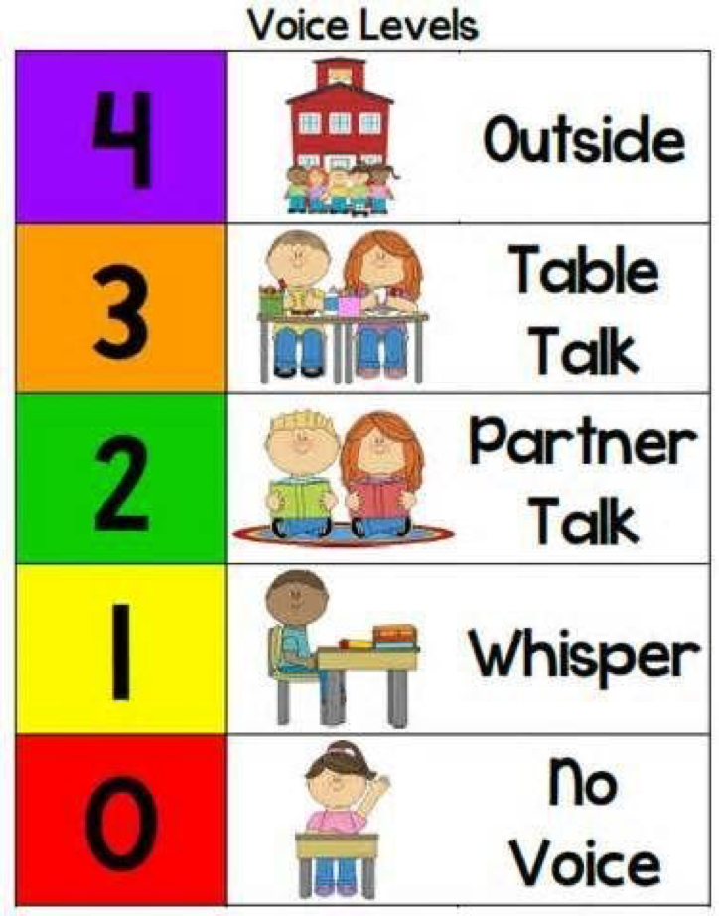
IX. Materials List
- 1 set of food web cards for wood Ecosystem ( 20 cards per set)
- Worksheet
- Pencil
- Science notebook

Formation of Groups

~ Students will number off (e.g. 1.2.3.4)

Role Assignments: Beginning with the Checker all roles are assigned to the right (clockwise)

- Materials Manager/ Encourager: *Person with the Earliest Birthday*Student retrieves materials and encourages students to do their best

- Checker/Timekeeper: Student will keep an eye on how much time they have left to finish project

- Recorder: Student will be responsible to recording all data

- Observer/Reporter: Student observes and also will be the illustrator

- Other: Traveler/Spy--Can be the checker

X. ENGAGING CONTEXT: Hook- Launch activity

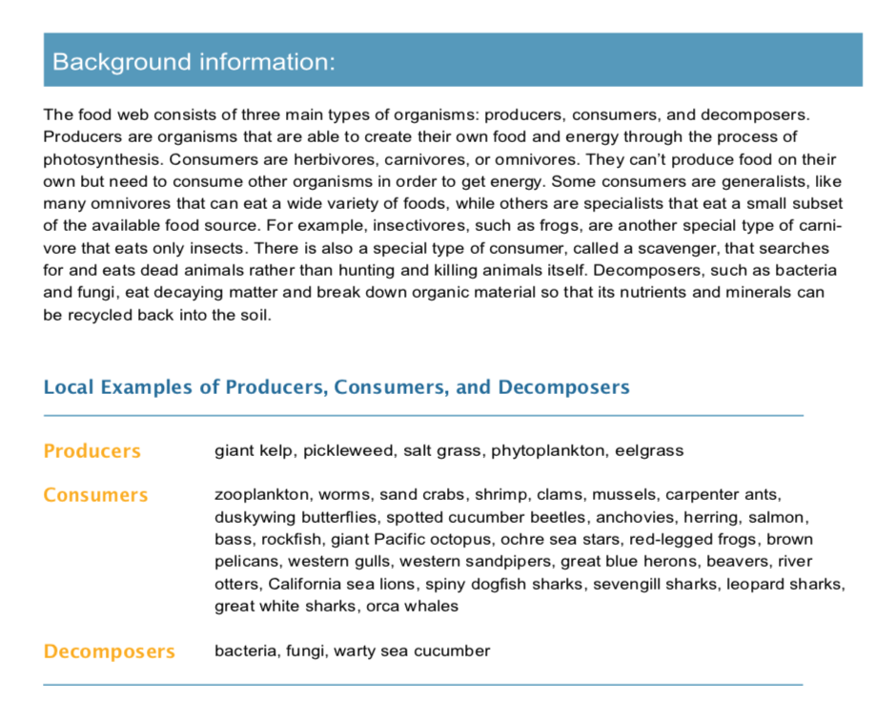

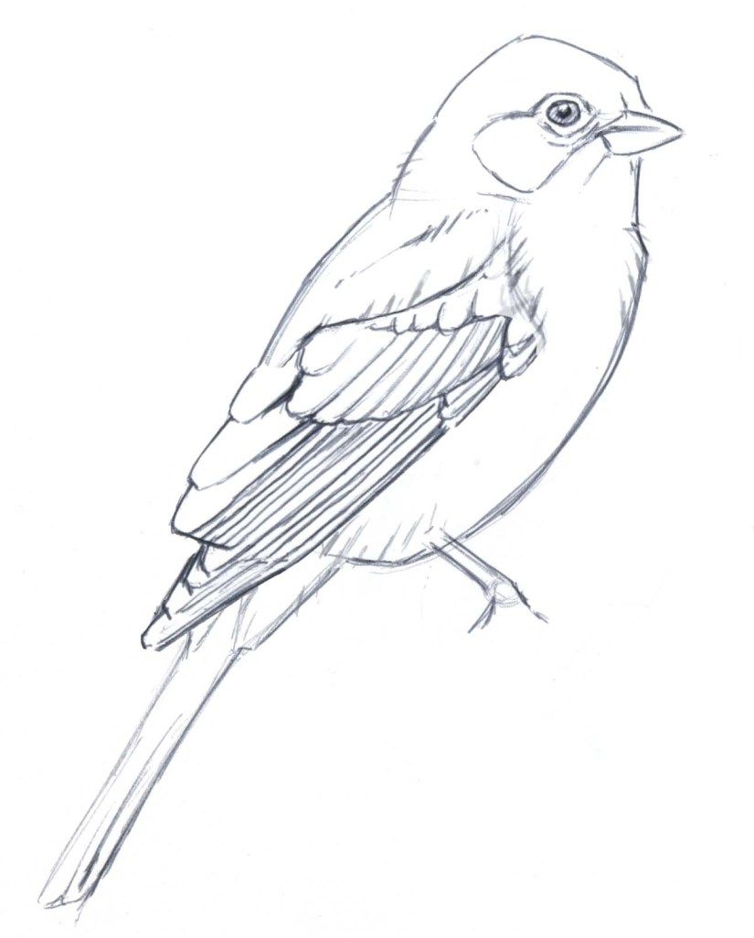

XI. EXPLORE - Building Knowledge
- Each car will describe an organism (plant or animal) that lives in a woods or forest ecosystem
- Students will get to know these organisms
- Students will spread out cards
- Each group member takes 5 cards to study
- Once everyone has had a chance to study their 5 cards, the group should look for pairs of organisms that go together
- Students will then mix up the deck and place cards in the order they believe is the correct order (food chain)

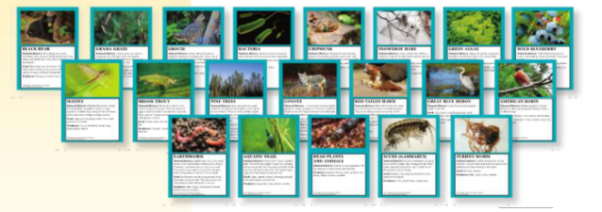

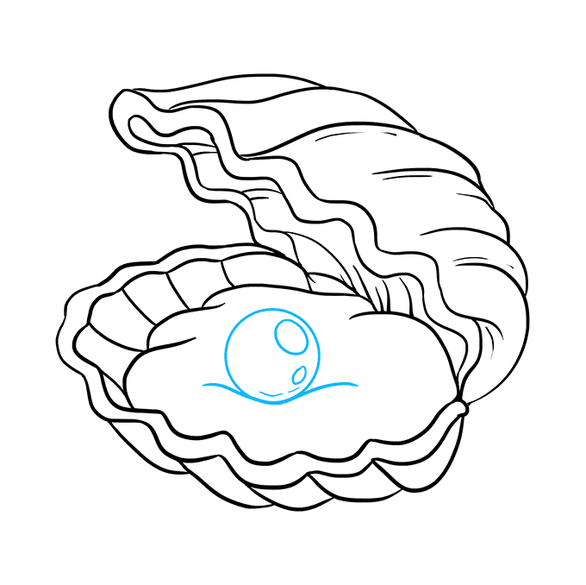
XII. EXPLAIN
Food web investigation
  - After learning about the different roles that animals play in the food web, students will investigate an outdoor area by searching for animals and thinking about how they fit together in a food web.
  - This can be done as a class in an outdoor space near the school, or students can take the worksheet home and do this investigation in their backyard or nearby park.
- At school, students can work in small groups or individually, and the teacher can float among groups, giving them support
  - Using the “Food Web Investigation” sheet, students record up to ten animals that they are able to find in a chosen outdoor area.
- Students record the animal, what they think it eats, what they think eats it, and what trophic level they think it is at.
- If students are having a difficult time with the concept of trophic level, they can write whether the animal is an herbivore, omnivore, or carnivore.
- Students should think about how all the animals in the area fit together into a food web. They should make observations to support their ideas.
Optional activity
• Using the data they gathered from their first exploration, students can choose a second site to explore and predict what animals they think they will find in the area.
- Students use the same “Food Web Investigation” sheet and record the animals they find at the new site.
• What animals did they predict they would see and why? How many animals were found in both areas? Were there any animals that were different? How were the outdoor sites different and how might that attract different animals?
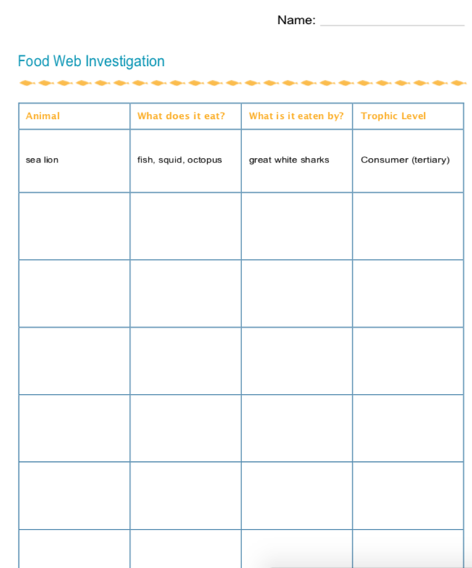

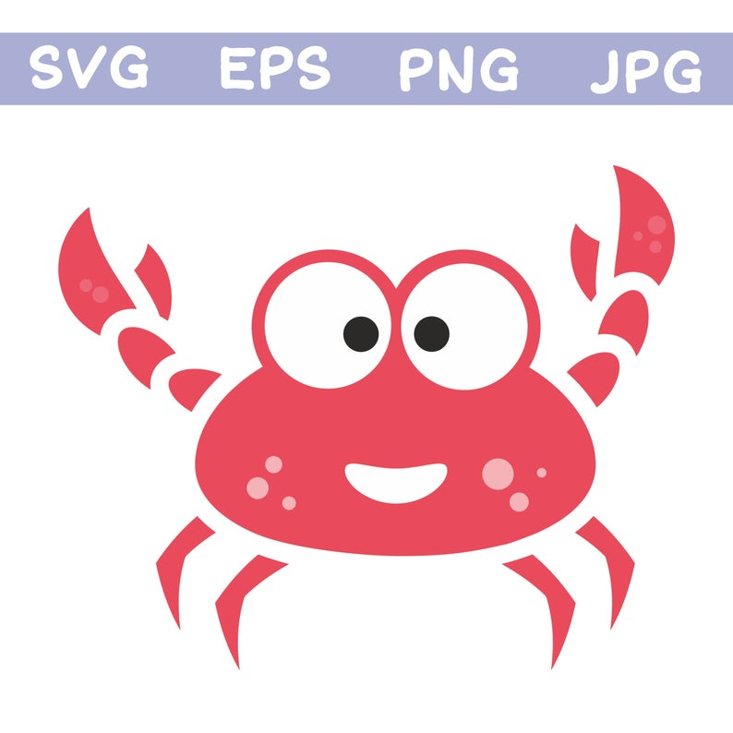
XIII. EXTEND/ELABORATE
Group discussion
- Once students have finished their investigations and filled out their sheets, gather them in small groups to discuss their findings.

- Guiding Questions:
- Did you all find the same animals? What did you find that was different?
- What other animals do they think might be there that they didn’t observe?
- Are there animals that live in burrows or somewhere else they can’t see?
- What about nocturnal animals that only come out at night?
- Do all the animals stay in one area or do they move around between spaces?
- Do all areas have their own separate food webs or do food webs overlap throughout the world?
- How could they investigate more of these questions?

XV. EVALUATE
Assessment Content
Assessment of Cooperation/Collaboration and Student
Self-Assessment of Collaborative Performance

 | St Students will be able to the role animals play in the food web
4 | - Students were able to identify animals as either producers, consumers, or decomposers and be able to determine what it can eat and what it is eaten by.
3 | - Students were able to identify animals as either producers, consumers, or decomposers and be able to determine what it can eat
2 | - Students were able to identify animals as either producers, consumers, or decomposers
1 | - Students was able to identify be able to determine what the animal can eat

Peer Assessment

Teammate Rating Chart
 | 1 | 2 | 3 | 4
Work | Did very little work during work period | Did most of the work assigned to the team | Did all work assigned to them well | Graciously accepted extra work
Organization | Did their own thing | Followed directions | Helped organize the group | Took charge and organized the group
Contribution | Held our group back | Helped our group succeed | Our group was better because of them | Group was much better because of them
Motivation | They prevented me from doing my best | They expected too much from me | They pushed me to be better | They brought out the best in me

Group members Overall Performance Total from above
_________________ 1 2 3 4 _______/16
_________________ 1 2 3 4 _______/16
_________________ 1 2 3 4 _______/16
_________________ 1 2 3 4 _______/16
_________________ 1 2 3 4 _______/16

Encouraging Energizer

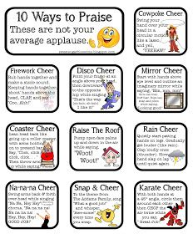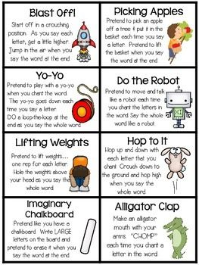

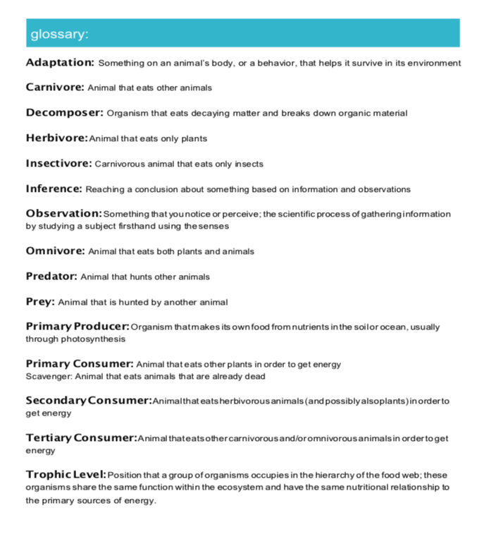

In this

