Jennifer Laras
Rachel Bonilla
EED 480 PBL with 5E Framework
- Trash Personalities! Grade 2
BIG IDEA:
Americans produce 254 million tons of trash each year. We tend to think of trash as an isolated entity with gross features and a foggy lifespan. We do not stop to think of where it comes from and where it goes once it leaves our sight. How can we become more mindful of our relationship with trash? How can we begin to realize not all trash is the same and as a result, have very different paths? Can trash become treasure?
How much trash do we produce? Is that amount relative?
Where does trash come from?
Why is trash sorted?
What happens when it isn’t sorted?
Where does our trash go when we throw it in a garbage bin?
What happens to our trash?
Let's investigate the properties of trash and its impact on the world.
Let's be engineers as we look for patterns in the trash that was collected from our community, so we can distinguish the different varieties of trash and the purpose for these groups.
- JUSTIFICATION This lesson combines several different disciplines: Science, Language Arts, technology, Civics, Political Science, and Art.
In this PBK K-5 unit, students explore how trash is an integral part of our existence on this planet. Furthermore, they will observe patterns in each category of trash and follow its progression from the moment humans use it for the first time to the moment we throw it away and thereafter.
As K-12 teachers explore and discuss the connections between the scientific practices in which we categorize garbage and the way society deals with the waste we produce, students learn how direct a relationship they have to that garbage. As a result of investigating the complete process of trash and its impact on climate change, students reflect on their own habits and how little by little, they add up. Students become activists to share the knowledge they have learned with their community and design ways to make changes beyond themselves.
- ENGAGE: We will observe a large quantity of trash in groups and discuss patterns we notice in order to then categorize the trash.
- EXPLORE: We will make predictions and record observations and questions about the sorting process on the first day.
- EXPLORE: We will learn about the four categories of trash (compost, recycling, hazardous, and landfill) and group the garbage according to these labels on the second day.
- EXPLAIN/ELABORATE: We will compare and contrast the four labels of trash and investigate what happens in each “family” after it leaves us and is sorted properly and incorrectly.
- EVALUATE: Each group will create a poster that models what they have learned. They will identify a research topic or a specific type of trash they would like to pursue further.
Finally, as a class we will become advocates for the importance of sorting our garbage at the school. Students will visit classrooms to share their knowledge about trash, its effect on the world, and its relationship to climate change. Ultimately, everyone will cooperate as they petition for garbage bins that include labels for landfill, compost, hazard, and recycling materials on campus by going to the classrooms of their peers, lobbying what they have learned, and collecting signatures to then take to the principle of the school.
- STANDARDS: Grade Level and Subject Area: Kindergarten to 5th Science, Social Studies, Language Arts, Mathematics and the Arts Standards
NGSS (Next Generation Science Standards)
2-PS1-1.
Plan and conduct an investigation to describe and classify different kinds of materials by their observable properties.
K-2-ETS1-1.
Ask questions, make observations, and gather information about a situation people want to change to define a simple problem that can be solved through the development of a new or improved object or tool.
Disciplinary Core Ideas
ESS: Earth and Space Science
ETS: Engineering, Technology, and the Application of Science
Science and Engineering Practices
- Asking Questions and Defining Problems
- Developing and Using Models
- Planning and Carrying out Investigations
- Constructing Explanations and Designing Solutions
- Engaging in Argument from Evidence
- Obtaining, Evaluating, and Communicating Information
Crosscutting Concepts
- Patterns
- Cause and Effect
- Scale, Proportion, and Quantity
- Systems and System Models
SOCIAL STUDIES
CCHSS.2.4.3.
Understand how limits on resources affect production and consumption.
HSS.4.5.4.
Explain the structures and functions of state governments, including the roles and responsibilities of their elected officials.
LANGUAGE ARTS
ECCSS.ELA-LITERACY.RI.2.4
Determine the meaning of words and phrases in a text relevant to a grade 2 topic or subject area.
CCSS.ELA-LITERACY.RI.2.7
Explain how specific images (e.g., a diagram showing how a machine works) contribute to and clarify a text.
CCSS.ELA-LITERACY.SL.2.1
Participate in collaborative conversations with diverse partners about grade 2 topics and texts with peers and adults in small and larger groups.
CCSS.ELA-LITERACY.SL.2.2
Recount or describe key ideas or details from a text read aloud or information presented orally or through other media.
CCSS.ELA-LITERACY.SL.4.4
Report on a topic or text, tell a story, or recount an experience in an organized manner, using appropriate facts and relevant, descriptive details to support main ideas or themes; speak clearly at an understandable pace.
CCSS.ELA-LITERACY.SL.4.5
Add audio recordings and visual displays to presentations when appropriate to enhance the development of main ideas or themes.

V. MEASURABLE OBJECTIVES
A. As student thinking drives this lesson, they will essentially conduct an extended investigation in parts. On the first day one, they investigate based on their senses, personal knowledge, and observations. Later, they build on this investigation as they learn vocabulary and scientific concepts of the different subgroups of trash. Students can pursue their own inquiry to further investigate a selected category of trash and its impact on the environment.
B. As the culminating activity of this PBL students share their knowledge by creating posters about what they have learned in other classrooms. Posters may include topics such as the four categories of trash, its impact on the environment, the lifespan of trash, and our relationship and responsibility to it. By sharing what they learn, students become advocates and empower one another. It is then that they can use this momentum to take what they know about trash and its effect on climate change to engage in a schoolwide solution.
VI TOTAL TIME:
This PBL will be led over Two- Nine Class Periods ; ~60 minutes each
Launch Event: One Class Period of 60 minutes.
Building Knowledge: Two Class Periods
Present Product and Develop Products: Three Class Periods
VII. Social Skills and or Habits of Mind to Engage/Assess to Promote Student Motivation and Success
[ ] Persistence  [ ] Decreasing impulsivity  [ ] Empathic listening  [ ] Flexibility in thinking  [ ] Metacognitive awareness  [ ] Checking for accuracy  [ ] Questioning  [ ] Problem posing | [ ] Drawing on past knowledge  [ ] Application to new situations  [ ] Precision of language and thought  [ ] Using all the senses  [ ] Ingenuity, originality, insightfulness and creativity  [ ] Inquisitiveness, curiosity  [ ] Enjoyment of problem solving
VIII. Level of Voice Appropriate for Each Day/Period of the PBL
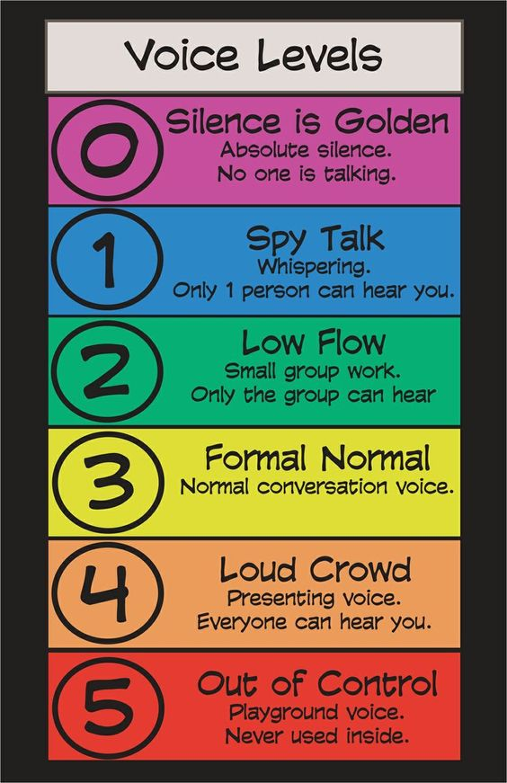
IX. Materials List
Day 1-2
- A large bag of classroom trash from the previous day or week
- Butcher paper to lay on the desks or reusable tablecloths
- Gloves
- Markers/Crayons/Colorful writing utensils
- Open Space
- Labels that say and have pictures of “COMPOST”, “RECYCLING”, “LANDFILL”, and “HAZARD”
Day 3-6
- Compostable Materials: Peels of different kinds, Egg shells, Coffee Grounds, newspaper
- Composting Video: https://www.youtube.com/watch?v=qHYzRaepeMw
- Recyclable Materials: plastics, aluminums, paper, glass
- Recycling Video: https://www.youtube.com/watch?v=6jQ7y_qQYUA
- Ask an Adult Materials: Cleaned and Safe to Handle Bottles, Electronics, and Hazardous Waste Materials
- Electronics/Hazardous Materials: https://www.youtube.com/watch?v=B53oSGacs1M , https://www.youtube.com/watch?v=Dsva5Ag8l-0
- Landfill Materials: Styrofoam, chicken bones, broken ceramics
- Landfill Video: https://www.youtube.com/watch?v=mA608GJ-EzM
Day 7-8
- Posters
- Markers
- Half Sheet handout to write an explanatory/persuasive paragraph to explain why it is important to have different kinds of bins at our school and why sorting trash helps the environment. The hand out also has spaces for signatures from grade level classmates from another room.
AFTER INSTRUCTOR RESPONDS TO OUTLINE CONTINUE TO DEVELOP THE PBL USING THE FOLLOWING PLAN:
NASA/BSCS 5-e FRAMEWORK
X. ENGAGING CONTEXT: Hook- Launch activity
Students will begin the Trash PBL by conducting an investigation that relies on their background knowledge and observations to guide them.
DIRECT INSTRUCTION: Engage students with a whole class discussion and ask questions such as “Where does trash come from?” and “What happens when we throw it away?”
FORMATION OF GROUPS: Students will form 6 groups of 4 using a human line graph related to the whole class discussion. Students will be assigned and described roles and tasks.
Roles:
Materials Manager/Traveler (SPY)- Responsible for gathering supplies and laying it out at the group’s workstation. As a spy, they will walk around and see how other groups are sorting their trash. If they are unsure of which category a piece of trash belongs, they can get suggestions by looking at how others are organizing their garbage.
Checker- Responsible for ensuring that all four labels are represented on the workstation. They also help ensure that the trash is placed in the appropriate place based on the team’s consensus, by describing with their group the makeup of each category and talking about the observations they make about the different articles of trash.
Recorder/Reporter- Will record any questions or observations that the group has as they are sorting trash. They will also record the characteristics of each label (compost, recycling, etc.). In other words, guidelines for what goes where.
Observer/Illustrator- Will help ensure that the trash is placed in the appropriate place. They will also facilitate the group in making observations about the similarities in the trash of each label.

EXPLORE
We will use our inquiry skills of predicting (hypothesis testing) comparing and analyzing to make observations of different pieces of trash, find connections and patterns between these pieces in order to categorize them, and analyze the properties of each category. On the first day, students will explore freely and base their categories based on observations and personal background knowledge. On the second day, students will use the categories they learn about at the start of the lesson such as recycling, landfill, compost, and hazard to sort out the trash. Here students will also have an opportunity to compare and analyze the categories. What patterns do they notice in each category? Students will also learn about the four different types of trash and then be able to make changes to their original groupings of trash. They are self-assessing, reflecting, and thinking critically about their choices.
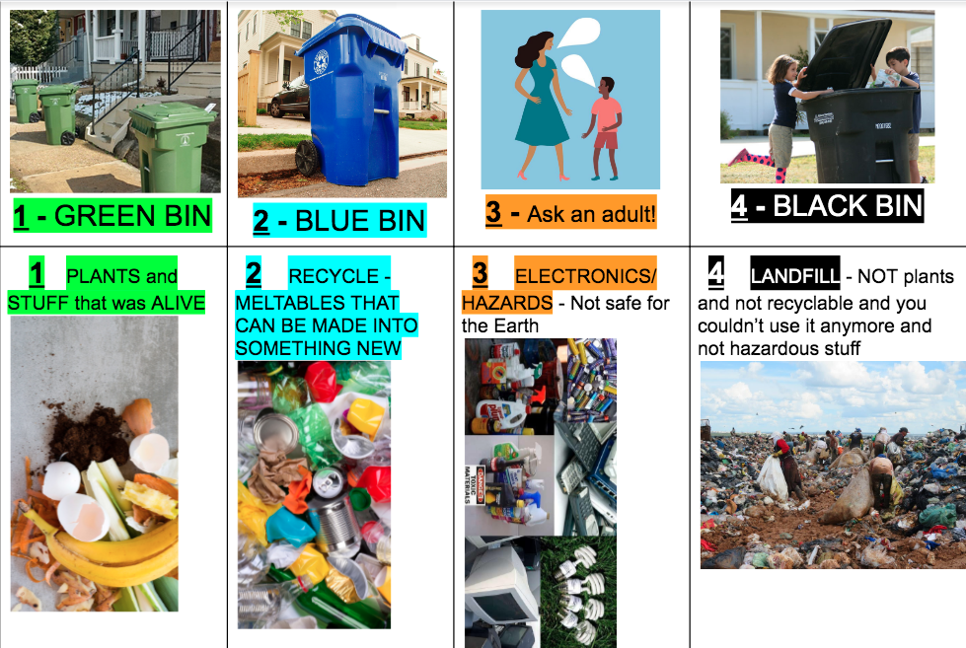
EXPLAIN
Students have an opportunity to show and share knowledge individually as they discuss with their teams where each piece of trash should belong in the launch activity. As a team, students will present to the class how they formed their groups of trash and later, how they decided where each piece of trash belongs. They present this to the class with reasoning as well as explain any changes they made from when they first categorized their trash items. During the culminating activity each group of students will show the different categories of trash they learned about by creating education posters collaboratively. Students will share with other classrooms the impact trash has on the planet and explain what they can do to help minimize these effects (aka by sorting trash!).
EXTEND/ELABORATE
Students further develop their learning by extending the first two days of their investigations. On day 3-6 students will have an opportunity to elaborate on their learning by focusing on one category of trash per day. The first day will be focused on Compost, the second day will be recyclables, the third will be Electronics and Hazardous Materials (materials that contain dangerous chemicals and/or need to be disposed of in a different place than the trash bins we have), and lastly, on the fourth day, we will discuss Landfills. The order of how we discuss each type of trash is important because at the end of learning about the journey of each kind of trash, this same order is the way we will ask students to think about trash when they are throwing it away. First students will be asked, is what I am throwing away “organic” material or is it made of material that can be broken down/decomposed? If the answer is yes, it goes in the green bin, also our number 1 bin shown in the chart above. If students answer no, then, they go to question if it should go in the 2nd bin: the blue bin. Students need ask themselves if what they are going to throw away is made of glass, plastic, and/or aluminum and can be melted to be created into something new -- if the answer is yes, then it goes in the blue bin and their job there is done, but if the response is no, then they need to hold onto it and go to their orange/3rd question which is: “does what I’m throwing away have dangerous chemicals? Or is it an electronic device such as lightbulbs, batteries, or cellphones?” If the answer is yes, then they should take that item to an adult to dispose of it in the best way it can be at their nearest Hazardous waste facility. If the answer is no, then that means what they are throwing away is not organic material, it is not recyclable, and it does not contain harmful chemicals or components to the planet, so now it needs to be put in the black bin/our 4th and last option. Each type of trash we are talking about throughout the PBL will have videos and conversations discussing the life of that type of trash to help students understand that if we do not sort trash properly, it quickly collects and that is bad for the planet because it hurts animals, the air we breathe; it is bad for humans because we do not have unlimited space on the planet!; and also we want to empower students to know that they can make choices everyday that can help this problem. They can save animals in the oceans who eat our trash or die suffocating from it, and that putting trash in our landfills is the last thing we want to do. To assess students’ understanding, on the penultimate day, Student teams will create posters that compare and contrast what happens to each category of trash after it leaves us as well as any other details about why it is important to sort trash and negative effects of not paying attention to our trash management, which they learned throughout the PBL from the videos and conversations we had as a class. The teacher provides mini-lessons as needed to scaffold student thinking and understanding. Students will also help each other write a brief paragraph that either persuades, informs, or both about the topic. This will be used on a different day for students to outreach to other students in other classrooms to advocate for trash specific bins at their school and collect signatures to eventually take to the principle of our campus.
EVALUATE
Throughout the PBL, students will self-assess and conduct peer assessments to evaluate their performance in the group. During the culminating activity, students will be assessed based on the posters they create to use as visual aids that they take into other classrooms. Students will become teachers as they go into other classrooms and share their knowledge about the different categories of trash and where each one ends up, and the responsibility we all have to sort our trash to take care of our Earth home. Students will reflect in their presentations as they discuss the importance of sorting trash and describe its impact on the environment. Students will be evaluated based on these presentations and their plans to get fellow students to sign their petition. We will also play a Kahoot! game before going out to lobby in order to test their sorting powers! They will also then direct the class they are presenting to, through this Kahoot! as well. The students become the teachers.
Content Summative Assessment:
- Kahoot! Game we made about sorting trash:
https://create.kahoot.it/share/trash/9fc29a3a-6296-437d-b0e3-802aa4b2bc69
- Individual information detailing student learning takeaways from the Launch activity
- Formative Assessment of Non-Cognitive Factors: Self-Assessment Using the Habits of Mind Check Sheet and Write-up Form:

Self-Assessment of Collaborative Performance:

 | Did I...
Work | do the work assigned to me?
Organization | help keep the group organized?
Contribution | put my 100% effort into the assignment?
Motivation | push myself to do my best?

Peer Assessment:

 | 1 | 2 | 3 | 4
Work | He/she did very little work throughout the activity. | He/she did most of the work assigned to the team. | He/she did all of the work assigned to them. | He/she graciously accepted the work given to them.
Organization | He/she did their own thing. | He/she followed directions. | He/she helped to organize the group. | He/she took charge and organized the group.
Contribution | He/she held your group back. | He/she helped our group succeed. | Our group was better because of him/her. | Our group was much better because of him/her.
Motivation | He/she prevented us from doing our best work | He/she expected too much from me. | He/she pushed me to be better. | He/she brought out the best in me.

Group Members | Overall Performance | Total from Above
 | 1 2 3 4 | _____/16
 | 1 2 3 4 | _____/16
 | 1 2 3 4 | _____/16
 | 1 2 3 4 | _____/16
 | 1 2 3 4 | _____/16

XI. Children's Literature that Supports the PBL:
- One Plastic Bag
- Dumpster Diver
- The Berenstain Bears GO GREEN
- The Wartville Wizard
- Magic Trash
XII. Criteria to Assess the Value of Your PBL:
1. Does it include a driving question in any of the identified disciplines?
2. Does it include any new STEAM vocabulary words?
3. Does it propose the development of a project--students/unit plan?
4. Does it assure that students show evidence that all team members were involved?
5. Have you inserted a comment when submitting that shows evidence that you reviewed
Koch chapters to assist in the NGSS aspects of the PBL?

