Play Day Books Spring 2010

Celebrating the First Space Flight of

Astronaut Jose Hernandez onboard Shuttle Mission – 128

August 28-September 10, 2009

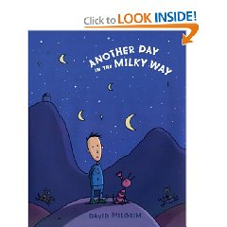

Monty’s world seems a little different this morning. For one thing he can’t noticing his mother has three heads and is serving liver flakes for breakfast. Then there are the usual animals he encounters, who all seem to be talking and……wearing costumes? There’s no way around it Monty has definitely woken upon the wrong planet. The problem is, he needs advice. But from whom? One of the rather odd-looking horses? The no-nonsense ant? Or the old man on the mountaintop? Readers will have a ball joining Monty’s journey through this oddball alternate universe, packed with funny details sure to elicit giggles.

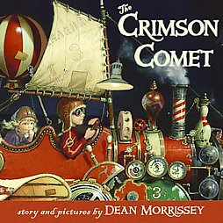 Join Nora and her brother Jack as they search for the moon that has suddenly clicked off. They climb into their self designed spaces ship. Out they blast through the window off in search of the moon. They crash into the moon and try to help the man in the moon get the moon relit. Join the crimson comet as it fights to save the moon and get it re-powered. Will they save the moon and make it back home in time for morning. Read on and enjoy this imaginative filled tale.

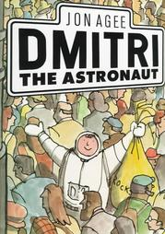 This is a great story about an astronaut named Dmitri who has been on the moon for two years. When his space shuttle lands no one is there but a big ship is there to rescue him. Sadly wherever he goes people don’t know who he is. He is starting to get sad and dumps his bag of moon rocks in the trash. There is more than moon rocks in the bag but his trusty pet LULU. Lulu is found to be the greatest discovery and reunites Dmitri with Lulu. In the end everyone remembers who he is and is glad he safely makes it home.

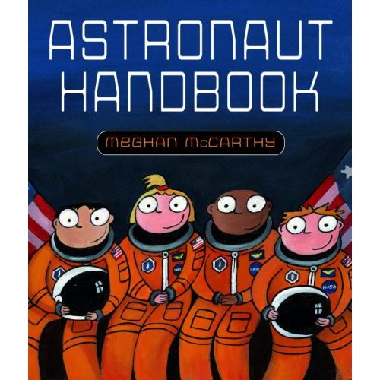 Do you have what it takes to be an astronaut? Blast off to astronaut school with Megan McCarthy and the Astronaut Handbook. Take a ride on the “vomit Comet and learn how it feels to be weightless. Try a bite of astronaut food, such as delicious freeze-dried ice cream. Have your measurements taken-one hundred of your hand alone-for your very own. Get ready for liftoff!!

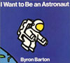 Blast off! Up into the sky goes the space shuttle. In orbit, the astronaut get a taste of ready to eat food, experience zero gravity, go for space walks, and even fix a satellite. It’s fun to fly aboard the shuttle……..and then come back to Earth.

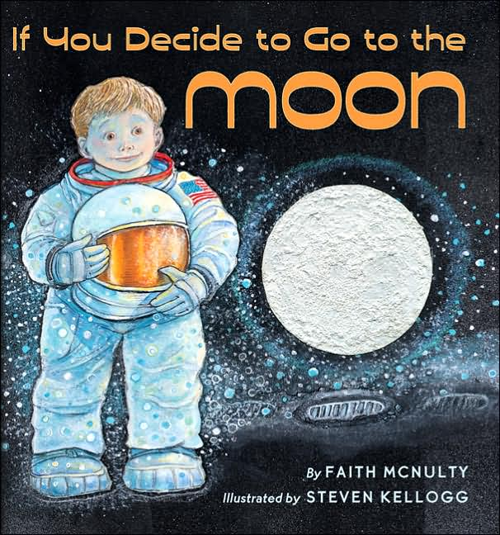 Take an imaginary journey and discover the breathtaking beauty of the moon, glows like a pearl I the black, black night. After your return you will never see the moon-or Earth-in quite the same way.

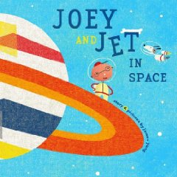 Join Joey and his pet dog Jet as they journey through space. Joey loses Jet at one point and is on the search for him. He looks all over space meeting space people along the way. Will he ever find his precious Jet? Will he ever find a way to get back home? Read on and see how the story unfolds.

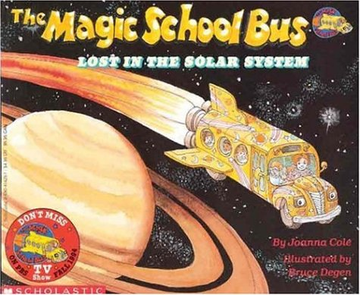 Join Ms Frizzie and her class as they journey into the solar system. Thanks to their trusty school bus it blasts into space teaching the children more about gravity and weightlessness. The class discovers being active on the moon, journey’s near the sun. Join the class and Ms Frizzie as they discover and explore the planets in the solar system and learn interesting facts about each.

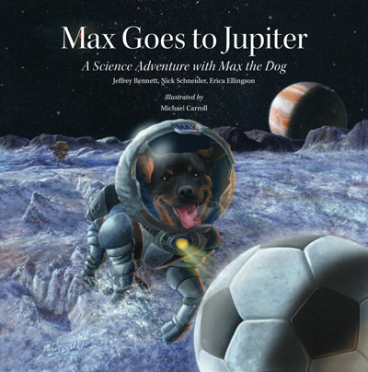 Prepare to be amazed as you join Max and his friends on an incredible journey to Jupiter. Ride a space Elevator to orbit, visit Jupiter’s volcanically active moon to, send a robotic submarine into the hidden ocean of ice-encrusted Europa. Along the way learn why Jupiter has been so important tin human history, and find out how Max’s mission carries a message of hope and inspirtion to people around the world.

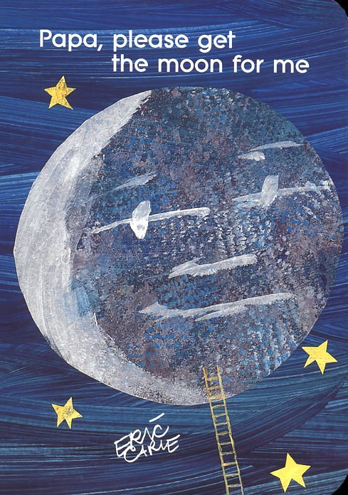 Monica wants the moont oplay with, so her papa sets out to get it for her. It isn’t easy to climb all the way up to the moon, but he finally succeeds-only to find that the moon is too big to carry home. In this unique and delightful picture book, the story unfolds as pafes open dramatically, extending both outward and upward.

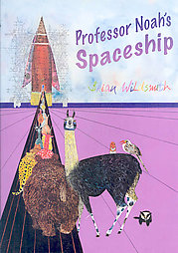 This a story about rain forest animals who are experiencing a deterioration of their natural habitats. They encounter a professor who is building a space ship for the animals so they can find a new forest to live in. Join the animals and professor Noah as they journey through space and travel back in time to the time when the forest was ripe and plentiful.

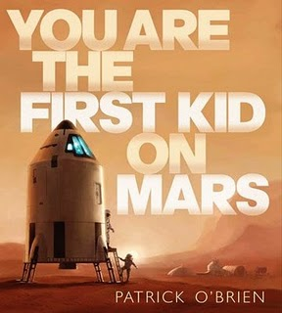 How would you like to ride a rocket all the way to the mysterious red planet? Humans have never visited Mars, but in this close encounter you will get to experience first hand what it would be like. What kind of rocket ship would take you there? How would you survive on the surface? Open the book and take your first step toward exploring a world that no kid has ever been to before. You will be the first.

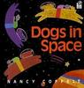 Join these dogs on a journey into space. They visit each of the planets and share facts about each one. The dogs also encounter an asteroid belt as they dodge their way through. The dogs enjoy exploring space but begin to miss homes and the comfort it brings.

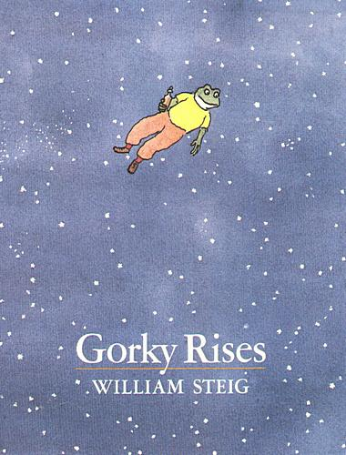 Gorky is a young scientist who has developed a special potion. Once the motion is just right he heads out to special spot to lay down. All of sudden Gorky takes flight into the air and awakens to discover that he is flying high above the ground and he was not scared. He embarks on an amazing exploration of flight even through a storm and into space. He is reunited with his family with a special story to share.

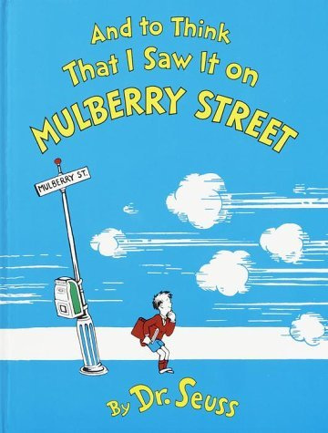 Marco heads home after school hopeful and ready to share with his dad what he saw on his way home. When he spies a horse and wagon his imagination gets fired up and he quickly finds himself creating and designing animals and carriages so much so that the horse and wagon become a full fledge parade with endless possibilities. With all of the fun generated on Marco’s walk home what will Marco tell his dad when he gets home?

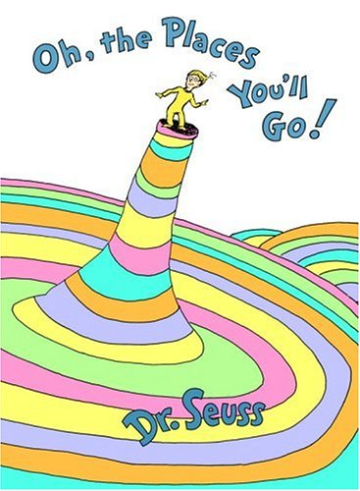 Dr Suess takes us humorous journey as he addresses the great balancing act (life itself, and the ups and downs its presents) while encouraging us to find the success that lies within us. And will you succeed? Yes! You will indeed! (98 and ¾ percent indeed). Everyone will find this story inspired good gun.

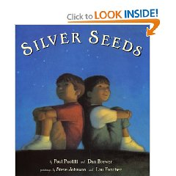 Silver Seeds tossed in the air and planted in the sky, reaching out of the darkness sprouting wonder. Is the night sky filled with stars, or are they silver seeds? Do you see fall leaves floating down, or are they little brown parachutes? Turn the pages and see the world of nature in a different light. Then take a look outside, what do you see?
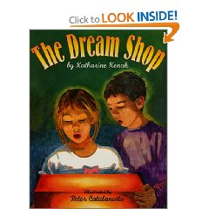 “Once upon a while, on an island above the ice and below he stars, there is a small shop made of wood…where one ca purchase dreams One hot summer night a cousin’s word transport Pip to a strange and unexpected place, where cowardice and courage are for sale. The choice is hers. A writer whose words sparkle with imagination and an illustrator who dazzles with inspiration combine their talents in bringing this mysterious tale to like.

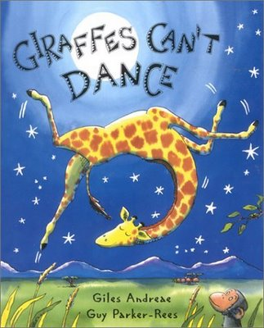 Gerald the giraffe longs to dance, but his legs are too skinny and his neck is too long. His knees buckle whenever he tries to twirl. At the jungle dance the warthogs waltz, the chimps cha-cha, and the lions tango. “giraffes can’t dance,” the animals all jeer when its Gerald’s turn to prance. Fortunately there is one little creature who believes in Gerald “everything makes music , if you really want it to,” says cricket. With the light footed rhymes and high stepping illustrations, this tale is gentle inspiration for every child with dreams of greatness.

