Geography 103: Weather
Exercise 9. Surface weather charts.

Surface Data Plot
The surface data plot gives the following information:
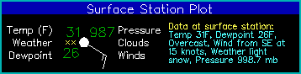
Data | Description
temperature (F) | plotted upper left
present weather | symbol plotted center left (see below)
dewpoint (F) | plotted lower left
pressure (.1 mb-coded) | plotted upper right as last 3 digits (987=998.7mb, 024=1002.4mb)
cloud cover | center circle. white fill indicates % cloud coverage (see below)
winds | wind barb (see below)

Weather Symbols
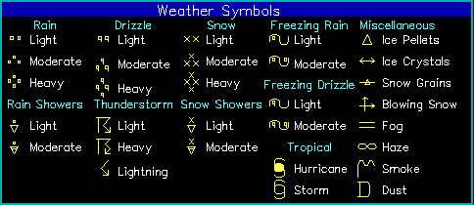
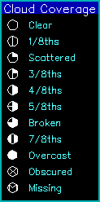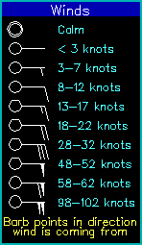

Frontal Location Plot
Frontal locations are denoted by bold lines in the following colors:
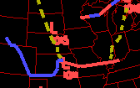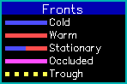
High and Low pressure systems are plotted with H and L and the associated pressure in millibars is displayed below the letter.
NOTE: Frontal data are only available every 3 hours so fronts may not exactly match the weather conditions. A label at the bottom left denotes what time the fronts are valid.

Pressure/Isobar Contours
The pressure contours (or isobars) are plotted as blue lines every 4 millibars and indicate positioning and extent of various pressure systems.

