Geography 103: Weather
Exercise 8. Winds at 300 mb.
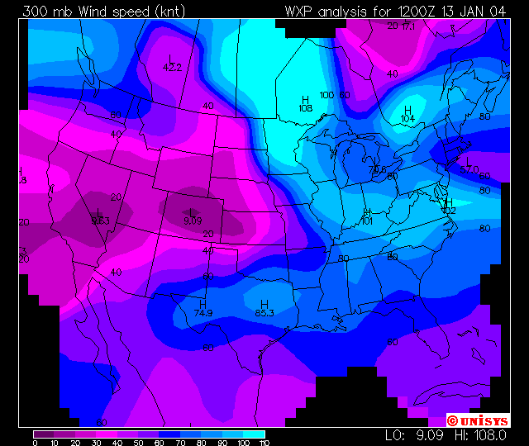

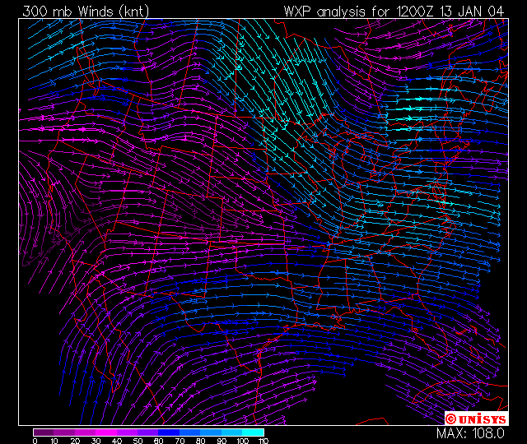

Contour Plots

(top) This is a contour plot of 300 mb wind speeds in knots. The contour interval is 10 knots. This level is referred to as the jet stream level. Areas of strong winds at this level (winds > 100 knots or 115 mph), commonly referred to as jets, indicate areas of high atmospheric energy. These are created by strong temperature contrasts in the lower and middle tropopause and reflect areas of potential storm development. A strong jet (winds > 130 knots) can indicate the potential for the development of a strong low pressure system especially when if moves over the Rocky mountains and into the Plains states. A strong jet hitting the west coast can indicate the existence of a strong precipitation producing system.

(bottom) This is a streamline plot of 300 mb winds. The lines follow the direction of the wind. Small arrows denote actual direction. The streamlines are colored based on their speed.

