Geography 103: Weather
Exercise 7. An 850 mb chart.

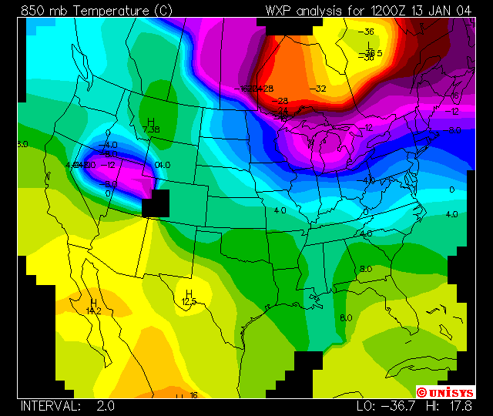

Contour Plots
This is a contour plot of temperature in Celsius at the 850 mb level. The interval is 5 degrees. The temperature field shows where warm and cold air are located. Temperatures at this level do not show the diurnal temperature changes from morning low to afternoon high we see at the earth's surface. The 850 temperature is also a decent indicator of the type of precipitation. Since most precipitation forms at 5000 feet or above, a temperature of freezing (0 Celsius) or below would indicate snow whereas a temperature above freezing would indicate rain.

