Geography 103: Weather
Exercise 10. Los Angeles weather.

Surface Data Plot
The surface data plot gives the following information:
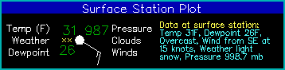
Data | Description
temperature (F) | plotted upper left
present weather | symbol plotted center left (see below)
dewpoint (F) | plotted lower left
pressure (.1 mb-coded) | plotted upper right as last 3 digits (987=998.7mb, 024=1002.4mb)
cloud cover | center circle. white fill indicates % cloud coverage (see below)
winds | wind barb (see below)

Weather Symbols
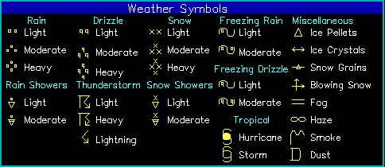
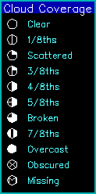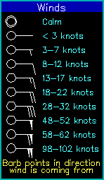

Pressure/Isobar Contours
The pressure contours (or isobars) are plotted as blue lines every 4 millibars and indicate positioning and extent of various pressure systems.

