Chapter 5
Cost Behavior: Analysis and Use
Solutions to Questions

5-1
- Variable cost: A variable cost remains constant on a per unit basis, but changes in total in direct relation to changes in volume.
- Fixed cost: A fixed cost remains constant in total amount. The average fixed cost per unit varies inversely with changes in volume.
- Mixed cost: A mixed cost contains both variable and fixed cost elements.
5-2
- Unit fixed costs decrease as volume increases.
- Unit variable costs remain constant as volume increases.
- Total fixed costs remain constant as volume increases.
- Total variable costs increase as volume increases.
5-3
- Cost behavior: Cost behavior refers to the way in which costs change in response to changes in a measure of activity such as sales volume, production volume, or orders processed.
- Relevant range: The relevant range is the range of activity within which assumptions about variable and fixed cost behavior are valid.
5-4 An activity base is a measure of whatever causes the incurrence of a variable cost. Examples of activity bases include units produced, units sold, letters typed, beds in a hospital, meals served in a cafe, service calls made, etc.
5-5
- Variable cost: A variable cost remains constant on a per unit basis, but increases or decreases in total in direct relation to changes in activity.
- Mixed cost: A mixed cost is a cost that contains both variable and fixed cost elements.
- Step-variable cost: A step-variable cost is a cost that is incurred in large chunks, and which increases or decreases only in response to fairly wide changes in activity.
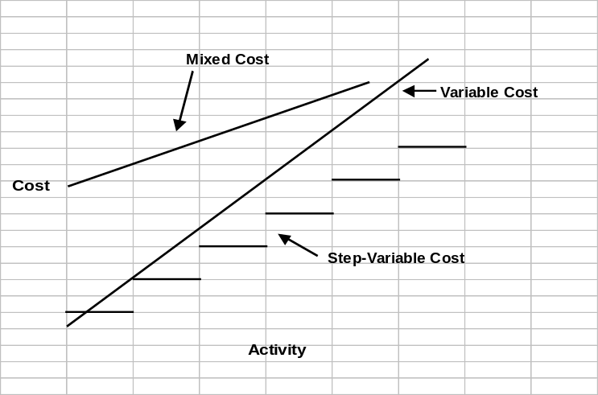5-6 The linear assumption is reasonably valid providing that the cost formula is used only within the relevant range.
5-7 A discretionary fixed cost has a fairly short planning horizon—usually a year. Such costs arise from annual decisions by management to spend on certain fixed cost items, such as advertising, research, and management development. A committed fixed cost has a long planning horizon—generally many years. Such costs relate to a company’s investment in facilities, equipment, and basic organization. Once such costs have been incurred, they are “locked in” for many years.
5-8
- Committed d. Committed
- Discretionary e. Committed
- Discretionary f. Discretionary
5-9 Yes. As the anticipated level of activity changes, the level of fixed costs needed to support operations may also change. Most fixed costs are adjusted upward and downward in large steps, rather than being absolutely fixed at one level for all ranges of activity.
5-10 The high-low method uses only two points to determine a cost formula. These two points are likely to be less than typical since they represent extremes of activity.
5-11 The formula for a mixed cost is Y = a + bX. In cost analysis, the “a” term represents the fixed cost, and the “b” term represents the variable cost per unit of activity.
5-12 The term “least-squares regression” means that the sum of the squares of the deviations from the plotted points on a graph to the regression line is smaller than could be obtained from any other line that could be fitted to the data.
5-13 Ordinary single least-squares regression analysis is used when a variable cost is a function of only a single factor. If a cost is a function of more than one factor, multiple regression analysis should be used to analyze the behavior of the cost.
5-14 The contribution approach income statement organizes costs by behavior, first deducting variable expenses to obtain contribution margin, and then deducting fixed expenses to obtain net operating income. The traditional approach organizes costs by function, such as production, selling, and administration. Within a functional area, fixed and variable costs are intermingled.
5-15 The contribution margin is total sales revenue less total variable expenses.

Exercise 5-1 (15 minutes)
1. |  | Cups of Coffee Served  in a Week
 |  | 1,800 | 1,900 | 2,000
 | Fixed cost | $1,100 | $1,100 | $1,100
 | Variable cost | 468 | 494 | 520
 | Total cost | $1,568 | $1,594 | $1,620
 | Cost per cup of coffee served * | $0.871 | $0.839 | $0.810

* Total cost ÷ cups of coffee served in a week

2. The average cost of a cup of coffee declines as the number of cups of coffee served increases because the fixed cost is spread over more cups of coffee.
Exercise 5-2 (30 minutes)
1. The completed scattergraph is presented below:

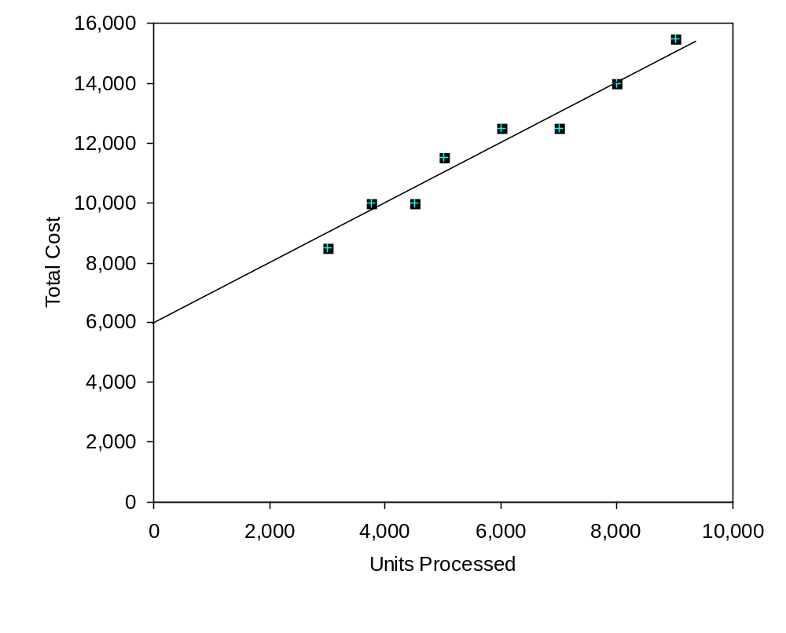

Exercise 5-2 (continued)
2. (Students’ answers will vary considerably due to the inherent imprecision and subjectivity of the quick-and-dirty scattergraph method of estimating variable and fixed costs.)

The approximate monthly fixed cost is $6,000—the point where the straight line intersects the cost axis.

The variable cost per unit processed can be estimated as follows using the 8,000-unit level of activity, which falls on the straight line:

Total cost at the 8,000-unit level of activity | $14,000
Less fixed costs | 6,000
Variable costs at the 8,000-unit level of activity | $ 8,000

$8,000 ÷ 8,000 units = $1 per unit.

Observe from the scattergraph that if the company used the high-low method to determine the slope of the line, the line would be too steep. This would result in underestimating the fixed cost and overestimating the variable cost per unit.
Exercise 5-3 (20 minutes)
1. | Month | Occupancy-Days | Electrical Costs
 | High activity level (August) | 3,608 | $8,111
 | Low activity level (October) | 186 | 1,712
 | Change | 3,422 | $6,399

Variable cost = Change in cost ÷ Change in activity
= $6,399 ÷ 3,422 occupancy-days
= $1.87 per occupancy-day

 | Total cost (August) | $8,111
 | Variable cost element  ($1.87 per occupancy-day × 3,608 occupancy-days) | 6,747
 | Fixed cost element | $1,364

2. Electrical costs may reflect seasonal factors other than just the variation in occupancy days. For example, common areas such as the reception area must be lighted for longer periods during the winter. This will result in seasonal effects on the fixed electrical costs.
Additionally, fixed costs will be affected by how many days are in a month. In other words, costs like the costs of lighting common areas are variable with respect to the number of days in the month, but are fixed with respect to how many rooms are occupied during the month.
Other, less systematic, factors may also affect electrical costs such as the frugality of individual guests. Some guests will turn off lights when they leave a room. Others will not.
Exercise 5-4 (20 minutes)
1. | The Haaki Shop, Inc.  Income Statement—Surfboard Department  For the Quarter Ended May 31
 | Sales |  | $800,000
 | Variable expenses:
 | Cost of goods sold ($150 per surfboard × 2,000 surfboards*) | $300,000
 | Selling expenses ($50 per surfboard × 2,000 surfboards) | 100,000
 | Administrative expenses (25% × $160,000) | 40,000 | 440,000
 | Contribution margin |  | 360,000
 | Fixed expenses:
 | Selling expenses | 150,000
 | Administrative expenses | 120,000 | 270,000
 | Net operating income |  | $ 90,000

*$800,000 sales ÷ $400 per surfboard = 2,000 surfboards.

2. Since 2,000 surfboards were sold and the contribution margin totaled $360,000 for the quarter, the contribution of each surfboard toward fixed expenses and profits was $180 ($360,000 ÷ 2,000 surfboards = $180 per surfboard). Another way to compute the $180 is:

 | Selling price per surfboard |  | $400
 | Less variable expenses:
 | Cost per surfboard | $150
 | Selling expenses | 50
 | Administrative expenses  ($40,000 ÷ 2,000 surfboards) | 20 | 220
 | Contribution margin per surfboard |  | $180
Exercise 5-5 (20 minutes)
The least-squares regression estimates of fixed and variable costs can be computed using any of a variety of statistical and mathematical software packages or even by hand. The solution below uses Microsoft® Excel as illustrated in the text.

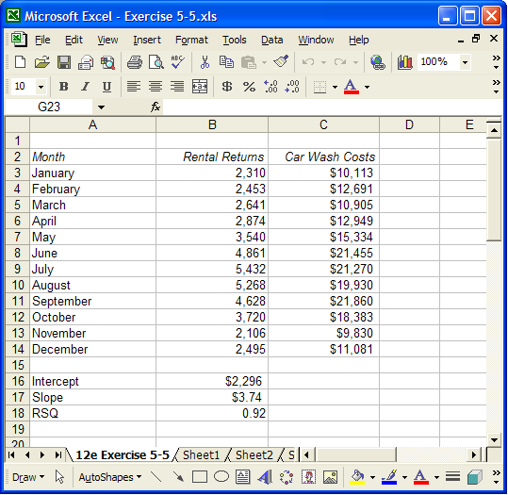

The intercept provides the estimate of the fixed cost element, $2,296 per month, and the slope provides the estimate of the variable cost element, $3.74 per rental return. Expressed as an equation, the relation between car wash costs and rental returns is
Y = $2,296 + $3.74X
where X is the number of rental returns.
Note that the R² is 0.92, which is quite high, and indicates a strong linear relationship between car wash costs and rental returns.
Exercise 5-5 (continued)
While not a requirement of the exercise, it is always a good to plot the data on a scattergraph. The scattergraph can help spot nonlinearities or other problems with the data. In this case, the regression line (shown below) is a reasonably good approximation to the relationship between car wash costs and rental returns.
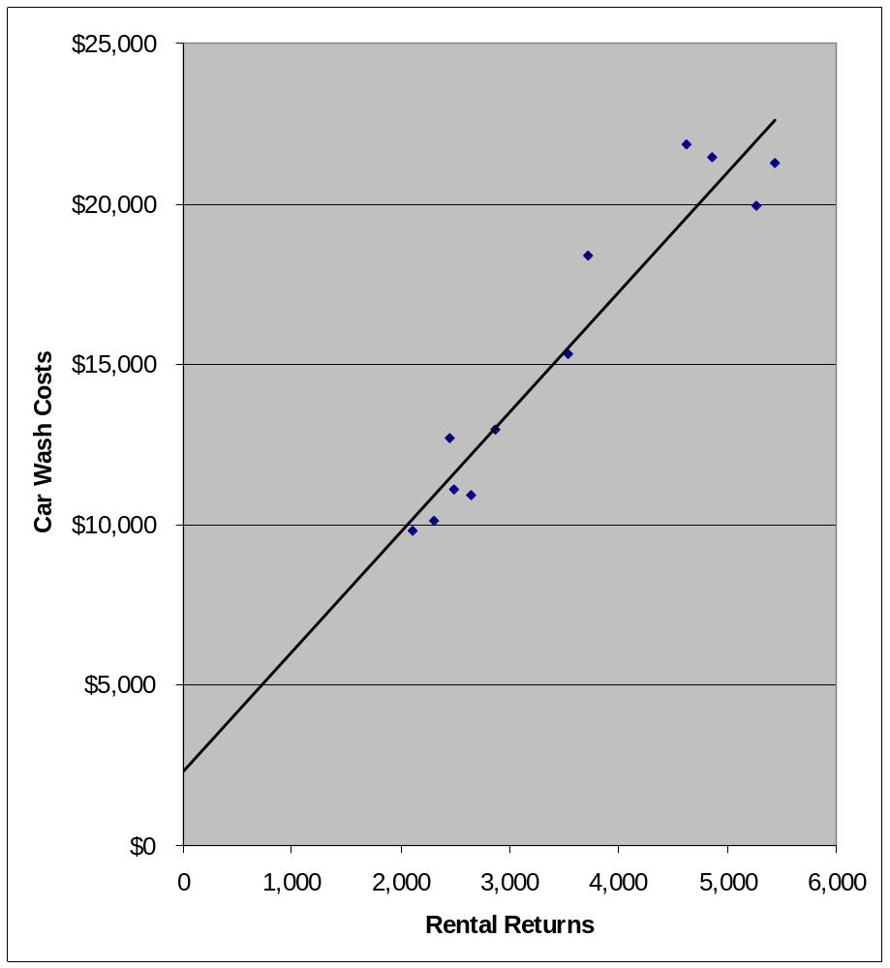
Exercise 5-6 (20 minutes)
1. The company’s variable cost per unit would be:
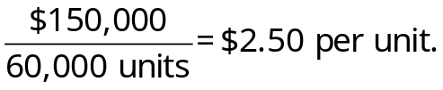
Taking into account the difference in behavior between variable and fixed costs, the completed schedule would be:

 | Units produced and sold
 | 60,000 |  | 80,000 |  | 100,000
Total costs:
Variable costs | $150,000 | * | $200,000 |  | $250,000
Fixed costs | 360,000 | * | 360,000 |  | 360,000
Total costs | $510,000 | * | $560,000 |  | $610,000
Cost per unit:
Variable cost | $2.50 |  | $2.50 |  | $2.50
Fixed cost | 6.00 |  | 4.50 |  | 3.60
Total cost per unit | $8.50 |  | $7.00 |  | $6.10
*Given.

2. The company’s income statement in the contribution format would be:

Sales (90,000 units × $7.50 per unit) | $675,000
Variable expenses (90,000 units × $2.50 per unit) | 225,000
Contribution margin | 450,000
Fixed expenses | 360,000
Net operating income | $ 90,000
Exercise 5-7 (45 minutes)
1. |  | Units Shipped | Shipping Expense
 | High activity level | 8 | $3,600
 | Low activity level | 2 | 1,500
 | Change | 6 | $2,100

Variable cost element:
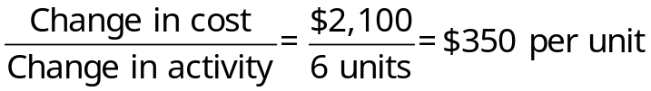
Fixed cost element:
Shipping expense at the high activity level | $3,600
Less variable cost element ($350 per unit × 8 units) | 2,800
Total fixed cost | $ 800

The cost formula is $800 per month plus $350 per unit shipped or

Y = $800 + $350X,

where X is the number of units shipped.

2. a. See the scattergraph on the following page.

b. (Note: Students’ answers will vary due to the imprecision and subjective nature of this method of estimating variable and fixed costs.)

Total cost at 5 units shipped per month [a point  falling on the line in (a)] | $2,600
Less fixed cost element (intersection of the Y axis) | 1,100
Variable cost element | $1,500

$1,500 ÷ 5 units = $300 per unit.

The cost formula is $1,100 per month plus $300 per unit shipped or

Y = $1,100 + 300X,

where X is the number of units shipped.
Exercise 5-7 (continued)
2. a. The scattergraph appears below:
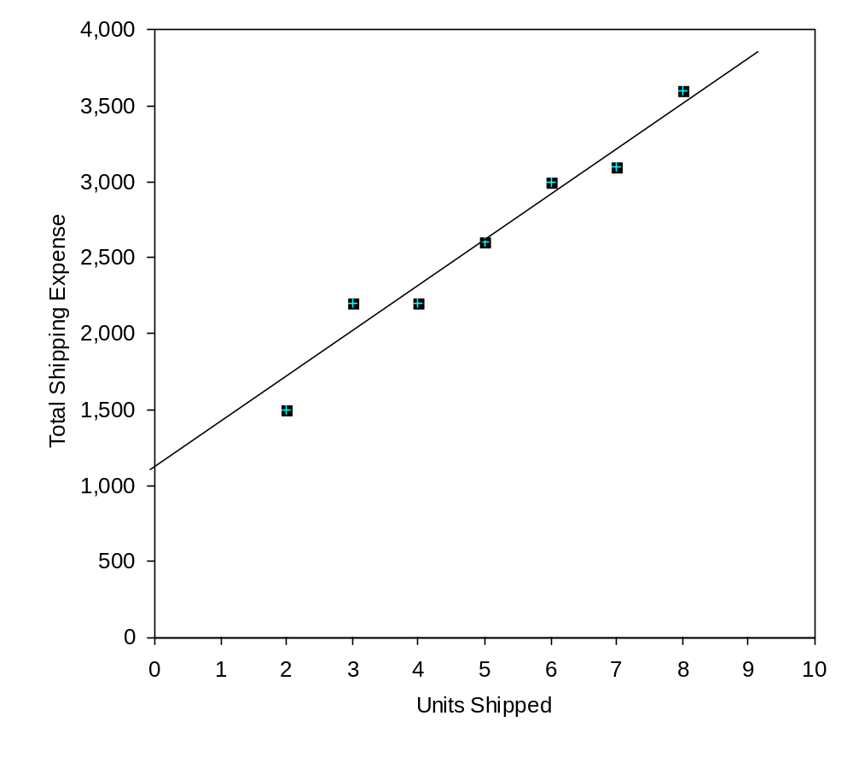
3. The cost of shipping units is likely to depend on the weight and volume of the units shipped and the distance traveled as well as on the number of units shipped. In addition, higher cost shipping might be necessary to meet a deadline.
Exercise 5-8 (30 minutes)
1. | Month | Units Shipped (X) | Shipping Expense (Y)
 | January | 4 | $2,200
 | February | 7 | $3,100
 | March | 5 | $2,600
 | April | 2 | $1,500
 | May | 3 | $2,200
 | June | 6 | $3,000
 | July | 8 | $3,600

A spreadsheet application such as Excel or a statistical software package can be used to compute the slope and intercept of the least-squares regression line for the above data. The results are:

 | Intercept (fixed cost) | $1,011
 | Slope (variable cost per unit) | $318
 | R² | 0.96

Therefore, the cost formula is $1,011 per month plus $318 per unit shipped or

Y = $1,011 + $318X.

Note that the R² is 0.96, which means that 96% of the variation in shipping costs is explained by the number of units shipped. This is a very high R² and indicates a very good fit.

2. |  | Variable Cost per Unit | Fixed Cost per Month
 | Quick-and-dirty scattergraph method | $300 | $1,100
 | High-low method | $350 | $800
 | Least-squares regression method | $318 | $1,011

Note that the high-low method gives estimates that are quite different from the estimates provided by least-squares regression.
Exercise 5-9 (20 minutes)
1. |  | Miles Driven | Total Annual Cost*
 | High level of activity | 120,000 | $13,920
 | Low level of activity | 80,000 | 10,880
 | Change | 40,000 | $ 3,040

* | 120,000 miles × $0.116 per mile = $13,920
 | 80,000 miles × $0.136 per mile = $10,880

Variable cost per mile:

Fixed cost per year:

Total cost at 120,000 miles | $13,920
Less variable cost element:  120,000 miles × $0.076 per mile | 9,120
Fixed cost per year | $ 4,800

2. Y = $4,800 + $0.076X

3. | Fixed cost | $ 4,800
 | Variable cost: 100,000 miles × $0.076 per mile | 7,600
 | Total annual cost | $12,400
Exercise 5-10 (20 minutes)
1. |  | X-rays Taken | X-ray Costs
 | High activity level (February) | 7,000 | $29,000
 | Low activity level (June) | 3,000 | 17,000
 | Change | 4,000 | $12,000

Variable cost per X-ray:
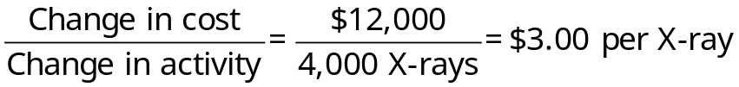
Fixed cost per month:

X-ray cost at the high activity level | $29,000
Less variable cost element:  7,000 X-rays × $3.00 per X-ray | 21,000
Total fixed cost | $ 8,000

The cost formula is $8,000 per month plus $3.00 per X-ray taken or, in terms of the equation for a straight line:

Y = $8,000 + $3.00X

where X is the number of X-rays taken.

2. Expected X-ray costs when 4,600 X-rays are taken:

Variable cost: 4,600 X-rays × $3.00 per X-ray | $13,800
Fixed cost | 8,000
Total cost | $21,800
Exercise 5-11 (30 minutes)
1. The scattergraph appears below.

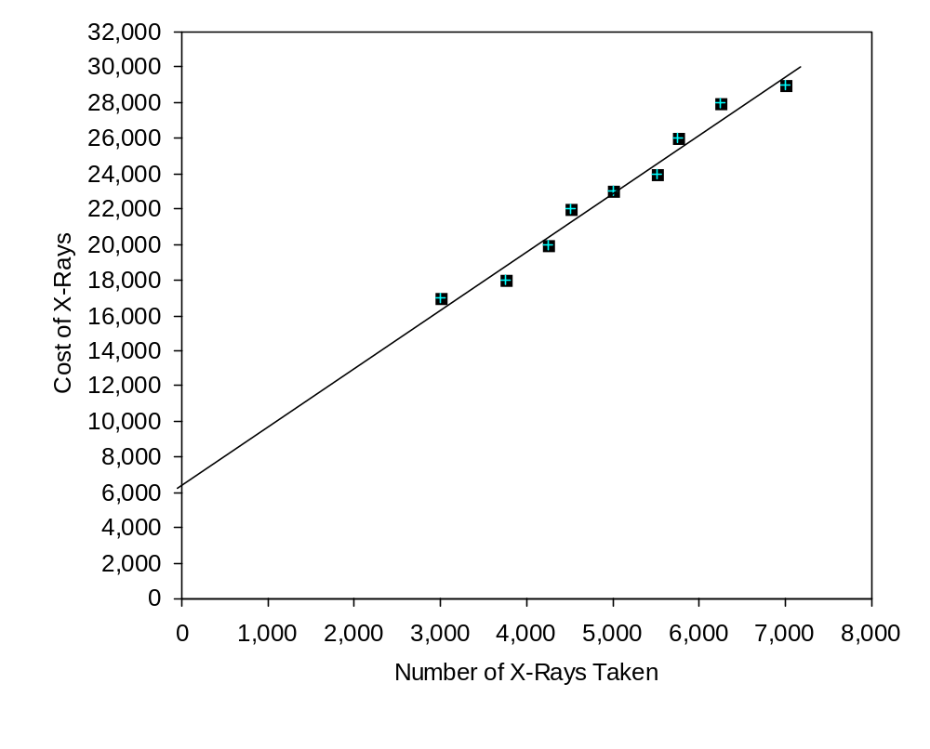
Exercise 5-11 (continued)
2. (Note: Students’ answers will vary considerably due to the inherent lack of precision and subjectivity of the quick-and-dirty method.)

Total costs at 5,000 X-rays per month [a point falling on the line in (1)] | $23,000
Less fixed cost element (intersection of the Y axis) | 6,500
Variable cost element | $16,500

$16,500 ÷ 5,000 X-rays = $3.30 per X-ray.

The cost formula is therefore $6,500 per month plus $3.30 per X-ray taken. Written in equation form, the cost formula is:

Y = $6,500 + $3.30X,

where X is the number of X-rays taken.

3. The high-low method would not provide an accurate cost formula in this situation, since a line drawn through the high and low points would have a slope that is too flat. Consequently, the high-low method would overestimate the fixed cost and underestimate the variable cost per unit.
Exercise 5-12 (30 minutes)
1. | Monthly operating costs at 70% occupancy:
 | 2,000 rooms × 70% = 1,400 rooms;
 | 1,400 rooms × $21 per room per day × 30 days | $882,000
 | Monthly operating costs at 45% occupancy (given) | 792,000
 | Change in cost | $ 90,000

 | Difference in rooms occupied:
 | 70% occupancy (2,000 rooms × 70%) | 1,400
 | 45% occupancy (2,000 rooms × 45%) | 900
 | Difference in rooms (change in activity) | 500

$180 per room ÷ 30 days = $6 per room per day.

2. | Monthly operating costs at 70% occupancy (above) | $882,000
 | Less variable costs:  1,400 rooms × $6 per room per day × 30 days | 252,000
 | Fixed operating costs per month | $630,000

3. 2,000 rooms × 60% = 1,200 rooms occupied.

Fixed costs | $630,000
Variable costs:  1,200 rooms × $6 per room per day × 30 days | 216,000
Total expected costs | $846,000
Exercise 5-13 (30 minutes)
1. | Units  (X) | Total Glazing Cost  (Y)
 | 8 | $270
 | 5 | $200
 | 10 | $310
 | 4 | $190
 | 6 | $240
 | 9 | $290

A spreadsheet application such as Excel or a statistical software package can be used to compute the slope and intercept of the least-squares regression line for the above data. The results are:

 | Intercept (fixed cost) | $107.50
 | Slope (variable cost per unit) | $20.36
 | R² | 0.98

Therefore, the cost formula is $107.50 per week plus $20.36 per unit.

Note that the R² is 0.98, which means that 98% of the variation in glazing costs is explained by the number of units glazed. This is a very high R² and indicates a very good fit.

2. Y = $107.50 + $20.36X, where X is the number of units glazed.

3. Total expected glazing cost if 7 units are processed:

Variable cost: 7 units × $20.36 per unit | $142.52
Fixed cost | 107.50
Total expected cost | $250.02
Problem 5-14 (45 minutes)
1. | Number of Leagues  (X) | Total Cost  (Y)
 | 5 | $13,000
 | 2 | $7,000
 | 4 | $10,500
 | 6 | $14,000
 | 3 | $10,000

A spreadsheet application such as Excel or a statistical software package can be used to compute the slope and intercept of the least-squares regression line for the above data. The results are:

 | Intercept (fixed cost) | $4,100
 | Slope (variable cost per unit) | $1,700
 | R² | 0.96

Therefore, the variable cost per league is $1,700 and the fixed cost is $4,100 per year.

Note that the R² is 0.96, which means that 96% of the variation in cost is explained by the number of leagues. This is a very high R² and indicates a very good fit.

2. Y = $4,100 + $1,700X

3. The expected total cost for 7 leagues would be:

Fixed cost | $ 4,100
Variable cost (7 leagues × $1,700 per league) | 11,900
Total cost | $16,000

The problem with using the cost formula from (2) to estimate total cost in this particular case is that an activity level of 7 leagues may be outside the relevant range—the range of activity within which the fixed cost is approximately $4,100 per year and the variable cost is approximately $1,700 per league. These approximations appear to be reasonably accurate within the range of 2 to 6 leagues, but they may be invalid outside this range.
Problem 5-14 (continued)
4.
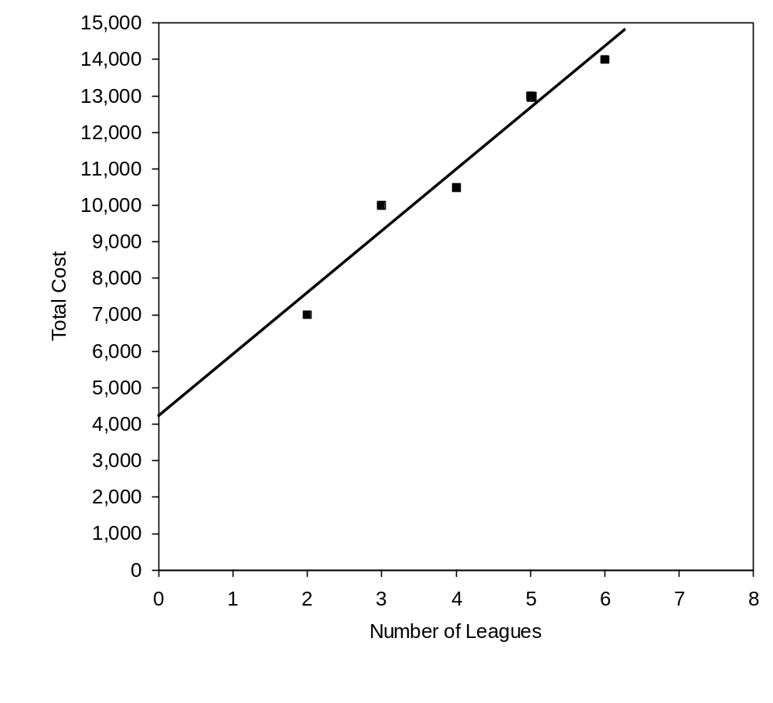
Problem 5-15 (45 minutes)
1.
 | House Of Organs, Inc.
 | Income Statement
 | For the Month Ended November 30
 | Sales (60 organs × $2,500 per organ) |  | $150,000
 | Cost of goods sold  (60 organs × $1,500 per organ) |  | 90,000
 | Gross margin |  | 60,000
 | Selling and administrative expenses:
 | Selling expenses:
 | Advertising | $ 950
 | Delivery of organs  (60 organs × $60 per organ) | 3,600
 | Sales salaries and commissions  [$4,800 + (4% × $150,000)] | 10,800
 | Utilities | 650
 | Depreciation of sales facilities | 5,000
 | Total selling expenses | 21,000
 | Administrative expenses:
 | Executive salaries | 13,500
 | Depreciation of office equipment | 900
 | Clerical  [$2,500 + (60 organs × $40 per organ)] | 4,900
 | Insurance | 700
 | Total administrative expenses | 20,000
 | Total selling and administrative expenses |  | 41,000
 | Net operating income |  | $ 19,000
Problem 5-15 (continued)
2. | House Of Organs, Inc.
 | Income Statement
 | For the Month Ended November 30
 |  | Total | Per Unit
 | Sales (60 organs × $2,500 per organ) | $150,000 | $2,500
 | Variable expenses:
 | Cost of goods sold  (60 organs × $1,500 per organ) | 90,000 | 1,500
 | Delivery of organs  (60 organs × $60 per organ) | 3,600 | 60
 | Sales commissions (4% × $150,000) | 6,000 | 100
 | Clerical (60 organs × $40 per organ) | 2,400 | 40
 | Total variable expenses | 102,000 | 1,700
 | Contribution margin | 48,000 | $ 800
 | Fixed expenses:
 | Advertising | 950
 | Sales salaries | 4,800
 | Utilities | 650
 | Depreciation of sales facilities | 5,000
 | Executive salaries | 13,500
 | Depreciation of office equipment | 900
 | Clerical | 2,500
 | Insurance | 700
 | Total fixed expenses | 29,000
 | Net operating income | $ 19,000

3. Fixed costs remain constant in total but vary on a per unit basis with changes in the activity level. For example, as the activity level increases, fixed costs decrease on a per unit basis. Showing fixed costs on a per unit basis on the income statement make them appear to be variable costs. That is, management might be misled into thinking that the per unit fixed costs would be the same regardless of how many organs were sold during the month. For this reason, fixed costs should be shown only in totals on a contribution-type income statement.
Problem 5-16 (45 minutes)
1. | Cost of goods sold | Variable
 | Shipping expense | Mixed
 | Advertising expense | Fixed
 | Salaries and commissions | Mixed
 | Insurance expense | Fixed
 | Depreciation expense | Fixed

2. Analysis of the mixed expenses:

 | Units | Shipping Expense | Salaries and Comm. Expense
High level of activity | 4,500 | £56,000 | £143,000
Low level of activity | 3,000 | 44,000 | 107,000
Change | 1,500 | £12,000 | £ 36,000

Variable cost element:
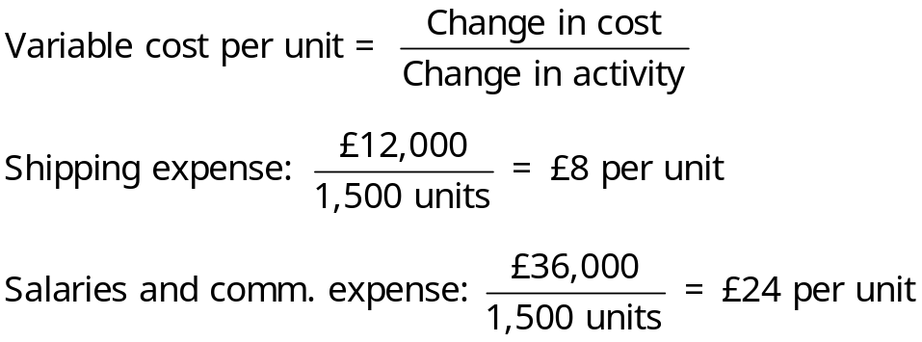
Fixed cost element:
 | Shipping Expense | Salaries and Comm. Expense
Cost at high level of activity | £56,000 | £143,000
Less variable cost element:
4,500 units × £8 per unit | 36,000
4,500 units × £24 per unit |  | 108,000
Fixed cost element | £20,000 | £ 35,000
Problem 5-16 (continued)
The cost formulas are:

Shipping expense: £20,000 per month plus £8 per unit or
Y = £20,000 + £8X.

Salaries and Comm. expense: £35,000 per month plus £24 per unit or
Y = £35,000 + £24X.

3. | Frankel Ltd.
 | Income Statement
 | For the Month Ended June 30
 | Sales revenue |  | £630,000
 | Variable expenses:
 | Cost of goods sold  (4,500 units × £56 per unit) | £252,000
 | Shipping expense  (4,500 units × £8 per unit) | 36,000
 | Salaries and commissions expense  (4,500 units × £24 per unit) | 108,000 | 396,000
 | Contribution margin |  | 234,000
 | Fixed expenses:
 | Shipping expense | 20,000
 | Advertising | 70,000
 | Salaries and commissions | 35,000
 | Insurance | 9,000
 | Depreciation | 42,000 | 176,000
 | Net operating income |  | £ 58,000
Problem 5-17 (30 minutes)
1. | a. | 6
 | b. | 11
 | c. | 1
 | d. | 4
 | e. | 2
 | f. | 10
 | g. | 3
 | h. | 7
 | i. | 9

2. Without a knowledge of underlying cost behavior patterns, it would be difficult if not impossible for a manager to properly analyze the firm’s cost structure. The reason is that all costs don’t behave in the same way. One cost might move in one direction as a result of a particular action, and another cost might move in an opposite direction. Unless the behavior pattern of each cost is clearly understood, the impact of a firm’s activities on its costs will not be known until after the activity has occurred.
Problem 5-18 (45 minutes)
1. High-low method:

 | Number of Ingots | Power Cost
High activity level | 130 | $6,000
Low activity level | 40 | 2,400
Change | 90 | $3,600
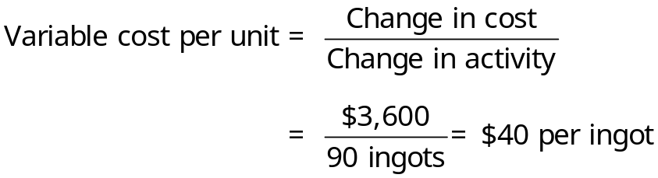
Fixed cost: | Total power cost at high activity level | $6,000
 | Less variable element:
 | 130 ingots × $40 per ingot | 5,200
 | Fixed cost element | $ 800

Therefore, the cost formula is: Y = $800 + $40X.

2. Scattergraph method (see the scattergraph on the following page):

(Note: Students’ answers will vary due to the inherent imprecision and subjectivity of the quick-and-dirty scattergraph method of estimating fixed and variable costs.)

The line intersects the cost axis at about $1,200. The variable cost can be estimated as follows:

Total cost at 100 ingots (a point that falls on the line) | $5,000
Less the fixed cost element (intersection of the Y axis on the graph) | 1,200
Variable cost element at 100 ingots (total) | $3,800

$3,800 ÷ 100 ingots = $38 per ingot.

Therefore, the cost formula is: Y = $1,200 + $38X.
Problem 5-18 (continued)
The completed scattergraph follows:

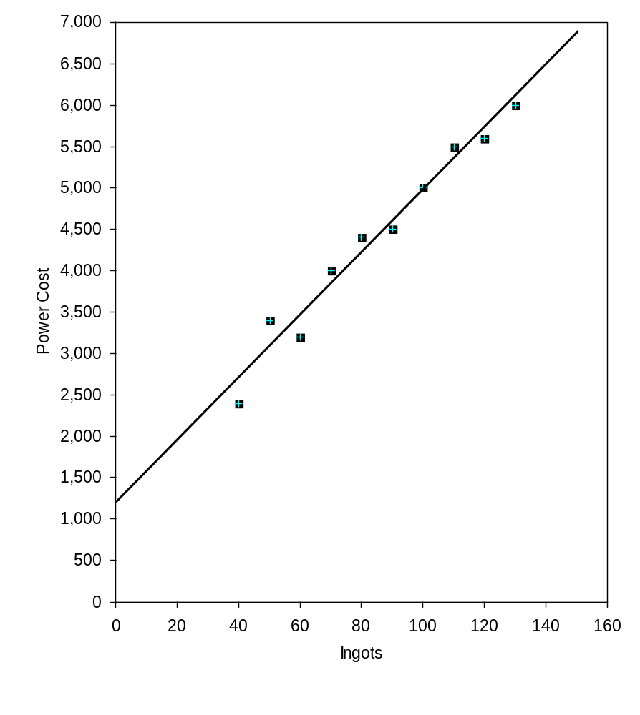
Problem 5-19 (30 minutes)
1. The least squares regression method:

Number of Ingots  (X) | Power Cost  (Y)
110 | $5,500
90 | $4,500
80 | $4,400
100 | $5,000
130 | $6,000
120 | $5,600
70 | $4,000
60 | $3,200
50 | $3,400
40 | $2,400

A spreadsheet application such as Excel or a statistical software package can be used to compute the slope and intercept of the least-squares regression line for the above data. The results are:

 | Intercept (fixed cost) | $1,185
 | Slope (variable cost per unit) | $37.82
 | R² | 0.97

Therefore, the variable cost of power per ingot is $37.82 and the fixed cost of power is $1,185 per month and the cost formula is:

Y = $1,185 + $37.82X.

Note that the R² is 0.97, which means that 97% of the variation in power cost is explained by the number of ingots. This is a very high R² and indicates a very good fit.
Problem 5-19 (continued)
2. | Method | Total Fixed Cost | Variable Cost per Ingot
 | High-low | $800 | $40.00
 | Quick-and-dirty scattergraph | $1,200 | $38.00
 | Least squares | $1,185 | $37.82

The high-low method is accurate only in those situations where the variable cost is truly constant, or where the high and the low points happen to fall on the correct regression line. Due to the high degree of potential inaccuracy, this method is less useful than the least-squares regression method.

The quick-and-dirty scattergraph method is imprecise and the results will depend on where the analyst chooses to place the line. However, the scattergraph plot can provide invaluable clues about nonlinearities and other problems with the data.

The least squares regression method is generally considered to be the most accurate method of cost analysis. However, it should always be used in conjunction with a scattergraph plot to ensure that the underlying relation really is linear.
Problem 5-20 (45 minutes)
1. | Units Sold  (000s)  (X) | Shipping Expense  (Y)
 | 16 | $160,000
 | 18 | $175,000
 | 23 | $210,000
 | 19 | $180,000
 | 17 | $170,000
 | 20 | $190,000
 | 25 | $230,000
 | 22 | $205,000

A spreadsheet application such as Excel or a statistical software package can be used to compute the slope and intercept of the least-squares regression line for the above data. The results are:

 | Intercept (fixed cost) | $40,000
 | Slope (variable cost per unit) | $7,500
 | R² | 0.99

Therefore the cost formula for shipping expense is $40,000 per quarter plus $7,500 per thousand units sold ($7.50 per unit), or

Y = $40,000 + $7.50X,

where X is the number of units sold.

Note that the R² is 0.99, which means that 99% of the variation in shipping cost is explained by the number of meals served. This is a very high R² and indicates a very good fit.
Problem 5-20 (continued)
2. | Alden Company
 | Budgeted Income Statement
 | For the First Quarter of Year 3
 | Sales (21,000 units × $50 per unit) |  | $1,050,000
 | Variable expenses:
 | Cost of goods sold  (21,000 units × $20 per unit) | $420,000
 | Shipping expense  (21,000 units × $7.50 per unit) | 157,500
 | Sales commission ($1,050,000 × 0.05) | 52,500
 | Total variable expenses |  | 630,000
 | Contribution margin |  | 420,000
 | Fixed expenses:
 | Shipping expenses | 40,000
 | Advertising expense | 170,000
 | Administrative salaries | 80,000
 | Depreciation expense | 50,000
 | Total fixed expenses |  | 340,000
 | Net operating income |  | $ 80,000
Problem 5-21 (45 minutes)
1. Maintenance cost at the 70,000 machine-hour level of activity can be isolated as follows:

 | Level of Activity
 | 40,000 MH | 70,000 MH
Total factory overhead cost | $170,200 | $241,600
Deduct:
Utilities cost @ $1.30 per MH* | 52,000 | 91,000
Supervisory salaries | 60,000 | 60,000
Maintenance cost | $ 58,200 | $ 90,600

*$52,000 ÷ 40,000 MHs = $1.30 per MH

2. High-low analysis of maintenance cost:

 | Maintenance Cost | Machine-Hours
High activity level | $90,600 | 70,000
Low activity level | 58,200 | 40,000
Change | $32,400 | 30,000

Variable cost per unit of activity:

Total fixed cost:

Total maintenance cost at the low activity level | $58,200
Less the variable cost element  (40,000 MHs × $1.08 per MH) | 43,200
Fixed cost element | $15,000

Therefore, the cost formula is $15,000 per month plus $1.08 per machine-hour or Y = $15,000 + $1.08X, where X represents machine-hours.
Problem 5-21 (continued)
3. |  | Variable Rate per Machine-Hour | Fixed Cost
 | Maintenance cost | $1.08 | $15,000
 | Utilities cost | 1.30
 | Supervisory salaries cost |  | 60,000
 | Totals | $2.38 | $75,000

Therefore, the cost formula would be $75,000 plus $2.38 per machine-hour, or Y = $75,000 + $2.38X.

4. | Fixed costs | $ 75,000
 | Variable costs: $2.38 per MH × 45,000 MHs | 107,100
 | Total overhead costs | $182,100
Problem 5-22 (45 minutes)
1. |  | July—Low |  | October—High
 |  | 9,000 Units |  | 12,000 Units
 | Direct materials cost @ $15 per unit | $135,000 |  | $180,000
 | Direct labor cost @ $6 per unit | 54,000 |  | 72,000
 | Manufacturing overhead cost | 107,000 | * | 131,000 | *
 | Total manufacturing costs | 296,000 |  | 383,000
 | Add: Work in process, beginning | 14,000 |  | 22,000
 |  | 310,000 |  | 405,000
 | Deduct: Work in process, ending | 25,000 |  | 15,000
 | Cost of goods manufactured | $285,000 |  | $390,000

*Computed by working upwards through the statements.

2. |  | Units Produced | Cost Observed
 | October—High level of activity | 12,000 | $131,000
 | July—Low level of activity | 9,000 | 107,000
 | Change | 3,000 | $ 24,000
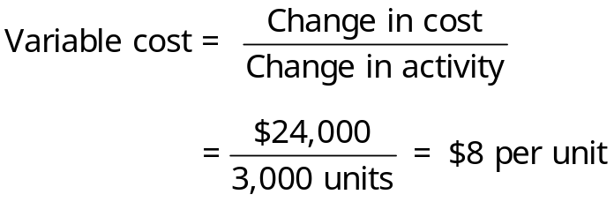
Total cost at the high level of activity | $131,000
Less variable cost element  ($8 per unit × 12,000 units) | 96,000
Fixed cost element | $ 35,000

Therefore, the cost formula is: $35,000 per month plus $8 per unit produced, or Y = $35,000 + $8X, where X represents the number of units produced.
Problem 5-22 (continued)
3. The cost of goods manufactured if 9,500 units are produced:

Direct materials cost (9,500 units × $15 per unit) |  | $142,500
Direct labor cost (9,500 units × $6 per unit) |  | 57,000
Manufacturing overhead cost:
Fixed portion | $35,000
Variable portion (9,500 units × $8 per unit) | 76,000 | 111,000
Total manufacturing costs |  | 310,500
Add: Work in process, beginning |  | 16,000
 |  | 326,500
Deduct: Work in process, ending |  | 19,000
Cost of goods manufactured |  | $307,500
Problem 5-23 (30 minutes)
1. Maintenance cost at the 80,000 machine-hour level of activity can be isolated as follows:

 | Level of Activity
 | 60,000 MH |  | 80,000 MH
Total factory overhead cost | 274,000 | pesos | 312,000 | pesos
Deduct:
Indirect materials @ 1.50 pesos per MH* | 90,000 |  | 120,000
Rent | 130,000 |  | 130,000
Maintenance cost | 54,000 | pesos | 62,000 | pesos

* 90,000 pesos ÷ 60,000 MHs = 1.50 pesos per MH

2. High-low analysis of maintenance cost:

 | Maintenance Cost |  |  | Machine-Hours
High activity level | 62,000 | pesos |  | 80,000
Low activity level | 54,000 |  |  | 60,000
Change observed | 8,000 | pesos |  | 20,000
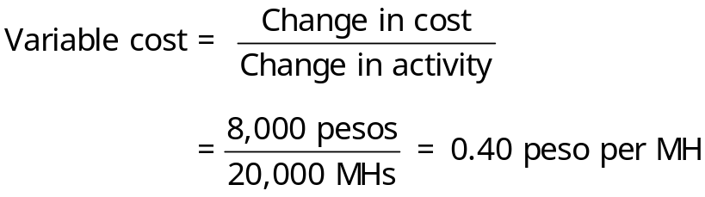
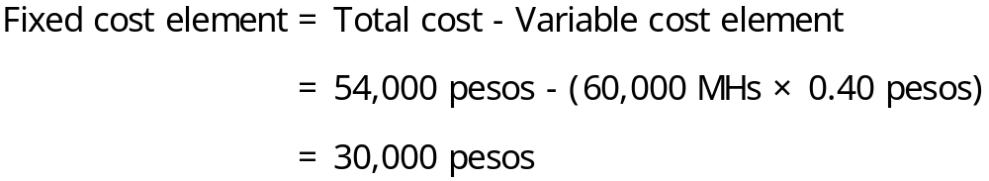

Therefore, the cost formula is 30,000 pesos per year, plus 0.40 peso per machine-hour or

Y = 30,000 pesos + 0.40 peso X.
Problem 5-23 (continued)
3. | Indirect materials (65,000 MHs × 1.50 pesos per MH) |  |  | 97,500 | pesos
 | Rent |  |  | 130,000
 | Maintenance:
 | Variable cost element (65,000 MHs × 0.40 peso per MH) | 26,000 | pesos
 | Fixed cost element | 30,000 |  | 56,000
 | Total factory overhead cost |  |  | 283,500 | pesos
Case 5-24 (30 minutes)
1. The completed scattergraph for the number of units produced as the activity base is presented below:

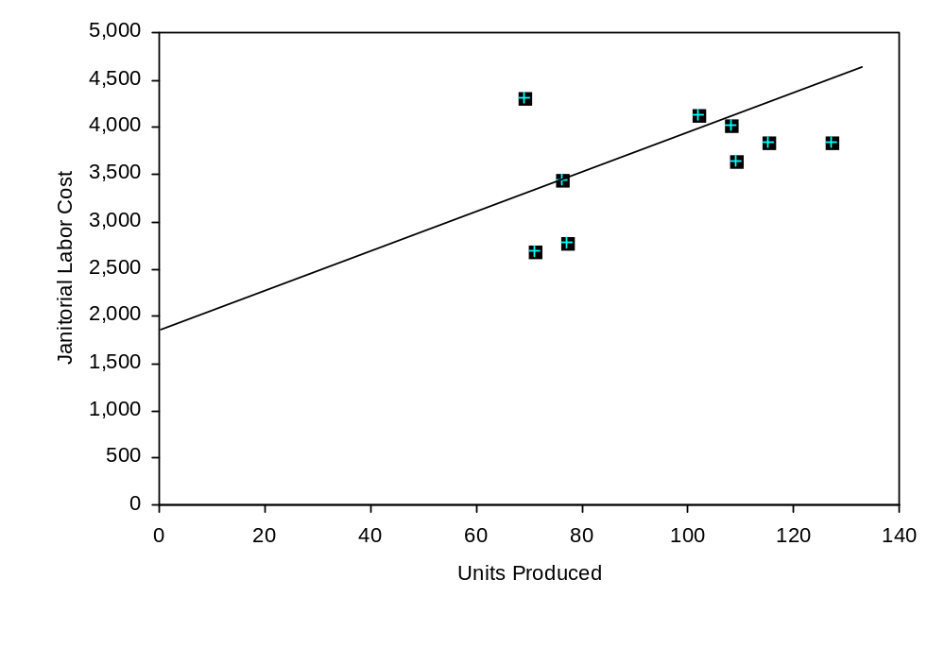

Case 5-24 (continued)
2. The completed scattergraph for the number of workdays as the activity base is presented below:

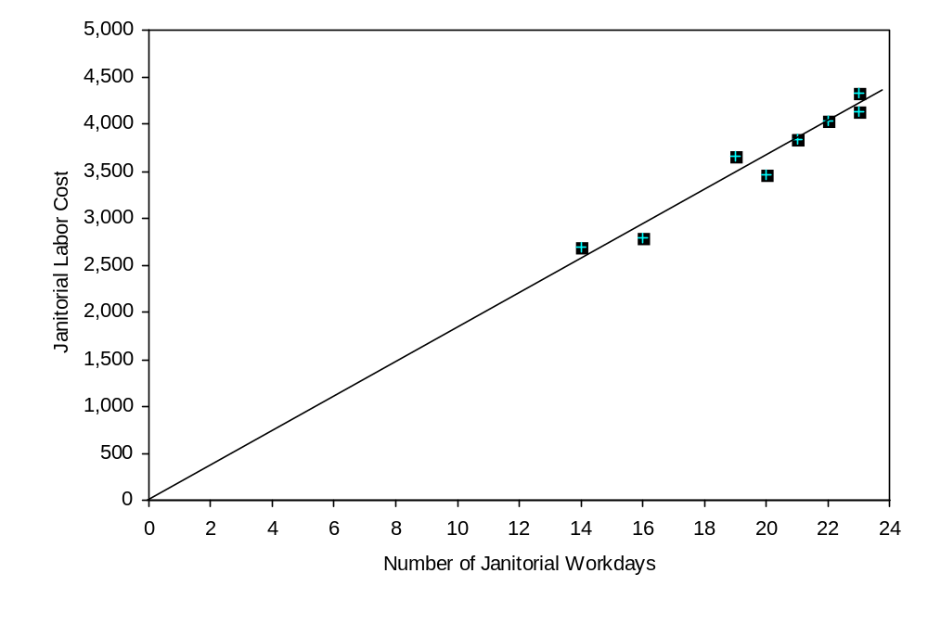
Case 5-24 (continued)
3. The number of workdays should be used as the activity base rather than the number of units produced. There are several reasons for this. First, the scattergraphs reveal that there is a much stronger relationship (i.e., higher correlation) between janitorial costs and number of workdays than between janitorial costs and number of units produced. Second, from the description of the janitorial costs, one would expect that variations in those costs have little to do with the number of units produced. Two janitors each work an eight-hour shift—apparently irrespective of the number of units produced or how busy the company is. Variations in the janitorial labor costs apparently occur because of the number of workdays in the month and the number of days the janitors call in sick. Third, for planning purposes, the company is likely to be able to predict the number of working days in the month with much greater accuracy than the number of units that will be produced.

Note that the scattergraph in part (1) seems to suggest that the janitorial labor costs are variable with respect to the number of units produced. This is false. Janitorial labor costs do vary, but the number of units produced isn’t the cause of the variation. However, since the number of units produced tends to go up and down with the number of workdays and since the janitorial labor costs are driven by the number of workdays, it appears on the scattergraph that the number of units drives the janitorial labor costs to some extent. Analysts must be careful not to fall into this trap of using the wrong measure of activity as the activity base just because it appears there is some relationship between cost and the measure of activity. Careful thought and analysis should go into the selection of the activity base.
Case 5-25 (90 minutes)
1. | a. | Tons  Mined (000s)  (X) | Utilities Cost  (Y)
 |  | 15 | $50,000
 |  | 11 | $45,000
 |  | 21 | $60,000
 |  | 12 | $75,000
 |  | 18 | $100,000
 |  | 25 | $105,000
 |  | 30 | $85,000
 |  | 28 | $120,000

A spreadsheet application such as Excel or a statistical software package can be used to compute the slope and intercept of the least-squares regression line for the above data. The results are:

 | Intercept (fixed cost) | $28,352
 | Slope (variable cost per unit) | $2,582
 | R² | 0.47

Therefore, the cost formula using tons mined as the activity base is $28,352 per quarter plus $2,582 per thousand tons mined, or

Y = $28,352 + $2,582X.

Note that the R² is 0.47, which means that only 47% of the variation in utility costs is explained by the number of tons mined.
Case 5-25 (continued)
b. The scattergraph plot of utility costs versus tons mined appears below:
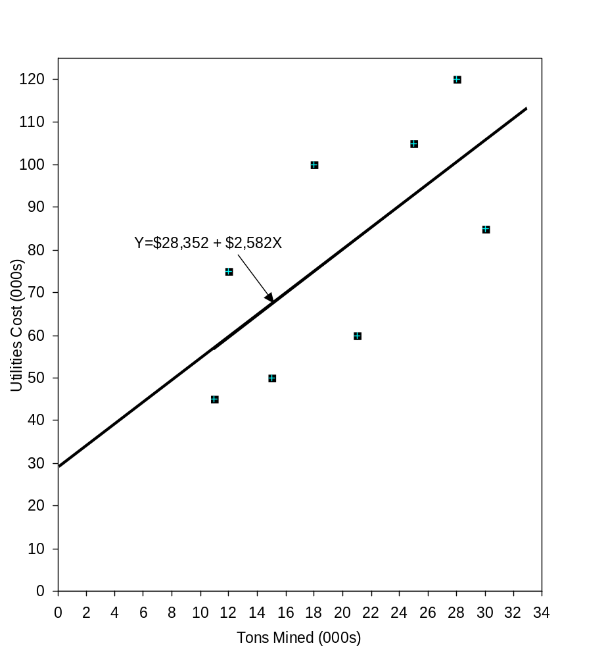
Case 5-25 (continued)
2. | a. | DLHs (000)  (X) | Utilities Cost  (Y)
 |  | 5 | $50,000
 |  | 3 | $45,000
 |  | 4 | $60,000
 |  | 6 | $75,000
 |  | 10 | $100,000
 |  | 9 | $105,000
 |  | 8 | $85,000
 |  | 11 | $120,000

A spreadsheet application such as Excel or a statistical software package can be used to compute the slope and intercept of the least-squares regression line for the above data. The results are:

 | Intercept (fixed cost) | $17,000
 | Slope (variable cost per unit) | $9,000
 | R² | 0.93

Therefore, the cost formula using direct labor-hours as the activity base is $17,000 per quarter plus $9,000 per thousand direct labor-hours, or

Y = $17,000 + $9,000X.

Note that the R² is 0.93, which means that 93% of the variation in utility costs is explained by the number of direct labor-hours. This is a very high R² and is an indication of a good fit.
Case 5-25 (continued)
b. The scattergraph plot of utility costs versus direct labor-hours appears below:
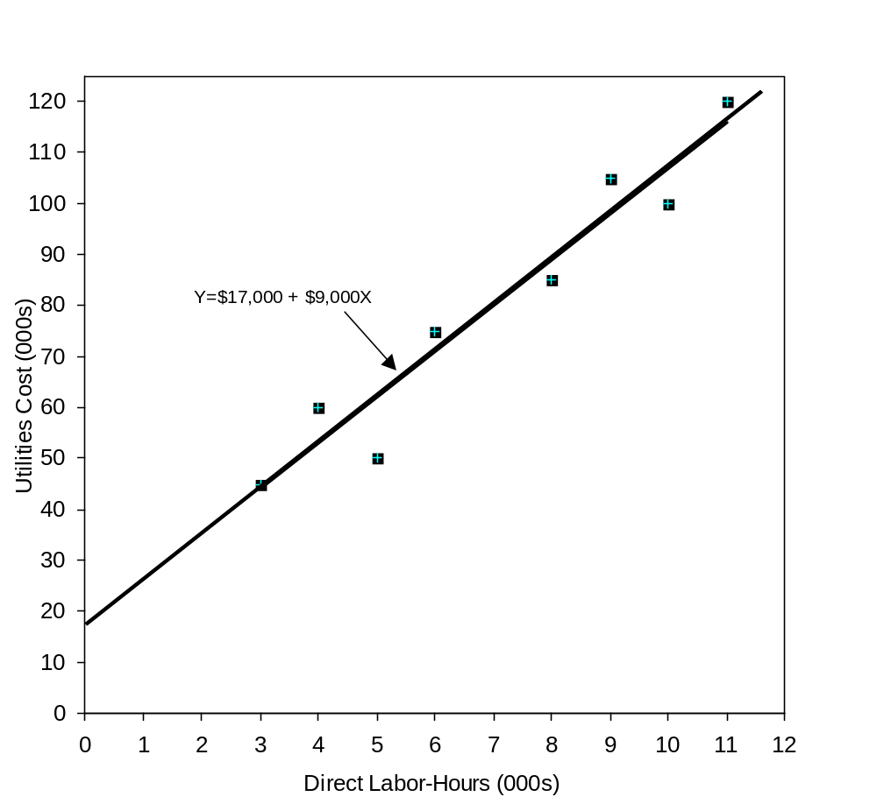
3. The company should probably use direct labor-hours as the activity base, since the fit of the regression line to the data is much tighter than it is with tons mined. The R² for the regression using direct labor-hours as the activity base is twice as large as for the regression using tons mined as the activity base. However, managers should look more closely at the costs and try to determine why utilities costs are more closely tied to direct labor-hours than to the number of tons mined.
CASE 5-26 (90 minutes)
1. | Direct labor-hour allocation base:
 | Electrical costs (a) | SFr 3,865,800
 | Direct labor-hours (b) | 427,500 | DLHs
 | Predetermined overhead rate (a) ÷ (b) | SFr 9.04 | per DLH

 | Machine-hour allocation base:
 | Electrical costs (a) | SFr 3,865,800
 | Machine-hours (b) | 365,400 | MHs
 | Predetermined overhead rate (a) ÷ (b) | SFr 10.58 | per MH

2. | Electrical cost for the custom tool job using direct labor-hours:
 | Predetermined overhead rate (a) | SFr 9.04 | per DLH
 | Direct labor-hours for the job (b) | 30 | DLHs
 | Electrical cost applied to the job (a) × (b) | SFr 271.20

 | Electrical cost for the custom tool job using machine-hours:
 | Predetermined overhead rate (a) | SFr 10.58 | per MH
 | Machine-hours for the job (b) | 25 | MHs
 | Electrical cost applied to the job (a) × (b) | SFr 264.50
CASE 5-26 (continued)
3. The scattergraph for electrical costs and machine-hours appears below:

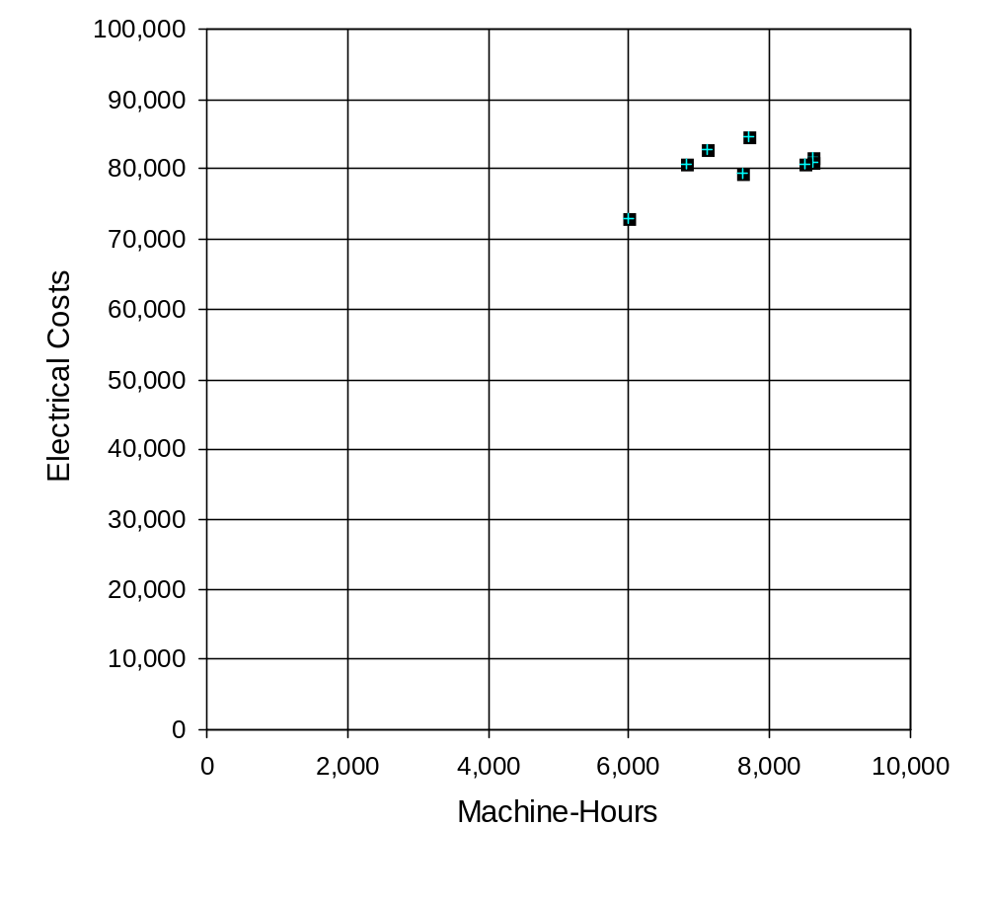
CASE 5-26 (continued)
The scattergraph for electrical costs and direct labor-hours appears below:

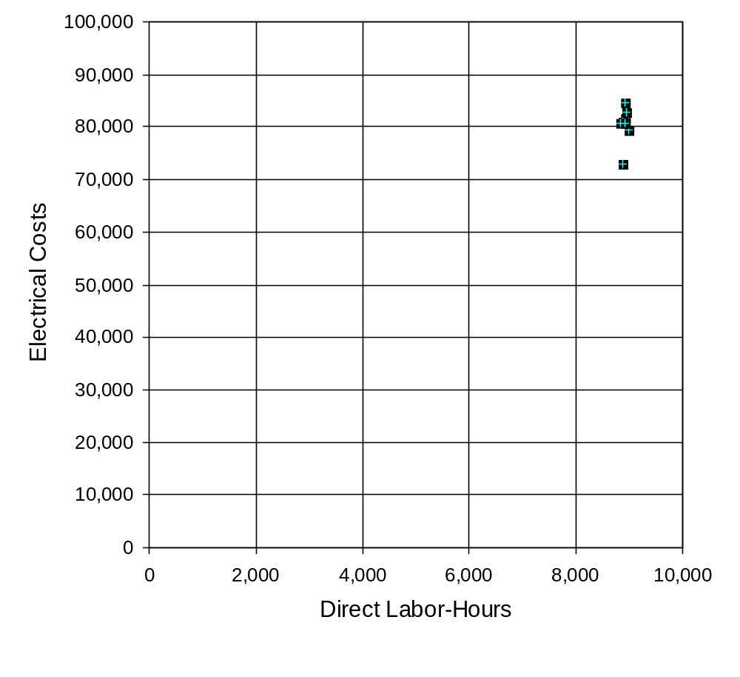
CASE 5-26 (continued)
In general, the allocation base should actually cause the cost being allocated. If it doesn’t, costs will be incorrectly assigned to jobs. Incorrectly assigned costs are worse than useless for decision-making.

Examining the two scattergraphs reveals that electrical costs do not appear to be related to direct labor-hours. Electrical costs do vary, but apparently not in response to changes in direct labor-hours. On the other hand, looking at the scattergraph for machine-hours, electrical costs do tend to increase as the machine-hours increase. So if one must choose between machine-hours and direct labor-hours as an allocation base, machine-hours seems to be the better choice. Even so, it looks like little of the overhead cost is really explained even by machine hours. Electrical cost has a large fixed component and much of the variation in the cost is unrelated to machine hours.

4. | Machine-Hours | Electrical Costs
 | 7,700 | 84,600
 | 8,600 | 81,800
 | 8,600 | 81,000
 | 8,500 | 80,800
 | 7,600 | 79,400
 | 7,100 | 82,800
 | 6,000 | 73,100
 | 6,800 | 80,800

Using statistical software or a spreadsheet application such as Excel to compute estimates of the intercept and the slope for the above data, the results are:

 | Intercept (fixed cost) | SFr 64,840
 | Slope (variable cost per unit) | SFr 2.06
 | R² | 0.33

Therefore the cost formula for electrical costs is SFr 64,840 per week plus SFr 2.06 per machine-hour, or

Y = SFr 64,840 + SFr 2.06 X, where X is machine-hours.
CASE 5-26 (continued)
Note that the R² is 0.33, which means that only 33% of the variation in electrical cost is explained by machine-hours. Other factors, discussed in part (6) below, are responsible for most of the variation in electrical costs from week to week.

5. The custom tool job requires 25 machine-hours. At SFr 2.06 per machine-hour, the electrical cost actually caused by the job would be only SFr 51.5. This contrasts with the electrical cost of SFr 271.20 under the old cost system and SFr 264.50 under the new ABC system. Both the old cost system and the new ABC system grossly overstate the electrical costs of the job. This is because under both cost systems, the large fixed electrical costs of SFr 64,840 per week are allocated to jobs along with the electrical costs that actually vary with the amount of work being done. In practice, almost all categories of overhead costs pose similar problems. As a consequence, the costs of individual jobs are likely to be seriously overstated for decision-making purposes under both traditional and ABC systems. Both systems provide acceptable cost data for external reporting, but both provide potentially misleading data for internal decision-making unless suitable adjustments are made.

6. Electricity is used for heating and lighting the building as well as to run equipment. Therefore, consumption of electrical power is likely to be affected at least by the weather and by the time of the year as well as by how many hours the equipment is run. (Shorter days mean the lights have to be on longer.)
CASE 5-27 (90 minutes)
Note to the instructor: This case requires the ability to build on concepts that are introduced only briefly in the text. To some degree, this case anticipates issues that will be covered in more depth in later chapters.

1. In order to estimate the contribution to profit of the charity event, it is first necessary to estimate the variable costs of catering the event. The costs of food and beverages and labor are all apparently variable with respect to the number of guests. However, the situation with respect overhead expenses is less clear. A good first step is to plot the labor hour and overhead expense data in a scattergraph as shown below.

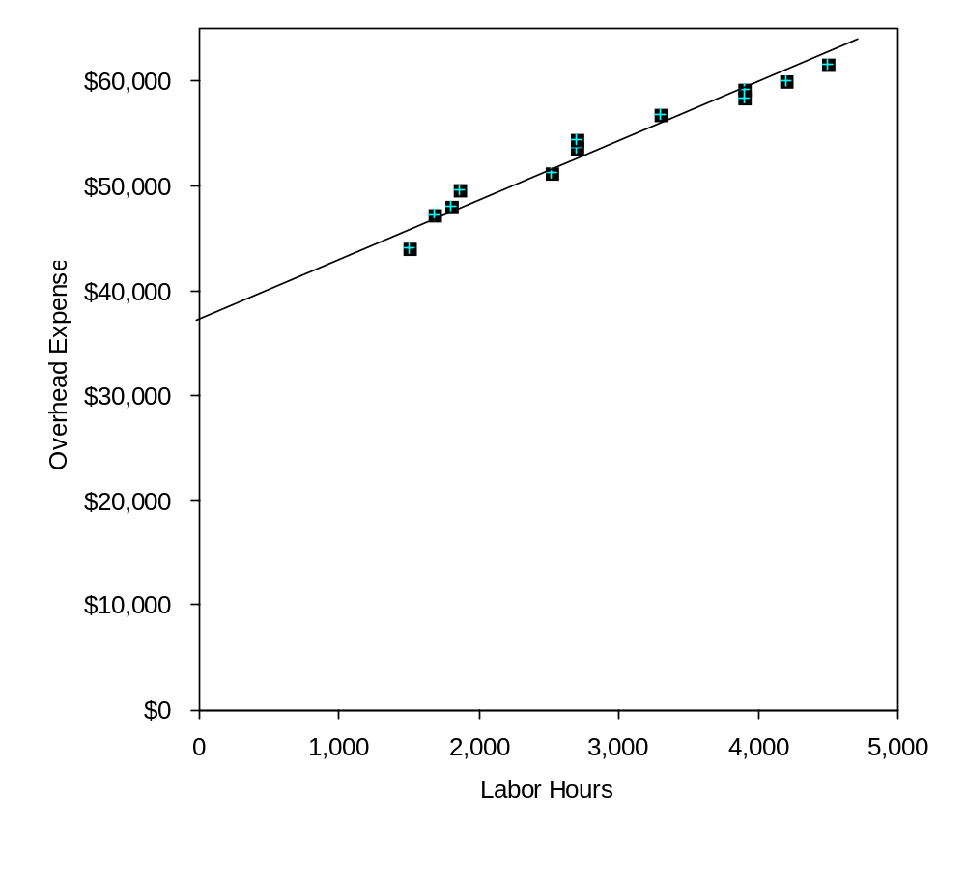
CASE 5-27 (continued)
This scattergraph reveals several interesting points about the behavior of overhead costs:

• The relation between overhead expense and labor hours is approximated reasonably well by a straight line. (However, there appears to be a slight downward bend in the plot as the labor hours increase—evidence of increasing returns to scale. This is a common occurrence in practice. See Noreen & Soderstrom, “Are overhead costs strictly proportional to activity?” Journal of Accounting and Economics, vol. 17, 1994, pp. 255-278.)

• The data points are all fairly close to the straight line. This indicates that most of the variation in overhead expenses is explained by labor hours. As a consequence, there probably wouldn’t be much benefit to investigating other possible cost drivers for the overhead expenses.

• Most of the overhead expense appears to be fixed. Jasmine should ask herself if this is reasonable. Does the company have large fixed expenses such as rent, depreciation, and salaries?

The overhead expenses can be decomposed into fixed and variable elements using the high-low method, least-squares regression method, or even the quick-and-dirty method based on the scattergraph.

• The high-low method throws away most of the data and bases the estimates of variable and fixed costs on data for only two months. For that reason, it is a decidedly inferior method in this situation. Nevertheless, if the high-low method were used, the estimates would be computed as follows:

 | Labor | Overhead
 | Hours | Expense
High level of activity | 4,500 | $61,600
Low level of activity | 1,500 | 44,000
Change | 3,000 | $17,600
CASE 5-27 (continued)
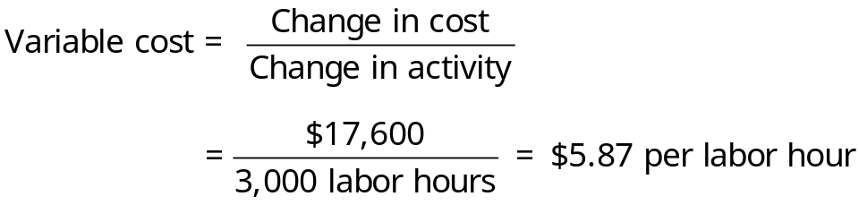
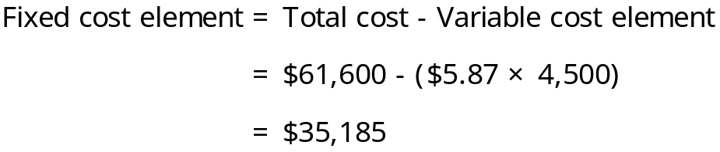

• In contrast, the least-squares regression method yields estimates of $5.27 per labor hour for the variable cost and $38,501 per month for the fixed cost using statistical software. (The adjusted R² is 96%.) To obtain these estimates, use a statistical software package or a spreadsheet application such as Excel.

Using the least-squares regression estimates of the variable overhead cost, the total variable cost per guest is computed as follows:

Food and beverages | $17.00
Labor (0.5 hour @ $10 per hour) | 5.00
Overhead (0.5 hour @ $5.27 per hour) | 2.64
Total variable cost per guest | $24.64

The total contribution from 120 guests paying $45 each is computed as follows:

Revenue (120 guests @ $45.00 per guest) | $5,400.00
Variable cost (120 guests @ $24.64 per guest) | 2,956.80
Contribution to profit | $2,443.20

Fixed costs are not included in the above computation because there is no indication that any additional fixed costs would be incurred as a consequence of catering the cocktail party. If additional fixed costs were incurred, they should also be subtracted from revenue.
CASE 5-27 (continued)
2. Assuming that no additional fixed costs are incurred as a result of catering the charity event, any price greater than the variable cost per guest of $24.64 would contribute to profits.

3. We would favor bidding slightly less than $42 to get the contract. Any bid above $24.64 would contribute to profits and a bid at the normal price of $45 is unlikely to land the contract. And apart from the contribution to profit, catering the event would show off the company’s capabilities to potential clients. The danger is that a price that is lower than the normal bid of $45 might set a precedent for the future or it might initiate a price war among caterers. However, the price need not be publicized and the lower price could be justified to future clients because this is a charity event. Another possibility would be for Jasmine to maintain her normal price but throw in additional services at no cost to the customer. Whether to compete on price or service is a delicate issue that Jasmine will have to decide after getting to know the personality and preferences of the customer.
Research and Application 5-28 (240 minutes)
1. Blue Nile succeeds first and foremost because of its operational excellence customer value proposition. Page 3 of the 10-K says “we have developed an efficient online cost structure … that eliminates traditional layers of diamond wholesalers and brokers, which allows us to generally purchase most of our product offerings at lower prices by avoiding markups imposed by those intermediaries. Our supply solution generally enables us to purchase only those diamonds that our customers have ordered. As a result, we are able to minimize the costs associated with carrying diamond inventory.” On page 4 of the 10-K, Blue Nile’s growth strategy hinges largely on increasing what it calls supply chain efficiencies and operational efficiencies. Blue Nile also emphasizes jewelry customization and customer service, but these attributes do not differentiate Blue Nile from its competitors.

2. Blue Nile faces numerous business risks as described in pages 8-19 of the 10-K. Students may mention other risks beyond those specifically mentioned in the 10-K. Here are four risks faced by Blue Nile with suggested control activities:

- Risk: Customer may not purchase an expensive item such as a diamond over the Internet because of concerns about product quality (given that customers cannot see the product in person prior to purchasing it.)
Control activities: Sell only independently certified diamonds and market this fact heavily. Also, design a web site that enables customers to easily learn more about the specific products that they are interested in purchasing.
- Risk: Customers may avoid Internet purchases because of fears that security breaches will enable criminals to have access to their confidential information.
Control activities: Invest in state-of-the-art encryption technology and other safeguards.
Research and Application 5-28 (continued)
- Risk: Because Blue Nile sells luxury products that are often purchased on a discretionary basis, sales may decline significantly in an economic downturn as people have access to less disposable income.
Control activities: Expand product offerings and expand the number of geographic markets served.
- Risk: The financial reporting process may fail to function properly (e.g., it may not comply with the Sarbanes-Oxley Act of 2002) as the business grows.
Control activities: Implement additional financial accounting systems and internal control over those systems.

Blue Nile faces various risks that are not easily reduced through control activities. Three such examples include:

- If Blue Nile is required by law to charge sales tax on purchases it will reduce Blue Nile’s price advantage over bricks-and-mortar retailers (see page 17 of the 10-K).
- Restrictions on the supply of diamonds would harm Blue Nile’s financial results (see page 9 of the 10-K).
- Other Internet retailers, such as Amazon.com, could offer the same efficiencies and low price as Blue Nile, while leveraging their stronger brand recognition to attract Blue Nile’s customers (see page 10 of the 10-K).

3. Blue Nile is a merchandiser. The first sentence of the overview on page 3 of the 10-K says “Blue Nile Inc. is a leading online retailer of high quality diamonds and fine jewelry.” While Blue Niles does some assembly work to support its “Build Your Own” feature, the company essentially buys jewelry directly from suppliers and resells it to customers. In fact, Blue Nile never takes possession of some of the diamonds it sells. Page 4 of the 10-K says “our diamond supplier relationships allow us to display suppliers’ diamond inventories on the Blue Nile web site for sale to consumers without holding the diamonds in our inventory until the products are ordered by customers.” This sentence suggests that items are shipped directly from the supplier to the consumer.
Research and Application 5-28 (continued)
4. There is no need to calculate any numbers to ascertain that cost of sales is almost entirely a variable cost. Page 25 of the 10-K says “our cost of sales consists of the cost of diamonds and jewelry products sold to customers, inbound and outbound shipping costs, insurance on shipments and the costs incurred to set diamonds into ring, earring and pendant settings, including labor and related facilities costs.” The overwhelming majority of these costs are variable costs. Assuming the workers that set diamonds into ring, earring, and pendant settings are not paid on a piece rate, the labor cost would be step-variable in nature. The facilities costs are likely to be committed fixed in nature; however, the overwhelming majority of the cost of sales is variable.

Similarly, there is no need to calculate any numbers to ascertain that selling, general and administrative expense is a mixed cost. Page 25 of the 10-K says “our selling, general and administrative expenses consist primarily of payroll and related benefit costs for our employees, marketing costs, credit card fees and costs associated with being a publicly traded company. These expenses also include certain facilities, fulfillment, customer service, technology and depreciation expenses, as well as professional fees and other general corporate expenses.” At the bottom of page 25, the 10-K says “the increase in selling, general and administrative expenses in 2004 was due primarily to…higher credit card processing fees based on increased volume.” This indicates that credit card processing fees is a variable cost. At the top of page 26 of the 10-K it says “the decrease in selling, general and administrative expenses as a percentage of sales in 2004 resulted primarily from our ability to leverage our fixed cost base.” This explicitly recognizes that selling, general and administrative expense includes a large portion of fixed costs.

Examples of the various costs include:
- Variable costs: cost of sales, credit card processing fees
- Step-variable costs: diamond setting labor, fulfillment labor
- Discretionary fixed costs: marketing costs, employee training costs
- Committed fixed costs: general corporate expenses, facilities costs
Research and Application 5-28 (continued)
5. The data needed to complete the table as shown below is found on page 49 of the 10-K:

 | 2004 |  |  |  | 2005
 | Quarter 1 | Quarter 2 | Quarter 3 | Quarter 4 | Quarter 1 | Quarter 2
Net sales | $35,784 | $35,022 | $33,888 | $64,548 | $44,116 | $43,826
Cost of sales | 27,572 | 27,095 | 26,519 | 50,404 | 34,429 | 33,836
Gross profit | 8,212 | 7,927 | 7,369 | 14,144 | 9,687 | 9,990
Selling, general and administrative expense | 5,308 | 5,111 | 5,033 | 7,343 | 6,123 | 6,184
Operating income | $ 2,904 | $ 2,816 | $ 2,336 | $ 6,801 | $ 3,564 | $ 3,806

 | Net sales | Selling, General, and Administrative
High Quarter (‘04 Q4) | $64,548 | $7,343
Low Quarter (’04 Q3) | $33,888 | $5,033
Change | $30,660 | $2,310

Variable cost = $2,310/$30,660 = 0.075342 per dollar of revenue

Fixed cost estimate (using the low level of activity):

$5,033 − ($33,888 × 0.075342) = $2,480 (rounded up)

The linear equation is: Y = $2,480 + 0.075342X, where X is revenue.
Research and Application 5-28 (continued)
6. Using least-squares regression, the estimates are as follows:

SLOPE (variable cost) = 0.075206
INTERCEPT (fixed cost) = $2,627 (rounded up)
RSQ (goodness of fit) = 0.9587

The cost formula is: Y = $2,627 + 0.075206X

These estimates differ from the high-low method because least squares regression uses all of the data rather than just the data pertaining to the high and low quarters of activity.

7. The contribution format income statement using the high-low method for the third quarter of 2005 would be as follows:

2005
Third Quarter
Net sales |  | $45,500
Cost of sales | $35,128
Variable selling, general and administrative | 3,428 | 38,556
Contribution margin |  | 6,944
Fixed selling, general and administrative |  | 2,480
Operating income |  | $ 4,464

The contribution format income statement using least-squares regression for the third quarter of 2005 would be as follows:

2005
Third Quarter
Net sales |  | $45,500
Cost of sales | $35,128
Variable selling, general and administrative | 3,422 | 38,550
Contribution margin |  | 6,950
Fixed selling, general and administrative |  | 2,627
Operating income |  | $ 4,323
Research and Application 5-28 (continued)
8. Blue Nile’s cost structure is heavily weighted towards variable costs. Less than 10% of Blue Nile’s costs are fixed. Blue Nile’s cost of sales as a percentage of sales is higher than bricks and mortar retailers. Page 22 of the 10-K says “As an online retailer, we do not incur most of the operating costs associated with physical retail stores, including the costs of maintaining significant inventory and related overhead. As a result, while our gross profit margins are lower than those typically maintained by traditional diamond and fine jewelry retailers, we are able to realize relatively higher operating income as a percentage of net sales. In 2004, we had a 22.2% gross profit margin, as compared to gross profit margins of up to 50% by some traditional retailers. We believe our lower gross profit margins result from lower retail prices that we offer to our customers.”

