Chapter 2
Lecture Notes

Chapter theme: Managers need to assign costs to products to facilitate external financial reporting and internal decision making. This chapter illustrates an absorption costing approach (also called a full cost approach) to calculating product costs known as job-order costing.
1

Helpful Hint: Briefly review the concepts of fixed and variable manufacturing costs to help students grasp the meaning of absorption costing. Mention that total fixed costs are constant and therefore change on a per unit basis. Variable costs are proportional to the number of units produced and are constant on a per unit basis.

- Process and job-order costing: Two costing systems are commonly used in manufacturing and many service companies – process costing and job-order costing.

Learning Objective 1: Distinguish between process costing and job-order costing and identify companies that would use each costing method.
2

  - Process costing systems

    - This type of cost system is used when:
3
      - A company produces many units of a single product.
      - One unit of product is indistinguishable from other units of product.
      - The identical nature of each unit of product enables assigning the same average cost per unit.
3

    - Examples of companies that would use process costing include:
4
      - Weyerhaeuser (paper manufacturing)
      - Reynolds Aluminum (refining aluminum ingots)
      - Coca-Cola (mixing and bottling beverages)

  - Job-order costing systems

    - This type of cost system is used when:

      - Many different products are produced each period.
5
      - Products are manufactured to order.
      - The unique nature of each order requires tracing or allocating costs to each job, and maintaining cost records for each job.

    - Examples of companies that would use job-order costing include:

      - Boeing (aircraft manufacturing)
6
      - Bechtel International (large scale construction)
      - Walt Disney Studios (movie production)

  - Comparing process costing and job-order costing

    - With job-order costing, many jobs are worked on during the period; with process costing, a single product is produced for a long period of time.

    - With job-order costing, costs are accumulated by individual jobs; with process costing, costs are accumulated by departments.
7

    - With job-order costing, average unit costs are computed by job; with process costing, average unit costs are computed for a particular operation or by department.

Helpful Hint: To clarify the difference between process and job-order costing, contrast a company manufacturing standard metal desks with a company manufacturing custom-made hardwood desks. Ask the class, which company would probably use process costing and which company would probably use job-order costing, and why.

Quick Check – job-order vs. process costing
8-9

- Job-order costing−an overview

  - Types of manufacturing costs that are assigned to products using a job-order costing system:

    - Direct costs
10
      - Direct materials − Traced directly to each job as the work is performed.
      - Direct labor − Traced directly to each job as the work is performed.
10

    - Indirect costs

      - Manufacturing overhead (including indirect materials and indirect labor) − These costs are allocated to jobs rather than directly traced to each job.
11

  - The job cost sheet − The accounting department relies upon a job cost sheet for tracking the direct and indirect costs associated with a given job.

Learning Objective 2: Identify the documents used in a job-order costing system.
12

    - Here is a job cost sheet for a hypothetical company called PearCo. Notice:

      - A job number uniquely identifies each job.
      - Direct material, direct labor and manufacturing overhead costs are accumulated for each job.
13
      - The job cost sheet is a subsidiary ledger to the Work in Process account.

    - Measuring direct materials cost

      - Once a sales order has been received and a production order issued, the Production Department prepares a materials requisition form to specify the type, quantity, and total cost of materials (e.g., $116) to be drawn from the storeroom, and the job number (e.g., A-143) to which the cost of the materials is to be charged.

14
        - For an existing product, the production department can refer to a bill of materials to determine the type and quantity of each item of materials needed to complete a unit of product.
14
      - The Accounting Department records the total direct material cost (e.g., $116) on the appropriate job cost sheet. Notice, the material requisition number (e.g., X7-6890) is included on the job cost sheet to provide easy access to the source document.

15

    - Measuring direct labor costs

      - Workers use time tickets to record the amount of time that they spent on each job and the total cost assigned to each job.
16
      - The Accounting Department records the labor costs from the time tickets (e.g., $88) on to the job cost sheet.
17

“In Business Insights”
“Relationship of Direct Labor to Product Cost” (page 78)

    - Application of manufacturing overhead

      - An allocation base, such as direct labor hours, direct labor dollars, or machine hours, is used to assign manufacturing overhead to products. Allocation bases are used because:
18
        - It is impossible or difficult to trace these costs to particular jobs (i.e.,
manufacturing overhead is an indirect cost).
        - Manufacturing overhead consists of many different items ranging from the grease used in machines to the production manager’s salary.
18
        - Many types of manufacturing overhead costs are fixed even though output may fluctuate during the year.

Learning Objective 3: Compute predetermined overhead rates and explain why estimated overhead costs (rather than actual overhead costs) are used in the costing process.
19

      - The predetermined overhead rate is calculated by dividing the estimated amount of manufacturing overhead for the coming period by the estimated quantity of the allocation base for the coming period. Ideally, the allocation base chosen should be the cost driver of overhead cost.
20
      - Predetermined overhead rates that rely on estimated data are often used because:
8

        - Actual overhead costs for the period are not known until the end of the period, thus inhibiting the ability to estimate job costs during the period.
21
        - Actual overhead costs can fluctuate seasonally, thus misleading decision makers.
        - It simplifies record keeping.
      - Manufacturing overhead is applied to jobs using the predetermined overhead rate multiplied by the actual amount of the allocation base used completing the job (this is called a normal costing system). For example, assume PearCo:
22
        - Applies overhead to jobs based on direct labor hours.
        - Estimated its total overhead for the year to be $640,000.
23
        - Estimated its total direct labor hours for the year to be 160,000.
        - Calculated its predetermined overhead rate to be $4 per direct labor hour.
        - The amount of overhead that would be applied to the job cost sheet for Job A-143 is $32 (8 direct labor hours × $4 per hour).
24

“In Business Insights”
“Waist Management” (see page 82)

“In Business Insights”
“Understanding Cost Drivers Can Be Tricky Business” (see page 82)

    - Completing the job cost sheet

      - The total direct material, direct labor, and manufacturing overhead costs assigned to Job A-143 is $236. Since this particular job included two units of production, the average cost per unit is $118.
25
        - The average unit cost should not be interpreted as the costs that would actually be incurred if another unit were produced.
26
        - The fixed overhead would not change if another unit were produced, so the incremental cost of another unit is something less than $118.
27-28
Quick Check – job cost accounting

  - Job-order costing―document flow summary
29

    - A sales order is prepared as a basis for issuing a production order.
30

    - A production order initiates work on a job.

    - A materials requisition form is used to draw direct and indirect materials from the storeroom.

      - Direct material costs are charged to specific jobs.
31
      - Indirect material costs are included in manufacturing overhead.

    - Employee time tickets are used to quantify direct and indirect labor costs.
32
      - Direct labor costs are charged to specific jobs.
      - Indirect labor costs are included in manufacturing overhead.

    - The predetermined overhead rate is used to apply manufacturing overhead costs to jobs.
33

- Job-order costing ― the flow of costs

Helpful Hint: Sometimes students need a brief review of journal entries and the use of T-accounts before beginning this section of the chapter.

Learning Objective 4: Prepare journal entries to record costs in a job-order costing system.
34

Learning Objective 7: Use T-accounts to show the flow of costs in a job-order costing system.
35

  - The transactions (in T-account and journal entry form) that capture the flow of costs in a job-order costing system are as follows:
36

    - The purchase and issue of raw materials.

      - In T-account form:
        - The cost of raw material purchases is debited, and although not shown, the credit side of the transaction would be to Accounts Payable.
        - The cost of direct material requisitions is debited to Work in Process and added to the job cost sheets which serve as a subsidiary ledger.
37
        - The cost of indirect material requisitions is debited to Manufacturing Overhead.

      - In journal entry form:
        - Debit Raw Materials and credit Accounts Payable.
38-39
        - Debit Work in Process and Manufacturing Overhead and credit Raw Materials.

    - The recording of labor costs.

      - In T-account form:
        - Direct labor costs are debited to Work in Process and added to the job cost sheets which serve as a subsidiary ledger.
40
        - Indirect labor costs are debited to Manufacturing Overhead.

      - In journal entry form:
        - Debit Work in Process and Manufacturing Overhead and credit Salaries and Wages Payable.

41

    - Recording actual manufacturing overhead costs (other than indirect materials and indirect labor).

      - In T-account form:
        - The manufacturing overhead costs are debited to Manufacturing Overhead.
42
        - The credit side of the entry is the various liability accounts (e.g., Accounts Payable and Property Taxes Payable), prepaid asset accounts (e.g., Prepaid Insurance) and contra-asset accounts (e.g., Accumulated Depreciation).
      - In journal entry form:
42
43
        - Debit Manufacturing Overhead and credit various accounts as shown.

Learning Objective 5: Apply overhead cost to Work in Process using a predetermined overhead rate.
44

    - Applying manufacturing overhead costs to work in process

      - In T-account form:
        - Work in Process is debited and Manufacturing Overhead is credited by the amount of the actual quantity of the allocation base multiplied by the predetermined rate.
        - Actual manufacturing overhead costs are not debited to Work in Process, nor are they charged to jobs via the job cost sheets.
45
        - The Manufacturing Overhead account is a clearing account. The actual amount of overhead incurred during the period on the debit side of the account will almost certainly not equal the amount applied to Work in Process as shown on the credit side of the account. This requires a year-end adjusting entry that will be discussed shortly.

      - In journal entry form:
        - Debit Work in Process and credit Manufacturing Overhead.
46

Helpful Hint: Students sometimes have difficulty understanding the use of Manufacturing Overhead as a clearing account. Explain that the purpose of the clearing account is to find any discrepancy that exists between the amount of overhead applied to inventory and the amount of overhead actually incurred. Actual overhead incurred is debited to the account. Overhead applied to inventory using the predetermined rate is credited to the account.

    - Accounting for nonmanufacturing costs

Helpful Hint: Review the concepts of product and period costs at this point. Since period costs are not directly related to the actual manufacture of the products, they are expensed as incurred.
47
      - Companies that use job-order cost systems to assign manufacturing costs to products also incur nonmanufacturing costs.
      - Nonmanufacturing costs should not go into the Manufacturing Overhead account.
      - Nonmanufacturing costs are not assigned to individual jobs, rather they are expensed in the period incurred. For example:
        - The salary expense for employees that work in a selling or administrative capacity are expensed in the period incurred.
48
        - Advertising expenses are expensed in the period incurred.

    - Transferring completed units from work in process to finished goods

      - In T-account form:
        - The sum of all amounts transferred from work in process to finished goods represents the cost of goods manufactured for the period.
49
        - The Work in Process account is credited and the Finished Goods account is debited.
      - In journal entry form:
50
        - Debit Finished Goods and credit Work in Process.

Learning Objective 6: Prepare schedules of cost of goods manufactured and cost of goods sold.
51

    - Transferring finished goods to cost of goods sold

      - In T-account form:

        - Debit Cost of Goods Sold and credit Finished Goods.
        - If only a portion of the units associated with a particular job are shipped, then the unit cost figure from the job cost sheet is used to determine the amount of the journal entry.
52
        - This journal entry is also accompanied by a journal entry that recognizes the sales revenue.

      - In journal entry form:
        - Debit Accounts Receivable and credit Sales.
53
        - Debit Cost of Goods Sold and credit Finished Goods.

Helpful Hint: As a concluding thought, remind students that all inventory accounts are governed by the same logic: Beginning inventory + Additions = Ending Inventory + Transfers out. In the case of raw materials, transfers out consist of both direct and indirect materials requisitions. Direct materials requisitions are added to Work in Process inventory. Indirect materials requisitions are debited to Manufacturing Overhead. Additions to Work in Process consist of direct materials requisitions, direct labor, and overhead applied. Transfers out of Work in Process consist of costs transferred to Finished Goods. Transfers out of Finished Goods consist of Cost of Goods Sold.

Learning Objective 8: Compute underapplied or overapplied overhead cost and prepare the journal entry to close the balance in Manufacturing Overhead to the appropriate accounts.
54

- Problems of overhead application

  - There are two complications relating to overhead application.
55

    - Defining and computing underapplied and overapplied overhead

      - The difference between the overhead cost applied to Work in Process and the actual overhead costs of a period is termed either underapplied or overapplied overhead.
        - Underapplied overhead exists when the amount of overhead applied to jobs during the period using the predetermined overhead rate is less than the total amount of overhead actually incurred during the period.
55
        - Overapplied overhead exists when the amount of overhead applied to jobs during the period using the predetermined overhead rate is greater than the total amount of overhead actually incurred during the period.

Helpful Hint: Students need to understand that factory overhead must be estimated at the beginning of the production period. Therefore, there will most likely be a difference between actual and applied overhead. A debit balance in the Manufacturing Overhead account indicates more overhead has been incurred than has been applied to inventory and overhead is underapplied. A credit balance indicates more overhead has been applied than has been incurred and overhead is overapplied.

      - Computing underapplied or overapplied overhead, an example:
        - Assume that PearCo’s actual overhead and direct labor hours for the year are $650,000 and 170,000, respectively.
56
        - Recall that PearCo’s total estimated overhead and direct labor hours for the year were $640,000 and 160,000, respectively. Therefore, the predetermined overhead rate was $4 per direct labor hour.
56
        - The amount of overhead applied to jobs during the year would be 170,000 direct labor hours × $4 per hour = $680,000.
        - In this example, overhead is overapplied by $30,000 ($680,000 − $650,000).
57
58-59
Quick Check – underapplied and overapplied overhead

    - Disposition of under- or overapplied overhead balances

      - The simplest way to close out any remaining balance in the Manufacturing Overhead account is to close it out to Cost of Goods Sold.
60

      - The journal entry, in T-account form, to close out PearCo.’s $30,000 of overapplied overhead into Cost of Goods Sold would be as follows:
        - Debit Manufacturing Overhead and credit Cost of Goods Sold.

Quick Check – underapplied and overapplied overhead
61-62
- Selected topics

  - Multiple predetermined overhead rates

    - The chapter discussion assumes that there is a single predetermined overhead rate for an entire factory called a plantwide overhead rate.

    - In larger companies, multiple predetermined overhead rates are often used. For example, each production department may have its own predetermined overhead rate.

63

    - While using multiple predetermined overhead rates is more complex, it is also more accurate because it reflects differences across departments in how overhead costs are incurred.

  - Job-order costing in services companies

    - Although our attention has focused on manufacturing applications, it bears re-emphasizing that job-order costing is also used in services industries.
64
      - For example, in a law firm, each client represents a “job.” Legal forms and similar inputs represent direct materials. The time expended by attorneys represents direct labor. The costs of secretaries, clerks, rent, depreciation, and so forth, represent the overhead.

“In Business Insights”
“A Fair Share of Profits” (see page 98)

AGENDA: JOB-ORDER COSTING
1. The documents used and the flow of costs in job-order costing.
a. Materials requisition form.
b. Direct labor time ticket.
c. Job cost sheet.
2. Applying overhead using a predetermined overhead rate.
a. Computing the predetermined overhead rate.
b. Applying the predetermined overhead rate to jobs.
3. Underapplied and overapplied overhead. How is it determined? What is it? What is done with it?
4. Journal entries and T-accounts in a job-order costing system.
THE FLOW OF DOCUMENTS IN A JOB-ORDER COSTING SYSTEM
(Exhibit 2-5)
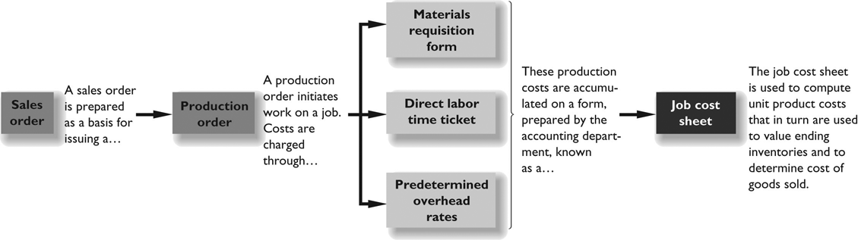

MATERIALS REQUISITION FORM
(Exhibit 2-1)
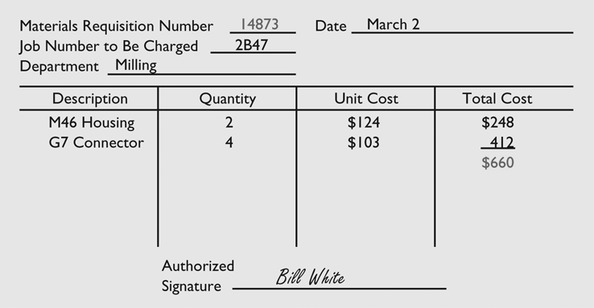
EMPLOYEE TIME TICKET
(Exhibit 2-3)
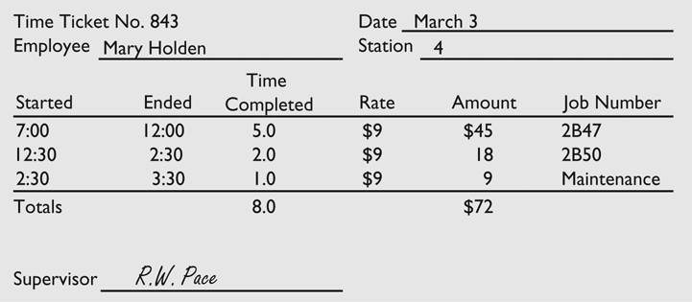

JOB COST SHEET
(Exhibit 2-4)
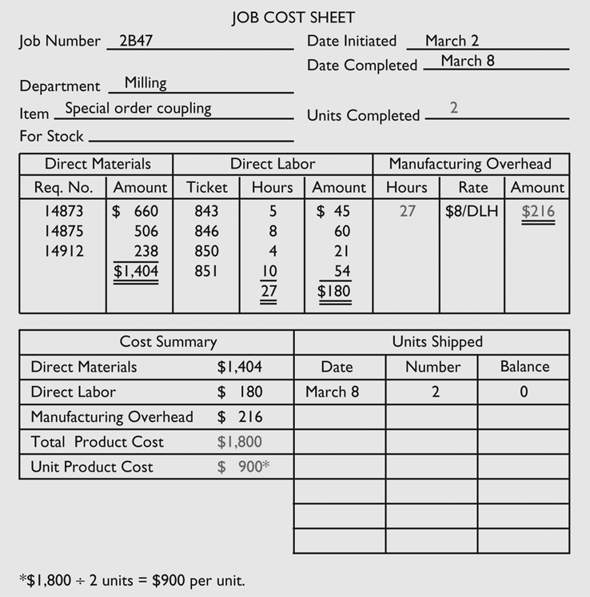

APPLICATION OF OVERHEAD
• In a job-order costing system, the cost of a job consists of:
1. Actual direct material costs traced to the job.
2. Actual direct labor costs traced to the job.
3. Manufacturing overhead applied to the job using a predetermined overhead rate. Actual overhead costs are not assigned to jobs.

• A predetermined overhead rate is used to assign overhead cost to products and services. It is:
• Based on estimated data.
• Established before the period begins.

• Why use estimated data?
• Waiting until the year is over to determine actual overhead costs would be too late. Managers want cost data immediately.
• Overhead rates, if based on actual costs and activity, would vary substantially from month to month. Much of this variation would be due to random changes in activity.
PREDETERMINED OVERHEAD RATE FORMULA
The formula for computing a predetermined overhead rate is:
The company in the preceding example applies overhead costs to jobs on the basis of direct labor-hours. In other words, the allocation base is direct labor-hours.
At the beginning of the year the company estimated that it would incur $320,000 in manufacturing overhead costs and would work 40,000 direct labor hours. The company’s predetermined overhead rate is:
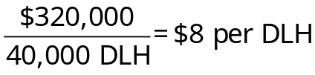

APPLICATION OF OVERHEAD TO JOBS
The process of assigning overhead to jobs is known as applying overhead.
In the preceding example, Job 2B47 required 27 direct labor-hours. Therefore, $216 of overhead cost was applied to the job as follows:

Predetermined overhead rate | $8 | per DLH
Direct labor-hours required for Job 2B47 | × 27 | DLHs
Overhead applied to Job 2B47 | $216
JOB-ORDER COSTING EXAMPLE
In the example appearing on the next few pages, we will trace how costs flow through Reeder Company’s job-order costing system.
1. Summary journal entries for the year for Reeder Company appear below:
a. Raw materials were purchased on account for $150,000.
Raw Materials 150,000
Accounts Payable 150,000

b. Raw materials that cost $160,000 were issued from the storeroom for use in production. Of this total, $136,000 was for direct materials and $24,000 for indirect materials.
Work in Process 136,000
Manufacturing Overhead 24,000
Raw Materials 160,000

Note: Actual manufacturing overhead costs incurred are debited to a control account called Manufacturing Overhead.
c. The following costs were incurred for employee services: direct labor, $200,000; indirect labor, $85,000; selling and administrative wages and salaries, $90,000.
Work in Process 200,000
Manufacturing Overhead 85,000
Wage and Salary Expense 90,000
Salaries and Wages Payable (or Cash) 375,000
JOB-ORDER COSTING EXAMPLE (cont’d)
d. Utility costs of $40,000 were incurred in the factory.
Manufacturing Overhead 40,000
Accounts Payable (or Cash) 40,000

e. Prepaid insurance of $20,000 expired during the year. (80% related to factory operations and 20% to selling and administration.)
Manufacturing Overhead 16,000
Insurance Expense 4,000
Prepaid Insurance 20,000

f. Advertising costs of $100,000 were incurred during the year.
Advertising Expense 100,000
Accounts Payable (or Cash) 100,000

g. Depreciation of $145,000 was accrued for the year on factory assets and $15,000 on selling and administrative assets.
Manufacturing Overhead 145,000
Depreciation Expense 15,000
Accumulated Depreciation 160,000
JOB-ORDER COSTING EXAMPLE (cont’d)
h. Manufacturing overhead was applied to jobs. The company’s predetermined overhead rate was based on the following estimates: manufacturing overhead, $315,000; direct labor cost, $210,000.
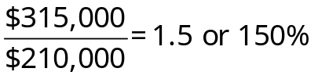
Since the total direct labor cost incurred was $200,000, the total manufacturing overhead applied to work in process was 150% of this amount or $300,000. The journal entry to record this is:
Work in Process 300,000
Manufacturing Overhead 300,000

i. Goods that cost $650,000 to manufacture according to their job cost sheets were completed and transferred to the finished goods warehouse.
Finished Goods 650,000
Work in Process 650,000

j. Sales for the year (all on credit) were $900,000.
Accounts Receivable 900,000
Sales 900,000

k. The goods that were sold had cost $600,000 to manufacture according to their job cost sheets.
Cost of Goods Sold 600,000
Finished Goods 600,000
JOB-ORDER COSTING EXAMPLE (cont’d)
2. T-accounts are provided below for the manufacturing accounts (beginning balances are assumed).

Raw Materials |  |  |  |  | Work in Process
Bal. | 20,000 |  |  |  | Bal. | 74,000
(a) | 150,000 | (b) | 160,000 |  | (b) | 136,000 | (i) | 650,000
Bal. | 10,000 |  |  |  | (c) | 200,000
 |  |  |  |  | (h) | 300,000
 |  |  |  |  | Bal. | 60,000
Finished Goods |  |  |  |  | Manufacturing Overhead
Bal. | 40,000 |  |  |  | (b) | 24,000 | (h) | 300,000
(f) | 650,000 | (k) | 600,000 |  | (c) | 85,000
Bal. | 90,000 |  |  |  | (d) | 40,000
 |  |  |  |  | (e) | 16,000
 |  |  |  |  | (g) | 145,000
 |  |  |  |  | Bal. | 10,000
Cost of Goods Sold
(k) | 600,000

a) Purchase of raw materials. | g) Depreciation of factory assets.
b) Issue of materials. | h) Apply manufacturing overhead.
c) Labor costs. | i) WIP completed.
d) Factory utility costs. | k) Finished Goods sold.
e) Factory insurance costs.
UNDERAPPLIED AND OVERAPPLIED OVERHEAD
Since predetermined overhead rates are based on estimated data, at the end of an accounting period overhead costs are usually either underapplied or overapplied. In the example, overhead is underapplied by $10,000, which can be determined by examining the balance in the Manufacturing Overhead account:

Manufacturing Overhead
Actual | (b) | 24,000 | (h) | 300,000 | Applied
Overhead | (c) | 85,000 |  |  | Overhead
Costs | (d) | 40,000 |  |  | Costs
 | (e) | 16,000
 | (g) | 145,000
 |  | 310,000 |  | 300,000
Under-applied | Bal. | 10,000

The difference of $10,000 between the actual overhead costs and the applied overhead costs in this case is called underapplied overhead because actual overhead costs exceeded the overhead costs that were applied to inventory.
Alternatively, the amount of the underapplied or overapplied overhead can be determined as follows:
 | Actual overhead costs incurred | $310,000
 | Applied overhead costs (150% × $200,000) | 300,000
 | Underapplied overhead | $ 10,000

3. Disposition of underapplied or overapplied overhead. Close the balance in Manufacturing Overhead to Cost of Goods Sold:
Cost of Goods Sold 10,000
Manufacturing Overhead 10,000

JOB-ORDER COSTING EXAMPLE (cont’d)
Reeder Company
Schedule of Cost of Goods Manufactured
Direct materials:
Beginning raw materials inventory | $ 20,000
Add: Purchases of raw materials | 150,000
Total raw materials available | 170,000
Deduct: Ending raw materials inventory | 10,000
Raw materials used in production | 160,000
Less: Indirect materials | 24,000 | $136,000
Direct labor |  | 200,000
Manufacturing overhead applied* |  | 300,000
Total manufacturing costs |  | 636,000
Add: Beginning work in process inventory |  | 74,000
 |  | 710,000
Deduct: Ending work in process inventory |  | 60,000
Cost of goods manufactured |  | $650,000

* Note that manufacturing overhead applied during the period is used to compute the total manufacturing costs on the schedule of cost of goods manufactured, not the actual manufacturing costs.
JOB-ORDER COSTING EXAMPLE (cont’d)
4. Reeder Company’s income statement for the year (assuming that the underapplied overhead is closed directly to Cost of Goods Sold) would be:
Reeder Company
Income Statement

Sales |  | $900,000
Cost of goods sold ($600,000 + $10,000) |  | 610,000
Gross margin |  | 290,000
Less selling and admin. expenses:
Wage and salary expense | $ 90,000
Insurance expense | 4,000
Advertising expense | 100,000
Depreciation expense | 15,000 | 209,000
Net operating income |  | $ 81,000

Reeder Company
Schedule of Cost of Goods Sold

Beginning finished goods inventory |  | $ 40,000
Add: Cost of goods manufactured |  | 650,000
Goods available for sale |  | 690,000
Ending finished goods inventory |  | 90,000
Unadjusted cost of goods sold |  | 600,000
Add: Underapplied overhead |  | 10,000
Adjusted cost of goods sold |  | $610,000
COST FLOWS IN A JOB-ORDER COSTING SYSTEM
(Exhibit 2-14)


