Chapter 1
Lecture Notes

Chapter theme: This chapter serves three main purposes. First, it describes the work of management and the need for managerial accounting information. Second, it compares financial accounting and managerial accounting. Third, it discusses the four main uses of cost information – to prepare external financial reports, to predict cost behavior, to assign costs to cost objects, and to make business decisions.
1

- The work of management and the need for managerial accounting information

  - Managers carry out three main activities – planning, directing and motivating, and controlling.
2

    - Planning

      - The first step in planning is to identify alternatives and then to select from among the alternatives the one that does the best job of furthering the organization’s objectives.
      - Once alternatives have been identified, the plans of management are often expressed formally in budgets.
3
        - Budgets are usually prepared under the direction of the controller, who is the manager in charge of the accounting department.
        - Typically, budgets are prepared annually.

    - Directing and motivating

      - In addition to planning for the future, managers must oversee day-to-day activities to keep the organization functioning smoothly.
4
      - Managerial accounting data, such as daily sales reports, are often used in this type of day-to-day decision making.

    - Controlling

      - In carrying out the control function, managers seek to ensure that the plan is being followed. Feedback, which signals whether operations are on track, is the key to effective control.
5

        - A performance report compares budgeted to actual results. It suggests where operations are not proceeding as planned and where some parts of the organization may require additional attention.

    - The planning and control cycle
6
      - The work of management, which is known as the planning and control cycle, can be depicted as shown.

Comparison of financial and managerial accounting

Seven key differences

    - Users

      - Financial accounting reports are prepared for external parties, whereas managerial accounting reports are prepared for internal users.

    - Emphasis on the future

      - Financial accounting summarizes past transactions. Managerial accounting has a strong future orientation.

    - Relevance of data
7

      - Financial accounting data are expected to be objective and verifiable. Managerial accountants focus on providing relevant data even if it is not completely objective or verifiable.

    - Less emphasis on precision

      - Financial accounting focuses on precision when reporting to external parties. Managerial accounting aids decision makers by providing good estimates as soon as possible rather than waiting for precise data later.

    - Segments of an organization

      - Financial accounting is concerned with reporting for the company as a whole. Managerial accounting focuses more on the segments of the company. Examples of segments include:
7
        - Product lines, sales territories, divisions, departments, etc.

“In Business Insights”
“Recordkeeping for the Future” (see page 32)

    - Generally Accepted Accounting Principles (GAAP)

      - Financial accounting conforms to GAAP. Managerial accounting is not bound by GAAP.
7
    - Managerial accounting – not mandatory

      - Financial accounting is mandatory because various outside parties require periodic financial statements. Managerial accounting is not mandatory.

- General cost classifications: Our initial focus is on manufacturing companies since their basic activities include most of the activities found in other types of business organizations. Nonetheless, many of the concepts developed in this chapter apply to diverse organizations.

Learning Objective 1: Identify and give examples of each of the three basic manufacturing cost categories.
8

  - Classifications of manufacturing costs (e.g., direct materials, direct labor, and manufacturing overhead):
9

    - Direct materials − Raw materials that become an integral part of the finished product and whose costs can be conveniently traced to it.
10

    - Direct labor − Labor costs that can be easily traced to individual units of product (also called touch labor).
11

“In Business Insights”
“Is Sending Jobs Overseas Always a Good Idea?” (see page 34)

    - Manufacturing overhead − Includes all manufacturing costs except direct materials and direct labor. These costs cannot be easily traced to specific units produced (also called indirect manufacturing cost, factory overhead, and factory burden).

      - Includes indirect materials that are part of the finished product, but that cannot be easily traced to it.
12
      - Includes indirect labor costs that cannot be physically or conveniently traced to the creation of products.
      - Other examples of manufacturing overhead include: maintenance and repairs on production equipment, heat and light, property taxes, depreciation and insurance on manufacturing facilities, etc.

Helpful Hint: Use something in the classroom such as a chair to illustrate manufacturing cost concepts. Center discussion on the raw materials classified as direct materials and as manufacturing overhead; labor costs classified as direct labor and as manufacturing overhead; and other costs incurred to produce the chair that are classified as manufacturing overhead.

    - Prime cost − Direct materials plus direct labor.
13

    - Conversion cost – Direct labor plus manufacturing overhead.

  - Classifications of nonmanufacturing costs (also called selling and administrative costs).

    - Selling costs – Includes all costs necessary to secure customer orders and get the finished product into the hands of the customer.
14

    - Administrative costs – Includes all executive, organizational, and clerical costs associated with the general management of an organization.

Learning Objective 2: Distinguish between product costs and period costs and give examples of each.
15

Product costs versus period costs
16
    - Product costs (also called inventoriable costs) – Includes all the costs that are involved in acquiring or making a product. In the case of manufactured goods, it includes direct materials, direct labor, and manufacturing overhead.

      - Consistent with the matching principle, product costs are recognized as expenses when the products are sold.
16

    - Period costs – Includes all selling and administrative costs.

      - These costs are expensed on the income statement in the period incurred.
17-18
Quick Check – product versus period costs

“In Business Insights”
“Bloated Selling and Administrative Expenses” (page 36)

- Cost classifications on financial statements

Merchandising vs. manufacturing companies

    - Merchandising companies − Purchase finished goods from suppliers for resale to customers.
19
    - Manufacturing companies − Purchase raw materials from suppliers and produce and sell finished goods to customers.

The balance sheet: merchandising vs. manufacturing companies
20

    - Merchandising companies do not have to distinguish between raw materials, work in process, and finished goods. They report one inventory number on their balance sheet labeled merchandise inventory.
20

    - Manufacturing companies report three types of inventory on their balance sheets.

      - Raw materials – The materials used to make the product.
      - Work in process – Consists of units of product that are partially complete, but that will require further work before they are ready for sale to customers.
21
      - Finished goods – Consists of units of product that have been completed but not yet sold to customers.

Learning Objective 3: Prepare an income statement including calculation of the cost of goods sold.
22

The income statement: merchandising vs. manufacturing companies

    - Merchandising companies calculate cost of goods sold as:
23
COGS = BMI + Purchases – EMI

    - Manufacturing companies calculate cost of goods sold as:

COGS = BFGI + COGM – EFGI

Helpful Hint: Explain that the raw materials, work in process, and finished goods inventories all follow the same logic. They start out with some beginning inventory. Additions are made during the period. At the end of the period, everything that started in the inventory or that was added must be in the ending inventory or have been transferred out to another inventory account or to cost of goods sold.
24

Quick Check – inventory flows
25-26

Learning Objective 4: Prepare a schedule of cost of goods manufactured.
27

The schedule of cost of goods manufactured

This schedule contains the three elements of costs mentioned previously, namely direct materials, direct labor, and manufacturing overhead.
28
    - It calculates the cost of raw material, direct labor and manufacturing overhead used in production during the period.

    - It calculates the manufacturing costs associated with goods that were finished during the period.

Product cost flows

    - To create a schedule of cost of goods manufactured as well as a balance sheet and income statement, it is important to understand the flow of product costs:

      - Raw material purchases made during the period are added to beginning raw materials inventory. The ending raw materials inventory is deducted to arrive at the raw materials used in production.
29
        - As items are removed from raw materials inventory and placed into the production process, they are called direct materials.
      - Direct labor and manufacturing overhead (also called conversion costs) used in production are added to direct materials to arrive at total manufacturing costs.
30
      - Total manufacturing costs are added to the beginning work in process to arrive at total work in process.
31
      - The ending work in process inventory is deducted from the total work in process for the period to arrive at the cost of goods manufactured.
32
      - The cost of goods manufactured is added to the beginning finished goods inventory to arrive at cost of goods available for sale. The ending finished goods inventory is deducted from this figure to arrive at cost of goods sold.
33
      - All raw materials, work in process, and unsold finished goods at the end of the period are shown as inventoriable costs in the asset section of the balance sheet.
34
      - As finished goods are sold, their costs are transferred to cost of goods sold on the income statement.
      - Selling and administrative expenses are not involved in making the product; therefore, they are treated as period costs and reported in the income statement for the period the cost is incurred.
34
35-42
Quick Check – product cost flows

“In Business Insights”
“Benetton and the Value Chain” (see page 43)

“In Business Insights”
“Product or Period Cost? – Not Just an Academic Decision” (see page 45)

Cost classifications for predicting cost behavior

Learning Objective 5: Define and give examples of variable costs and fixed costs
43

Cost behavior refers to how a cost will react to changes in the level of activity within the relevant range. The most commonly used classifications of cost behavior are variable and fixed costs:
44

    - Variable cost − A cost that varies, in total, in direct proportion to changes in the level of activity. However, variable cost per unit is constant.
45-46

“In Business Insights”
“Brown is Thinking Green” (see page 47)

    - Fixed cost − A cost that remains constant, in total, regardless of changes in the level of the activity. However, if expressed on a per unit basis, the average fixed cost per unit varies inversely with changes in activity.
47-48

“In Business Insights”
“Food Costs at a Luxury Hotel” (see page 47)

    - It is helpful to think about variable and fixed cost behavior in a 2x2 matrix.
49

Helpful Hint: To illustrate fixed costs, ask students for the cost of a large pizza. Then ask: What would be the cost per student if two students buy a pizza? What if four students buy a pizza? This makes it clear why average fixed costs change on a per unit basis. To illustrate variable costs, add that a beverage costs $1 and each student eating the pizza has one beverage. So, if two people were eating the pizza, the total beverage bill would come to $2; if four people, $4. The cost per beverage remains the same, but the total cost depends on the number of people ordering a beverage.
50-51
Quick Check –variable vs. fixed costs

“In Business Insights”
“The Cost of a Call” (see page 49)

- Cost classifications for assigning costs to cost objects

Learning Objective 6: Define and give examples of direct and indirect costs.
52

Cost object − Anything for which cost data are desired including products, customers, jobs, organizational subunits, etc. For purposes of assigning costs to cost objects, costs are classified two ways:

    - Direct costs − Costs that can be easily and conveniently traced to a unit of product or other cost object.
53

    - Indirect costs − Costs that cannot be easily and conveniently traced to a unit of product or other cost object.

      - Common costs − Indirect costs incurred to support a number of cost objects. These costs cannot be traced to any individual cost object.

- Cost classifications for decision making

Learning Objective 7: Define and give examples of cost classifications used in making decisions: differential costs, opportunity costs, and sunk costs.
54

It is important to realize that every decision involves a choice between at least two alternatives. The goal of making decisions is to identify those costs that are either relevant or irrelevant to the decision. To make decisions, it is essential to have a grasp on three concepts:
55

    - Differential costs (or incremental costs) − A difference in cost between any two alternatives (a difference in revenue between two alternatives is called differential revenue).
56
56
      - Differential costs can be either fixed or variable.

“In Business Insights”
“The Cost of a Healthier Alternative” (see page 50)

    - Opportunity cost − The potential benefit that is given up when one alternative is selected over another.
57

      - These costs are not usually entered into the accounting records of an organization, but must be explicitly considered in all decisions.

Helpful Hint: Ask students what opportunity costs they incur by attending class. Their opportunity cost is the value to them of the activity they would be doing otherwise (e.g., working, sleeping, partying, studying, etc.)

“In Business Insights”
“Using Those Empty Seats” (see page 52)

    - Sunk cost − A cost that has already been incurred and that cannot be changed by any decision now or in the future.
58

Helpful Hint: Ask students: “Suppose you had purchased gold for $400 an ounce, but now it is selling for $250 an ounce. Should you wait for the gold to reach $400 an ounce before selling it?” Many students will say “yes” even though the $400 purchase is a sunk cost.

Quick Check – relevant costs
59-64

“In Business Insights”
“What Number Did You Have in Mind” (see page 53)

Summary of the types of cost classifications

We have looked at the cost classifications used for financial reporting, predicting cost behavior, assigning costs to cost objects, and making business decisions.
65

AGENDA: AN INTRODUCTION TO MANAGERIAL ACCOUNTING AND COST CONCEPTS
1. The work of management.
2. Management accounting contrasted with financial accounting.
3. Cost concepts for preparing external financial reports.
4. Cost concepts for predicting changes in costs due to changes in activity.
5. Cost concepts for assigning costs to costing objects.
6. Cost concepts for making decisions.
THE PLANNING AND CONTROL CYCLE
(Exhibit 1-1)
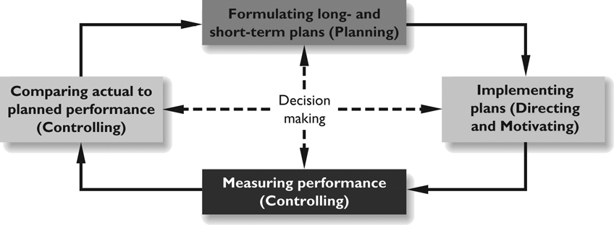
Managerial and Financial Accounting Contrasted
(Exhibit 1-2)
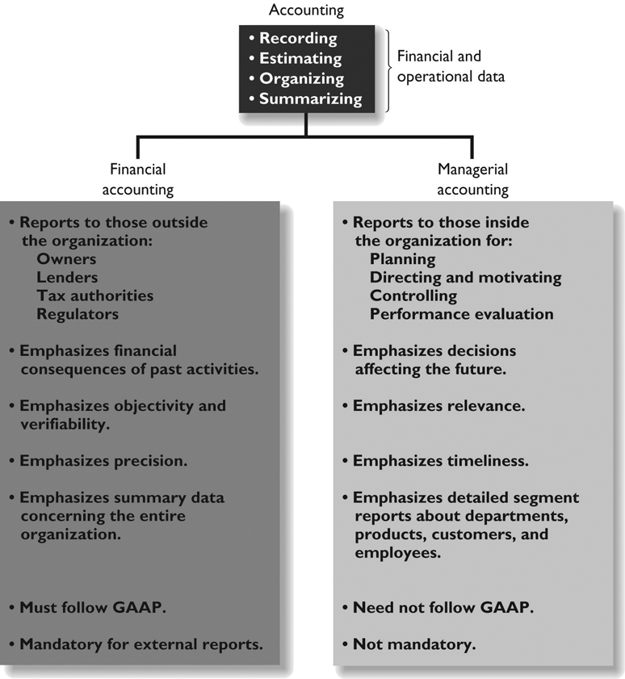
AN OVERVIEW OF COST TERMS

Purpose of classification | Cost classifications
Preparing an income statement and a balance sheet | • Product costs  • Direct materials  • Direct labor  • Manufacturing overhead  • Period costs (nonmanufacturing costs)  • Marketing and selling costs  • Administrative costs
Predicting changes in cost due to changes in activity | • Variable costs  • Fixed costs
Assigning costs to cost objects | • Direct costs  • Indirect costs
Making decisions | • Differential costs  • Sunk costs  • Opportunity costs

COST CLASSIFICATIONS IN MANUFACTURING COMPANIES
(Exhibit 1-3)
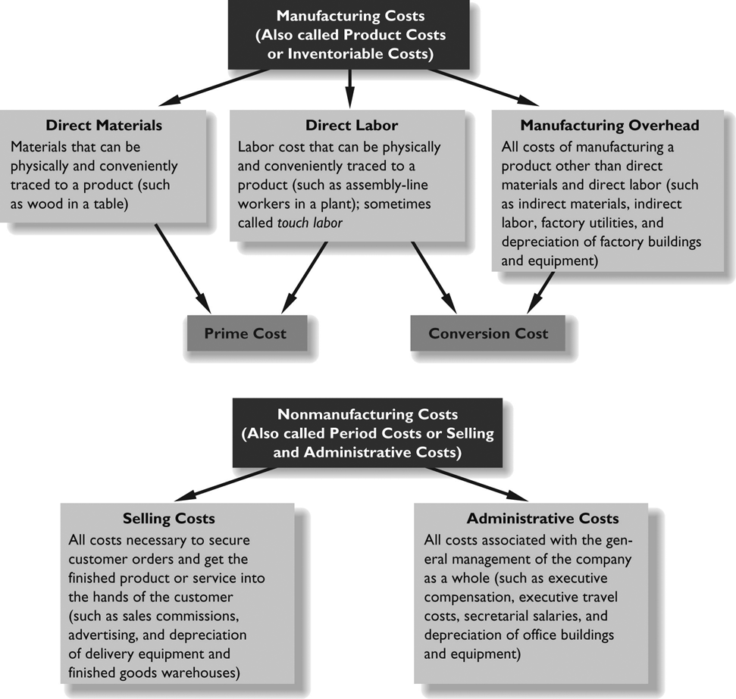
COST FLOWS IN A MANUFACTURING COMPANY
(Exhibit 1-7)
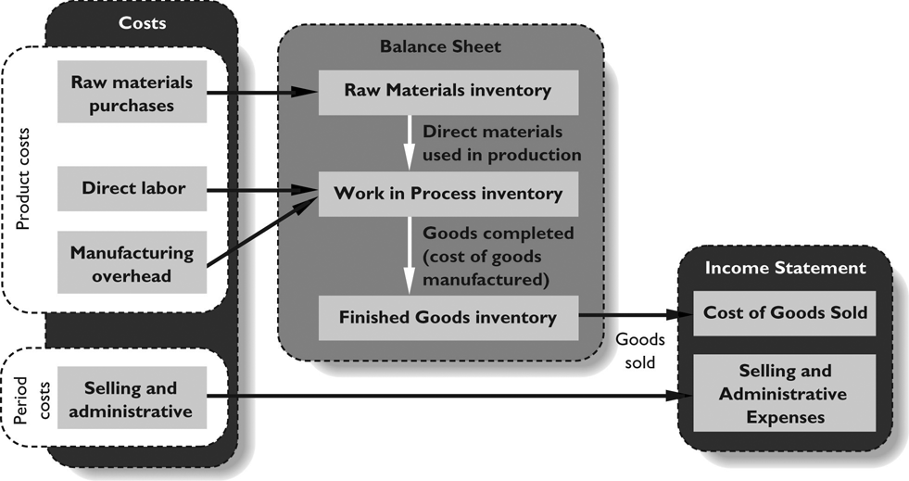
COST FLOWS EXAMPLE
EXAMPLE: Ryarder Company incurred the following costs last month:

Purchases of raw materials |  | $200,000
Direct labor |  | 270,000
Manufacturing overhead:
Indirect materials | $ 5,000
Indirect labor | 100,000
Utilities, factory | 80,000
Property taxes, factory | 36,000
Insurance, factory | 9,000
Equipment rental | 70,000
Depreciation, factory | 120,000 | 420,000

But:
• Some of the goods sold this month were produced in previous months.
• Some of the costs listed above were incurred to make goods that were not sold this month.
Therefore:
• Cost of goods sold does not equal the sum of the above costs.
• We need to determine the values of the various inventories.
COST FLOWS EXAMPLE (cont’d)
Additional data for Ryarder Company:
Raw materials inventory:
Beginning raw materials inventory | $10,000
Purchases of raw materials | $200,000
Ending raw materials inventory | $30,000
Raw materials used in production | ?
Work in process inventory:
Beginning work in process inventory | $40,000
Total manufacturing costs | ?
Ending work in process inventory | $60,000
Cost of goods manufactured (i.e., finished) | ?
Finished goods inventory:
Beginning finished goods inventory | $130,000
Cost of goods manufactured (i.e., finished) | ?
Ending finished goods inventory | $80,000
Cost of goods sold | ?
INVENTORY FLOWS
(Exhibit 1-5)

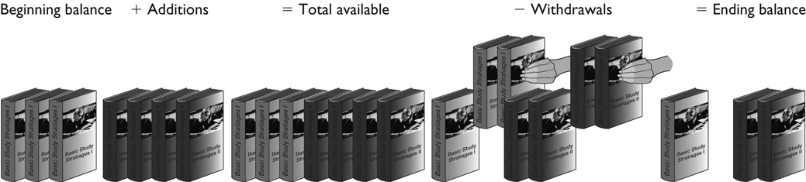

Basic Equation for Inventory Accounts:

or
COST FLOWS EXAMPLE (cont’d)

Computation of raw materials used in production
 |  | Beginning raw materials inventory | $ 10,000
 | + | Purchases of raw materials | 200,000
 | – | Ending raw materials inventory | 30,000
 | = | Raw materials used in production | $180,000

Computation of total manufacturing cost
 |  | Raw materials used in production | $180,000
 | + | Direct labor | 270,000
 | + | Manufacturing overhead | 420,000
 | = | Total manufacturing costs | $870,000

Computation of cost of goods manufactured
 |  | Beginning work in process inventory | $ 40,000
 | + | Total manufacturing costs | 870,000
 | – | Ending work in process inventory | 60,000
 | = | Cost of goods manufactured (i.e., finished) | $850,000

Computation of cost of goods sold
 |  | Beginning finished goods inventory | $130,000
 | + | Cost of goods manufactured (i.e., finished) | 850,000
 | – | Ending finished goods inventory | 80,000
 | = | Cost of goods sold | $900,000

SCHEDULE OF COST OF GOODS MANUFACTURED

Ryarder Company
Schedule of Cost of Goods Manufactured

 | Direct materials:
 | Beginning raw materials inventory | $ 10,000
 | Add: Purchases of raw materials | 200,000
 | Raw materials available for use | 210,000
 | Deduct: Ending raw materials inventory | 30,000
 | Raw materials used in production |  | $180,000
 | Direct labor |  | 270,000
 | Manufacturing overhead:
 | Indirect materials | 5,000
 | Indirect labor | 100,000
 | Utilities, factory | 80,000
 | Property taxes, factory | 36,000
 | Insurance, factory | 9,000
 | Equipment rental | 70,000
 | Depreciation, factory | 120,000
 | Total manufacturing overhead |  | 420,000
 | Total manufacturing costs |  | 870,000
 | Add: Beginning work in process inventory |  | 40,000
 |  |  | 910,000
 | Deduct: Ending work in process inventory |  | 60,000
 | Cost of goods manufactured |  | $850,000

Cost of Goods Sold
 | Beginning finished goods inventory |  | $130,000
 | Add: Cost of goods manufactured |  | 850,000
 | Goods available for sale |  | 980,000
 | Deduct: Ending finished goods inventory |  | 80,000
 | Cost of goods sold |  | $900,000
COST CLASSIFICATIONS TO DESCRIBE COST BEHAVIOR
To describe how costs react to changes in activity, costs are often classified as variable or fixed.

VARIABLE COSTS
Variable cost behavior can be summarized as follows:

Variable Cost Behavior
In Total | Per Unit
Total variable cost increases  and decreases in proportion  to changes in activity. | Variable cost per  unit is constant.

EXAMPLE: A company manufactures microwave ovens. Each oven requires a timing device that costs $30. The per-unit and total cost of the timing device at various levels of activity (i.e., number of ovens produced) would be:

Cost per Timing Device | Number of Ovens Produced | Total Variable Cost—Timing Devices
$30 | 1 | $30
$30 | 10 | $300
$30 | 100 | $3,000
$30 | 200 | $6,000
FIXED COSTS
Fixed cost behavior can be summarized as follows:

Fixed Cost Behavior
In Total | Per Unit
Total fixed cost is not affected by changes in activity (i.e., total fixed cost remains constant even if activity changes). | Fixed cost per unit decreases as the activity level rises and increases as the activity level falls.

EXAMPLE: Assume again that a company manufactures microwave ovens. The company pays $9,000 per month to rent its factory building. The total and per unit cost of rent at various levels of activity would be:

Rent Cost per Month | Number of Ovens Produced | Rent Cost per Oven
$9,000 | 1 | $9,000
$9,000 | 10 | $900
$9,000 | 100 | $90
$9,000 | 200 | $45
A GRAPHIC VIEW OF COST BEHAVIOR

RELEVANT RANGE
If activity changes enough, fixed costs may change. For example, if microwave production were doubled, another factory building might have to be rented.
The relevant range is the range of activity within which the assumptions that have been made about variable and fixed costs are valid. For example, the relevant range within which total fixed factory rent is $9,000 per month might be 1 to 200 microwaves produced per month.
COST CLASSIFICATIONS FOR ASSIGNING COSTS
COST OBJECT
A cost object is anything for which cost data are desired.
Examples:
• Products
• Customers
• Departments
• Jobs
DIRECT COSTS
A direct cost is a cost that can be easily and conveniently traced to a particular cost object.
Examples:
• The direct costs of a Ford SUV would include the cost of the steering wheel purchased by Ford from a supplier, the costs of direct labor workers, the costs of the tires, and so on.
• The direct costs of a hospital’s radiology department would include X-ray film used in the department, the salaries of radiologists, and the costs of radiology lab equipment.
INDIRECT COSTS
An indirect cost is a cost that cannot be easily and conveniently traced to a particular cost object.
Examples:
• Manufacturing overhead, such as the factory managers’ salary at a multi-product plant, is an indirect cost of any one product.
• General hospital administration costs are indirect costs of the radiology lab.
COST CLASSIFICATIONS FOR MAKING DECISIONS
DIFFERENTIAL COST
Every decision involves choosing from among at least two alternatives. Any cost that differs between alternatives is a differential cost. Only the differential costs are relevant in making a decision.
EXAMPLE: Bill is currently employed as a lifeguard, but he has been offered a job in an auto service center in the same town. The differential revenues and costs between the two jobs are listed below:

 | Lifeguard | Auto Service Center | Differential Costs and Revenues
Monthly salary | $1,200 | $1,500 | $300
Monthly expenses:
Commuting | 30 | 90 | 60
Meals | 150 | 150 | 0
Apartment rent | 450 | 450 | 0
Uniform rental | 0 | 50 | 50
Union dues | 10 | 0 | (10)
Total monthly expenses | 640 | 740 | 100
Net monthly income | $ 560 | $ 760 | $200
OPPORTUNITY COST
An opportunity cost is the potential benefit given up when selecting one course of action over another.
EXAMPLE: Linda is employed in the campus bookstore and is paid $65 per day. One of her friends is getting married and Linda would like to attend the wedding, but she would have to miss a day of work. If she attends the wedding, the $65 in lost wages will be an opportunity cost of attending the wedding.
EXAMPLE: The reception for the wedding mentioned above will be held in the ballroom at the Lexington Club. The manager of the Lexington Club had to decide between accepting the booking for the wedding reception or accepting a booking for a corporate seminar. The hall could have been rented to the corporation for $600. The lost rental revenue of $600 is an opportunity cost of accepting the reservation for the wedding.

SUNK COST
A sunk cost is a cost that has already been incurred and that cannot be changed by any decision made now or in the future. Sunk costs are irrelevant and should be ignored in decisions.
EXAMPLE: Linda has already purchased a ticket to a rock concert for $35. Unfortunately, if she goes to the wedding, she will be unable to attend the concert. The $35 is a sunk cost that she should ignore when deciding whether or not to attend the wedding. [However, any amount she can get by reselling the ticket is NOT a sunk cost.]

