
WEEKLY SCHEDULE 6-10
Class | Tuesdays meet in JR 248 | Thursdays meet in JR 247
be prepared for | Homework:Readings done prior to Class | Writing Projects
Wk 6 | 2/28 | 3/1
Project Space  Convergences | Due outside of and prior to class:  - Moodle response 5  Due in Class:  - Rhetorical Analysis #4 Kim & Mendoza  - Groups choose Convergences clusters for Proj Space unit  Review & download handouts from Projects link above:  - Another City: 25b. "Los Angeles"  Readings:  - Convergences 285-345 Chap 3 review clusters  - Another City handout 25b.  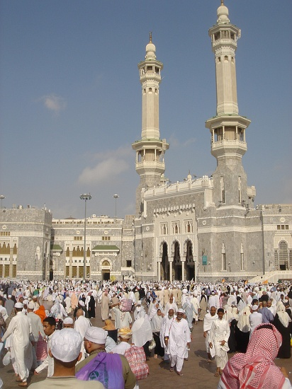 | Due in of class:  - Each group will present readings below discussing how they support or challenge the customary ways we see the world around us ?  Review & download handouts from Projects link above:  - Another City: 25d "Inside Miss Los Angeles"  Readings:  - Convergences: "Home" 290-301 -- We chose this cluster because it is a personal space where you can be yourself. Be free. Have an emotional attachment to it. A place to go to everyday. Our reasoning is the home cluster will assist our knowledge of project space in class by creating different forms of space. Because every person has a different space not only the size but the comfort of having that space. Each room represents a person or different people. Home can also not be such a great place. Everyone comes from a different background and different ideas of home. Home can be where your heart is. We chose this because we all feel we can relate to this cluster in different perspectives, opinions, and ideas. --Group Bohen, Revivo, Ramos, Kim  - Another City handout 25d.  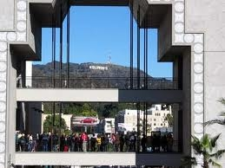
Wk 7 | 3/6 | 3/8
Convergences | Due outside of and prior to class:  - Moodle response 6  Due in of class:  - Each group will present one website link on Projects to compare/analyze with our readings as a "Sacred Space" or "... Saved My Life"!  Review & download handouts from Projects link above:  - Another City: 25e. "Minnie Riperton Saved My Life"  Readings:  - Convergences: "Sacred Space" 314-323--  Our group chose this subject because we all have our sacred places in our lives. The Sacred places we have are part of what describes us as individuals. When describing our sacred places allot of questions arose like, why is it your choice? how long has it been that you have decided this place as your sacred place? We are very excited to show the whole class our own personal places and what they mean to us. --Group Maciel, Min, Valderrama, Blades  - Another City handout 25e.  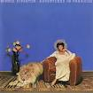 | Due in of class:  - Rhetorical analysis presentation #5 Maciel & Santiesteban  - Project Space Proposals Typed in MLA format!  Review & download handouts from Projects link above:  - "Creating the Annotated Bibliography"  - Review link "Citing your Sources: Annotated Bibliography"  - Review link "Sample Annotated Bibliography"  Readings:  - Convergences "The Full MoA" (Mall of America) 572-585  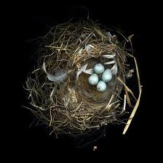
Wk 8 | 3/13 | 3/15 Field work and Ethnograpy due 3/29
Convergences | Due outside of and prior to class:  - Moodle response 7 must dicuss readings below!  Review & download handouts from Projects link above:  - Another City: 25c. "An Empty Classroom, Lincoln Heights"  Readings:  - Convergences: "Public Space" 329-334--  can assist the class in Project Space because, Public Space can be a foundation of  - A good thesis  - It can be a great topic to relate too  - is everywhere around us so there can be many views to it  - It can change the view of any space in Los Angeles--Group Rodriguez, Echeverria, Henriquez, Santiesteban  - Another City handout 25c.  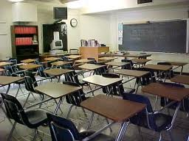  Due In Class:  - Meet in library Lab C | Use 113B and SI class time to do your field work and ethnography for Project Space  
Wk 9 | 3/20 | 3/22
Project Space rough draft due | Due outside of and prior to class:  - Post in Forum: Project Space Annotated Bibliography  Due In Class  - Rhetorical Presentation #6 Cordero & Alcocer  - Another City: 25a. "Bad Girl on the Curb  Readings:  - Convergences:"Mental Space: The Human Imagination" 335-345--  First off, we'd like to state "I can't believe it's not butter" :o  - We will provide the use of imagery.  - Physiology of the brain in relation to images.  - Scientific Method's rapid cycle: hypothesis, experiment, and analysis.  - "Virtual World" examination --Possibility space [videogames]  - Considering the Cluster: Message, Method, Medium  - Perspective views on art.  - Will Wright's DREAM MACHINES --Group Mendoza, Ptah, Cordero, Alcocer  - Another City handout 25a.  | Due outside of and prior to class:  - Due Sun 3/18 1155PM entire class post Project Web rough drafts-make sure you post correctly in one of the Three forums provided!  - Due Tues 3/20 1155PM Post in Workshop 3 Forum response to each student's below rough draft. Students work to be dicussed  Facilitator/Writer:  Maciel/Kim  Mendoza/Maciel  Min/Henriquez  Ptah/Echeverria  - Review Writing Response Protocols handout in Projects link above.  - Conferences  Due in class:  - Whole-class workshop 3
Wk 10 | 3/27 | 3/29
 | Due outside of and prior to class:  - Due Sun 3/25 1155PM Post in Workshop 4 Forum response to each student's below rough draft. Students work to be dicussed  Facilitator/Writer:  Ramos/Cordero  Revivo/Bohen  Rodriguez/Blades  Santiesteban/Alcocer  - Review Writing Response Protocols handout in Projects link above.  Due in class:  - Whole-class workshop 4  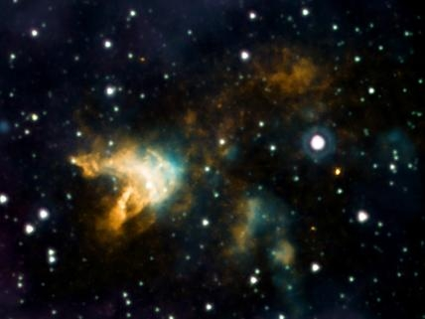 | Due outside of and prior to class:  - Upload Project Space teacher draft & Ethnography on blog prior to class must follow MLA format but feel free to include multi media  Due in Class:  - Project Space Presentations  - Project Space Ethnography  Review & download handouts from Projects link above:  - Project Web Essay
- Updated on 2/29/12

