Spring 2012 Prof L Overman's English 113B
WEEKLY SCHEDULE 1-5
Class | Tuesdays meet in JR 248 | Thursdays meet in JR 247
be prepared for | Homework:Readings done prior to Class | Writing Projects
Wk 1 | 1/24 | 1/26
Bring Perseoplis & Convergences each week until instructed otherwise | Due outside of and prior to class:  - Completed 3 study guide answers posted to Blog (handed out last semester)  Due in Class:  - Discuss syllabus  - Choose presentation dates  - Discuss presentation strategies  - Group assignments  Download & Review from Projects link:  - Basic Questions for Rhetorical Analysis  Readings:  - Persepolis  - Convergences "Introduction" 1-17 | Due outside of and prior to class:  - Complete Quiz in Moodle on Persepolis  - Moodle response 1  Due in Class:  - Rhetoric review  - Whole-class workshop protocol  - Whole-class workshop assigned  - Group assignments  Download & Review from Projects link:  - Writing Response Protocols  - Workshop Guidelines  Readings:  - Convergences "Introduction" 21-24 & 38-49
Wk 2 | 1/31 | 2/2
Persepolis & Convergences | Due outside of and prior to class:  - Moodle response 2  Due in Class:  - Rhetorical analysis presentation #1 by: Ptah & Bohen  Readings:  - Persepolis 1-53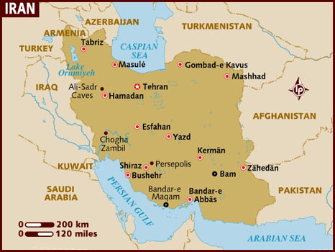  Review & download handouts from Projects link above:  - Project Text Essay | Due in class:  - Bring blue book for In Class Essay 1  - Bring Persepolis, study guide, notes
Wk 3 | 2/7 | 2/9
Persepolis & Convergences | Due outside of and prior to class:  - Moodle response 3  Due in Class  - Rhetorical analysis presentation #2 by: Echeverria & Valderrama  Review & download handouts from Projects link above:  Freytag Pyramid - Plot  Readings:  - Persepolis 54-102 | Due in class:  - Rhetorical analysis presentation #3 by: Henriquez & Mendoza  Review & download handouts from Projects link above:  - Sample Writing response papers
Wk 4 | 2/14 | 2/16
Persepolis  Project Text rough drafts due | Due outside of and prior to class:  - Moodle response 4  Due in class:  - Whole-class workshop preparation & practice  Review & download handouts from Projects link above:  - Wings "Reasons to Pursue A Purpose" download  - Workshop Guidelines  - Peer Reviewer rubric handout (from Syllabus link)  Readings:  - New Voices "The Forgotten Ones" (26)  - Persepolis 103-end | Due outside of and prior to class:  - Due Sun 2/12 1155PM entire class post Project Web rough drafts-make sure you post correctly in one of the Three forums provided!  - Due Tues 2/14 1155PM Post in Workshop 1 Forum response to each student's below rough draft. Students work to be dicussed  Facilitator/Writer:  Alcocer/Valderrama  Amador/Santiesteban  Blades/Rodriguez  Bohen/Revivo  - Review Writing Response Protocols handout in Projects link above.  - Review Sample Writing Response Papers in Projects link above.  Due in class:  - Whole-class workshop 1
Wk 5 | 2/21 | 2/23
Persepolis  Start Project Text rough draft & revise for upload to Blogs | Due outside of and prior to class:  - Due Sun 2/19 1155PM Post in Workshop 2 Forum response to each student's below rough draft. Students work to be dicussed  Facilitator/Writer:  Cordero/Ramos  Echeverria/Ptah  Henriquez/Min  Kim/Mendoza  - Review Writing Response Protocols handout in Projects link above.  Due in Class  - Whole class workshop 2 | Due outside of and prior to class:  - Upload Project Text teacher draft on blog prior to class must follow MLA format but feel free to include multi media  Due in Class  - Project Text presentations from each group
- Updated on 1/26/12

